|  |  |
| --- | --- |
|  | **MINISTRY OF EDUCATION AND TRAINING** |

|  |
| --- |
| **FPT UNIVERSITY** |
| Capstone Project Document |
| Photographer Booking System |

|  |  |
| --- | --- |
| **FA20SE21** | |
| **Group Members** | Trần Thiên Thảo – Leader – SE62888  Bồ Công Đạt – Member – SE63154  Đào Sỹ Trung Kiên – Member – SE63208  Trương Ngọc Mỹ - Member – SE62050 |
| **Supervisor** | Lại Đức Hùng |
| **Ext Supervisor** | N/A |
| **Capstone Project code** | PBS |

- HoChiMinh, September 2020 -

**Table of Contents**

Acknowledgement 4

Definition and Acronyms 4

I. Project Introduction 5

1. Overview 5

1.1 Project Information 5

1.2 Project Team 5

a. Supervisor 5

b. Team Members 5

2. Product Background 5

3. Existing Systems 6

3.1 WeHelp 6

3.2 vLance 6

3.3 Tripo 7

4. Business Opportunity 7

5. Software Product Vision 8

6. Project Scope & Limitations 8

6.1 Major Features 8

6.2 Limitations & Exclusions 10

II. Project Management Plan 11

1. Overview 11

1.1 WBS & Estimation 11

1.2 Project Objectives 16

1.3 Project Risks 17

2. Management Approach 17

2.1 Project Process 17

2.2 Quality Management 18

2.3 Training Plan 18

3. Master Schedule 18

4. Project Organization 20

4.1 Team & Structures 20

4.2 Roles & Responsibilities 20

5. Project Communication 21

5.1 Communication Plan 21

5.2 External Interface 21

a. FU Contacts 21

b. Customer Contacts 22

6. Configuration Management 22

6.1 Tools & Infrastructures 22

6.2 Document Management 22

6.3 Source Code Management 22

VII. Appendix 24

1. Glossary [Optional] 24

2. References [Optional] 24

3. Others [Optional] 24

**List of Figures**

Figure 1 Feature mind map 14

Figure 2 Project process 22

Figure 3 Project organization 24

Figure 4 Context diagram 27

Figure 5 Overview Use Case Diagram 28

Figure 6 <Guest> Overview 31

Figure 7<Guest> Register 31

Figure 8 <Guest> Register Specification 33

Figure 9 <Guest> Login 34

Figure 10 <Customer> Overview 36

Figure 11 <Customer> Search photographers 37

Figure 12 <Customer> Get photographer's detail 38

Figure 13 <Customer> Book photographer 39

Figure 14 <Customer> Review photographers 41

Figure 15 <Customer> Get booking 43

Figure 16 <Customer> Edit booking 44

Figure 17 <Customer> Cancel booking 47

Figure 18 <Customer> Open thread 49

Figure 19<Customer> Edit thread 50

Figure 20 <Customer> Comment thread 53

Figure 21 <Customer> Chat 55

Figure 22 <Photographer> Overview 57

Figure 23 <Photographer> Accept booking 58

Figure 24 <Photographer> Decline booking 60

Figure 25 <Photographer> Edit working weekdays 62

Figure 26 <Photographer> Add busy day 63

Figure 27 <Photographer> Get customer's review 65

Figure 28 <Photographer> Add package 66

Figure 29<Photographer> Edit package 68

Figure 30 <Photographer> Remove package 70

Figure 31 <Photographer> Add album 72

Figure 32 <Photographer> Edit album 74

Figure 33 <Photographer> Remove album 76

Figure 34 <Authenticated User> Overview 78

Figure 35 <Authenticated User> Get profile 78

Figure 36 <Authenticated User> Edit profile 79

Figure 37 <Authenticated User> Change password 81

Figure 38 <Authenticated User> Logout 83

Figure 39 <Admin> Overview 84

Figure 40 <Admin> Block user 85

Figure 41 <Admin> Unblock user 86

Figure 42 <Admin> Add category 88

Figure 43 <Admin> Edit category 89

Figure 44 <Admin> Remove category 91

Figure 45 <Admin> Add returning type 93

Figure 46 <Admin> Edit returning type 94

Figure 47 <Admin> Remove returning type 96

Figure 48 <Admin> Change variables 98

Figure 49<Admin> Ban thread 99

Figure 50 <System Handler> Overview 101

Figure 51 <System Handler> Make booking notification 101

Figure 52 <System Handler> Make scheduling notification 103

Figure 53 <System Handler> Make weather warning 104

Figure 54 <System Handler> Make time warning 105

Figure 55 Customer's screen flow 107

Figure 56 Photographer's screen flow 108

Figure 57 Screen authorization 113

Figure 58 ER Diagram 115

Figure 59 Overall Architecture 120

Figure 60 Mobile App Architecture 121

Figure 61 Webapi Package Diagram 122

Figure 62 Package Diagram – Mobile app 124

Figure 63 Class Diagram 125

Figure 64 Sequence Diagram - Add Category 126

Figure 65 Sequence Diagram - Edit Category 126

Figure 66 Sequence Diagram - Remove Category 127

Figure 67 Sequence Diagram - Add returning type 127

Figure 68 Sequence Diagram - Edit returning type 128

Figure 69 Sequence Diagram - Remove returning type 128

Figure 70 Sequence Diagram - Block User 129

Figure 71 Sequence Diagram - Unblock User 129

Figure 72 Sequence Diagram - Change Variables 130

Figure 73 Activity Diagram - Make Request 131

Figure 74 Activity Diagram – Edit Request 132

Figure 75 Activity Diagram - Cancel booking 133

Figure 76 Activity Diagram - Rating 134

Figure 77 Activity Diagram - Accept booking 135

Figure 78 Activity Diagram - Reject booking 136

Figure 79 State Machine Diagram - Booking 137

Figure 80 Database Design 149

Figure 81 Flowchart - Multiple factors sorting 158

Figure 82 Test Model 163

Figure 83 Setup files - 1 168

Figure 84 Setup files - 2 168

Figure 85 Installation - 1 169

Figure 86 Installation - 2 170

Figure 87 Installation - 3 171

Figure 88 Installation - 4 172

Figure 89 Deployment - 1 172

Figure 90 Deployment -2 173

Figure 91 Deployment - 3 173

Figure 92 Register 176

Figure 93 - Login 177

Figure 94 - Logout 178

Figure 95 Search photographers 179

Figure 96 - Make request for a day 180

Figure 97 - Make request for days 181

Figure 98 - Update booking for a day 181

Figure 99 - Update booking for days 182

Figure 100 - Decline /Accept /Cancel Booking 182

Figure 101 - View Reviews 183

Figure 102 - Write reviews 184

Figure 103 - Change Booking Status 185

Figure 104 - Shooting schedule 186

Figure 105 - Make changes to daily shooting schedule 187

Figure 106 - Add busy days 188

Figure 107 - Follow Album 189

Figure 108 - Add Album 190

Figure 109 - Edit Album 191

Figure 110 - View Services 192

Figure 111 - Add Service 192

Figure 112 - Update Service 193

Figure 113 - Select / View Categories 194

Figure 114 - Chat 195

Figure 115 - View Thread 196

Figure 116 - View Comment 197

Figure 117 - Add Comment 198

Figure 118 - Create Thread 199

Figure 119 - Select Photo Delivery Methods 200

Figure 120 - Update Profile 201

Figure 121 - Update Avatar/ Cover 202

図122 – ログアウト 208

図123-フォトグラファー／サービスの検索 209

図124 –一日の予約 210

図125 –数日の予約 211

図126 - 一日の予約の変更 211

図127 -数日の予約の変更 212

図128 – 予約の断り/受入 /キャンセル 212

図129 – レビューをを観ます 213

図130 – レビューを書きます 214

図131 - 予約の状態を変更します 215

図132 - 撮るスケジュール 216

図133 – 毎日の撮るスケジュールを変更します 217

図134 – 都合がない日を追加します 218

図135 – アルバムをフォローする 219

図136 - アルバムを追加します 220

図137 – アルバムを変更します 221

図138 – サービスを観ます 222

図139 - サービスを追加します 222

図140 – サービスを変更します 223

図141 – カテゴリーを観ます／選択します 224

図142 – チャット 225

図143 – スレッドを観ます 226

図144 – コメントを観ます 227

図145 – コメントをを追加します 228

図146 – スレッドを追加します 229

図147 - 配信方法を選びます 230

図148 – プロファイルを編集します 231

図149 –アバター／コバーを変更します 232

**List of Tables**

Table 1 Team members 11

Table 2 WBS & Estimation 22

Table 3 Project objectives 22

Table 4 Project risks 23

Table 5 Training plan 24

Table 6 Master schedule 25

Table 7 Roles & Responsibilities 26

Table 8 Communication plan 27

Table 9 FU Contacts 27

Table 10 Customer contacts 28

Table 11 Tools & Infrastructures 28

Table 12 Business Rules 29

Table 13 System Actors 30

Table 14 Use Case List 32

Table 15 <Guest> Register Specification 37

Table 16 <Customer> Search Photographers Specification 40

Table 17 <Customer> Get photographer's detail specification 41

Table 18 <Customer> Book photographer specification 43

Table 19 <Customer> Review photographers speicification 45

Table 20 <Customer> Get booking specification 46

Table 21 <Customer> Edit booking specification 48

Table 22 <Customer> Cancel booking specification 50

Table 23 <Customer> Open thread specification 52

Table 24 <Customer> Edit thread specification 54

Table 25 <Customer> Comment thread specification 56

Table 26 <Customer> Chat specification 58

Table 27 <Photographer> Accept booking specification 61

Table 28 <Photographer> Decline booking specification 63

Table 29 Edit working weekdays specification 65

Table 30 <Photographer> Add busy day specification 67

Table 31<Photographer> Get customer's review specification 68

Table 32 <Photographer> Add package specification 70

Table 33 <Photographer> Edit package specification 72

Table 34 <Photographer> Remove package specification 74

Table 35 <Photographer> Add album specification 76

Table 36 <Photographer> Edit album specification 78

Table 37<Photographer> Remove album specification 79

Table 38 <Authenticated User> Get profile specification 81

Table 39 <Authenticated User> Edit profile specification 83

Table 40 <Authenticated User> Change password specification 84

Table 41 <Authenticated User> Logout specification 86

Table 42 <Admin> Block user specification 88

Table 43 <Admin> Unblock user specification 90

Table 44 <Admin> Add category specification 91

Table 45 <Admin> Edit category specification 93

Table 46 <Admin> Remove category specification 94

Table 47 <Admin> Add returning type specification 96

Table 48 <Admin> Edit returning type specification 98

Table 49 <Admin> Remove returning type specification 99

Table 50 <Admin> Change variables specification 101

Table 51 <Admin> Ban thread specification 103

Table 52 <System Handler> Make booking notification specification 105

Table 53 <System Handler> Make scheduling notification specification 106

Table 54 <System Handler> Make weather warning specification 107

Table 55<System Handler> Make time warning specification 108

Table 56 Customer's screen details 112

Table 57 Photographer's screen details 114

Table 58 Non-screen functions 116

Table 59 Entities List 118

Table 60 Messages List 121

Table 61 Package Diagram Description 125

Table 62 Package Diagram Description 127

Table 63 Class Diagram - User 140

Table 64 Class Diagram - Role 140

Table 65 Class Diagram - ERole 141

Table 66 Class Diagram - Package 141

Table 67 Class Diagram - Service 142

Table 68 Class Diagram - Booking 142

Table 69 Class Diagram - EBookingStatus 143

Table 70 Class Diagram - Album 144

Table 71 Class Diagram - Image 144

Table 72 Class Diagram - Category 145

Table 73 Class Diagram - DayOfWeek 145

Table 74 Class Diagram - Location 146

Table 75 Class Diagram - BookingComment 146

Table 76 Class Diagram - BookingDetail 147

Table 77 Class Diagram - BusyDay 147

Table 78 Class Diagram - Thread 148

Table 79 Class Diagram - ThreadTopic 149

Table 80 Class Diagram - ThreadComment 149

Table 81 Class Diagram - ReturningType 149

Table 82 Class Diagram - EReturningType 150

Table 83 Class Diagram - TimeLocationDetail 150

Table 84 Database - users 152

Table 85 Database - roles 152

Table 86 Database - photographer_packages 152

Table 87 Database - packages_services 152

Table 88 Database - services 153

Table 89 Database - bookings 154

Table 90 Database - albums 154

Table 91 Database - locations 154

Table 92 Database - categories 154

Table 93 Database - album_images 155

Table 94 Database - images 155

Table 95 Database - customer_albums 155

Table 96 Database - working_day_of_week 155

Table 97 Database - busy_days 156

Table 98 Database - returning_types 156

Table 99 Database - booking_details 156

Table 100 Database - time_location_details 157

Table 101 Database - booking_comments 157

Table 102 Database - threads 157

Table 103 Database - thread_comments 157

Table 104 Database - thread_topics 158

Table 105 Date File Design 158

Table 106 Testing levels 165

Table 107 Testing Types 166

Table 108 Test Stages 166

Table 109 Human Resources 166

Table 110 Environment 167

Table 111 Test Milestones 167

Table 112 Deliverables 167

Table 113 Test Cases 167

Table 114 Test Reports 167

Table 115 Deliverable Package 168

Table 116 PC Hardware requirements 169

Table 117 Android Hardware requirements 169

Table 118 Software requirements 170

Table 119 Glossary 236

# Acknowledgement

# Definition and Acronyms

|  |  |
| --- | --- |
| **Acronym** | **Definition** |
| PWM | Psychology website |
| AWS | Amazon Web Services |
| BA | Business Analysis |
| BR | Business Rule |
| ERD | Entity Relationship Diagram |
| GUI | Graphical User Interface |
| PM | Project Manager |
| SDD | Software Design Description |
| SPMP | Software Project Management Plan |
| SRS | Software Requirement Specification |
| UAT | User Acceptance Test |
| UC | Use Case |
| API | Application Program Interface |

# I. Project Introduction

## 1. Overview

### 1.1 Project Information

* Project name: Photographer Booking System
* Project code: PBS
* Group name: FA20SE21
* Software type: Mobile Application

### 1.2 Project Team

#### a. Supervisor

|  |  |  |  |
| --- | --- | --- | --- |
| **Full Name** | **Email** | **Phone Number** | **Title** |
| Lại Đức Hùng | Hungld5@fe.edu.vn |  | Lecturer |

#### b. Team Members

|  |  |  |  |
| --- | --- | --- | --- |
| **Full Name** | **Email** | **Mobile** | **Role** |
| Trần Thiên Thảo | Thaottse62888@fpt.edu.vn | 0903917982 | Leader |
| Bồ Công Đạt | Datbcse63154@fpt.edu.vn | 0915223623 | Member |
| Đào Sỹ Trung Kiên | Kiendstse63208@fpt.edu.vn | 0769606867 | Member |
| Trương Ngọc Mỹ | Mytnse62050@fpt.edu.vn | 0906969071 | Member |

*Table 1 Team members*

## 2. Product Background

Despite the ever-increasingly fast-paced development of science and technology, there are still difficulties in the connections between customers and photographers.

As for customers:

* They find it difficult to contact skilful photographers living nearby or near where they want to shoot.
* They cannot view photographers’ working schedule, so they are not able to book the ones they want.
* Without viewing photographers’ albums beforehand, they are not sure if photographers’ style meets their requirements before booking.
* They are unlikely to find the appropriate rates quickly.

As for photographers:

* They are likely to miss potential customers living nearby or near their current shooting sites because customers do not know where they are and how to contact them.
* Applications that allow them to arrange a working schedule and receive bookings from customers are scarce.

## 3. Existing Systems

Currently, there are a myriad of platforms that help connect freelancers from various industries to the customers. However, there are only a few platforms specializing in photography. In addition, there are no systems or applications that provide photographers with time and business management.

Below are some employment and job-search systems that the team takes into consideration while doing research. Learning from their strengths and weaknesses can help better the team’s product/system.

### 3.1 WeHelp

WeHelp is a platform which allows freelancers from a wide range of industries to market their skills and services that companies, organizations and others may need.

Link:

<https://wehelp.vn/>

[https://apps.apple.com/us/app/wehelp-tìm-người-tìm-việc/id1447795502/](https://apps.apple.com/us/app/wehelp-t%C3%ACm-ng%C6%B0%E1%BB%9Di-t%C3%ACm-vi%E1%BB%87c/id1447795502/)

System actors:

* Customer.
* Freelancer.
* Admin.

Features:

* Allow freelancers to market their skills and services.
* Allow customers to state their requirements and book photographers.

Pros

* Good design, user-friendly

Cons

* Covering a wide range of job sectors, hence not well-support any sector.
* No time management for freelancers.
* No payment method.

### 3.2 vLance

A job-search website for freelancers, which helps companies or individuals reach the ones that can fulfil their needs.

Link: <https://www.vlance.vn/>

System actors:

* Customer.
* Freelancer.
* Admin.

Features:

* Allow customers to add job postings and desired commissions.
* E-wallet is supported.

Pros

* Allow freelancers to propose competitive commissions.
* E-wallet helps ensure both sides’ benefits.

Cons

* Complex layouts, not user-friendly.

### 3.3 Tripo

Tripo is a young developed web application for photographer booking. Provide photographer and studio ways to approach potential customers and express their skills.

Link: <https://tripo.vn/>

System actors:

* Customer.
* Photographer.
* Admin.

Features:

* Allows customers to post their request as auction format.
* Photographers can offer the price after viewing customers’ requests.

Pros

* Specialize in the photography domain.
* Easy to use design.

Cons

* Don’t support mobile applications, lack of interactivity.
* Don’t support schedule managing features for photographers.
* Customers can’t book directly from their favoured photographer.

## 4. Business Opportunity

The model that we want to build is not the one emerging in the current market, which freelancers seek websites such as vLance, FreeLancerViet in Vietnam or foreign ones such as Upwork, PeoplePerHour and so on. Despite their long-time existence, they still have limitations, which is a huge opportunity for the research team. Researching comparison websites and users’ feedback, the team realized that most job search websites allow customers to hire photographers, but they cannot arrange shooting time effectively. In addition, photography has various branches such as cosplay photography, portrait photography, product photography, etc. Each of these branches would have its techniques, which means that shooting prices vary. The team would like to improve the drawbacks of those job-seeking websites via this project.

In fact, there is also a need for contact between customers and photographers to help minimize difficulties in finding the most appropriate one. With the team’s product, customers could save a lot of time in searching and thanks to other users’ feedback, they no longer need to ask for advice from friends, family or social networks. Customers would be able to view photographers’ working schedule and then easily arrange desired shooting time. Photographers would not miss potential customers and have the chance to market their abilities via profile and users’ feedback. They could also be more flexible in their working time management.

## 5. Software Product Vision

Intending to help customers easily contact skilful photographers, the researchers came up with the idea of building two mobile applications, which serve as a platform for connecting customers and photographers and vice versa.

All things considered, this project is conducted to provide customers with a faster, more convenient and effective way to contact photographers. They now can view photographers’ working schedules and make their reservations easily without double-booking. Similarly, photographers can also efficiently arrange their schedule and manage their bookings.

Thanks to those applications, customers can reach the most appropriate photographers based on criteria such as shooting time, rates, and feedback from other users. Customers would also be provided with a pricing list and can avoid being overcharged. On the other hand, photographers can easily get booked, upload their album, efficiently manage their working schedule and develop their brand thanks to users’ feedback.

## 6. Project Scope & Limitations

### 6.1 Major Features

FE-01: Customers can search for photographers based on requirements

FE-02: Customers can view photographers’ albums, services and profile

FE-03: Customers can like photographers’ albums

FE-04: Customers can book photographers that meet requirements and be able to cancel bookings due to inconvenient time and weather

FE-05: Customers and photographers can view booking history

FE-06: Customers and photographers can view direction to booking history

FE-07: Customers and photographers can edit and cancel booking

FE-08: Customers can rate and write review for photographers

FE-09: Photographers can manage their schedule

FE-10: Photographers can create and edit their albums

FE-11: Photographers can manage services they provide

FE-12: Photographers can accept or decline customers’ request

FE-13: Photographers and admin can view customers’ review

FE-14: Admin can disable customers’ review

FE-15: Admin, photographers, and customers can sign up and sign in

FE-16: Admin, photographers, and customers can add and edit profile and change password

FE-17: Admin, photographers, and customers can discuss in forum

FE-18: Admin can create and edit and forum’s topics

FE-19: Admin, photographers, and customers can create, edit, and delete their threads

FE-20: Admin, photographers, and customers can create, edit, and delete their comments in threads

FE-21: Admin can delete inappropriate comments and threads

FE-22: Customers and photographers can send messages to each other

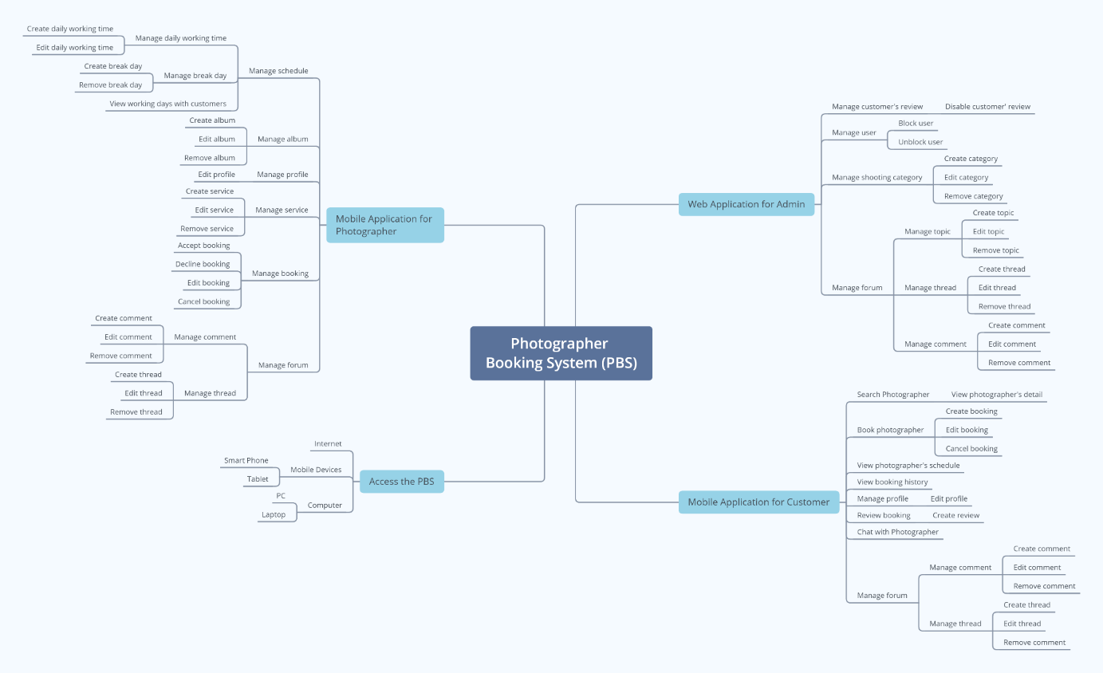

*Figure 1 Feature mind map*

### 6.2 Limitations & Exclusions

LI-01: The application has not supported payment.

LI-02: The system has not had a photo verification feature.

LI-03: The system has not provided a website version to both customers and photographers. Users may find it uncomfortable to use applications.

LI-04: The system only supports Vietnamese language.

# II. Project Management Plan

## 1. Overview

### 1.1 WBS & Estimation

|  |  |  |  |
| --- | --- | --- | --- |
| **#** | **WBS Item** | **Complexity** | **Est. Effort**  **(man-days)** |
| ***1*** | ***Initiating*** |  | ***5*** |
| 1.1 | Kick-off project   * Identify Project Goals & Vision * Get the Right Team Together * Define the Right Key Performance Indicators (KPIs) or Timeline * Project Tools & Methodologies * Project Kick-off Meeting Planning * Project Kick-off Meeting | Medium | 1 |
| 1.2 | Develop business case   * Confirm the opportunity * Analyse and develop shortlisted options * Evaluate the options * Implementation strategy * Recommendation | Medium | 2 |
| 1.3 | Assign Project Manager | Simple | 1 |
| 1.4 | Identify stake-holder   * Identifying * Analysing  1. Stakeholder Type 2. Contribution (value) 3. Legitimacy 4. Willingness to engage 5. Influence 6. Involvement  * Mapping | Medium | 1 |
| ***2*** | ***Planning*** |  | ***14*** |
| 2.1 | Create business plan   * Executive summary * Opportunity * Execution * Company and management summary * Financial plan * Appendix | Medium | 2 |
| 2.2 | Collect requirement | Complex | 7 |
| 2.3 | Define scope   * Identify the project needs * Confirm the objectives and goals of the Project * Project Scope description * Expectations and acceptance * Identify constraints * Identify necessary changes | Medium | 1 |
| 2.4 | Define vision   * Define outcome * Define what unique brings to the above outcome * Apply Add relatable, human, aspects | Medium | 1 |
| 2.5 | Create WBS   * Identify the most important pieces of scope * Break down the project * Identify the known attributes for each activity | Medium | 1 |
| 2.6 | Create Risk Management Plan   * Identify the Risk * Analyse the Risk * Evaluate or Rank the Risk * Treat the Risk * Monitor and Review the Risk | Medium | 1 |
| 2.7 | Create Human Resource Plan   * Analyse the objectives * Make an inventory of current human resources * Forecast your HR demand * Determine the number and extent of skills gaps * Draw up an action plan * Integrate and implement the plan * Monitoring, measurement, and feedback | Simple | 1 |
| ***3*** | ***Executing*** |  | ***22*** |
| **3.1** | **Analysis** |  |  |
| 3.1.1 | Analyse Requirements   * Identify customer's needs. * Evaluate system for feasibility. * Perform economic and technical analysis. * Allocate functions to system elements. * Establish schedule and constraints. * Create system definitions. | Medium | 2 |
| 3.1.2 | Create Use case diagram   * Identify the Actors * For each category of users, identify all roles played by the users relevant to the system * Identify what are the users required the system to be performed to achieve these goals * Create use cases for every goal * Structure the use cases | Medium | 1 |
| 3.1.3 | Create Use case specification   * Create a use case model showing the use cases and actors * Create an overview of the steps (content) of the use case * Write the use case specification | Complex | 1 |
| 3.1.4 | Create SRS   * Create an Outline * Start with a Purpose * Give an Overview * Detail Specific Requirements * Get Approval for the SRS | Medium | 2 |
| **3.2** | **Design** |  |  |
| 3.2.1 | Design System Architecture   * Analyse the requirements * Define use cases for the system * Identify processor/modules to implement the use cases * Select operating system and hardware platform * Define sequence diagrams | Medium | 2 |
| 3.2.2 | Design System Detail (Diagrams) | Medium | 3 |
| 3.2.3 | Design Database   * Determine the purpose * Find and organize the information required * Divide the information into tables * Turn information items into columns * Specify primary keys * Set up the table relationships * Refine your design * Apply the normalization rules | Medium | 3 |
| 3.2.4 | Design User Interface   * Briefing * Analytics * Wireframing * UX prototype * UI creation | Complex | 3 |
| **3.3** | **Prototype** |  |  |
| 3.3.1 | Define storyboard | Medium | 1 |
| 3.3.2 | Create paper prototype | Simple | 1 |
| 3.3.3 | Create digital prototype | Complex | 3 |
| **3.4** | **Implementation** |  |  |
| 3.4.1 | Coding/ implement every module defined in SRS | ***Medium*** | ***30*** |
| **3.5** | **Perform quality assurance** |  | ***7*** |
| 3.5.1 | Perform unit testing | Simple | 1 |
| 3.5.2 | Perform integration testing | Medium | 2 |
| 3.5.3 | Perform system testing | Medium | 2 |
| 3.5.4 | Perform acceptance testing | Medium | 2 |
| **3.6** | **Support** |  | ***7*** |
| 3.6.1 | Training | Medium | 2 |
| 3.6.2 | Documentation | Medium | 2 |
| 3.6.3 | User Support | Simple | 1 |
| 3.6.4 | Enhancement | Medium | 2 |
| ***4*** | ***Monitoring*** |  | ***3*** |
| 4.1 | Validate Scope | Medium | 2 |
| 4.2 | Monitor project work | Medium | 1 |
| ***5*** | ***Controlling*** |  | ***5*** |
| 5.1 | Control scope | *Medium* | *1* |
| 5.2 | Control quality | *Medium* | *1* |
| 5.3 | Control risks | *Medium* | *1* |
| 5.4 | Control schedule | *Medium* | *1* |
| 5.5 | Control communication | *Simple* | *1* |
| ***6*** | ***Closing*** |  | ***1*** |
| 6.1 | Close project | Simple | 1 |
| ***Total Estimated Effort (man-days)*** | | | FINAL PRESENTATION |
|  | | | ***94*** |

*Table 2 WBS & Estimation*

### 1.2 Project Objectives

|  |  |  |  |  |
| --- | --- | --- | --- | --- |
| **#** | **Quality Stage** | **No. of Defects** | **% of Defect** | **Notes** |
| 1 | Initiating | 2 | 8.7 | Must be completed in the first stage. |
| 2 | Planning | 4 | 17.4 | Plan to complete at least 80% of the project, and time distribution. |
| 3 | Analysis | 4 | 17.4 | Detailed project analysis. |
| 4 | Design | 2 | 8.8 | Design diagram and database. |
| 5 | Prototype | 4 | 17.4 | Make a prototype of a project |
| 6 | Implementation | 1 | 4.3 | Implementation of the plans. |
| 7 | Perform quality assurance | 2 | 8.8 | Write test cases to check the quality of the project. |
| 8 | Support | 1 | 4.3 | Discuss unclear issues with the instructor. |
| 9 | Monitoring | 1 | 4.3 | Monitoring the steps taken. |
| 10 | Controlling | 1 | 4.3 | Track the progress of the project |
| 11 | Closing | 1 | 4.3 | Review code and document. |
| ***Total*** | | ***23*** | ***100%*** |  |

*Table 3 Project objectives*

### 1.3 Project Risks

|  |  |  |  |  |
| --- | --- | --- | --- | --- |
| **#** | **Risk Description** | **Impact** | **Possibility** | **Response Plans** |
| 1 | Most members find it unfamiliar to use flutter or spring framework | High | 30% | Hold training session to get familiar with them |
| 2 | Scrum model is applied for the first time hence there may be difficulties in system development | High | 30% | Hold daily meeting to avoid misunderstandings among members |
| 3 | Wrong estimation of time needed | Medium | 10% | Regularly track progress and update time estimation |
| 4 | Unexpected scope change | High | 10% | Be careful in planning to minimize impact of scope change |
| 5 | Poor code quality | Medium | 20% | Strictly follow code convention, carry out acceptance test to ensure quality source code |

*Table 4 Project risks*

## 2. Management Approach

Scrum model would be implemented in the development of this project because it is appropriate for the process.

### 2.1 Project Process

We choose Scrum model to do this project because of the following reasons:

* The feature can be changed during the developing process to be suitable with the Scrum model we can adapt to change it easily and help reduce risk.
* Scrum allows us to learn new frameworks or technology and develop projects at the same time.
* Because dividing the project allows the team to check partial inspection, identify and fix problems faster.

*Reference:* [*https://www.scrum.org/resources/what-is-scrum*](https://www.scrum.org/resources/what-is-scrum)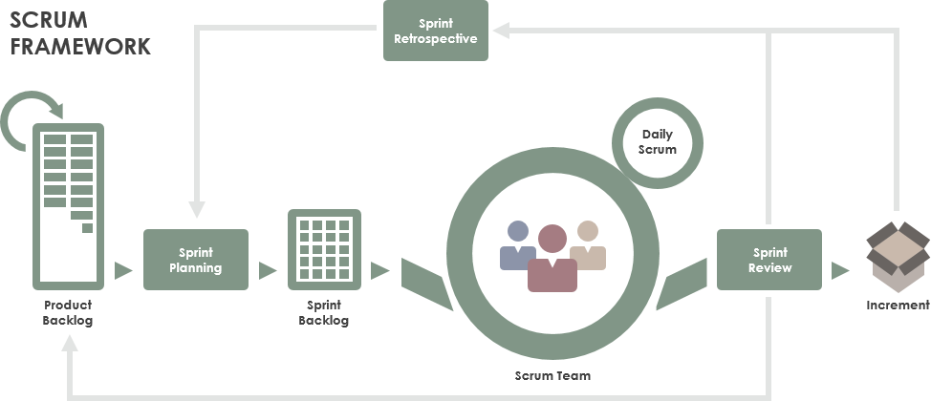

### 2.2 Quality Management

To increase the pace of the project, the team take following measures:

* Observe similar available applications.
* Discuss all requirements together to achieve the best quality.
* Hold daily meetings so that all members are acknowledged of the progress and others’ ability.

### 2.3 Training Plan

|  |  |  |  |
| --- | --- | --- | --- |
| **Training Area** | **Participants** | **When, Duration** | **Waiver Criteria** |
| Java Spring Boot | All team members | 3 days | Mandatory |
| Dart, Flutter | All team members | 4 days | Mandatory |
| Staruml | All team members | 3 days | Mandatory |
| MySql | All team members | 3 days | Mandatory |
| Git, Github | All team members | 1 day | Mandatory |

*Table 5 Training plan*

## 3. Master Schedule

|  |  |  |  |
| --- | --- | --- | --- |
| **#** | **Deliverable** | **Due Date** | **Deliverable Scope** |
| 1 | Project Plan | 17/09/2020 | Make a goal plan, list tasks to do, time distribution. |
| 2 | Use case diagram | 24/09/2020 | Design use case diagram |
| 3 | Conceptual diagram | 24/09/2020 | Design conceptual diagram |
| 4 | ER diagram | 29/09/2020 | Design ER diagram |
| 5 | Database | 29/09/2020 | Design database |
| 6 | Design | 08/10/2020 | Architecture Design, Detailed Design |
| 7 | Screen prototype | 13/10/2020 | Design screen of application |
| 8 | Report 1 | 20/10/2020 | Project introduction |
| 9 | Report 2 | 20/10/2020 | Project management plan |
| 10 | Report 3 | 20/10/2020 | Software requirement specification |
| 11 | Report 4 | 20/10/2020 | Software design document |
| 12 | Report 5 | 26/11/2020 | Test case document, test documentation |
| 13 | Report 6 | 26/11/2020 | Software user guides |
| 14 | Report 7 | 26/11/2020 | Final project report |
| 15 | Code package 1 | 15/10/2020 | Code & Unit test, System test cases |
| 16 | Code package 2 | 05/11/2020 | Code & Unit test, System test cases |
| 17 | Code package 3 | 10/11/2020 | Code & Unit test, System test cases |
| 18 | Code front-end 1 | 15/10/2020 | Code & design screen |
| 19 | Code front-end 2 | 10/11/2020 | Code & design screen |
| 20 | Code front-end 3 | 24/11/2020 | Code & design screen |
| 21 | Final Package | 08/12/2020 | Final Codes & documents, User manual |

*Table 6 Master schedule*

## 4. Project Organization

### 4.1 Team & Structures

### 4.2 Roles & Responsibilities

|  |  |
| --- | --- |
| **Role** | **Responsibility** |
| Project Manager | Give guidance, check, and help correct mistakes in project |
| Analysis Leader | Give guidance and adjust projects’ requirement |
| Analysis Member | Create and update projects’ requirement |
| Design Leader | Give guidance, design and write code for website layouts |
| Design Member | Design and write code for website layouts |
| Technical Leader | Introduce new techniques to the team |
| Test Leader | Write test case and test plan for the project |
| Test Member | Write test case and test plan for the project |

*Table 7 Roles & Responsibilities*

## 5. Project Communication

### 5.1 Communication Plan

|  |  |  |  |  |
| --- | --- | --- | --- | --- |
| **Communication Item** | **Who/ Target** | **Purpose** | **When, Frequency** | **Type, Tool, Method(s)** |
| Kick off meeting | Project supervisor, project team | Introduce the project | Once | Meeting |
| Project status report | Project supervisor, Project team | Discuss project status, resolve potential issues or delays | Weekly | Meeting |
| Daily stand up meeting | Project team | Review each member work status or any happening problems | Daily | Meeting |
| Meeting minute reports | Project supervisor | Inform supervisor about meeting content | Weekly | Email |

*Table 8 Communication plan*

### 5.2 External Interface

#### a. FU Contacts

|  |  |  |  |
| --- | --- | --- | --- |
| **Function** | **Contact Person**  **(name, position)** | **Contact address**  **(email, telephone)** | **Responsibility** |
| Supervisor | Lại Đức Hùng | Hungld5@fe.edu.vn | - Provide document template - Give instruction to project team - Review deliverables - Supervise project status  - Answer questions about the project |

*Table 9 FU Contacts*

#### b. Customer Contacts

|  |  |  |  |
| --- | --- | --- | --- |
| **Function** | **Contact Person**  **(name, position)** | **Contact address**  **(email, telephone)** | **Responsibility** |
| Supervisor | Lại Đức Hùng | Hungld5@fe.edu.vn | - Provide document template - Give instruction to project team - Review deliverables - Supervise project status  - Answer questions about the project |

*Table 10 Customer contacts*

## 6. Configuration Management

### 6.1 Tools & Infrastructures

|  |  |
| --- | --- |
| **Programming languages** | Java, Dart |
| **Framework** | Spring framework, Flutter |
| **API** | API |
| **DBMS** | MySQL |
| **IDEs/Editors** | Visual Studio Code, Android Studio, IntelliJ |
| **UML tools** | StarUML, Draw.io |
| **Version Control** | Github, Git |
| **Deployment server** | Hostinger VPS, AWS EC2 (backup) |
| **Project management tool** | Microsoft Excel |

*Table 11 Tools & Infrastructures*

### 6.2 Document Management

*https://github.com/thienthao/pbs/tree/master/Documents*

*https://drive.google.com/drive/folders/1A--J0H-8uMiggtnQg93W7fExSaF_4xsl*

### 6.3 Source Code Management

*https://github.com/thienthao/pbs*

# III. Software Requirement Specification

## 1. Overall Description

### 1.1 Product Overview

Photographer Booking System is a new system that helps users find photographers effectively based on their needs. The context diagram below describes the 1.0 version of the system and external entities that interact with it.

### 1.2 Business Rules

|  |  |
| --- | --- |
| **ID** | **Rule Definition** |
|  |  |

*Table 12 Business Rules*

## 2. User Requirements

### 2.1 Overview

#### a. Use Case Diagram

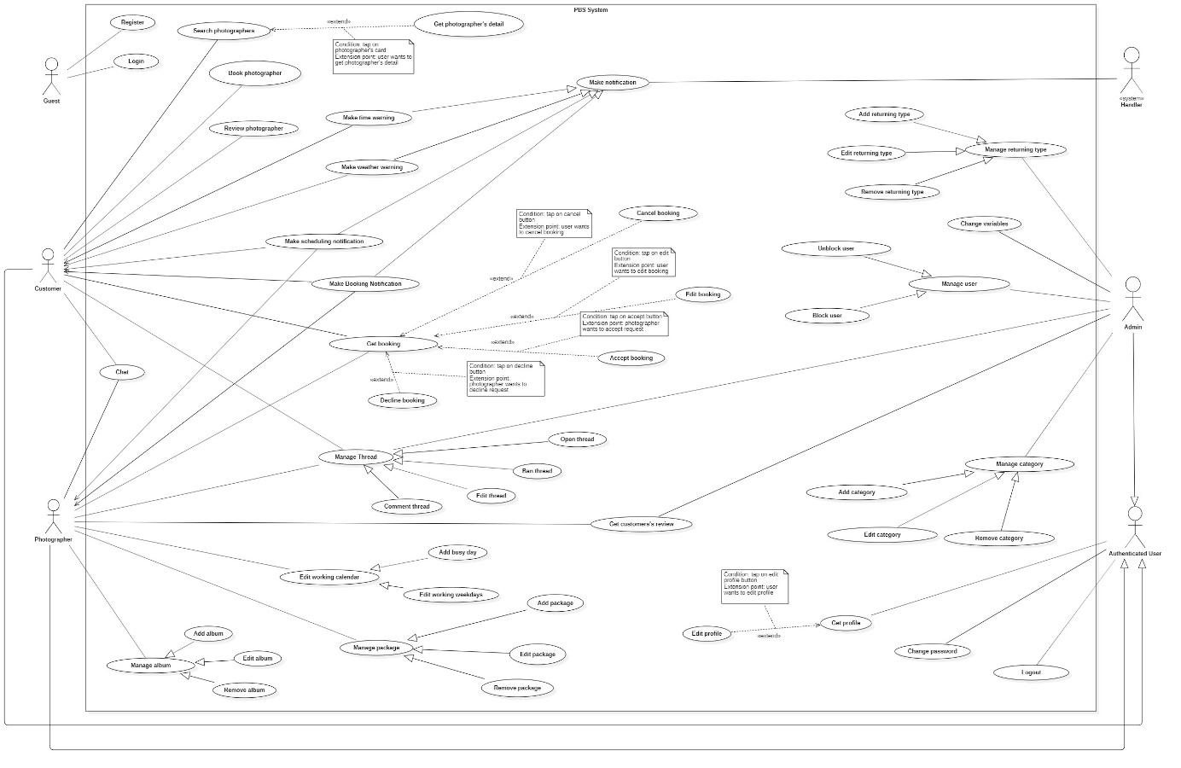

*Figure 5 Overview Use Case Diagram*

#### b. System Actors

|  |  |  |
| --- | --- | --- |
| **No** | **Actor** | **Description** |
| 1 | Administrator | Administrators manage the whole system |
| 2 | Photographer | Photographers offer shooting services and handle customers’ requests |
| 3 | Customer | Customers make bookings to use photographers’ services |
| 4 | Guest | Guests are the ones without accounts |
| 5 | Authenticated User | Authenticated Users are the ones have accounts (admins, photographers, customers) |
| 6 | <<system>> Handler | <<system>> Handler deals with internal process. |

*Table 13 System Actors*

#### c. Use Cases List

|  |  |  |  |
| --- | --- | --- | --- |
| **No** | **Use Case** | **Primary Actors** | **Secondary Actors** |
| 01 | Register | Guest |  |
| 02 | Login | Guest |  |
| 03 | Search photographers | Customer |  |
| 04 | Get photographer’s detail | Customer |  |
| 05 | Book photographer | Customer |  |
| 06 | Review photographer | Customer |  |
| 07 | Get booking | Customer, Photographer |  |
| 08 | Edit booking | Customer |  |
| 09 | Cancel booking | Customer |  |
| 10 | Accept booking | Photographer |  |
| 11 | Decline booking | Photographer |  |
| 12 | Open thread | Customer, Photographer, Admin |  |
| 13 | Edit thread | Customer, Photographer,  Admin |  |
| 14 | Comment thread | Customer, Photographer, Admin |  |
| 15 | Chat | Customer, Photographer |  |
| 16 | Edit working weekdays | Photographer |  |
| 17 | Add busy day | Photographer |  |
| 18 | Get customer’s review | Photographer, Admin |  |
| 19 | Add package | Photographer |  |
| 20 | Edit package | Photographer |  |
| 21 | Remove package | Photographer |  |
| 22 | Add album | Photographer |  |
| 23 | Edit album | Photographer |  |
| 24 | Remove album | Photographer |  |
| 25 | Get profile | Authenticated User |  |
| 26 | Edit profile | Authenticated User |  |
| 27 | Change password | Authenticated User |  |
| 28 | Logout | Authenticated User |  |
| 29 | Block user | Admin |  |
| 30 | Unblock user | Admin |  |
| 31 | Add category | Admin |  |
| 32 | Edit category | Admin |  |
| 33 | Remove category | Admin |  |
| 34 | Add returning type | Admin |  |
| 35 | Edit returning type | Admin |  |
| 36 | Remove returning type | Admin |  |
| 37 | Change variables | Admin |  |
| 38 | Ban thread | Admin |  |
| 39 | Make booking notification | System Handler |  |
| 40 | Make scheduling notification | System Handler |  |
| 41 | Make weather warning | System Handler |  |
| 42 | Make time warning | System Handler |  |

*Table 14 Use Case List*

### 2.2 List of use case

#### 2.2.1 <Guest> Overview use case

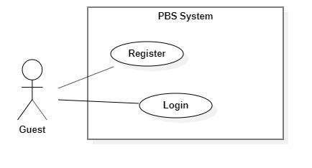

*Figure 6 <Guest> Overview*

##### a. <Guest> Register

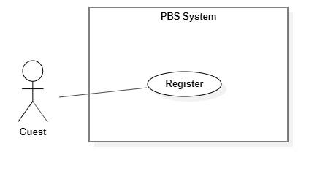

*Figure 7<Guest> Register*

|  |  |  |  |  |  |
| --- | --- | --- | --- | --- | --- |
| UC ID and Name: | **UC – 01 Register** | | | | |
| Created By: | Trần Thiên Thảo | | Date Created: | 08/10/2020 | |
| Primary Actor: | Guest | | Secondary Actors: |  | |
| Trigger: | The Guest sends a request to register an account. | | | | |
| Description: | This use case allows Guest to register an account in the system. | | | | |
| Preconditions: | User is not logged in. | | | | |
| Post-conditions: | **Success:** Guest successfully registered an account.  **Fail:** System shows error message. | | | | |
| Normal Flow: | **Step** | **Actor Action** | | | **System Response** |
| 1 | Guest goes to register view | | | System requires information from Guest:  - “Họ và tên”: text input, required.  - “Tên đăng nhập”: text input, required  - “Mật khẩu”: password input, required.  - “Xác nhận mật khẩu”: password input, required.  - “Số điện thoại”: phone number input.  - “Email”: text input, required. |
| 2 | Guest inputs required information | | |  |
| 3 | Guest send request to register in the system | | | The system validates data, outputs message “Đăng ký thành công”  [Exception 1]  [Exception 2]  [Exception 3]  [Exception 4] |
| Alternative Flows: | N/A | | | | |
| Exceptions: | **No** | **Cause** | | | **System Response** |
| 1 | Required fields are empty. | | | System shows error message:  “Thông tin này là bắt buộc” |
| 2 | Password and confirm password are not matched. | | | System shows error message:  “Mật khẩu không khớp”. |
| 3 | Required fields are not valid. | | | System shows error message corresponds to the field:  “Tên đăng nhập không đúng”  “Email không đúng”  “Mật khẩu chưa đủ mạnh” |
| 4 | Required information exists in the system (username, email). | | | System shows error message corresponds to the field:  “Tên đăng nhập đã có người sử dụng. Vui lòng nhập tên khác.”  “Email đã tồn tại.” |
| Priority: | Medium | | | | |
| Frequency of Use: | Usually | | | | |
| Business Rules: | * Needed information are: username, password, phone number, email, full name. * Username format should be 8-20 characters long, starts with character and underscore or dot can’t be at the end or beginning. * Password format should be a minimum eight characters, contains at least one number, one letter and one special character. * Email format should match regex: ^\w+@[a-zA-Z_]+?\.[a-zA-Z]{2,3}$ * Phone should be in Vietnamese format. * All information must not be empty when submit. * After register successfully, navigate back to login view. | | | | |
| Other Information: | N/A | | | | |
| Assumptions: | N/A | | | | |

*Figure 8 <Guest> Register Specification*

##### b. <Guest> Login

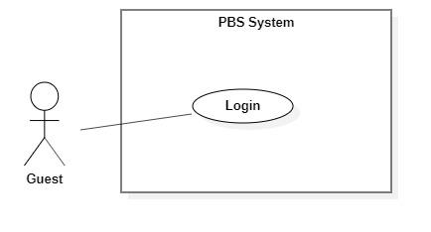

*Figure 9 <Guest> Login*

|  |  |  |  |  |  |
| --- | --- | --- | --- | --- | --- |
| UC ID and Name: | **UC – 02 Login** | | | | |
| Created By: | Trần Thiên Thảo | | Date Created: | 08/10/2020 | |
| Primary Actor: | Guest | | Secondary Actors: |  | |
| Trigger: | The Guest sends a request to login into the system. | | | | |
| Description: | This use case allows Guest to login into the system. | | | | |
| Preconditions: | User is not logged in. | | | | |
| Post-conditions: | **Success**: Guest successfully logged into the system.  **Fail:** System shows error message. | | | | |
| Normal Flow: | **Step** | **Actor Action** | | | **System Response** |
| 1 | Guest goes to login view | | | System requires information from Guest:  - “Tên đăng nhập”: text input, required  - “Mật khẩu”: password input, required |
| 2 | Guest inputs required information | | |  |
| 3 | Guest sends request to login into the system | | | System validates data, outputs message “Đăng nhập thành công”  [Exception 1]  [Exception 2] |
| Alternative Flows: | N/A | | | | |
| Exceptions: | **No** | **Cause** | | | **System Response** |
| 1 | Required fields are empty | | | System shows error message: “Thông tin này là bắt buộc” |
| 2 | Username or password is incorrect | | | System shows error message: “Thông tin đăng nhập không chính xác” |
| Priority: | Medium | | | | |
| Frequency of Use: | Usually | | | | |
| Business Rules: | * New Json web token will be return to client side. * New user session will be created. * After login successfully, navigate user to Home view. | | | | |
| Other Information: | N/A | | | | |
| Assumptions: | N/A | | | | |

*Table 15 <Guest> Register Specification*

#### 2.2.2 <Customer> Overview use case

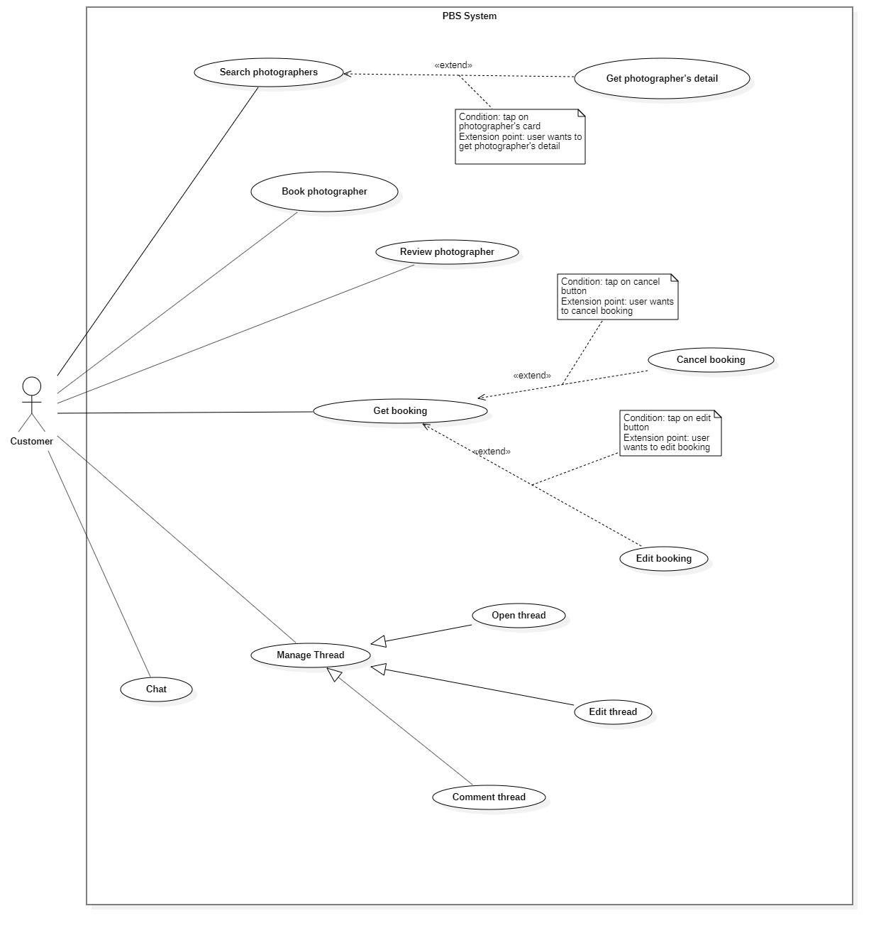

*Figure 10 <Customer> Overview*

##### <Customer> Search photographer

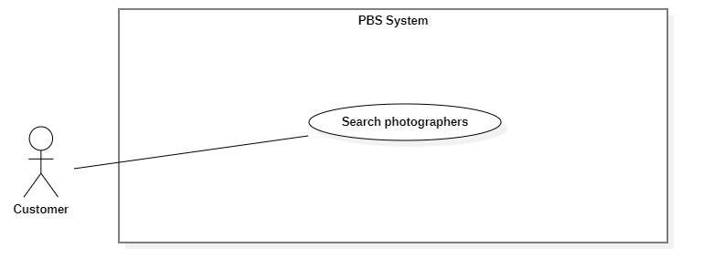

*Figure 11 <Customer> Search photographers*

|  |  |  |  |  |  |
| --- | --- | --- | --- | --- | --- |
| UC ID and Name: | **UC – 04 Search photographers** | | | | |
| Created By: | Trần Thiên Thảo | | Date Created: | 08/10/2020 | |
| Primary Actor: | Customer | | Secondary Actors: |  | |
| Trigger: | The customer sends a request to find photographers. | | | | |
| Description: | This use case allows customers to find photographers and also packages. | | | | |
| Preconditions: | User must be authenticated as Customer | | | | |
| Post-conditions: | **Success**: A list of photographers is shown.  **Fail**: System shows error messages. | | | | |
| Normal Flow: | **Step** | **Actor Action** | | | **System Response** |
| 1 | Customer goes to photographers searching view | | | System requires information from Guest:  - “Tìm kiếm”: text input |
| 2 | Customer inputs information | | |  |
| 3 | Customer sends request to search photographers | | | System displays list of photographers and packages  [Exception 1] |
| Alternative Flows: | N/A | | | | |
| Exceptions: | **No** | **Cause** | | | **System Response** |
| 1 | The process run into an internal error | | | System shows error message: “Đã có lỗi xảy ra” |
| Priority: | Medium | | | | |
| Frequency of Use: | Sometimes | | | | |
| Business Rules: | * User inputs text in search field, system returns photographers’ name and packages’ name match the text. * The list of photographers will be ordered by rating count. * List of photographers is shown with following information: name, avatar, rating count. * List of packages is shown with following information: name, price, description. | | | | |
| Other Information: | N/A | | | | |
| Assumptions: | N/A | | | | |

*Table 16 <Customer> Search Photographers Specification*

##### <Customer> Get photographer’s detail

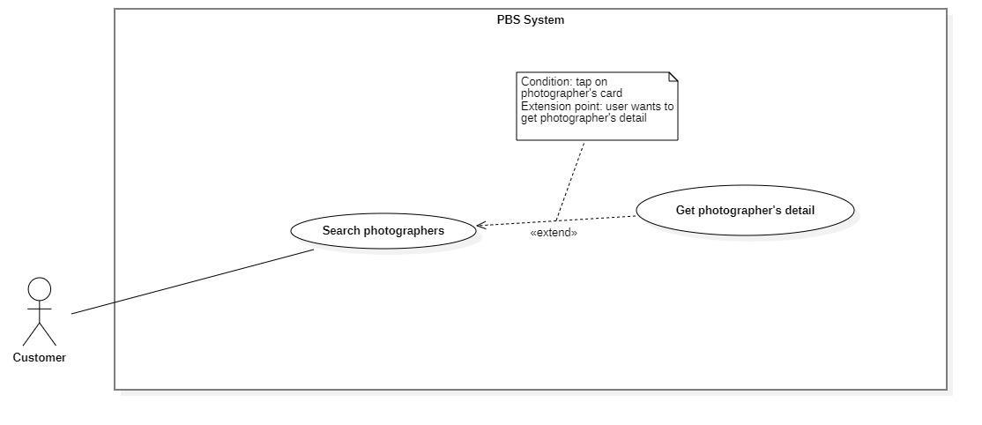

*Figure 12 <Customer> Get photographer's detail*

|  |  |  |  |  |  |
| --- | --- | --- | --- | --- | --- |
| UC ID and Name: | **UC – 04 Get photographer’s detail** | | | | |
| Created By: | Trần Thiên Thảo | | Date Created: | 08/10/2020 | |
| Primary Actor: | Customer | | Secondary Actors: |  | |
| Trigger: | The customer sends a request to get the photographer's details. | | | | |
| Description: | This use case allows customers to get photographer’s detail. | | | | |
| Preconditions: | User has been authenticated as a Customer. | | | | |
| Post-conditions: | **Success:** The system displays the photographer’s detail.  **Fail:** The system shows error message | | | | |
| Normal Flow: | **Step** | **Actor Action** | | | **System Response** |
| 1 | Customer sends request to get photographer’s detail | | | System returns photographer’s detail  [Exception 1] |
| Alternative Flows: | N/A | | | | |
| Exceptions: | No | Cause | | | System Response |
| 1 | The process run into an internal error | | | System shows error message: “Đã có lỗi xảy ra” |
| Priority: | Medium | | | | |
| Frequency of Use: | Usually | | | | |
| Business Rules: | * The photographer’s detail return contains the following information: photographer’s basic information like rating count, self-description, customers’ reviews, photographer’s working calendar, photographer’s packages. | | | | |
| Other Information: | N/A | | | | |
| Assumptions: | N/A | | | | |

*Table 17 <Customer> Get photographer's detail specification*

##### <Customer> Book photographer

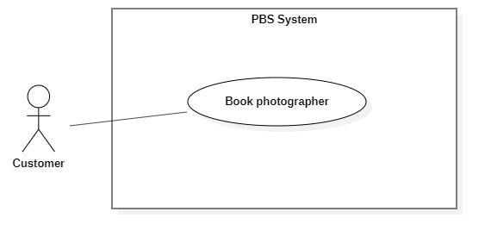

*Figure 13 <Customer> Book photographer*

|  |  |  |  |  |  |
| --- | --- | --- | --- | --- | --- |
| UC ID and Name: | **UC – 05 Book photographer** | | | | |
| Created By: | Trần Thiên Thảo | | Date Created: | 08/10/2020 | |
| Primary Actor: | Customer | | Secondary Actors: |  | |
| Trigger: | The customer sends a request to make a booking. | | | | |
| Description: | This use case allows customers to make a booking for photographers. | | | | |
| Preconditions: | - Users must login into the system with the role Customer.  - The photographer must exist in the system with status as “active”. | | | | |
| Post-conditions: | **Success:** A booking will be stored with status is “Pending” **Fail:** System outputs error message and sends to Customer. | | | | |
| Normal Flow: | **Step** | **Actor Action** | | | **System Response** |
| 1 | The customer goes to booking view | | | System returns the available photographer’s detail.  System requires information from customers:  - “Thời gian chụp”: date time picker, required  - “Thời gian nhận ảnh”: date time picker, required  - “Địa điểm”: map picker, required  - “Phương thức nhận ảnh”: dropdownlist, required,  - “Gói dịch vụ: drop down list, required  - “Tổng cộng”: text |
| 2 | The customer inputs required information and send request to create new booking | | | - The system validates data  - The system adds new booking to the system, outputs “Đặt hẹn thành công” and send to photographer.  [Exception 1]  [Exception 2] |
| Alternative Flows: | N/A | | | | |
| Exceptions: | **No** | **Cause** | | | **System Response** |
| 1 | The customer inputs invalid data or leaves empty required fields | | | System outputs error message and send request to ask Customer to input correctly |
| 2 | The process run into an internal error | | | Error will be recorded in a log file. System outputs error message to customer. |
| Priority: | Medium | | | | |
| Frequency of Use: | Usually | | | | |
| Business Rules: | - Booking will be managed by the system with following status: Pending, Ongoing, Editing, Done, Rejected, Cancelled  - Booking information contains: package’s details, time and location details, editing deadline, photographer’s detail, customer’s detail, returning type  - Package’s detail contains: package’s name, package’s price, package’s services  - Time and location detail contain: shooting date and time, shooting location  - Photographer’s detail: photographer’s name  - Customer’s detail: customer’s name, customer’s phone  - Photographer returned by the system will contain: photographer’s information, photographer’s package detail  - After booking successfully, a new booking will have “Pending” status. | | | | |
| Other Information: | N/A | | | | |
| Assumptions: | N/A | | | | |

*Table 18 <Customer> Book photographer specification*

##### <Customer> Review photographers

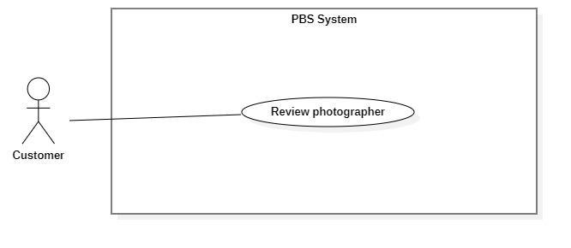

*Figure 14 <Customer> Review photographers*

|  |  |  |  |  |  |
| --- | --- | --- | --- | --- | --- |
| UC ID and Name: | **UC – 06 Review photographer** | | | | |
| Created By: | Trần Thiên Thảo | | Date Created: | 08/10/2020 | |
| Primary Actor: | Customer | | Secondary Actors: |  | |
| Trigger: | The customer sends a request to review photographer. | | | | |
| Description: | This use case allows customers to review photographer after booking is done. | | | | |
| Preconditions: | - User has been authenticated as Customer  - Booking status is “Đã hoàn thành” | | | | |
| Post-conditions: | **Success:** The review will be stored in the system and response message to Customer.  **Fail:** System shows error message. | | | | |
| Normal Flow: | **Step** | **Actor Action** | | | **System Response** |
| 1 | The customer goes to review view | | | System requires information from Customer:  - “Bình luận của bạn”: text  - “Đánh giá dịch vụ”: slider |
| 2 | The customer inputs information and sends requests | | | System creates new review and outputs message: “Đã gửi bình luận”  [Exception 1]  [Exception 2] |
|  |  | | |  |
| Alternative Flows: | N/A | | | | |
| Exceptions: | **No** | **Cause** | | | **System Response** |
| 1 | Customer inputs more than 150 characters for comment | | | System outputs error message: “Đã vượt quá 150 ký tự” |
| 2 | The process run into internal error | | | System outputs error message: “Đã có lỗi xảy ra” |
| Priority: | Medium | | | | |
| Frequency of Use: | Sometimes | | | | |
| Business Rules: | - The customer can only review if a booking state is “DONE”.  - Rating slider returns double value from 0 to 5.  - Customer can edit their rating. | | | | |
| Other Information: | N/A | | | | |
| Assumptions: | N/A | | | | |

*Table 19 <Customer> Review photographers specificationk*

##### <Customer> Get booking

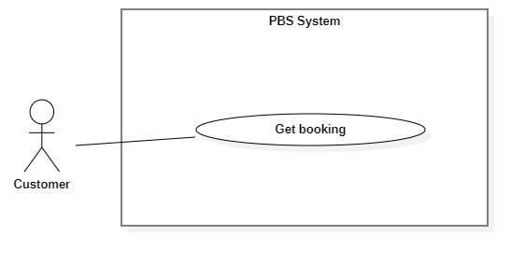

*Figure 15 <Customer> Get booking*

|  |  |  |  |  |  |
| --- | --- | --- | --- | --- | --- |
| UC ID and Name: | **UC – 07 Get booking** | | | | |
| Created By: | Trần Thiên Thảo | | Date Created: | 08/10/2020 | |
| Primary Actor: | Customer, Photographer | | Secondary Actors: |  | |
| Trigger: | Customer or Photographer sends a request to get a booking list. | | | | |
| Description: | This use case allows customers or photographers to get their booking list of all status. | | | | |
| Preconditions: | - User has been authenticated as Customer / Photographer | | | | |
| Post-conditions: | **Success:** System displays list of bookings.  **Fail:** System shows error message. | | | | |
| Normal Flow: | Step | Actor Action | | | System Response |
| 1 | Customer / Photographer sends a request to get a list of bookings. | | | System returns list of bookings.  [Exception 1] |
| Alternative Flows: | N/A | | | | |
| Exceptions: | No | Cause | | | System Response |
| 1 | System run into internal error | | | System shows error message: “Đã có lỗi xảy ra” |
| Priority: | Medium | | | | |
| Frequency of Use: | Usually | | | | |
| Business Rules: | - The list of bookings is displayed and ordered by most recent activity.  - Booking has following status:   * Pending * Ongoing * Editing * Done * Rejected * Cancelled   - Booking has following information: Name of the person who booked, time details (Datetime), location details, booking status, booked packages. | | | | |
| Other Information: | N/A | | | | |
| Assumptions: | N/A | | | | |

*Table 20 <Customer> Get booking specification*

##### <Customer> Edit Booking

|  |  |  |  |  |  |
| --- | --- | --- | --- | --- | --- |
| UC ID and Name: | **UC – 08 Edit booking** | | | | |
| Created By: | Trần Thiên Thảo | | Date Created: | 08/10/2020 | |
| Primary Actor: | Customer | | Secondary Actors: |  | |
| Trigger: | The Customer sends a request to edit booking. | | | | |
| Description: | This use case allows customer to edit their booking. | | | | |
| Preconditions: | - The User has been authenticated as Customer. | | | | |
| Post-conditions: | **Success:** Booking successfully edited and save to the system.  **Fail:** System shows error message. | | | | |
| Normal Flow: | **Step** | **Actor Action** | | | **System Response** |
| 1 | Customer sends request to receive booking detail | | | System returns booking detail with following information:  - “Trạng thái”: text  - “Thời gian”: text  - “Thời gian tác nghiệp dự kiến”: text  - “Thời gian trả ảnh”: text  - “Địa điểm”: map  - “Thông tin khách hàng”:   * “Tên khách hàng”: text   - “Tên gói dịch vụ”:   * “Tên gói”: text * “Mô tả”: text * “Giá dịch vụ: text * “Dịch vụ”: list of texts   [Exception 1] |
|  | Customer inputs information and sends request to edit booking | | | System outputs message: “Bạn muốn thay đổi thông tin cuộc hẹn này?” |
|  | Customer confirm “Có”  [Alternative 1] | | | - The system validates data  - The system adds new booking to the system, outputs “Cập nhật thành công” and send to photographer.  [Exception 2]  [Exception 3] |
| Alternative Flows: | **Step** | **Actor Action** | | | **System Response** |
| 1 | Customer confirm “Không” | | | Back to booking detail view |
| Exceptions: | **No** | **Cause** | | | **System Response** |
| 1 | System can’t get the booking detail | | | System show error message: “Không tìm thấy cuộc hẹn” |
| 2 | The customer inputs invalid data or leaves empty required fields | | | System outputs error message and send request to ask Customer to input correctly |
| 3 | The process run into an internal error | | | Error will be recorded in a log file. System outputs error message to customer. |
| Priority: | Medium | | | | |
| Frequency of Use: | Sometimes | | | | |
| Business Rules: | * Customer can only edit the booking if its status is “Pending”. * Customer can edit information like shooting time, shooting location, package and send request to photographer. | | | | |
| Other Information: | N/A | | | | |
| Assumptions: | N/A | | | | |

*Table 21 <Customer> Edit booking specification*

##### <Customer> Cancel booking

|  |  |  |  |  |  |
| --- | --- | --- | --- | --- | --- |
| UC ID and Name: | **UC – 09 Cancel booking** | | | | |
| Created By: | Trần Thiên Thảo | | Date Created: | 08/10/2020 | |
| Primary Actor: | Customer, Photographer | | Secondary Actors: |  | |
| Trigger: | Customer or Photographer sends a request to cancel booking. | | | | |
| Description: | This use case allows customers or photographers to cancel their booking. | | | | |
| Preconditions: | - The User has been authenticated as Customer / Photographer. | | | | |
| Post-conditions: | **Success:** The customer cancels booking successfully.  **Fail:** System shows error message | | | | |
| Normal Flow: | **Step** | **Actor Action** | | | **System Response** |
| 1 | Customer sends request to receive booking detail | | | System returns booking detail with following information:  - “Trạng thái”: text  - “Thời gian”: text  - “Thời gian tác nghiệp dự kiến”: text  - “Thời gian trả ảnh”: text  - “Địa điểm”: map  - “Thông tin khách hàng”:   * “Tên khách hàng”: text   - “Tên gói dịch vụ”:   * “Tên gói”: text * “Mô tả”: text * “Giá dịch vụ: text * “Dịch vụ”: list of texts   [Exception 1] |
| 2 | Customer sends request to cancel booking | | | System outputs message: “Bạn muốn hủy cuộc hẹn này?” |
| 3 | Customer confirm “Có” and inputs cancelling reasons to cancel booking  [Alternative 1] | | | System outputs message: “Đã hủy cuộc hẹn”  [Exception 2] |
| Alternative Flows: | **Step** | **Actor Action** | | | **System Response** |
| 1 | Customer confirm “Không” | | | Back to booking detail view |
| Exceptions: | **No** | **Cause** | | | **System Response** |
| 1 | System can’t get the booking detail | | | System show error message: “Không tìm thấy cuộc hẹn” |
| 2 | The process run into an internal error | | | System show error message: “Đã có lỗi xảy ra” |
| Priority: | Medium | | | | |
| Frequency of Use: | Sometimes | | | | |
| Business Rules: | * Customers or Photographers can cancel if status is PENDING, ONGOING, EDITING, but if their cancellation is not appropriate, the opposite side can report them. * If one side is being reported, increase their cancelling rate. * After one side cancels, notification will be sent to the other person. | | | | |
| Other Information: | N/A | | | | |
| Assumptions: | N/A | | | | |

*Table 22 <Customer> Cancel booking specification*

##### <Customer> Open thread

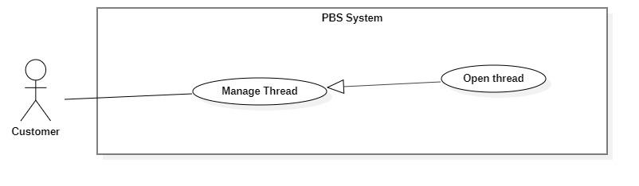

|  |  |  |  |  |  |
| --- | --- | --- | --- | --- | --- |
| UC ID and Name: | **UC – 12 Open thread** | | | | |
| Created By: | Trương Ngọc Mỹ | | Date Created: | 08/10/2020 | |
| Primary Actor: | Customer, Photographer, Admin | | Secondary Actors: |  | |
| Trigger: | User sends a request to open a thread. | | | | |
| Description: | This use case allows users to open new threads on forums. | | | | |
| Preconditions: | - The User has been authenticated. | | | | |
| Post-conditions: | **Success:** A new thread will be stored in the system.  **Fail:** System outputs error message. | | | | |
| Normal Flow: | **Step** | **Actor Action** | | | **System Response** |
| 1 | User goes to a new thread view. | | | Systems requires information from Customer:  - “Chủ đề”: combo box, required  - “Tiêu đề”: text, required  - “Nội dung”: text, required  - “Hình ảnh”: image picker |
| 2 | The User inputs required information and sends a request to open a new thread. | | | System validates information, add new thread to the system, outputs message “Đã tạo bài viết mới”  [Exception 1]  [Exception 2] |
| Alternative Flows: | N/A | | | | |
| Exceptions: | **No** | **Cause** | | | **System Response** |
| 1 | User inputs information incorrectly | | | System outputs error message corresponds to data fields:  “Bạn chưa chọn chủ đề”  “Tiêu đề không thể để trống”  “Nội dung đã vượt quá 250 ký tự” |
| 2 | The process runs into an internal error. | | | System outputs error message: “Đã có lỗi xảy ra” |
| Priority: | Medium | | | | |
| Frequency of Use: | Sometimes | | | | |
| Business Rules: | * Needed information are: thread’s name, thread’s content, thread’s topic. * User inputs thread’s name and content as text. * Thread’s topic will be picked from topic option list. * Users are not allowed to post bad content affecting the forum. Posts that violate other users have the right to report and post accounts will be locked. | | | | |
| Other Information: | N/A | | | | |
| Assumptions: | N/A | | | | |

*Table 23 <Customer> Open thread specification*

##### <Customer> Edit thread

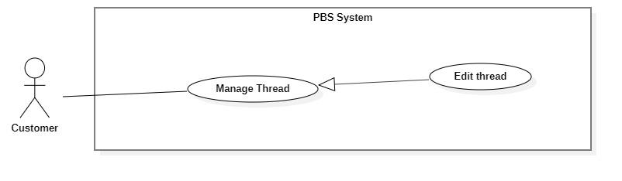

*Figure 19<Customer> Edit thread*

|  |  |  |  |  |  |
| --- | --- | --- | --- | --- | --- |
| UC ID and Name: | **UC – 13 Edit thread** | | | | |
| Created By: | Trương Ngọc Mỹ | | Date Created: | 08/10/2020 | |
| Primary Actor: | Customer, Photographer, Admin | | Secondary Actors: |  | |
| Trigger: | User sends a request to edit the thread. | | | | |
| Description: | This use case allows users to edit their thread. | | | | |
| Preconditions: | - The User has been authenticated. | | | | |
| Post-conditions: | **Success:** Thread will be updated in the system with new content.  **Fail:** System shows error message. | | | | |
| Normal Flow: | **Step** | **Actor Action** | | | **System Response** |
| 1 | User sends request to receive thread detail. | | | System return thread detail with following information:  - “Chủ đề”: combo box, required  - “Tiêu đề”: text, required  - “Nội dung”: text, required  - “Hình ảnh”: image picker  System requires information from customer:  - “Chủ đề”: combo box, required  - “Tiêu đề”: text, required  - “Nội dung”: text, required  - “Hình ảnh”: image picker  [Exception 1] |
| 2 | The user inputs required information and sends a request to edit the thread. | | | System outputs “Bạn muốn cập nhật bài viết này?” |
| 3 | User confirms “Có”  [Alternative 1] | | | System validates information, update thread to the system, outputs message “Đã cập nhật bài viết”  [Exception 2]  [Exception 3] |
| Alternative Flows: | **No** | **Actor Action** | | | **System Response** |
| 1 | User confirms “Không” | | | Back to thread detail view |
| Exceptions: | **Step** | **Cause** | | | **System Response** |
| 1 | System can’t get thread detail | | | System outputs “Không tìm được bài viết” |
| 2 | User inputs information incorrectly | | | System outputs error message corresponds to data fields:  “Bạn chưa chọn chủ đề”  “Tiêu đề không thể để trống”  “Nội dung đã vượt quá 250 ký tự” |
| 3 | The process runs into an internal error. | | | System outputs error message: “Đã có lỗi xảy ra” |
| Priority: | Medium | | | | |
| Frequency of Use: | Sometimes | | | | |
| Business Rules: | * User can edit thread no matter how long they have posted it. * User can edit every information they have posted. * User can’t change the topic of the thread. | | | | |
| Other Information: | N/A | | | | |
| Assumptions: | N/A | | | | |

*Table 24 <Customer> Edit thread specification*

##### <Customer> Comment thread

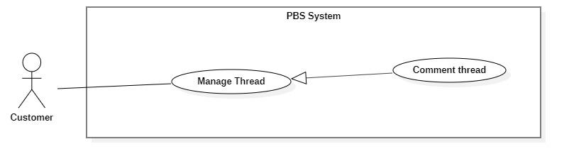

*Figure 20 <Customer> Comment thread*

|  |  |  |  |  |  |
| --- | --- | --- | --- | --- | --- |
| UC ID and Name: | **UC – 14 Comment thread** | | | | |
| Created By: | Trương Ngọc Mỹ | | Date Created: | 08/10/2020 | |
| Primary Actor: | Customer, Photographer, Admin | | Secondary Actors: |  | |
| Trigger: | The user sends a request to the comment thread. | | | | |
| Description: | This use case allows the user to comment on the thread. | | | | |
| Preconditions: | - The User has been authenticated. | | | | |
| Post-conditions: | **Success:** A new comment will be stored in the system.  **Fail:** System shows error message. | | | | |
| Normal Flow: | **Step** | **Actor Action** | | | **System Response** |
| 1 | User sends request to receive thread detail. | | | System return thread detail with following information:  - “Chủ đề”: combo box, required  - “Tiêu đề”: text, required  - “Nội dung”: text, required  - “Hình ảnh”: image picker  System requires information from customer:  - “Bình luận của bạn”: text, required  - “Hình ảnh”: image picker  [Exception 1] |
| 2 | The user inputs required information and sends a request to the comment thread. | | | System outputs “Bạn muốn bình luận bài viết này?” |
| 3 | User confirm “Có”  [Alternative 1] | | | System validates information, add new comment to the system, outputs message “Đã bình luận bài viết”  [Exception 2]  [Exception 3] |
| Alternative Flows: | **No** | **Actor Action** | | | **System Response** |
| 1 | User confirm “Không” | | | Back to thread detail view |
| Exceptions: | **No** | **Cause** | | | **System Response** |
| 1 | System can’t get thread detail | | | System outputs “Không tìm được bài viết” |
| 2 | Customer inputs information incorrectly | | | System outputs error message corresponds to data fields:  “Bình luận đã vượt quá 100 ký tự” |
| 3 | The process runs into an internal error. | | | System outputs error message: “Đã có lỗi xảy ra” |
| Priority: | Medium | | | | |
| Frequency of Use: | Sometimes | | | | |
| Business Rules: | * User inputs comment as text. Length is 350 words. * After the comment is made, notification will be sent to thread owner. | | | | |
| Other Information: | N/A | | | | |
| Assumptions: | N/A | | | | |

*Table 25 <Customer> Comment thread specification*

##### <Customer> Chat

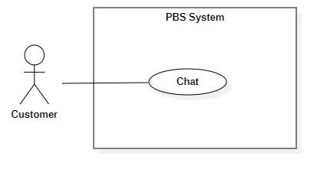

*Figure 21 <Customer> Chat*

|  |  |  |  |  |  |
| --- | --- | --- | --- | --- | --- |
| UC ID and Name: | **UC – 15 Chat** | | | | |
| Created By: | Trương Ngọc Mỹ | | Date Created: | 08/10/2020 | |
| Primary Actor: | Customer, Photographer | | Secondary Actors: |  | |
| Trigger: | Customer or Photographer sends a request to chat. | | | | |
| Description: | This use case allows the users to chat with each other. | | | | |
| Preconditions: | - The User has been authenticated. | | | | |
| Post-conditions: | **Success:** user send message to another user successfully.  **Fail:** System shows error message. | | | | |
| Normal Flow: | **Step** | **Actor Action** | | | **System Response** |
| 1 | User goes to chat view. | | | System return result with following information:   * Photographer’s name: text * Old messages: text   System receives chat input from customer.  [Exception 1] |
| 2 | User inputs messages and send request to chat with photographer. | | | System send messages to photographer and output in chat view.  [Exception 2] |
| Alternative Flows: | N/A | | | | |
| Exceptions: | **No** | **Cause** | | | **System Response** |
| 1 | System can’t get chat view with another user. | | | System outputs “Không tìm được photographer/ Khách hàng” |
| 2 | The process runs into an internal error. | | | System outputs error message: “Đã có lỗi xảy ra” |
| Priority: | Medium | | | | |
| Frequency of Use: | Sometimes | | | | |
| Business Rules: | - Chat view contains following information: Full name of two people who joined, previous messages.  - After a message is sent, notification will be sent to the other person. | | | | |
| Other Information: | N/A | | | | |
| Assumptions: | N/A | | | | |

*Table 26 <Customer> Chat specification*

#### 2.2.3 <Photographer> Overview Use Case

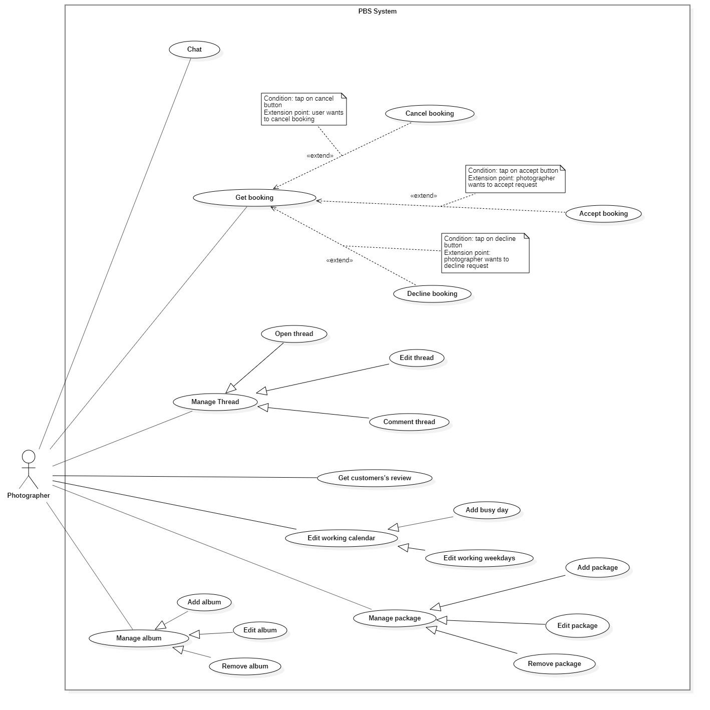

*Figure 22 <Photographer> Overview*

##### <Photographer> Accept Booking

|  |  |  |  |  |  |
| --- | --- | --- | --- | --- | --- |
| UC ID and Name: | **UC – 10 Accept booking** | | | | |
| Created By: | Trần Thiên Thảo | | Date Created: | 08/10/2020 | |
| Primary Actor: | Photographer | | Secondary Actors: |  | |
| Trigger: | The photographer sends a request to accept booking. | | | | |
| Description: | This use case allows photographers to accept booking from customer. | | | | |
| Preconditions: | - User has been authenticated as a Photographer.  - The booking time is still valid. | | | | |
| Post-conditions: | **Success:** The booking will be updated in the system with status change to “Ongoing”  **Fail:** System shows error message | | | | |
| Normal Flow: | **Step** | **Actor Action** | | | **System Response** |
| 1 | Photographer sends request to receive booking details. | | | System returns booking detail with following information:  - “Trạng thái”: text  - “Thời gian”: text  - “Thời gian tác nghiệp dự kiến”: text  - “Thời gian trả ảnh”: text  - “Địa điểm”: map  - “Thông tin khách hàng”:   * “Tên khách hàng”: text   - “Tên gói dịch vụ”:   * “Tên gói”: text * “Mô tả”: text * “Giá dịch vụ: text * “Dịch vụ”: list of texts   [Exception 1] |
| 2 | Photographer sends request to accept booking | | | System outputs: “Chấp nhận cuộc hẹn này?” |
| 3 | Photographer confirms “Có”  [Alternative 1] | | | System outputs: “Nhận cuộc hẹn thành công”  [Exception 2] |
|  |  | | |  |
| Alternative Flows: | **Step** | **Actor Action** | | | **System Response** |
| 1 | Photographer confirm “Không” | | | Back to booking detail view |
| Exceptions: | **No** | **Cause** | | | **System Response** |
| 1 | System can’t get the booking detail | | | System show error message: “Không tìm thấy cuộc hẹn” |
| 2 | The process run into an internal error | | | System show error message: “Đã có lỗi xảy ra” |
| Priority: | Medium | | | | |
| Frequency of Use: | Usually | | | | |
| Business Rules: | * Photographers can’t accept more than one booking with same starting time. * After photographer accept, notification will be sent to customer. | | | | |
| Other Information: | N/A | | | | |
| Assumptions: | N/A | | | | |

*Table 27 <Photographer> Accept booking specification*

##### <Photographer> Decline Booking

|  |  |  |  |  |  |
| --- | --- | --- | --- | --- | --- |
| UC ID and Name: | **UC – 11 Decline booking** | | | | |
| Created By: | Trương Ngọc Mỹ | | Date Created: | 08/10/2020 | |
| Primary Actor: | Photographer | | Secondary Actors: |  | |
| Trigger: | The photographer sends a request to cancel booking. | | | | |
| Description: | This use case allows photographer to cancel booking from customer | | | | |
| Preconditions: | - The User has been authenticated as a Photographer.  - The booking time is still valid | | | | |
| Post-conditions: | **Success:** The booking will be updated in the system and status change to “Rejected”  **Fail:** System shows error message | | | | |
| Normal Flow: | **Step** | **Actor Action** | | | **System Response** |
| 1 | Photographer sends request to receive booking details. | | | System returns booking detail with following information:  - “Trạng thái”: text  - “Thời gian”: text  - “Thời gian tác nghiệp dự kiến”: text  - “Thời gian trả ảnh”: text  - “Địa điểm”: map  - “Thông tin khách hàng”:   * “Tên khách hàng”: text   - “Tên gói dịch vụ”:   * “Tên gói”: text * “Mô tả”: text * “Giá dịch vụ: text * “Dịch vụ”: list of texts   [Exception 1] |
| 2 | Photographer sends request to decline booking | | | System outputs: “Từ chối cuộc hẹn này?” |
| 3 | Photographer confirms “Có”  [Alternative 1] | | | System outputs: “Đã từ chối cuộc hẹn”  [Exception 2] |
| Alternative Flows: | **Step** | **Actor Action** | | | **System Response** |
| 1 | Photographer confirm “Không” | | | Back to booking detail view |
| Exceptions: | **No** | **Cause** | | | **System Response** |
| 1 | System can’t get the booking detail | | | System show error message: “Không tìm thấy cuộc hẹn” |
| 2 | The process run into an internal error | | | System show error message: “Đã có lỗi xảy ra” |
| Priority: | Usually | | | | |
| Frequency of Use: | Sometimes | | | | |
| Business Rules: | * Photographer can only decline a booking with status “Pending”. * After photographer decline a booking, notification will be sent to customer. * Decline a booking will increase photographer’s rejecting rate, it could be used by admin to supervise photographers. | | | | |
| Other Information: | N/A | | | | |
| Assumptions: | N/A | | | | |

*Table 28 <Photographer> Decline booking specification*

##### <Photographer> Edit working weekdays

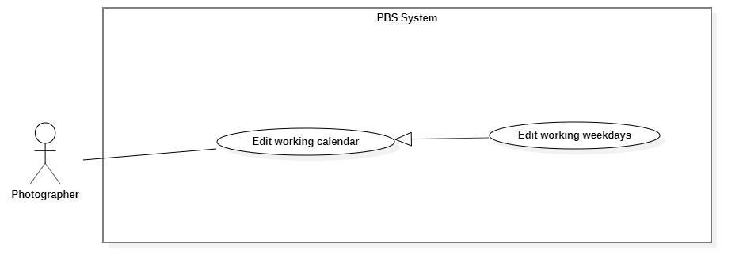

*Figure 25 <Photographer> Edit working weekdays*

|  |  |  |  |  |  |
| --- | --- | --- | --- | --- | --- |
| UC ID and Name: | **UC – 16 Edit working weekdays** | | | | |
| Created By: | Trương Ngọc Mỹ | | Date Created: | 08/10/2020 | |
| Primary Actor: | Photographer | | Secondary Actors: |  | |
| Trigger: | The photographer sends requests to edit working weekdays. | | | | |
| Description: | This use case allows photographers to edit their working weekday. | | | | |
| Preconditions: | - The User has been authenticated as a Photographer. | | | | |
| Post-conditions: | **Success:** Photographer’s working weekday will be updated in the system.  **Fail:** System outputs error message. | | | | |
| Normal Flow: | **Step** | **Actor Action** | | | **System Response** |
| 1 | Photographer goes to work weekday editing view. | | | System requires information from photographer:   * “Chọn ngày làm việc”: checkbox |
| 2 | Photographer inputs required information and sends requests to add busy days. | | | System outputs “Xác nhận” |
| 3 | Photographer confirm “Có”  [Alternative 1] | | | System add busy day to system and outputs message “Đã điều chỉnh thời gian làm việc”  [Exception 1]  [Exception 2] |
| Alternative Flows: | **Step** | **Actor Action** | | | **System Response** |
| 1 | Photographer confirms “Không”. | | | Back to working weekday editing view. |
| Exceptions: | **No** | **Cause** | | | **System Response** |
| 1 | The process runs into an internal error | | | System outputs “Đã có lỗi xảy ra” |
| Priority: | Medium | | | | |
| Frequency of Use: | Sometimes | | | | |
| Business Rules: | * Weekday is: Monday, Tuesday, Wednesday, Thursday, Friday, Saturday, Sunday * Photographer can decide whether or not they want to work on a weekday. A boolean isWorking will be used to keep track photographer’s working weekday. * Photographer can set starting time and ending time of a weekday. * All booking date will not be affected if they are accepted before photographer change the working weekday. | | | | |
| Other Information: | N/A | | | | |
| Assumptions: | N/A | | | | |

*Table 29 Edit working weekdays specification*

##### <Photographer> Add busy day

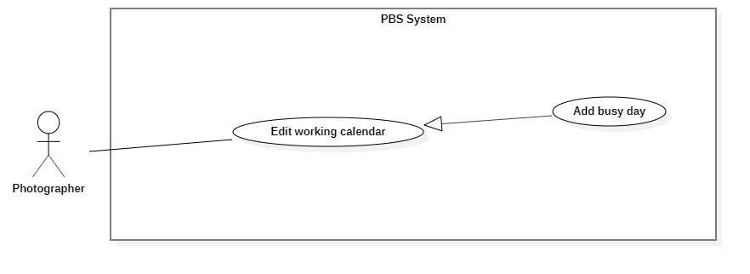

*Figure 26 <Photographer> Add busy day*

|  |  |  |  |  |  |
| --- | --- | --- | --- | --- | --- |
| UC ID and Name: | **UC – 17 Add busy day** | | | | |
| Created By: | Trương Ngọc Mỹ | | Date Created: | 08/10/2020 | |
| Primary Actor: | Photographer | | Secondary Actors: |  | |
| Trigger: | The photographer sends a request to add a busy day. | | | | |
| Description: | This use case allows photographers to add their busy day. | | | | |
| Preconditions: | - The User has been authenticated as a Photographer. | | | | |
| Post-conditions: | **Success:** New busy days will be stored in the system.  **Fail:** System outputs error message. | | | | |
| Normal Flow: | **Step** | **Actor Action** | | | **System Response** |
| 1 | Photographer goes on a busy day adding view. | | | System requires information from photographer:   * “Tiêu đề”: text, required * “Mô tả”: text, required * “Ngày nghỉ”: datepicker, required |
| 2 | Photographer inputs required information and sends requests to add busy days. | | | System outputs “Bạn muốn thêm ngày nghỉ?” |
| 3 | Photographer confirm “Có”  [Alternative 1] | | | System add busy day to system and outputs message “Đã thêm ngày nghỉ”  [Exception 1]  [Exception 2] |
| Alternative Flows: | **Step** | **Actor Action** | | | **System Response** |
| 1 | Photographer confirms “Không”. | | | Back to a busy day adding views. |
| Exceptions: | **No** | **Cause** | | | **System Response** |
| 1 | Photographer inputs data incorrectly or leave them empty | | | System outputs error message to notify photographer re-input. |
| 2 | The process runs into an internal error | | | System outputs “Đã có lỗi xảy ra” |
| Priority: | Medium | | | | |
| Frequency of Use: | Sometimes | | | | |
| Business Rules: | * Busy day information contains: busy day note, busy datetime, description on busy day. * If the picked day has booking deal, system will return a message to warn photographer that they have to cancel the booking before set busy day. | | | | |
| Other Information: | N/A | | | | |
| Assumptions: | N/A | | | | |

*Table 30 <Photographer> Add busy day specification*

##### <Photographer> Get customer’s review

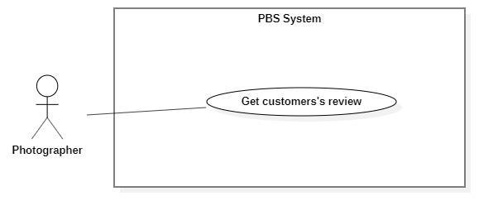

*Figure 27 <Photographer> Get customer's review*

|  |  |  |  |  |  |
| --- | --- | --- | --- | --- | --- |
| UC ID and Name: | **UC – 18 Get customer’s review** | | | | |
| Created By: | Trương Ngọc Mỹ | | Date Created: | 08/10/2020 | |
| Primary Actor: | Photographer | | Secondary Actors: |  | |
| Trigger: | The photographer sends a request to get a customer's review. | | | | |
| Description: | This use case allows photographers to get customers’ reviews. | | | | |
| Preconditions: | - The User has been authenticated as Photographer | | | | |
| Post-conditions: | **Success:** The system returns customers’ review of photographer  **Fail:** System shows error message | | | | |
| Normal Flow: | **Step** | **Actor Action** | | | **System Response** |
| 1 | Photographers send requests to get their reviews from customers. | | | System displays list of reviews.  [Exception 1] |
| Alternative Flows: | N/A | | | | |
| Exceptions: | **No** | **Cause** | | | **System Response** |
| 1 | The process runs into an internal error. | | | System outputs error message: “Đã có lỗi xảy ra” |
| Priority: | Medium | | | | |
| Frequency of Use: | Sometimes | | | | |
| Business Rules: | * The results contain: customers’ comments, customers’ ratings, commented dates | | | | |
| Other Information: | N/A | | | | |
| Assumptions: | N/A | | | | |

*Table 31<Photographer> Get customer's review specification*

##### <Photographer> Add package

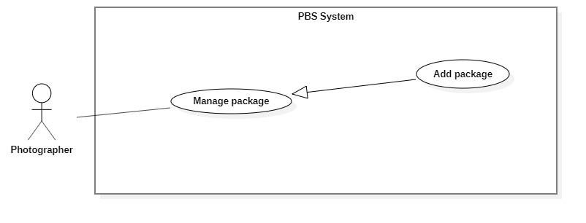

*Figure 28 <Photographer> Add package*

|  |  |  |  |  |  |
| --- | --- | --- | --- | --- | --- |
| UC ID and Name: | **UC – 19 Add package** | | | | |
| Created By: | Đào Sỹ Trung Kiên | | Date Created: | 08/10/2020 | |
| Primary Actor: | Photographer | | Secondary Actors: |  | |
| Trigger: | Photographer sends a request to add a new package. | | | | |
| Description: | This use case allows photographers to add new packages. | | | | |
| Preconditions: | The User has been authenticated as Photographer | | | | |
| Post-conditions: | **Success**: Package will be stored with status active.  **Fail**: System outputs error message and sends to Photographer. | | | | |
| Normal Flow: | **Step** | **Actor Action** | | | **System Response** |
| 1 | Photographer goes to New Package View. | | | System returns “phương thức giao hàng” for execution steps.  System requires information from photographer:  - “Kiểu dịch vụ”: text, required.  - “Tên dịch vụ”: text, required.  - “Mô tả”: text, required.  - “Giá thành dịch vụ”: text, required  - “Thời gian tác nghiệp”: text, required  - “Chi tiết dịch vụ”: text, required.  - “Phương thức giao hàng”: drop list, required. |
| 2 | Photographers input required information and send requests to create new packages. | | | System validates information, adds new package to system, output message “Tạo gói dịch vụ thành công” and send to Photographer  [Exception 1]  [Exception 2] |
| Alternative Flows: | N/A | | | | |
| Exceptions: | **No** | **Actor Action** | | | **System Response** |
| 1 | Photographer inputs invalid format text inputs or leaves empty required fields | | | System outputs error message and sends it to ask the photographer to input correct required fields. |
| 2 | The create process encountered an internal error. | | | System outputs error message and sends to photographer and notify that create new package fails. |
| Priority: | Medium | | | | |
| Frequency of Use: | Sometimes | | | | |
| Business Rules: | * Package will be managed by the system with status active and deactivated. * Package information contains: Id, Kiểu dịch vụ, Tên dịch vụ, Mô tả, Giá thành dịch vụ, Thời gian tác nghiệp , Chi tiết dịch vụ , Phương thức giao hàng. * Package id will be generated by the system. * Phương thức trả ảnh drop returned by system. * After creating a new package successfully, the new package will have status active and available for customers to choose. | | | | |
| Other Information: | N/A | | | | |
| Assumptions: | N/A | | | | |

*Table 32 <Photographer> Add package specification*

##### <Photographer> Edit Package

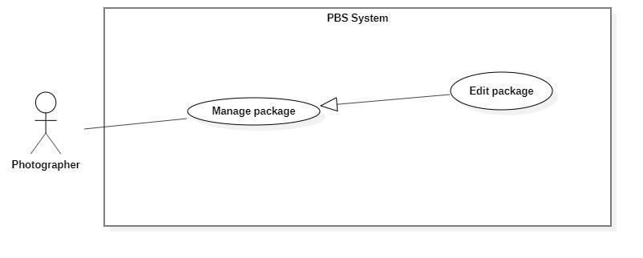

*Figure 29<Photographer> Edit package*

|  |  |  |  |
| --- | --- | --- | --- |
| UC ID and Name: | **UC – 20 Edit package** | | |
| Created By: | Đào Sỹ Trung Kiên | Date Created: | 08/10/2020 |
| Primary Actor: | Photographer | Secondary Actors: |  |
| Trigger: | Photographer sends request to edit package. | | |
| Description: | This use case allows photographers to edit packages. | | |
| Preconditions: | The User has been authenticated as Photographer | | |
| Post-conditions: | **Success**: Package is edited.  **Fail**: System outputs error message and sends to Photographer. | | |
| Normal Flow: | **No** | **Actor Action** | **System Response** |
| 1 | Photographers send requests to receive a list of packages. | System display list of package.  [Exception 1] |
| 2 | Photographer sends request to receive package details | System returns “phương thức giao hàng” for execution steps.  System requires information from photographer:  - “Kiểu dịch vụ”: text, required.  - “Tên dịch vụ”: text, required.  - “Mô tả”: text, required.  - “Giá thành dịch vụ”: text, required  - “Thời gian tác nghiệp”: text, required  - “Chi tiết dịch vụ”: text, required.  - “Phương thức giao hàng”: drop list, required.  [Exception 2] |
|  | 3 | Photographer inputs package required information and send request to update package | System validates information, updates package, sends output message: “Chỉnh sửa thành công” to photographer.  [Exception 3]  [Exception 4] |
| Alternative Flows: | N/A | | |
| Exceptions: | **No** | **Actor Action** | **System Response** |
| 1 | System retrieves an empty list of available packages. | System outputs the error message “Không tìm thấy package” and sends it to the photographer. |
| 2 | System retrieves an empty list of “Phương thức giao hàng”. | System outputs error message “Không tìm thấy phương thức giao hàng” and sends to photographer. |
| 3 | Photographer inputs invalid format text inputs or leaves empty required fields. | System outputs error message and sends it to photographer to ask photographer to input correct required fields. |
| 4 | Update package process encountered a system internal error. | System outputs error message to notify photographer that update package failed. |
| Priority: | Medium | | |
| Frequency of Use: | Sometimes | | |
| Business Rules: | * Photographers only access packages via package id. * Package will be updated in the system with inputted information. * Package id cannot be updated. * Package will be managed by the system with status active and deactivated. * Package information contains: Id, Kiểu dịch vụ, Tên dịch vụ, Mô tả, Giá thành dịch vụ, Thời gian tác nghiệp, Chi tiết dịch vụ , Phương thức giao hàng. * Phương thức trả ảnh drop list returned by system. * After updating the package successfully, the package will have new value and available for customers to choose. | | |
| Other Information: | N/A | | |
| Assumptions: | N/A | | |

*Table 33 <Photographer> Edit package specification*

##### <Photographer> Remove Package

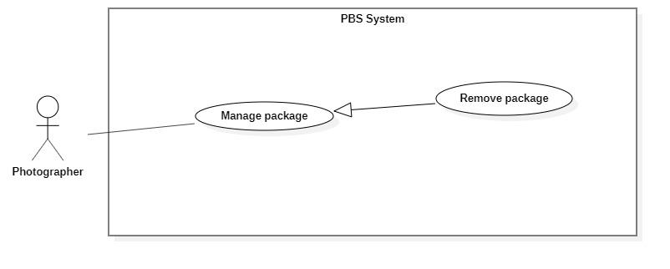

*Figure 30 <Photographer> Remove package*

|  |  |  |  |  |  |
| --- | --- | --- | --- | --- | --- |
| UC ID and Name: | **UC – 21 Remove package** | | | | |
| Created By: | Đào Sỹ Trung Kiên | | Date Created: | 08/10/2020 | |
| Primary Actor: | Photographer | | Secondary Actors: |  | |
| Trigger: | Photographer sends request to delete package. | | | | |
| Description: | This use case allows photographers to delete packages. | | | | |
| Preconditions: | The User has been authenticated as Photographer | | | | |
| Post-conditions: | **Success**: Package is set to deactivated.  **Fail**: System outputs error message and sends to Photographer. | | | | |
| Normal Flow: | **Step** | **Actor Action** | | | **System Response** |
| 1 | Photographer sends a request to get a list package. | | | System returns and displays list package.  [Exception 1] |
| 2 | Photographer sends request to delete package. | | | System outputs confirm messages: “Bạn có muốn xóa gói dịch vụ này không ?” and requires Photographer to confirm. |
| 2 | Photographer confirms “Đồng ý” to delete the package. | | | System outputs and sends message: “Xóa gói dịch vụ thành công” to photographer and updates list package.  [Exception 2] |
| Alternative Flows: | N/A | | | | |
| Exceptions: | **No** | **Actor Action** | | | **System Response** |
| 1 | System retrieves an empty list package. | | | System outputs error message “Không có gói dịch vụ nào” and sends to photographer. |
| 2 | The delete action process encountered an internal error. | | | System outputs error message and sends it to photographer to notify that the delete package failed. |
| Priority: | Medium | | | | |
| Frequency of Use: | Sometimes | | | | |
| Business Rules: | * Photographers only access packages via package id. * If package status is active: Update status to deactivate. * Customers will not use this package. | | | | |
| Other Information: | N/A | | | | |
| Assumptions: | N/A | | | | |

*Table 34 <Photographer> Remove package specification*

##### <Photographer> Add album

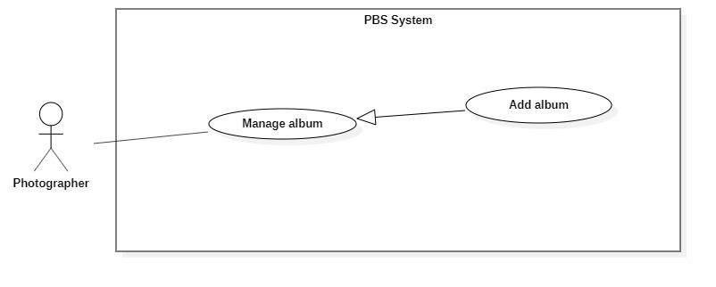

*Figure 31 <Photographer> Add album*

|  |  |  |  |  |  |
| --- | --- | --- | --- | --- | --- |
| UC ID and Name: | **UC – 22 Add album** | | | | |
| Created By: | Đào Sỹ Trung Kiên | | Date Created: | 08/10/2020 | |
| Primary Actor: | Photographer | | Secondary Actors: |  | |
| Trigger: | The photographer sends request to add new album | | | | |
| Description: | This use case allows Photographer to add new album | | | | |
| Preconditions: | The User has been authenticated as Photographer | | | | |
| Post-conditions: | **Success:** Album will be added successfully  **Fail:** Systems outputs error message and sends to Photographer | | | | |
| Normal Flow: | **Step** | **Actor Action** | | | **System Response** |
| 1 | The Photographer goes to new Package View | | | System returns “category” for execution steps.  System requires information from photographer:  - “Ngày tạo”: datetime, required.  - “Mô tả”: text, required.  - “Tên album”: text, required.  - “Hình ảnh”: picture, required.  - “Category”: chips, required  - “Địa điểm”: text, required. |
| 2 | Photographer inputs required information and send request to create new album | | | System validates information, adds new album to the system, outputs message “Tạo mới album thành công” and sends to the Photographer  [Exception 1]  [Exception 2] |
| Alternative Flows: | N/A | | | | |
| Exceptions: | **No** | **Actor Action** | | | **System Response** |
| 1 | Photographer inputs invalid format text inputs or leaves empty require fields. | | | System outputs error message and send to ask Photographer to input correct required fields. |
| 2 | The create process encountered an internal error. | | | System outputs error message and sends photographer to notify that create new album failed. |
| Priority: | Medium | | | | |
| Frequency of Use: | Sometimes | | | | |
| Business Rules: | * Album will be managed by the system with status active and deactivated. * Album information contains: id, ngày tạo, mô tả, tên album, hình ảnh, category, địa điểm. * Album id will be generated by the system. * Category returned by system. * After create new album successfully, new album will has status active and available for customers. | | | | |
| Other Information: | N/A | | | | |
| Assumptions: | N/A | | | | |

*Table 35 <Photographer> Add album specification*

##### <Photographer> Edit album

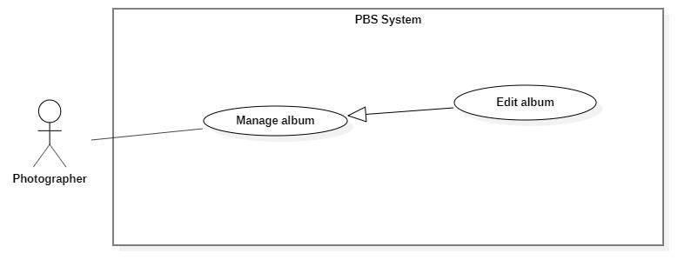

*Figure 32 <Photographer> Edit album*

|  |  |  |  |  |  |
| --- | --- | --- | --- | --- | --- |
| UC ID and Name: | **UC – 23 Edit album** | | | | |
| Created By: | Đào Sỹ Trung Kiên | | Date Created: | 08/10/2020 | |
| Primary Actor: | Photographer | | Secondary Actors: |  | |
| Trigger: | The photographer sends request to edit album | | | | |
| Description: | This use case allows Photographer to edit album | | | | |
| Preconditions: | The User has been authenticated as Photographer | | | | |
| Post-conditions: | **Success:** Album will be updated  **Fail:** Systems outputs error message and sends to Photographer | | | | |
| Normal Flow: | **No** | **Actor Action** | | | **System Response** |
| 1 | Photographers send requests to receive a list of albums. | | | System display list of album.  [Exception 1] |
| 2 | Photographer sends request to receive album details | | | System returns “category” for execution steps.  System requires information from photographer:  - “Ngày tạo”: datetime, required.  - “Mô tả”: text, required.  - “Tên album”: text, required.  - “Hình ảnh”: picture, required.  - “Category”: chips, required  - “Địa điểm”: text, required.  [Exception 2] |
| 3 | Photographer inputs album required information and send request to update album | | | System validates information, updates package, sends output message: “Chỉnh sửa thành công” to photographer.  [Exception 3]  [Exception 4] |
| Alternative Flows: | N/A | | | | |
| Exceptions: | **No** | **Actor Action** | | | **System Response** |
| 1 | System retrieves an empty list of available albums. | | | System outputs the error message “Không tìm thấy album” and sends it to the photographer. |
| 2 | System retrieves an empty list of “category”. | | | System outputs the error message “Không tìm thấy category” and sends it to the photographer. |
| 3 | Photographer inputs invalid format text inputs or leaves empty required fields. | | | System outputs error message and sends it to photographer to ask photographer to input correct required fields. |
|  | 4 | Update album process encountered a system internal error. | | | System outputs error message to notify photographer that update album failed. |
| Priority: | Medium | | | | |
| Frequency of Use: | Sometimes | | | | |
| Business Rules: | * Photographers only access albums by album id. * Albums will be updated in the system with inputted information. * Album id cannot be updated. * Albums will be managed by the system with status active and deactivated. * Album information contains: id, ngày tạo, mô tả, tên album, hình ảnh, category, địa điểm. * Category returned by system. * After updating the album successfully, the album will have new value and be available for customers. | | | | |
| Other Information: | N/A | | | | |
| Assumptions: | N/A | | | | |

*Table 36 <Photographer> Edit album specification*

##### <Photographer> Remove album

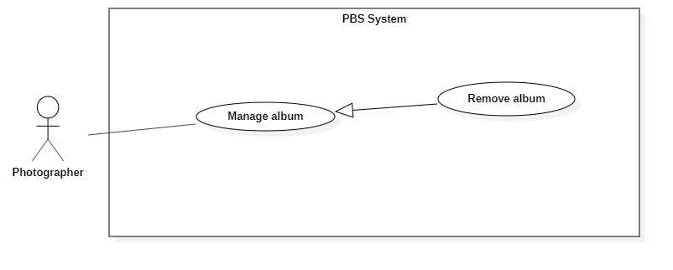

*Figure 33 <Photographer> Remove album*

|  |  |  |  |  |  |
| --- | --- | --- | --- | --- | --- |
| UC ID and Name: | **UC – 24 Remove album** | | | | |
| Created By: | Đào Sỹ Trung Kiên | | Date Created: | 08/10/2020 | |
| Primary Actor: | Photographer | | Secondary Actors: |  | |
| Trigger: | Photographer sends request to delete album | | | | |
| Description: | This use case allows photographers to delete albums. | | | | |
| Preconditions: | The User has been authenticated as Photographer | | | | |
| Post-conditions: | **Success**: Album is set to deactivated.  **Fail**: System outputs error message and sends to Photographer. | | | | |
| Normal Flow: | **Step** | **Actor Action** | | | **System Response** |
| 1 | Photographer sends request to get list album. | | | System returns and displays the list album.  [Exception 1] |
| 2 | Photographer sends request to delete album. | | | System outputs confirm messages: “Bạn có muốn xóa album này không ?” and requires Photographer to confirm. |
| 3 | Photographer confirms “Đồng ý” to delete album. | | | System outputs and sends a message: “Xóa album thành công” to photographer and updates list album.  [Exception 2] |
| Alternative Flows: | N/A | | | | |
| Exceptions: | **No** | **Actor Action** | | | **System Response** |
| 1 | System retrieves an empty list album. | | | System outputs the error message “Không có album nào” and sends it to the photographer. |
| 2 | The delete action process encountered an internal error. | | | System outputs error message and sends it to photographer to notify that the delete album failed. |
| Priority: | Medium | | | | |
| Frequency of Use: | Sometimes | | | | |
| Business Rules: | * Photographers only access albums via album id. * If album status is active: Update status to deactivate. * Customers will not use this album. | | | | |
| Other Information: | N/A | | | | |
| Assumptions: | N/A | | | | |

*Table 37<Photographer> Remove album specification*

#### 2.2.4 <Authenticated User> Overview Use Case

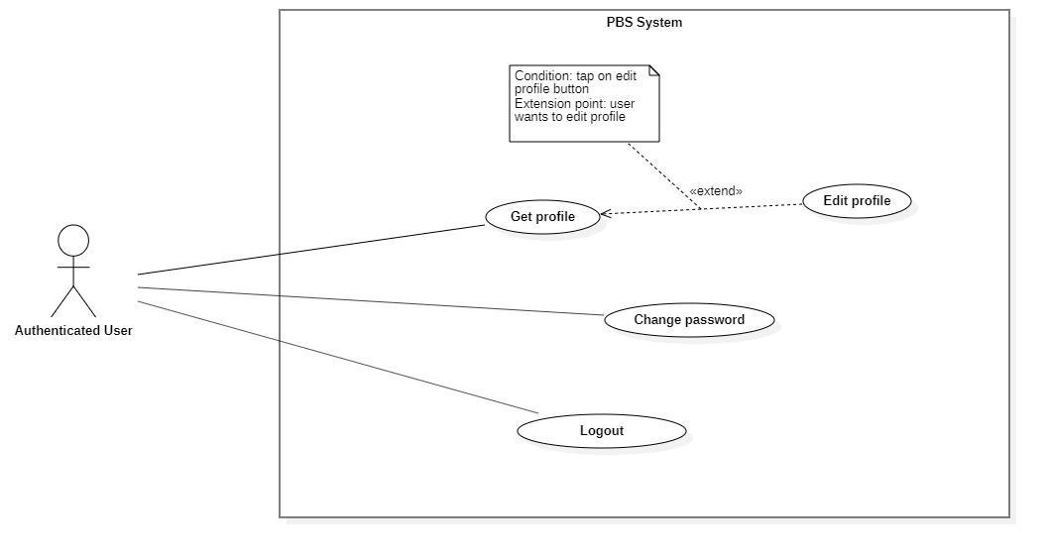

*Figure 34 <Authenticated User> Overview*

##### <Authenticated User> Get profile

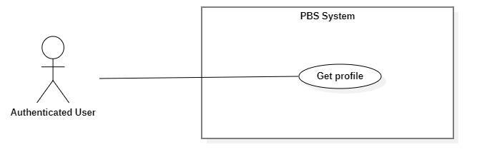

*Figure 35 <Authenticated User> Get profile*

|  |  |  |  |  |  |
| --- | --- | --- | --- | --- | --- |
| UC ID and Name: | **UC – 25 Get profile** | | | | |
| Created By: | Trương Ngọc Mỹ | | Date Created: | 08/10/2020 | |
| Primary Actor: | Authenticated User | | Secondary Actors: |  | |
| Trigger: | The Authenticated User sends request to get profile | | | | |
| Description: | This use case allows authenticated user to get their profile | | | | |
| Preconditions: | - User has been authenticated. | | | | |
| Post-conditions: | **Success:** System returns authenticated user’s profile.  **Fail:** System shows error message. | | | | |
| Normal Flow: | **Step** | **Actor Action** | | | **System Response** |
| 1 | Authenticated users send requests to get their profile. | | | System outputs the result to the authenticated user.  [Exception 1]  [Exception 2] |
| Alternative Flows: | N/A | | | | |
| Exceptions: | **No** | **Cause** | | | **System Response** |
| 1 | System can’t get the profile. | | | System outputs error message “Không thể tìm thấy thông tin”. |
| 2 | The process runs into an internal error. | | | System outputs error message “Đã có lỗi xảy ra” |
| Priority: | Medium | | | | |
| Frequency of Use: | Sometimes | | | | |
| Business Rules: | * The results contain following information: user’s avatar, user’ full name, user’s phone, user’s email, user’s description | | | | |
| Other Information: | N/A | | | | |
| Assumptions: | N/A | | | | |

*Table 38 <Authenticated User> Get profile specification*

##### <Authenticated User> Edit profile

|  |  |  |  |  |  |
| --- | --- | --- | --- | --- | --- |
| UC ID and Name: | **UC – 26 Edit profile** | | | | |
| Created By: | Trương Ngọc Mỹ | | Date Created: | 08/10/2020 | |
| Primary Actor: | Authenticated User | | Secondary Actors: |  | |
| Trigger: | The Authenticated User sends a request to edit the profile. | | | | |
| Description: | This use case allows authenticated users to edit their profile. | | | | |
| Preconditions: | * User has been authenticated | | | | |
| Post-conditions: | **Success:** The profile will be updated into the system.  **Fail:** System outputs error message. | | | | |
| Normal Flow: | **Step** | **Actor Action** | | | **System Response** |
| 1 | Authenticated users send requests to receive their profile. | | | System return results and requires information from user:  - “Họ tên”: text, required  - “Email”: text, required  - “Số điện thoại”: number, required  - “Mô tả”: text  - “Ảnh đại diện”: image  [Exception 1] |
| 2 | Authenticated user input information and send requests to edit their profile. | | | System outputs “Bạn muốn cập nhật hồ sơ?”. |
| 3 | Authenticated confirmation “Có”.  [Alternative 1] | | | System update data and outputs “Đã cập nhật hồ sơ”.  [Exception 2]  [Exception 3] |
| Alternative Flows: | **Step** | **Actor Action** | | | **System Response** |
| 1 | Authenticated confirm “Không”. | | | Back to profile view. |
| Exceptions: | **No** | **Cause** | | | **System Response** |
| 1 | System can’t get user’s profile | | | System outputs “Không thể tìm thấy hồ sơ” |
| 2 | User inputs information incorrectly or leaves it empty in the required field. | | | System outputs error messages to get user input correctly. |
| 3 | System runs into an internal error. | | | System outputs error message “Đã có lỗi xảy ra” |
| Priority: | Medium | | | | |
| Frequency of Use: | Sometimes | | | | |
| Business Rules: | * The return view contains following information: user’s avatar, user’ full name, user’s phone, user’s email, user’s description * User can every information in their profile. | | | | |
| Other Information: | N/A | | | | |
| Assumptions: | N/A | | | | |

*Table 39 <Authenticated User> Edit profile specification*

##### <Authenticated User> Change password

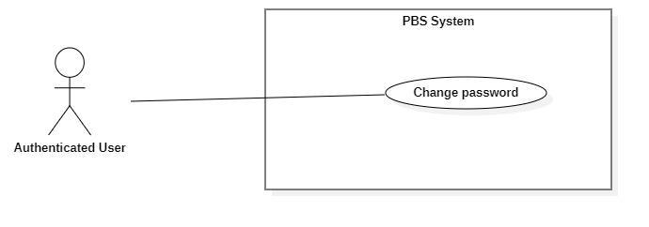

*Figure 37 <Authenticated User> Change password*

|  |  |  |  |  |  |
| --- | --- | --- | --- | --- | --- |
| UC ID and Name: | **UC – 27 Change password** | | | | |
| Created By: | Bồ Công Đạt | | Date Created: | 08/10/2020 | |
| Primary Actor: | Authenticated User | | Secondary Actors: |  | |
| Trigger: | The Authenticated User sends a request to change password. | | | | |
| Description: | This use case allows authenticated users to change their password. | | | | |
| Preconditions: | User has been authenticated. | | | | |
| Post-conditions: | **Success:** User’s password updated successfully in the system.  **Fail:** System outputs error message. | | | | |
| Normal Flow: | **Step** | **Actor Action** | | | **System Response** |
| 1 | Authenticated user sends request to get their password | | | System returns result and requires following information from user:  - “Mật khẩu cũ”: password, required  - “Mật khẩu mới”: password, required  - “Nhập lại mật khẩu”: password, required  [Exception 1] |
| 2 | Authenticated user inputs required information and sends request to change password | | | System outputs “Bạn muốn cập nhật mật khẩu?” |
| 3 | Authenticated user confirms “Có”  [Alternative 1] | | | System update data and output “Cập nhật mật khẩu thành công”  [Exception 2]  [Exception 3] |
| Alternative Flows: | **Step** | **Actor Action** | | | **System Response** |
| 1 | Authenticated user confirms “Không” | | | Back to password changing view |
| Exceptions: | **No** | **Cause** | | | **System Response** |
| 1 | System can’t get user’s password | | | System outputs “Không thể tìm thấy thông tin” |
| 2 | User inputs information incorrectly or leave required fields empty | | | System outputs error message to get user input information correctly |
| 3 | The process runs into an internal error | | | System outputs “Đã có lỗi xảy ra” |
| Priority: | Medium | | | | |
| Frequency of Use: | Sometimes | | | | |
| Business Rules: | * User must input the current password before changing new password. * Password format should be a minimum eight characters, contains at least one number, one letter and one special character. | | | | |
| Other Information: | N/A | | | | |
| Assumptions: | N/A | | | | |

*Table 40 <Authenticated User> Change password specification*

##### <Authenticated User> Logout

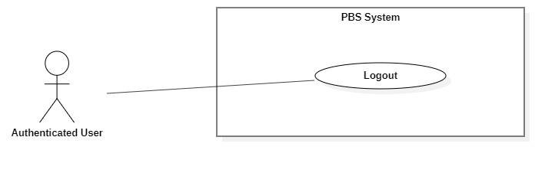

*Figure 38 <Authenticated User> Logout*

|  |  |  |  |  |  |
| --- | --- | --- | --- | --- | --- |
| UC ID and Name: | **UC – 28 Logout** | | | | |
| Created By: | Bồ Công Đạt | | Date Created: | 08/10/2020 | |
| Primary Actor: | Authenticated User | | Secondary Actors: |  | |
| Trigger: | The Authenticated User sends a request to log out from the system. | | | | |
| Description: | This use case allows users to log out from the system. | | | | |
| Preconditions: | User has been authenticated. | | | | |
| Post-conditions: | **Success:** User logged out from the system.  **Fail:** System outputs error message | | | | |
| Normal Flow: | **Step** | **Actor Action** | | | **System Response** |
| 1 | User sends a request to log out from the system. | | | System outputs “Bạn muốn đăng xuất?” |
| 2 | User confirms “Có”  [Alternative 1] | | | System logs the user out.  [Exception 1] |
| Alternative Flows: | **Step** | **Actor Action** | | | **System Response** |
| 1 | User confirms “Không” | | | Back to logout view |
| Exceptions: | **No** | **Cause** | | | **System Response** |
| 1 | The process runs into an internal error | | | System outputs “Đã có lỗi xảy ra” |
| Priority: | Medium | | | | |
| Frequency of Use: | Usually | | | | |
| Business Rules: | * User’s Json web token will be removed on client side. * User’s session will be destroyed on client side. | | | | |
| Other Information: | N/A | | | | |
| Assumptions: | N/A | | | | |

*Table 41 <Authenticated User> Logout specification*

#### 2.2.5 <Admin> Overview Use Case

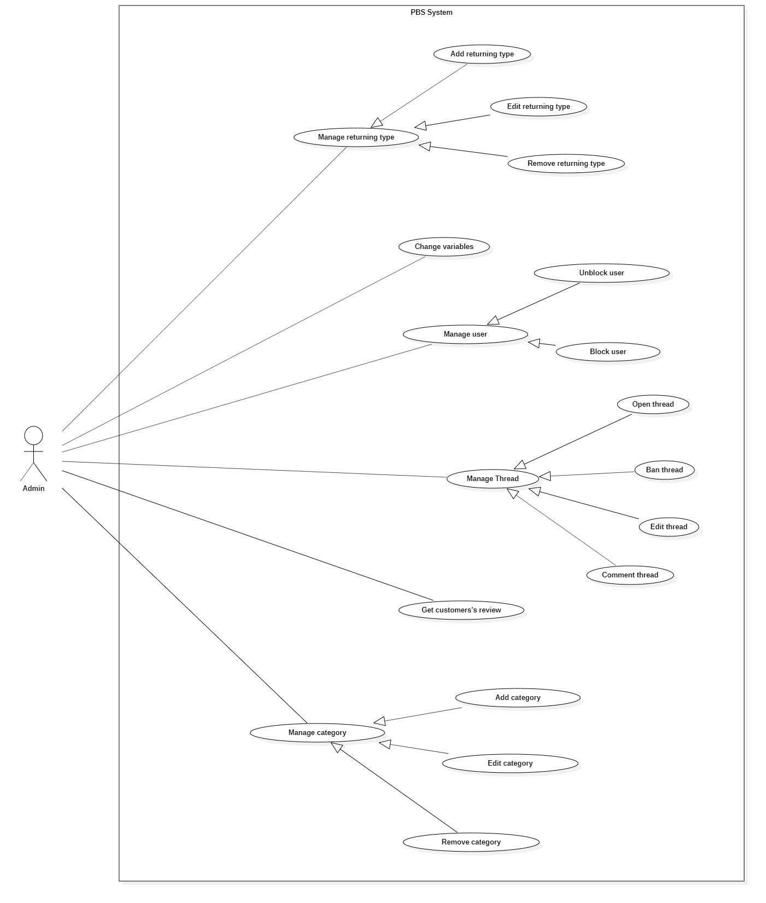

*Figure 39 <Admin> Overview*

##### <Admin> Block user

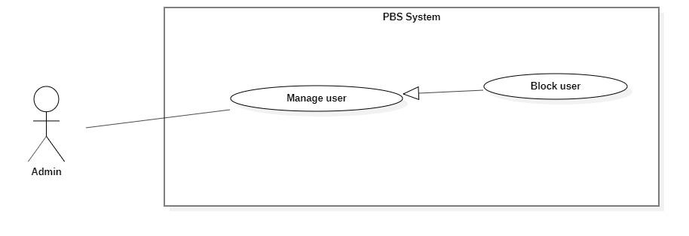

*Figure 40 <Admin> Block user*

|  |  |  |  |  |  |
| --- | --- | --- | --- | --- | --- |
| UC ID and Name: | **UC – 29 Block user** | | | | |
| Created By: | Dao Sy Trung Kien | | Date Created: | 08/10/2020 | |
| Primary Actor: | Admin | | Secondary Actors: |  | |
| Trigger: | The Admin sends request to block user | | | | |
| Description: | This use case allows Admin to block user | | | | |
| Preconditions: | The User has been authenticated as Admin | | | | |
| Post-conditions: | **Success:** User will be blocked and unable to access the system.  **Fail:** Systems outputs error message and sends to Admin | | | | |
| Normal Flow: | **Step** | **Actor Action** | | | **System Response** |
| 1 | The Admin goes to block user view | | | System requires information from admin:  - “User Id”:text, required. |
| 2 | Admin inputs required information and send request to block user | | | System validates information, block user and outputs message “Chặn người dùng thành công” and sends to the admin.  [Exception 1]  [Exception 2] |
| Alternative Flows: | N/A | | | | |
| Exceptions: | **No** | **Actor Action** | | | **System Response** |
| 1 | Admin inputs invalid format text inputs or leaves empty required fields. | | | System outputs error message and sends it to ask admin to input correct required fields. |
| 2 | The create process encountered an internal error. | | | System outputs error message and sends admin to notify that block user failed. |
| Priority: | Medium | | | | |
| Frequency of Use: | Sometimes | | | | |
| Business Rules: | * Users will be managed by the system with status active and deactivated. * Blocked user will have status deactivated. * User information contains: id. * After successfully blocking the user, this user will be unable to access the system. | | | | |
| Other Information: | N/A | | | | |
| Assumptions: | N/A | | | | |

*Table 42 <Admin> Block user specification*

##### <Admin> Unblock user

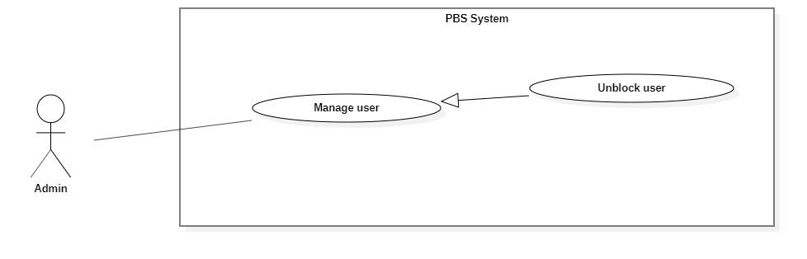

*Figure 41 <Admin> Unblock user*

|  |  |  |  |  |  |
| --- | --- | --- | --- | --- | --- |
| UC ID and Name: | **UC – 30 Unblock user** | | | | |
| Created By: | Dao Sy Trung Kien | | Date Created: | 08/10/2020 | |
| Primary Actor: | Admin | | Secondary Actors: |  | |
| Trigger: | The Admin sends request to unblock album | | | | |
| Description: | This use case allows Admin to unblock user | | | | |
| Preconditions: | The User has been authenticated as Admin | | | | |
| Post-conditions: | **Success:** User will be unblocked and enabled to access the system.  **Fail:** Systems outputs error message and sends to Admin | | | | |
| Normal Flow: | **Step** | **Actor Action** | | | **System Response** |
| 1 | The Admin goes to unblock user view | | | System requires information from admin:  - “User Id”:text, required. |
| 2 | Admin inputs required information and send request to unblock user | | | System validates information, unblock user and outputs message “Gỡ chặn người dùng thành công” and sends to the Admin.  [Exception 1]  [Exception 2] |
| Alternative Flows: | N/A | | | | |
| Exceptions: | **No** | **Actor Action** | | | **System Response** |
| 1 | Admin inputs invalid format text inputs or leaves empty required fields. | | | System outputs error message and sends it to ask admin to input correct required fields. |
| 2 | The create process encountered an internal error. | | | System outputs error message and sends admin to notify that unblock user failed. |
| Priority: | Medium | | | | |
| Frequency of Use: | Sometimes | | | | |
| Business Rules: | * Users will be managed by the system with status active and deactivated. * After unblock user will have status change from deactivated to active. * User information contains: id. * After unblocking the user successfully, this user will be enabled to access the system. | | | | |
| Other Information: | N/A | | | | |
| Assumptions: | N/A | | | | |

*Table 43 <Admin> Unblock user specification*

##### <Admin> Add Category

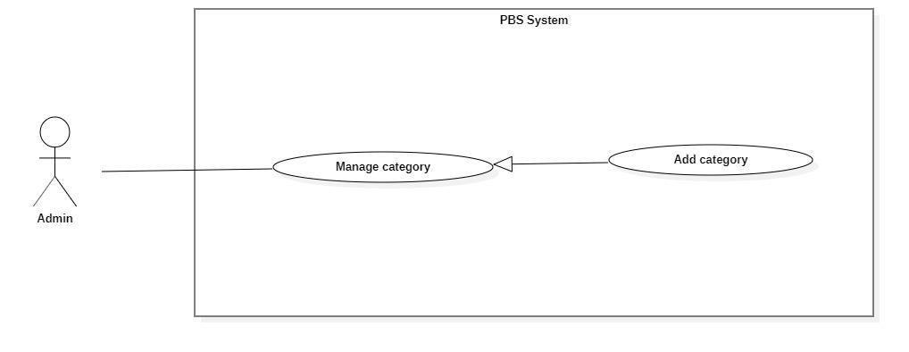

*Figure 42 <Admin> Add category*

|  |  |  |  |  |  |
| --- | --- | --- | --- | --- | --- |
| UC ID and Name: | **UC – 31 Add category** | | | | |
| Created By: | Dao Sy Trung Kien | | Date Created: | 08/10/2020 | |
| Primary Actor: | Admin | | Secondary Actors: |  | |
| Trigger: | The admin sends request to add new category | | | | |
| Description: | This use case allows Admin to add new category | | | | |
| Preconditions: | The User has been authenticated as Admin | | | | |
| Post-conditions: | **Success:** Category will be added successfully  **Fail:** Systems outputs error message and sends to Admin | | | | |
| Normal Flow: | **Step** | **Actor Action** | | | **System Response** |
| 1 | The Admin goes to new Category View | | | System requires information from admin:  - “Tên category”: text, required. |
| 2 | Admin inputs required information and send request to create category | | | System validates information, adds new category to the system, outputs message “Tạo mới category thành công” and sends to the Admin  [Exception 1]  [Exception 2] |
| Alternative Flows: | N/A | | | | |
| Exceptions: | **No** | **Actor Action** | | | **System Response** |
| 1 | Admin inputs invalid format text inputs or leaves empty required fields. | | | System outputs error message and sends it to ask admin to input correct required fields. |
| 2 | The create process encountered an internal error. | | | System outputs error message and sends admin to notify that create new category. |
| Priority: | Medium | | | | |
| Frequency of Use: | Sometimes | | | | |
| Business Rules: | * Category will be managed by the system with status active and deactivated. * Category information contains: id, category name. * Category id will be generated by the system. * After creating a new category successfully, the new category will have status active and available for customer and photographer. | | | | |
| Other Information: | N/A | | | | |
| Assumptions: | N/A | | | | |

*Table 44 <Admin> Add category specification*

##### <Admin> Edit category

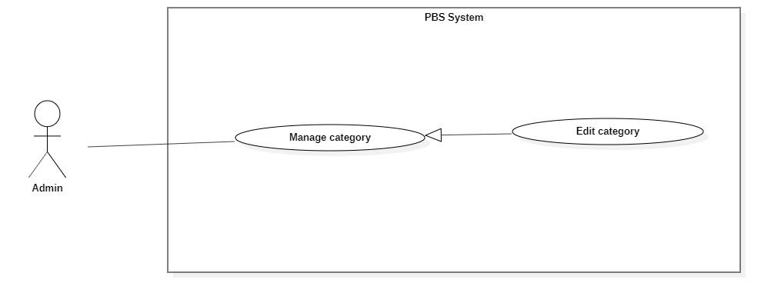

*Figure 43 <Admin> Edit category*

|  |  |  |  |  |  |
| --- | --- | --- | --- | --- | --- |
| UC ID and Name: | **UC – 32 Edit category** | | | | |
| Created By: | Đào Sỹ Trung Kiên | | Date Created: | 08/10/2020 | |
| Primary Actor: | Admin | | Secondary Actors: |  | |
| Trigger: | The admin sends request to edit category | | | | |
| Description: | This use case allows Admin to edit category | | | | |
| Preconditions: | The User has been authenticated as Admin | | | | |
| Post-conditions: | **Success:** Category will be updated  **Fail:** Systems outputs error message and sends to Admin | | | | |
| Normal Flow: | **No** | **Actor Action** | | | **System Response** |
| 1 | Admin sends a request to receive a list of categories. | | | System display list of category.  [Exception 1] |
| 2 | Admin sends request to receive category details | | | System requires information from admin:  - “Tên category”: text, required. |
| 3 | Admin inputs category required information and send request to update category | | | System validates information, updates category, sends output message: “Chỉnh sửa thành công” to admin.  [Exception 2]  [Exception 3] |
| Alternative Flows: | N/A | | | | |
| Exceptions: | **No** | **Actor Action** | | | **System Response** |
| 1 | System retrieves an empty list of available categories. | | | System outputs the error message “Không tìm thấy category” and sends it to the admin. |
| 2 | Admin inputs invalid format text inputs or leaves empty required fields. | | | System outputs error message and send to ask admin to input correct required fields |
|  | 3 | Update category process encountered a system internal error. | | | System outputs error message to notify admin that update category failed. |
| Priority: | Medium | | | | |
| Frequency of Use: | Sometimes | | | | |
| Business Rules: | * Admin only access category by category id. * Category will be updated in the system with inputted information. * Category id cannot be updated. * Category will be managed by the system with status active and deactivated. * Category information contains: id, category name. * After updating Category successfully, category will have new value and available for customer and photographer. | | | | |
| Other Information: | N/A | | | | |
| Assumptions: | N/A | | | | |

*Table 45 <Admin> Edit category specification*

##### <Admin> Remove category

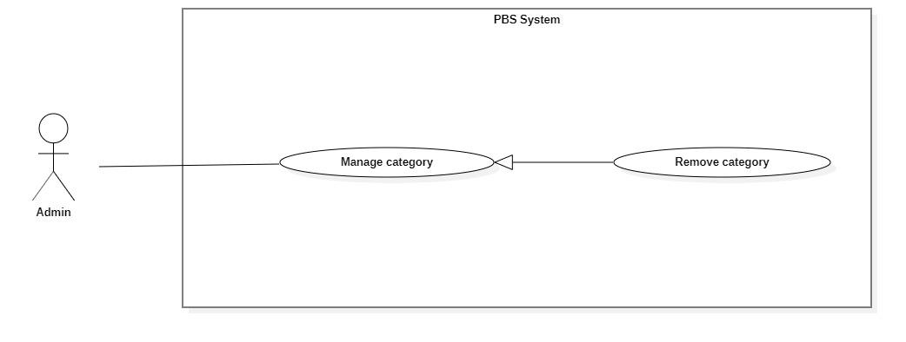

*Figure 44 <Admin> Remove category*

|  |  |  |  |  |  |
| --- | --- | --- | --- | --- | --- |
| UC ID and Name: | **UC – 33 Remove category** | | | | |
| Created By: | Đào Sỹ Trung Kiên | | Date Created: | 08/10/2020 | |
| Primary Actor: | Admin | | Secondary Actors: |  | |
| Trigger: | Admin sends a request to delete the category. | | | | |
| Description: | This use case allows the admin to delete categories. | | | | |
| Preconditions: | The User has been authenticated as Admin | | | | |
| Post-conditions: | **Success**: Category is set to deactivated.  **Fail**: System outputs error message and sends to Admin. | | | | |
| Normal Flow: | **Step** | **Actor Action** | | | **System Response** |
| 1 | Admin sends a request to get a list category. | | | System returns and displays list category.  [Exception 1] |
| 2 | Admin sends a request to delete category. | | | System outputs confirm messages: “Bạn có muốn xóa category này không ?” and requires Admin to confirm. |
| 3 | Admin confirms “Đồng ý” to delete the category. | | | System outputs and sends a message: “Xóa category thành công” to the admin and updates list category.  [Exception 2] |
| Alternative Flows: | N/A | | | | |
| Exceptions: | **No** | **Actor Action** | | | **System Response** |
| 1 | System retrieves an empty list category. | | | System outputs the error message “Không có category nào” and sends it to the admin. |
| 2 | The delete action process encountered an internal error. | | | System outputs error message and sends it to admin to notify that delete category failed. |
| Priority: | Medium | | | | |
| Frequency of Use: | Sometimes | | | | |
| Business Rules: | * Admin only access category by category id. * If category status is active: Update status to deactivate. * Customers and photographers will not use this category. | | | | |
| Other Information: | N/A | | | | |
| Assumptions: | N/A | | | | |

*Table 46 <Admin> Remove category specification*

##### <Admin> Add returning type

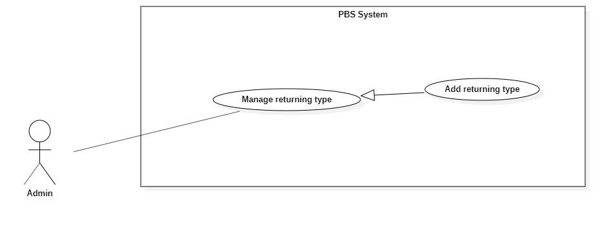

*Figure 45 <Admin> Add returning type*

|  |  |  |  |  |  |
| --- | --- | --- | --- | --- | --- |
| UC ID and Name: | **UC – 34 Add returning type** | | | | |
| Created By: | Dao Sy Trung Kien | | Date Created: | 08/10/2020 | |
| Primary Actor: | Admin | | Secondary Actors: |  | |
| Trigger: | The admin sends request to add new returning type | | | | |
| Description: | This use case allows Admin to add new returning type | | | | |
| Preconditions: | The User has been authenticated as Admin | | | | |
| Post-conditions: | **Success:** Returning type will be added successfully  **Fail:** Systems outputs error message and sends to Admin | | | | |
| Normal Flow: | **Step** | **Actor Action** | | | **System Response** |
| 1 | The Admin goes to new Returning type View | | | System requires information from admin:  - “Tên returning type”: text, required. |
| 2 | Admin inputs required information and send request to create returning type | | | System validates information, adds new returning type to the system, outputs message “Tạo mới returning type thành công” and sends to the Admin  [Exception 1]  [Exception 2] |
| Alternative Flows: | N/A | | | | |
| Exceptions: | **No** | **Actor Action** | | | **System Response** |
| 1 | Admin inputs invalid format text inputs or leaves empty required fields. | | | System outputs error message and sends it to ask admin to input correct required fields. |
| 2 | The create process encountered an internal error. | | | System outputs error message and sends admin to notify that create new returning type. |
| Priority: | Medium | | | | |
| Frequency of Use: | Sometimes | | | | |
| Business Rules: | * Returning type will be managed by the system with status active and deactivated. * Returning type information contains: id, returning type name. * Returning type id will be generated by the system. * After creating a new returning type successfully, the new returning type will have status active and available for customer and photographer. | | | | |
| Other Information: | N/A | | | | |
| Assumptions: | N/A | | | | |

*Table 47 <Admin> Add returning type specification*

##### <Admin> Edit returning type

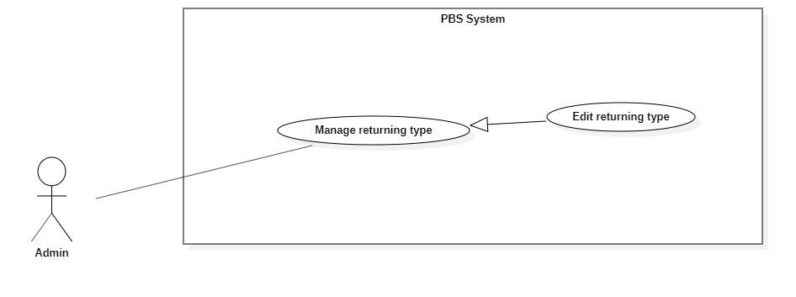

*Figure 46 <Admin> Edit returning type*

|  |  |  |  |  |  |
| --- | --- | --- | --- | --- | --- |
| UC ID and Name: | **UC – 35 Edit returning type** | | | | |
| Created By: | Đào Sỹ Trung Kiên | | Date Created: | 08/10/2020 | |
| Primary Actor: | Admin | | Secondary Actors: |  | |
| Trigger: | The admin sends request to edit returning type | | | | |
| Description: | This use case allows Admin to edit returning type | | | | |
| Preconditions: | The User has been authenticated as Admin | | | | |
| Post-conditions: | **Success:** Returning type will be updated  **Fail:** Systems outputs error message and sends to Admin | | | | |
| Normal Flow: | **No** | **Actor Action** | | | **System Response** |
| 1 | Admin sends a request to receive a list of returning types. | | | System display list of returning type.  [Exception 1] |
| 2 | Admin sends request to receive returning type details | | | System requires information from admin:  - “Tên returning type”: text, required. |
| 3 | Admin inputs returning type required information and send request to update returning type | | | System validates information, updates returning type, sends output message: “Chỉnh sửa thành công” to admin.  [Exception 2]  [Exception 3] |
| Alternative Flows: | N/A | | | | |
| Exceptions: | **No** | **Actor Action** | | | **System Response** |
| 1 | System retrieves an empty list of available returning types. | | | System outputs the error message “Không tìm thấy returning type” and sends it to the admin. |
| 2 | Admin inputs invalid format text inputs or leaves empty required fields. | | | System outputs error message and send to ask admin to input correct required fields |
|  | 3 | Update returning type process encountered a system internal error. | | | System outputs error message to notify admin that update returning type failed. |
| Priority: | Medium | | | | |
| Frequency of Use: | Sometimes | | | | |
| Business Rules: | * Admin only access returning type via returning type id. * Returning type will be updated in the system with inputted information. * Returning type id cannot be updated. * Returning type will be managed by the system with status active and deactivated. * Returning type information contains: id, returning type name. * After updating the returning type successfully, the returning type will have new value and available for customer and photographer. | | | | |
| Other Information: | N/A | | | | |
| Assumptions: | N/A | | | | |

*Table 48 <Admin> Edit returning type specification*

##### <Admin> Remove returning type

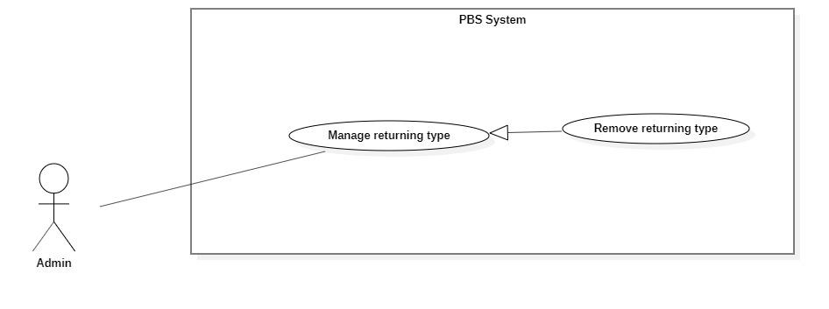

*Figure 47 <Admin> Remove returning type*

|  |  |  |  |  |  |
| --- | --- | --- | --- | --- | --- |
| UC ID and Name: | **UC – 36 Remove returning type** | | | | |
| Created By: | Đào Sỹ Trung Kiên | | Date Created: | 08/10/2020 | |
| Primary Actor: | Admin | | Secondary Actors: |  | |
| Trigger: | Admin sends a request to delete the returning type. | | | | |
| Description: | This use case allows admin to delete returning type. | | | | |
| Preconditions: | The User has been authenticated as Admin | | | | |
| Post-conditions: | **Success**: Returning type is set to deactivated.  **Fail**: System outputs error message and sends to Admin. | | | | |
| Normal Flow: | **Step** | **Actor Action** | | | **System Response** |
| 1 | Admin sends a request to get a list returning type. | | | System returns and displays list returning type.  [Exception 1] |
| 2 | Admin sends request to delete returning type | | | System outputs confirm messages: “Bạn có muốn xóa returning type này không ?” and requires Admin to confirm. |
| 3 | Admin confirms “Đồng ý” to delete the returning type. | | | System outputs and sends a message: “Xóa returning type thành công” to admin and updates list returning type.  [Exception 2] |
| Alternative Flows: | N/A | | | | |
| Exceptions: | **No** | **Actor Action** | | | **System Response** |
| 1 | System retrieves an empty list returning type. | | | System outputs the error message “Không có returning type nào” and sends it to the admin. |
| 2 | The delete action process encountered an internal error. | | | System outputs error message and sends it to admin to notify that delete returning type failed. |
| Priority: | Medium | | | | |
| Frequency of Use: | Sometimes | | | | |
| Business Rules: | * Admin only access returning type via returning type id. * If returning type status is active: Update status to deactivate. * Customer and photographer will not use this returning type. | | | | |
| Other Information: | N/A | | | | |
| Assumptions: | N/A | | | | |

*Table 49 <Admin> Remove returning type specification*

##### <Admin> Change variables

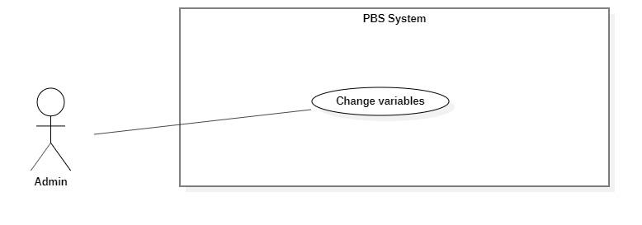

*Figure 48 <Admin> Change variables*

|  |  |  |  |  |  |
| --- | --- | --- | --- | --- | --- |
| UC ID and Name: | **UC – 37 Change variables** | | | | |
| Created By: | Đào Sỹ Trung Kiên | | Date Created: | 08/10/2020 | |
| Primary Actor: | Admin | | Secondary Actors: |  | |
| Trigger: | The admin sends request to change variables | | | | |
| Description: | This use case allows Admin to change variables | | | | |
| Preconditions: | The User has been authenticated as Admin | | | | |
| Post-conditions: | **Success:** Variables will be updated  **Fail:** Systems outputs error message and sends to Admin | | | | |
| Normal Flow: | **No** | **Actor Action** | | | **System Response** |
| 1 | Admin sends request to receive variables details | | | System requires information from admin:  - “Khoảng cách”: number, required.  - “Trung bình giá dịch vụ”: number, required.  - “Đánh giá từ người dùng”: number, required.  [Exception 1] |
| 2 | Admin inputs variables required information and send request to change variables | | | System validates information, change variables, sends output message: “Chỉnh sửa thành công” to admin.  [Exception 2]  [Exception 3] |
| Alternative Flows: | N/A | | | | |
| Exceptions: | **No** | **Actor Action** | | | **System Response** |
| 1 | System retrieves an empty variable. | | | System outputs error message “Không tìm thấy trọng số nào” and sends to admin. |
| 2 | Admin inputs invalid format text inputs or leaves empty required fields. | | | System outputs error message and send to ask admin to input correct required fields |
|  | 3 | Change variables process encountered a system internal error. | | | System outputs error message to notify admin that change variables failed. |
| Priority: | Medium | | | | |
| Frequency of Use: | Sometimes | | | | |
| Business Rules: | * Variables will be updated in the system with inputted information. * Variables id cannot be updated. * Shooting category information contains: id, variable name. * After changing the variables category successfully, variables will have new value. * The sum of the variable is equal to 1 | | | | |
| Other Information: | N/A | | | | |
| Assumptions: | N/A | | | | |

*Table 50 <Admin> Change variables specification*

##### <Admin> Ban thread

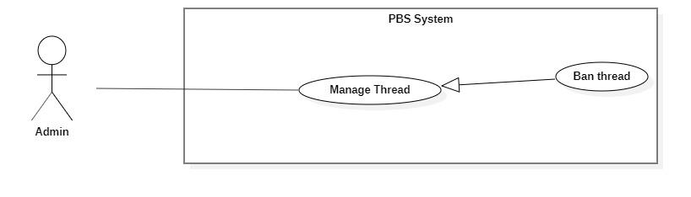

*Figure 49<Admin> Ban thread*

|  |  |  |  |  |  |
| --- | --- | --- | --- | --- | --- |
| UC ID and Name: | **UC – 38 Ban thread** | | | | |
| Created By: | Bồ Công Đạt | | Date Created: | 08/10/2020 | |
| Primary Actor: | Admin | | Secondary Actors: |  | |
| Trigger: | The Admin sends request to ban thread | | | | |
| Description: | This use case allows Admin to ban thread | | | | |
| Preconditions: | The User has been authenticated as Admin | | | | |
| Post-conditions: | **Success:** Thread will be banned successfully.  **Fail:** Systems outputs error message and sends to Admin | | | | |
| Normal Flow: | **Step** | **Actor Action** | | | **System Response** |
| 1 | The Admin goes to ban thread view. | | | System requires information from admin:  - “Thread id”: text, required. |
| 2 | Admin inputs required information and send request to ban thread | | | System validates information, ban thread and outputs message “Chặn bài đăng thành công” and sends to the admin.  [Exception 1]  [Exception 2] |
| Alternative Flows: | N/A | | | | |
| Exceptions: | **No** | **Actor Action** | | | **System Response** |
| 1 | Admin inputs invalid format text inputs or leaves empty required fields. | | | System outputs error message and sends it to ask admin to input correct required fields. |
| 2 | The create process encountered an internal error. | | | System outputs error message and sends admin to notify that ban thread failed. |
| Priority: | Medium | | | | |
| Frequency of Use: | Sometimes | | | | |
| Business Rules: | * Thread will be managed by the system with status active and banned. * After ban thread, thread’s status will be changed to banned. * Thread information contains: id. * After successfully ban the thread, save the admin name and time who have banned the thread. | | | | |
| Other Information: | N/A | | | | |
| Assumptions: | N/A | | | | |

*Table 51 <Admin> Ban thread specification*

#### 2.2.6 <<system>>Handler Overview use case

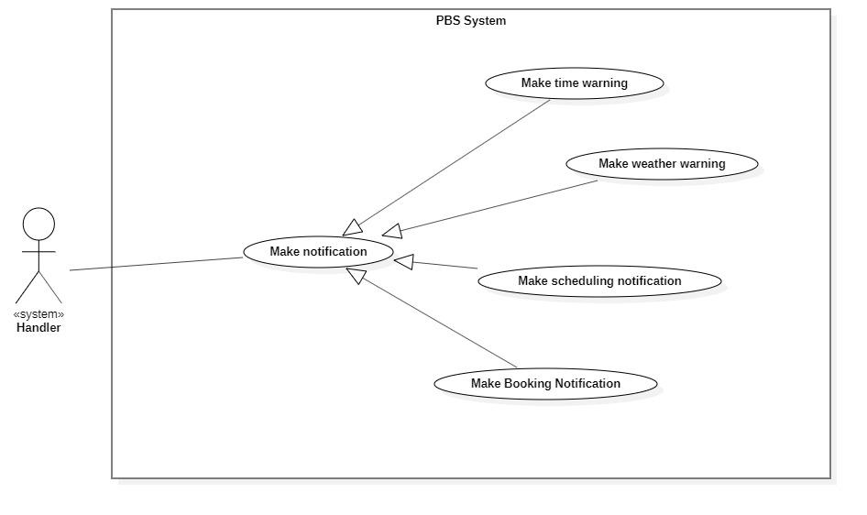

*Figure 50 <System Handler> Overview*

##### <<system>>Handler Make booking notification

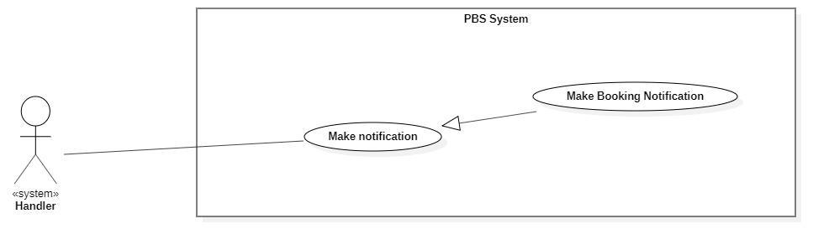

*Figure 51 <System Handler> Make booking notification*

|  |  |  |  |  |  |
| --- | --- | --- | --- | --- | --- |
| UC ID and Name: | **UC – 39 Make booking notification** | | | | |
| Created By: | Bồ Công Đạt | | Date Created: | 08/10/2020 | |
| Primary Actor: | System Handler | | Secondary Actors: |  | |
| Trigger: | System handler sends request to notify photographer or customer whenever booking status is changed | | | | |
| Description: | This use case allows system handler to make booking notification | | | | |
| Preconditions: | N/A | | | | |
| Post-conditions: | **Success:** System make booking notification and sends to photographer or customer  **Fail:** System outputs error and sends to photographer or customer | | | | |
| Normal Flow: | **Step** | **Actor Action** | | | **System Response** |
| 1 | System handler retrieves booking request | | | System stores booking information and return notification to system handler |
| 2 | System handler retrieves notification information and sends to photographer or customer  [Exception 1] | | |  |
| Alternative Flows: | N/A | | | | |
| Exceptions: | **No** | **Cause** | | | **System Response** |
| 1 | The process runs into an internal error | | | System outputs error and sends to photographer or customer |
| Priority: | Medium | | | | |
| Frequency of Use: | Usually | | | | |
| Business Rules: | This use case will be triggered in following situations:   * When customer makes a new booking request. Notification will be sent to photographer. * When photographer accepts an incoming request. Notification will be sent to customer. * When photographer reject an incoming request. Notification will be sent to customer. * When customer cancels a booking. Notification will be sent to photographer. * When photographer cancels a booking. Notification will be sent to customer. * When photographer changes status of a booking from “Ongoing” to “Editing”. Notification will be sent to customer. * When photographer changes status of a booking from “Editing” to “Done”. Notification will be sent to customer. | | | | |
| Other Information: | N/A | | | | |
| Assumptions: | N/A | | | | |

*Table 52 <System Handler> Make booking notification specification*

##### <<system>>Handler Make scheduling notification

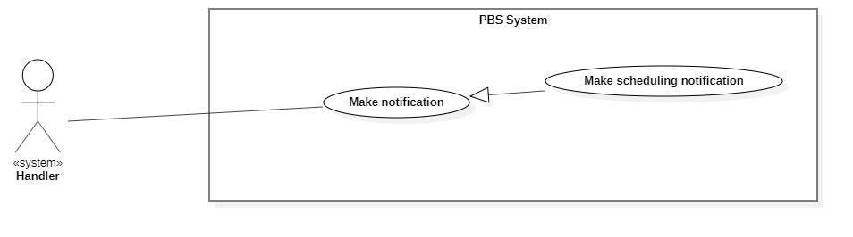

*Figure 52 <System Handler> Make scheduling notification*

|  |  |  |  |  |  |
| --- | --- | --- | --- | --- | --- |
| UC ID and Name: | **UC – 40 Make scheduling notification** | | | | |
| Created By: | Bồ Công Đạt | | Date Created: | 08/10/2020 | |
| Primary Actor: | System Handler | | Secondary Actors: |  | |
| Trigger: | System handler sends a request to notify photographer or customer on scheduling. | | | | |
| Description: | This use case allows system handler to make scheduling notification | | | | |
| Preconditions: | N/A | | | | |
| Post-conditions: | **Success:** System make scheduling notification and sends to photographer or customer  **Fail:** System outputs error and sends to photographer or customer | | | | |
| Normal Flow: | **Step** | **Actor Action** | | | **System Response** |
| 1 | System handler retrieves scheduling changing request | | | System stores scheduling information and return notification to system handler |
| 2 | System handler retrieves notification information and sends to photographer or customer  [Exception 1] | | |  |
| Alternative Flows: |  | | | | |
| Exceptions: | **No** | **Cause** | | | **System Response** |
| 1 | The process runs into an internal error | | | System outputs error and sends to photographer or customer |
| Priority: | Medium | | | | |
| Frequency of Use: | Usually | | | | |
| Business Rules: | This use case will be triggered in following situations:   * When booking start time is current date. Notification will be sent to photographer and customer to notice them about on day booking. | | | | |
| Other Information: | N/A | | | | |
| Assumptions: | N/A | | | | |

*Table 53 <System Handler> Make scheduling notification specification*

##### <<system>>Handler Make weather warning

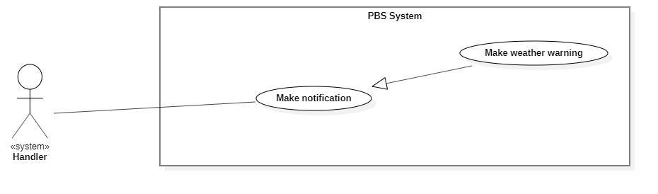

*Figure 53 <System Handler> Make weather warning*

|  |  |  |  |  |  |
| --- | --- | --- | --- | --- | --- |
| UC ID and Name: | **UC – 41 Make weather warning** | | | | |
| Created By: | Bồ Công Đạt | | Date Created: | 08/10/2020 | |
| Primary Actor: | System Handler | | Secondary Actors: |  | |
| Trigger: | System handler sends requests to notify customers of bad weather. | | | | |
| Description: | This use case allows the system handler to make weather warnings. | | | | |
| Preconditions: | N/A | | | | |
| Post-conditions: | **Success:** System makes weather warning and sends to customer.  **Fail:** System outputs error and sends to photographer or customer | | | | |
| Normal Flow: | **Step** | **Actor Action** | | | **System Response** |
| 1 | System handler retrieves bad weather request | | | System stores bad weather information and return notification to system handler |
| 2 | System handler retrieves notification information and sends to photographer or customer  [Exception 1] | | |  |
| Alternative Flows: |  | | | | |
| Exceptions: | **No** | **Cause** | | | **System Response** |
| 1 | The process runs into an internal error | | | System outputs error and sends to photographer or customer |
| Priority: | Medium | | | | |
| Frequency of Use: | Usually | | | | |
| Business Rules: | This use case will be triggered in following situations:   * Customer make a new booking, system checks whether if that day’s weather is suitable for shooting and send the warning notification back to her/his. | | | | |
| Other Information: | N/A | | | | |
| Assumptions: | N/A | | | | |

*Table 54 <System Handler> Make weather warning specification*

##### <<system>>Handler Make time warning

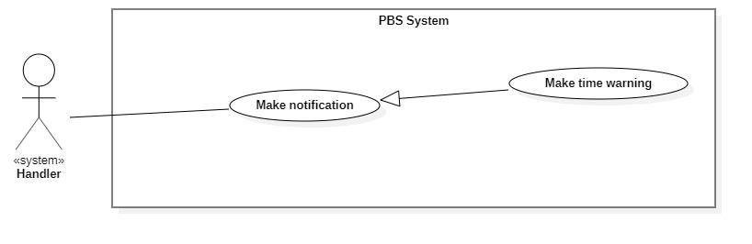

*Figure 54 <System Handler> Make time warning*

|  |  |  |  |  |  |
| --- | --- | --- | --- | --- | --- |
| UC ID and Name: | **UC – 42 Make time warning** | | | | |
| Created By: | Bồ Công Đạt | | Date Created: | 08/10/2020 | |
| Primary Actor: | System Handler | | Secondary Actors: |  | |
| Trigger: | System handler sends requests to notify customers of bad time selection. | | | | |
| Description: | This use case allows the system handler to make time warnings. | | | | |
| Preconditions: | N/A | | | | |
| Post-conditions: | **Success:** System makes time warning and sends to customer.  **Fail:** System outputs error and sends to customer | | | | |
| Normal Flow: | **Step** | **Actor Action** | | | **System Response** |
| 1 | System handler retrieves bad time selection request | | | System stores bad time information and return notification to system handler |
| 2 | System handler retrieves notification information and sends to customer  [Exception 1] | | |  |
| Alternative Flows: |  | | | | |
| Exceptions: | **No** | **Cause** | | | **System Response** |
| 1 | The process runs into an internal error | | | System outputs error and sends to customer |
| Priority: | Medium | | | | |
| Frequency of Use: | Usually | | | | |
| Business Rules: | This use case will be triggered in following situations:   * Customer make a new booking, system checks whether if the selected time is too tight for photographer. * For example, photographer have a booking between 9am – 12pm 10/10/2020, if customer book at 13pm 10/10/2020, the system will suggest the customer that photographer may not be able to accept this. | | | | |
| Other Information: | N/A | | | | |
| Assumptions: | N/A | | | | |

*Table 55<System Handler> Make time warning specification*

## 3. Functional Requirements

### 3.1 System Functional Overview

#### a. Screen Flow

1. **Customer’s screen flow**

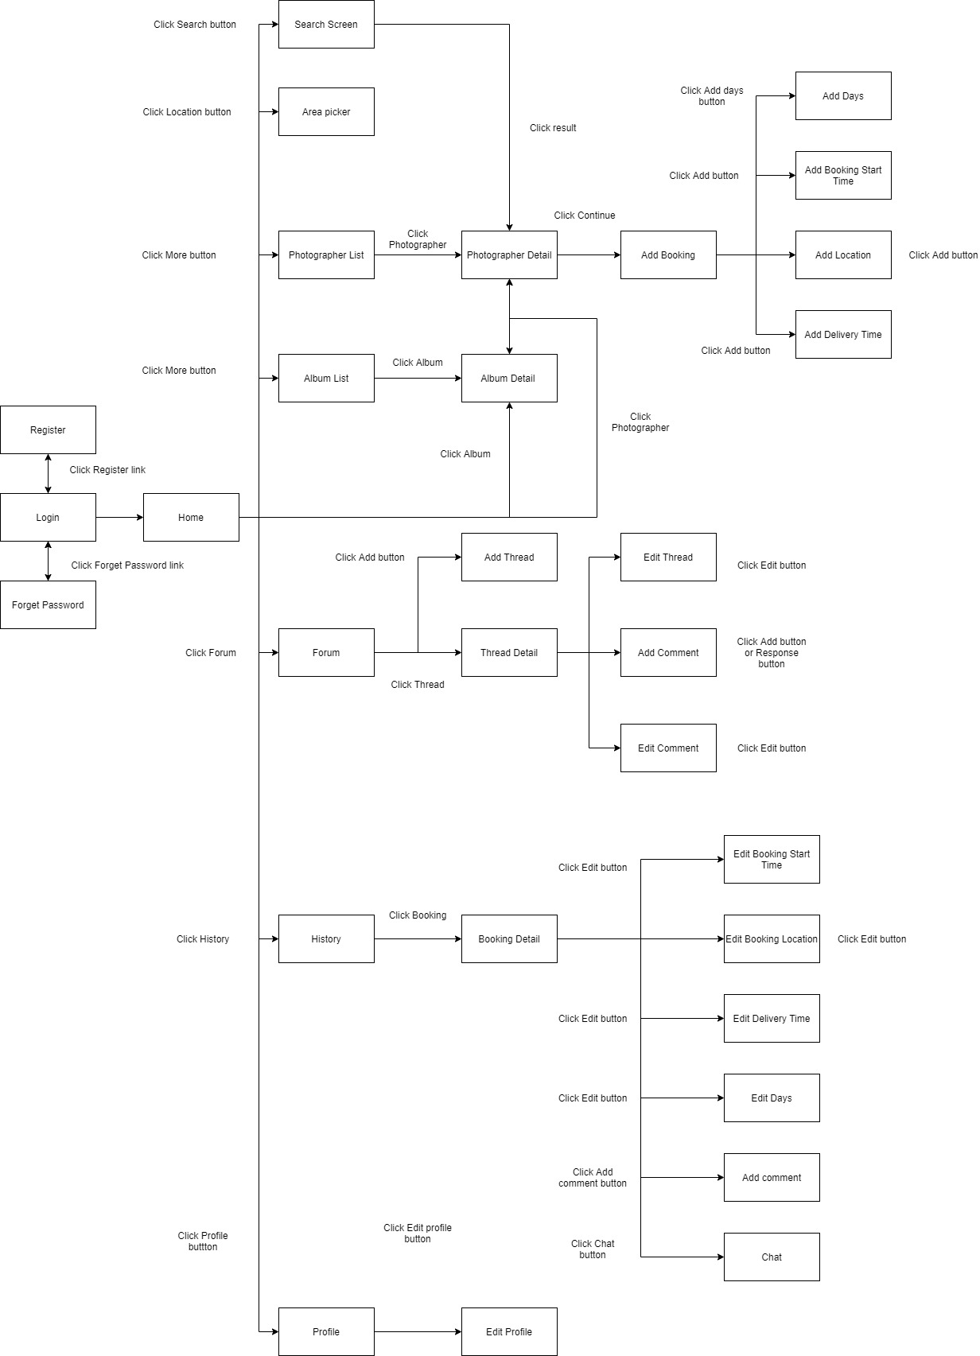

*Figure 55 Customer's screen flow*

1. **Photographer’s screen flow**

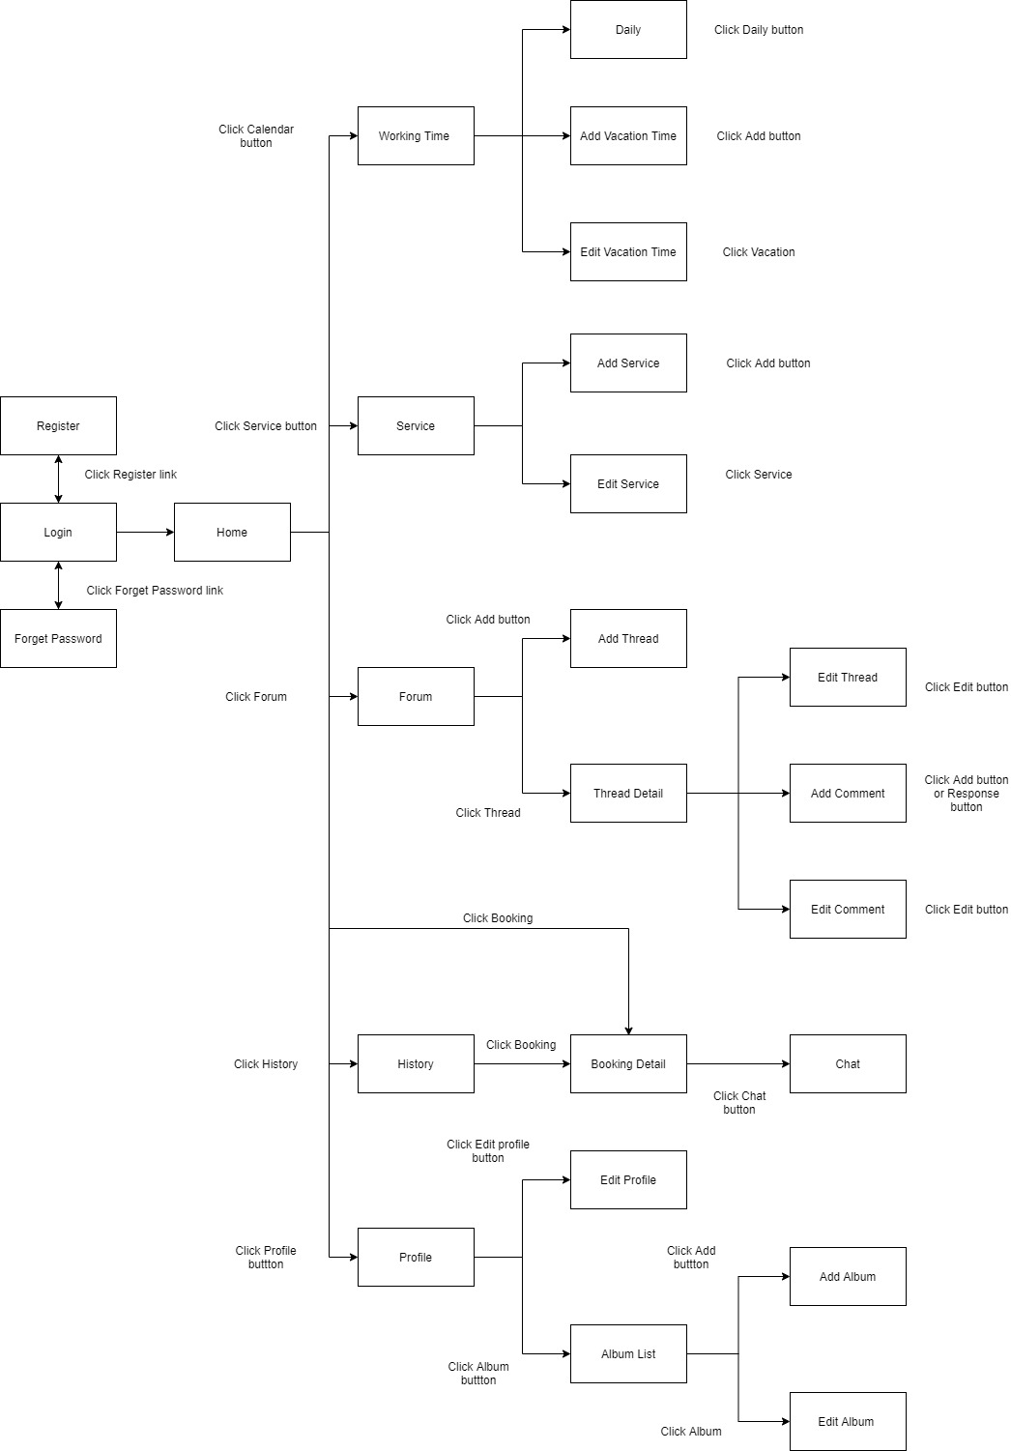

*Figure 56 Photographer's screen flow*

#### b. Screen Details

1. ***Customer’s screen details***

|  |  |  |  |
| --- | --- | --- | --- |
| **#** | **Feature** | **Screen** | **Description** |
| 1 | Register | Register | Register screen included: username textfield, password textfield, re-password textfield |
| 2 | Login | Login | Login screen included: username textfield, password textfield |
| 3 | Forgot password | Forgot password | Forgot password screen included: email textfield |
| 4 | View application | Home | Main screen included: Search icon, category list, photographer list, album list |
| 5 | View profile | Profile | Profile screen included: fullname, username, phone number, email. |
| 6 | Update profile | Edit profile | Edit profile screen included: fullname textfield, phone number textfield, email textfield. |
| 7 | View photographer | Photographer List | Photographer list screen included: photographer name, price, working location, rate. |
| Photographer Detail | Detail request screen included: photographer name, describe, album, review, schedule, package. |
| 9 | Booking | Add Booking | Add booking screen included: photographer name, start time button, delivery time button, location button, package drop list, delivery method drop list. |
| Add Days | Add days screen included: photographer name, days button, delivery time button, location button, package drop list, delivery method drop list. |
| Add Booking Start Time | Add booking start time screen included: calendar picker, time picker. |
| Add Location | Add location include: map picker |
| Add Delivery Time | Add delivery time screen included: calendar picker, time picker. |
| 14 | View album | Album List | Album list screen included: name, rating. |
| Album Detail | Album detail screens include: name, rating, describe, date, location. |
| 16 | View forum | Forum | Forum screen included: list thread |
| 17 | Add thread | Add Thread | Add thread screen included: name textfield , topic button, detail textfield |
| 18 | View thread | Thread Detail | Thread detail screen included: thread, comment |
| 19 | Edit thread | Edit Thread | Edit thread screen included: name textfield, detail textfield |
| 20 | Add comment in forum | Add Comment | Add comment screen included: comment textfield |
| 21 | Edit comment in forum | Edit Comment | Edit comment screen included: comment textfield |
| 22 | View booking | History | History screen included: booking list |
| Booking Detail | Booking detail screen included: photographer name, chat, location, start time, delivery time, delivery method, package |
| 24 | Edit booking | Edit Booking Start Time | Edit booking start time screen included: time picker, calendar picker |
| Edit Booking Location | Edit booking location screen included: map picker |
| Edit Delivery Time | Edit delivery screen included: time picker, calendar picker |
| Edit Days | Edit days screen included: days button |
| 27 | Add comment | Add Comment | Add comment screen included: rating slider, comment textfield |
| 28 | Chat | Chat | Chat screen included: chat bubble, chat textfield |
| 29 | Pick shooting area | Area Picker | Area picker screen included: map picker |
| 30 | Search photographer and package | Search | Search screen included: search area, result area |

*Table 56 Customer's screen details*

1. ***Photographer’s screen details***

|  |  |  |  |
| --- | --- | --- | --- |
| **#** | **Feature** | **Screen** | **Description** |
| 1 | Register | Register | Register screen included: username textfield, password textfield, re-password textfield |
| 2 | Login | Login | Login screen included: username textfield, password textfield |
| 3 | Forgot password | Forgot password | Forgot password screen included: email textfield |
| 4 | View application | Home | Main screen included: calendar icon, pending task list, to do task list |
| 5 | View profile | Profile | Profile screen included: fullname, username, phone number, working location, email. |
| 6 | Update profile | Edit profile | Edit profile screen included: fullname textfield, phone number textfield, working location picker, email textfield. |
| 7 | View album | Album List | Album list screen included: album picture |
| 8 | Add album | Add Album | Add album screen included: album name textfield, date picker, location picker, describe textfield, category picker, photo picker |
| 9 | Edit album | Edit Album | Edit album screen included: album name textfield, date picker, location picker, describe textfield, category picker, photo picker |
| 10 | View forum | Forum | Forum screen included: list thread |
| 11 | Add thread | Add Thread | Add thread screen included: name textfield, topic button, detail textfield |
| 12 | View thread | Thread Detail | Thread detail screen included: thread, comment |
| 13 | Edit thread | Edit Thread | Edit thread screen included: name textfield, detail textfield |
| 14 | Add comment in forum | Add Comment | Add comment screen included: comment textfield |
| 15 | Edit comment in forum | Edit Comment | Edit comment screen included: comment textfield |
| 16 | Booking | History | History screen included: booking list |
| Booking Detail | Booking detail screen included: customer name, chat, location, start time, delivery time, delivery method, package |
| 17 | Chat | Chat | Chat screen included: chat bubble, chat textfield |
| 18 | View working time | Working time | Working time screen included: daily button, add vacation button, vacation day list |
| 19 | Manage daily working time | Daily | Daily screen included: day of the week picker, begin time picker, end time picker |
| 20 | Add vacation time | Add Vacation time | Add vacation time included: calendar picker, name textfield |
| 21 | Edit vacation time | Edit Vacation time | Edit vacation time included: calendar picker, name textfield |
| 22 | View Service | Service | Service screen included: service list |
| 23 | Add Service | Add Service | Add service included: service type radio button, service name textfield, category drop list, describe textfield, duration textfield, price textfield, delivery type picker, detail list |
| 24 | Edit Service | Edit Service | Edit service included: service type radio button, service name textfield, category drop list, describe textfield, duration textfield, price textfield, delivery type picker, detail list |

*Table 57 Photographer's screen details*

#### c. Screen Authorization

|  |  |  |  |  |  |
| --- | --- | --- | --- | --- | --- |
| **Screen** | **Guest** | **Customer** | **Photographer** | **Admin** | **Authenticated User** |
| Register | X |  |  |  |  |
| Login |  | X | X | X | X |
| Forgot password |  | X | X | X | X |
| Home |  | X | X | X |  |
| Profile |  | X | X | X | X |
| Edit profile |  | X | X | X | X |
| Photographer List |  | X |  |  |  |
| Photographer Detail |  | X |  |  |  |
| Add Booking |  | X |  |  |  |
| Add Days |  | X |  |  |  |
| Add Booking Start Time |  | X |  |  |  |
| Add Location |  | X |  |  |  |
| Add Delivery Time |  | X |  |  |  |
| Album List |  | X | X |  |  |
| Album Detail |  | X | X |  |  |
| Add Album |  |  | X |  |  |
| Edit Album |  |  | X |  |  |
| Forum |  | X | X | X |  |
| Add Thread |  | X | X | X |  |
| Thread Detail |  | X | X | X |  |
| Edit Thread |  | X | X | X |  |
| Add Comment in Forum |  | X | X | X |  |
| Edit Comment in Forum |  | X | X | X |  |
| History |  | X | X |  |  |
| Booking Detail |  | X | X |  |  |
| Edit Booking Start Time |  | X |  |  |  |
| Edit Booking Location |  | X |  |  |  |
| Edit Delivery Time |  | X |  |  |  |
| Edit Days |  | X |  |  |  |
| Add Comment |  | X |  |  |  |
| Chat |  | X | X |  |  |
| Area Picker |  | X |  |  |  |
| Working time |  |  | X |  |  |
| Daily |  |  | X |  |  |
| Add Vacation time |  |  | X |  |  |
| Edit Vacation time |  |  | X |  |  |
| Service |  |  | X |  |  |
| Add Service |  |  | X |  |  |
| Edit Service |  |  | X |  |  |

*Figure 57 Screen authorization*

In which:

* Guest: The user has not registered for an account.
* Customer: The user who used this app for booking photographer services.
* Photographer: The user who used this app for providing services.
* Admin: The user who manages the whole system.
* Authenticated user: The user who has logged in to the system successfully.

#### d. Non-Screen Functions

|  |  |  |  |
| --- | --- | --- | --- |
| **No** | **Feature** | **System Function** | **Description** |
| 1 | Authentication | Register | Function allows user to register into the system to be either photographer or customer. |
| Login | Function allows user to log into the system if they have account. |
| 2 | Booking | Book photographer | Function allows customer to book a photographer. |
| Accept booking | Function allows photographer to accept incoming request. |
| Reject booking | Function allows photographer to reject incoming request. |
| Cancel booking | Function allows photographer or customer to cancel booking. But if their cancel is inappropriate, they could be ban by admin. |
| Edit booking | Function allows customer to edit their request, they can edit information like time, location or package. |
| Review booking | Function allows customer to review booking after it done. |
| 3 | Photographer | Manage package | Function allows photographer to manage their package service. |
| Manage album | Function allows photographer to manage their album. |
| Manage working calendar | Function allows photographer to manage their working schedule including add busy day, edit working weekday. |
| 4 | Forum | Open thread | Function allows user to open new thread. |
| Edit thread | Function allows user to edit their posted thread. |
| Comment thread | Function allows user to comment on a thread. |
| Ban thread | Function allows admin to ban a thread. |
| 5 | Profile | Edit profile | Function allows user to change their basic information like full name, avatar, etc. |
| Change password | Function allows user to change their password. |
| 6 | Notification | Make weather warning | Function allows system to warn customer about bad weather. |
| Make scheduling notification | Function allows system to notify customer or photographer on their schedule. |
| Make booking notification | Function allows system to notify customer or photographer about booking. |

*Table 58 Non-screen functions*

#### e. Entity Relationship Diagram

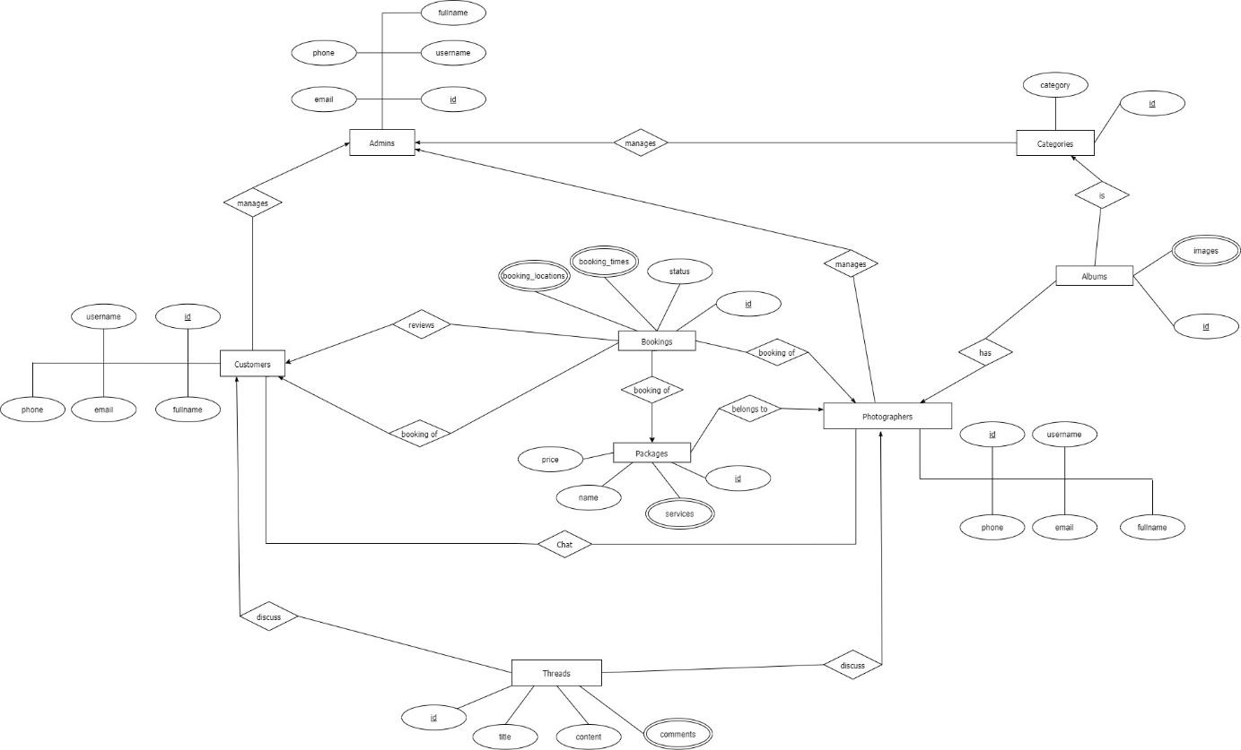

*Figure 58 ER Diagram*

**Entities List**

|  |  |  |
| --- | --- | --- |
| **#** | **Entity** | **Description** |
| 1 | Customer | Customer is an entity representing the person who purchases bookings from photographers: id, username, fullname, phone, email. |
| 2 | Admin | Admin is an entity represents the person who works for pbs system and manages activities of the system: id, username, fullname, phone, email |
| 3 | Booking | Booking is an entity represents the photography deal between photographer and customer: id, status, booking_times, booking_locations |
| 4 | Photographer | Photographer is an entity that represents the person who provides the photography services and takes customers’ deals. |
| 5 | Category | Category is an entity represents the type of albums (is it wedding or look book or anything else): id, category |
| 6 | Album | Album is an entity represents the images which photographer wants to show the customers to attract them: id, images |
| 7 | Package | Package is an entity represents the photography services which photographer provided: id, name, price, services |
| 8 | Thread | Thread is an entity represents a post of photographer or customer or admin on forum: id, title, content, comments |

*Table 59 Entities List*

## 4. Non-Functional Requirements

### 4.1 External Interfaces

#### a. User Interfaces

For web application:

UI-1: GUI has to be simple and easy to use.

UI-2: The language used in the web application is Vietnamese.

UI-3: The web application has to be responsive on multiple devices: laptop, tablet and mobile.

For mobile application:

UI-1: User interface is pleasant to look at and easy to use.

UI-2: The language is Vietnamese.

UI-3: The user interface can be responsive on multiple screen sizes.

UI-4: The functionalities are arranged clearly.

#### b. Software Interfaces

This system will have required software MySQL to program and create and manage the database for the system. Use for source control is Git and GitHub. Test browsers use Chrome 96 or above. Specification for developing the web application is Java EE 11.0.8. Program tools are Visual Studio Code, Android Studio, IntelliJ.

The system will require software window 7 and window 10 to program and manage photographer booking systems. Booking process of the system that organizes the distribution of users in the mobile app and able to do this manage review.

#### c. Hardware Interfaces

Just like any other system, this system requires a basic computer that consists of CPU, monitor, keyboard and mouse or laptop and smartphone for input and output. Smartphones could be used to do booking and use the system. Besides, for direction the system connected with a GPS device in every smartphone to get the location detail.

#### d. Communications Interfaces

The system communication interface is completely dependent on correctly sending and retrieving data from the database. Other than that is an online protocol to connect between GPS and the mobile.

### 4.2 Quality Attributes

#### a. Usability

* The system does not require its users to have any technical knowledge before using its functionalities.
* Layout and navigation are clear and easy to use.
* Customers can use PSB easily even if they have never used it before. They can find a photographer and make a request within 5 minutes.
* Photographers can use PSB easily even if they have never used it before. They can view and confirm requests received from the customers within 5 minutes. They can also use other functionalities quickly and effectively with easy-to-understand instructions and simple operation.

#### b. Reliability

* The availability of the system is 80%. The system can be used within 60 minutes and will automatically log the user out if there is no operation within 5 minutes.

#### c. Performance

All requests will be processed within 10 seconds on an Internet connection above 25Mbps.

#### d. Dependability

##### d1. Security

* All user’s passwords will be encrypted before being saved into the database.
* Accounts will be verified by email.
* Username must be unique.
* Photographers’ email and phone number will be secured.

##### d2. Safety

* A service price a photographer has posted cannot be changed when a customer chooses that service. If there is a surcharge, it must be negotiated with the customer.
* When the photos return day has come, if the photographer does not return the photos, the request will be cancelled automatically.

#### e. Supportability

* Online bookings in real time: The customer will be able to see all the available dates directly, and make a booking. If there is no further availability on one date, this will be blocked in real time to prevent further bookings.
* Intelligent calendar: An intelligent and easy-to-understand booking or occupancy calendar provides the user with a summary of all bookings, capacity and turnover for the required periods at a glance.
* Online and chat support for booking systems.
* Booking management via smartphone.

#### f. Design Constraints

* The software language is Vietnamese.
* The software process is Scrum.

#### g. Support Documents

The system does not use any references to support document writing.

#### h. Purchased Components

To support the system operation, we have used some third-party services such as:

* Google Map API.
* AWS S3.
* ClimaCell weather api.

## 5. Other Requirements

### 5.1 Messages List

|  |  |  |  |  |
| --- | --- | --- | --- | --- |
| # | Message code | Message Type | Context | Content |
| 1 | MSG01 | In line | There is not any search result | Không có kết quả. |
| 2 | MSG02 | In red, under the text box | Input-required fields are empty | Thông tin này là bắt buộc. |
| 3 | MSG03 | Toast message | Updating asset(s) information successfully | Cập nhật thành công. |
| 4 | MSG04 | Toast message | Adding new asset successfully | Thêm * thành công. |
| 5 | MSG05 | Toast message | Confirming email of asset hand-over is sent successfully | A confirmation email has been sent to {email_address}. |
| 6 | MSG06 | Toast message | Resetting asset information successfully | Thay đổi * thành công |
| 7 | MSG07 | Toast message | Deleting asset information successfully | Xóa * thành công. |
| 8 | MSG08 | In red, under the text box | Input value length > max length | Bạn vui lòng nhập đủ{max_length} ký tự. |
| 9 | MSG09 | In line | Username or password is not correct when clicking sign-in | Thông tin đăng nhập không chính xác. |
| 10 | MSG10 | In line | Password and Confirm password are not matched. | Mật khẩu nhập lại không khớp. |
| 11 | MSG11 | Toast message | Register successfully | Đăng ký thành công |
| 12 | MSG12 | In red, under the text box | Email is invalid | Email mail này không hợp lệ. Vui lòng nhập email khác |
| 13 | MSG13 | In red, under the text box | Username is existing | Tên đăng nhập của bạn đã có người sử dụng. Vui lòng nhập tên khác |
| 14 | MSG14 | Toast message | The customer book photographer successfully. | Gửi yêu cầu thành công. |
| 15 | MSG15 | In red, under the text box | The customer does not choose a calendar and address. | Bạn chưa chọn thông tin. |
| 16 | MSG16 | Notifications | The system sends notifications to the customer when photographers accept requests. | Yêu cầu của bạn đã được xác nhận |
| 17 | MSG17 | Notifications | The system sends notification to the customer when a photographer declines a request. | Yêu cầu của bạn đã bị từ chối. |
| 18 | MSG18 | In red, under the text box | Current password is invalid | Mật khẩu nhập lại chưa chính xác |
| 19 | MSG19 | Toast message | The system shows notifications to the admin when blocking users. | Bạn có muốn khóa người dùng này? |
| 20 | MSG20 | Toast message | The admin block user successfully. | Người dùng đã được khóa thành công. |
| 21 | MSG21 | Toast message | The system sends notifications to the user when the account has been blocked. | Tài khoản của bạn đã bị vi phạm. Vui lòng liên hệ với quản trị viên |
| 22 | MSG22 | Toast message | The system shows notifications to the admin when unblocking the user. | Bạn có muốn mở khóa người dùng này? |
| 23 | MSG23 | Toast message | The system sends notifications to the user when the account has unblocked. | Người dùng đã được mở khóa thành công |
| 24 | MSG24 | In red, under the text box | Information is duplicated | * đã tồn tại. |

*Table 60 Messages List*

# IV. Software Design Document

## 1. Overall Description

### 1.1 Assumptions

Assuming all the users for this system have basic mobile knowledge and knows how to operate the system smoothly.

### 1.2 Design Constraints

Hard drive space: The system will need at least 8GB storage space and minimum 1GB Storage space in order to run the booking system.

## 2. System Architecture Design

### 2.1 Overall Architecture

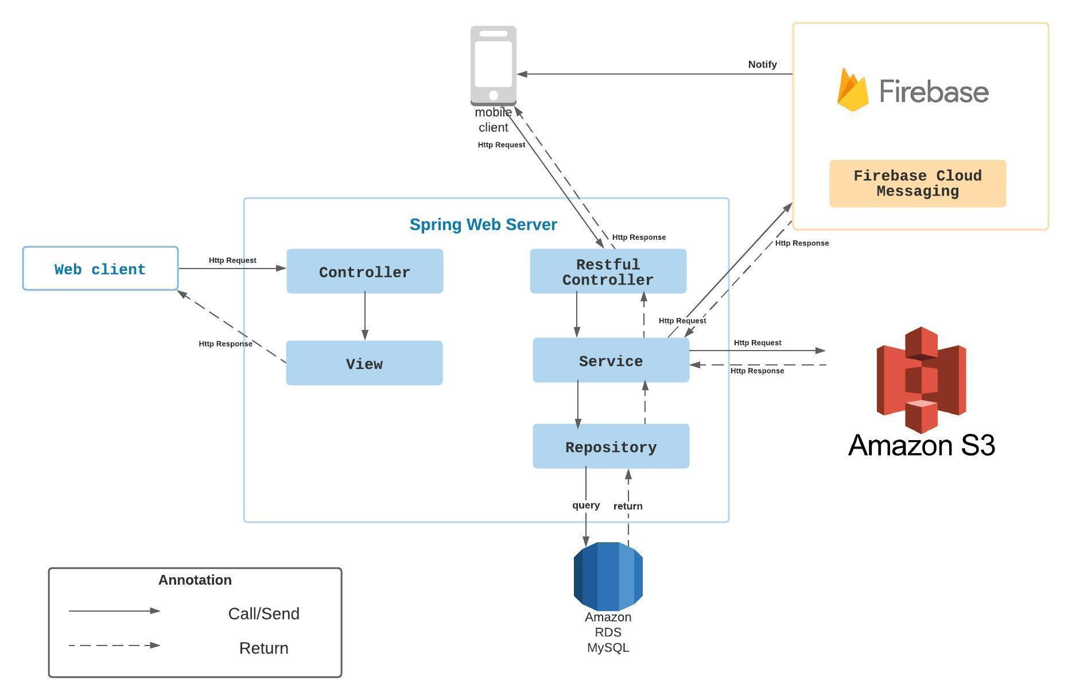

*Figure 59 Overall Architecture*

PBS system consists of three components, the spring boot web server provides APIs, two mobile applications for customers and photographers, and the web application for admin roles.

We also use several third-party services such as Aws S3 for image storage, Firebase cloud messaging for push notification functions and Amazon RDS for MySQL instances.

### 2.2 System Architecture

**2.2.1 Web server architecture**

We build our web server following n-tier architecture. We decided to use this pattern for several reasons:

* It has been proven to be a scalable architecture model.
* Provide reusability, maintainability and fault tolerance.
* Helps our members to create reusable and flexible functionality.

**2.2.2 Mobile app architecture**

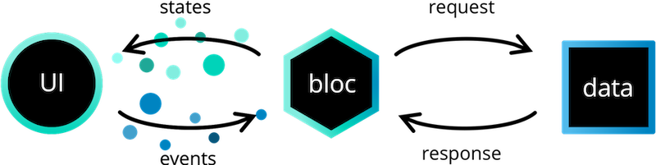

*Figure 60 Mobile App Architecture*

*Reference:* [*https://bloclibrary.dev/#/architecture*](https://bloclibrary.dev/#/architecture)

Bloc pattern allow us to separate our mobile app into 3 layers:

* Presentation: UI
* Business Logic Component: bloc (where we can manage events – click, tap, etc. - send a request to data layer, then retrieve data from data layer and response to input from UI through states).
* Data Layer: Repository (where we can retrieve data from sources).

### 2.3 Package Diagram

**2.3.1 Webapi**

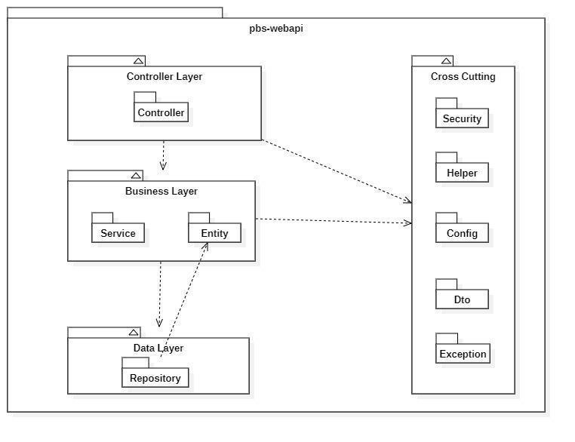

*Figure 61 Webapi Package Diagram*

|  |  |  |
| --- | --- | --- |
| **No** | **Package** | **Description** |
| 01 | Controller | Package contains classes responsible for handling Http request and return responses with values |
| 02 | Service | Package contains classes responsible for handling business logic, validation and communicate with repository |
| 03 | Entity | Package contains classes represents the business logic entities, also responsible for code first approach with hibernate |
| 04 | Repository | Package contains classes responsible for executing query and communicate with database |
| 05 | Security | Package contains classes responsible for performing security includes jwt handling, authentication and authorization |
| 06 | Helper | Package contains classes responsible for utilizing like map helper, datetime helper, String helper |
| 07 | Config | Package contains classes responsible for configuring spring boot app, from security, application properties to firebase notification |
| 08 | Exception | Package contains classes responsible for handling exception, including status code mapping or error messages returning |
| 09 | Dto | Package contains classes responsible for sharping the data to return to clients |

*Table 61 Package Diagram Description*

**2.3.2 Mobile App**

Both mobile apps share a same project structuring, so we use one diagram to represents both of them here:

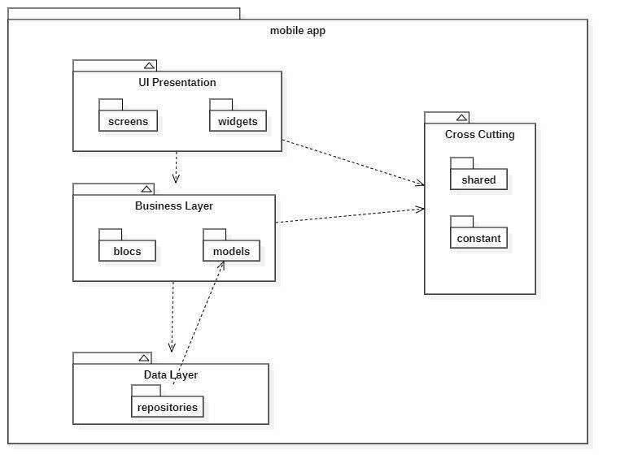

*Figure 62 Package Diagram – Mobile app*

|  |  |  |
| --- | --- | --- |
| **No** | **Package** | **Description** |
| 01 | screens | Package contains classes for UI representation |
| 02 | widgets | Package contains classes to form the widgets used by screens |
| 03 | blocs | Package contains classes to implement the bloc architecture including bloc’s state, bloc’s event |
| 04 | models | Package contains classes to form an object extracted from api |
| 05 | repositories | Package contains classes responsible for communicating with api server |
| 06 | shared | Package contains classes responsible for utilizing and environment variables |
| 07 | constant | Package contains classes represents the constants used by application |

*Table 62 Package Diagram Description*

## 3. System Detailed Design

### 3.1 Overall

#### a. Class Diagram

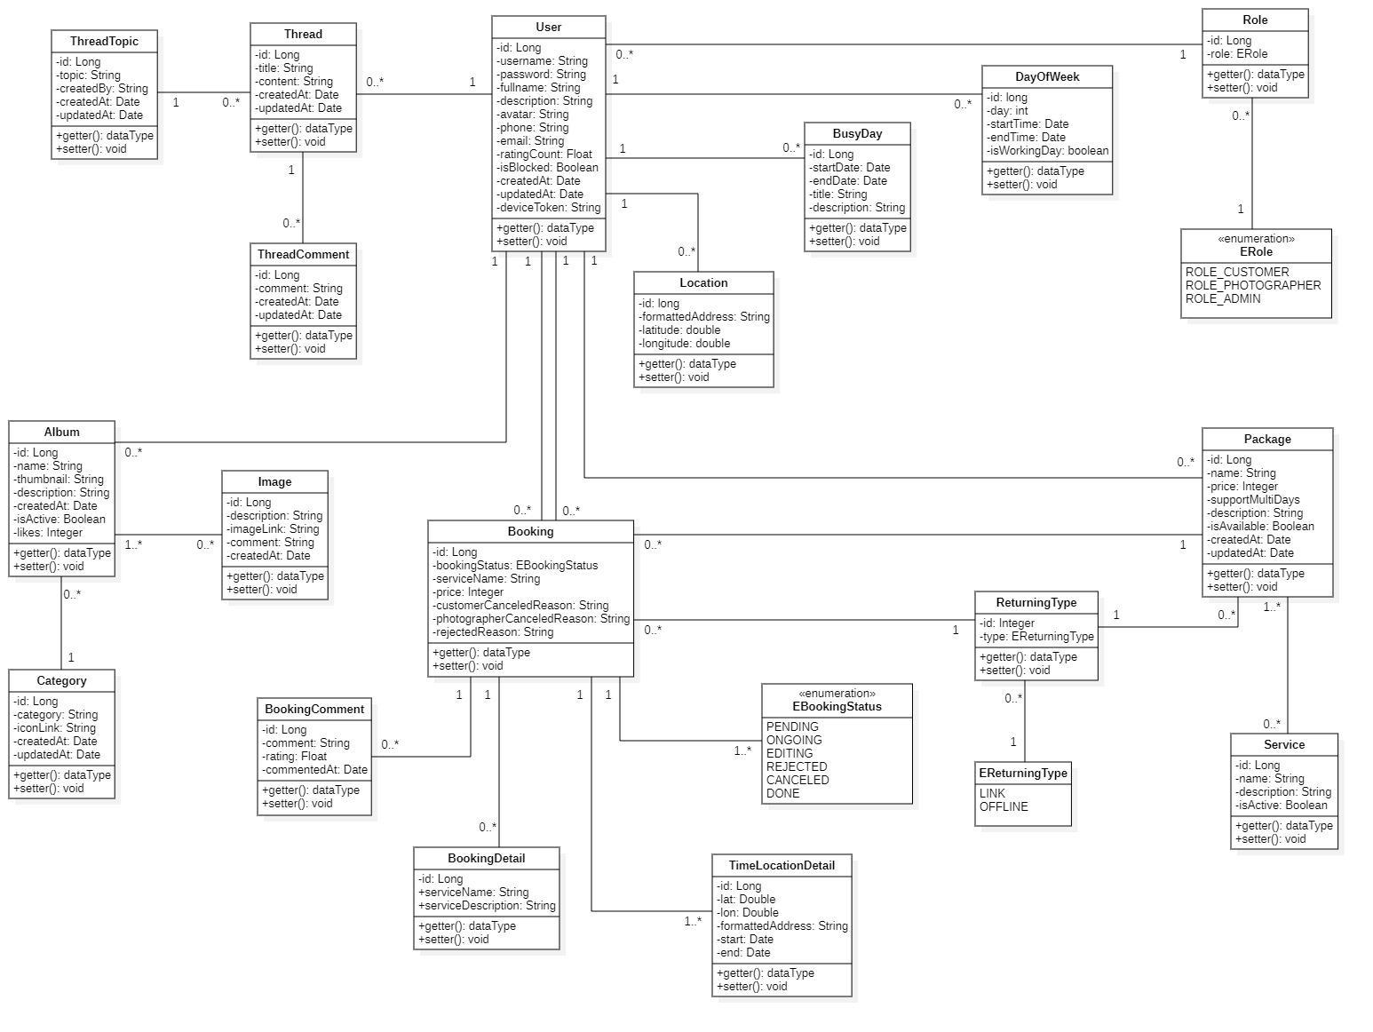

*Figure 63 Class Diagram*

#### b. Sequence Diagram(s)

1. Add Category

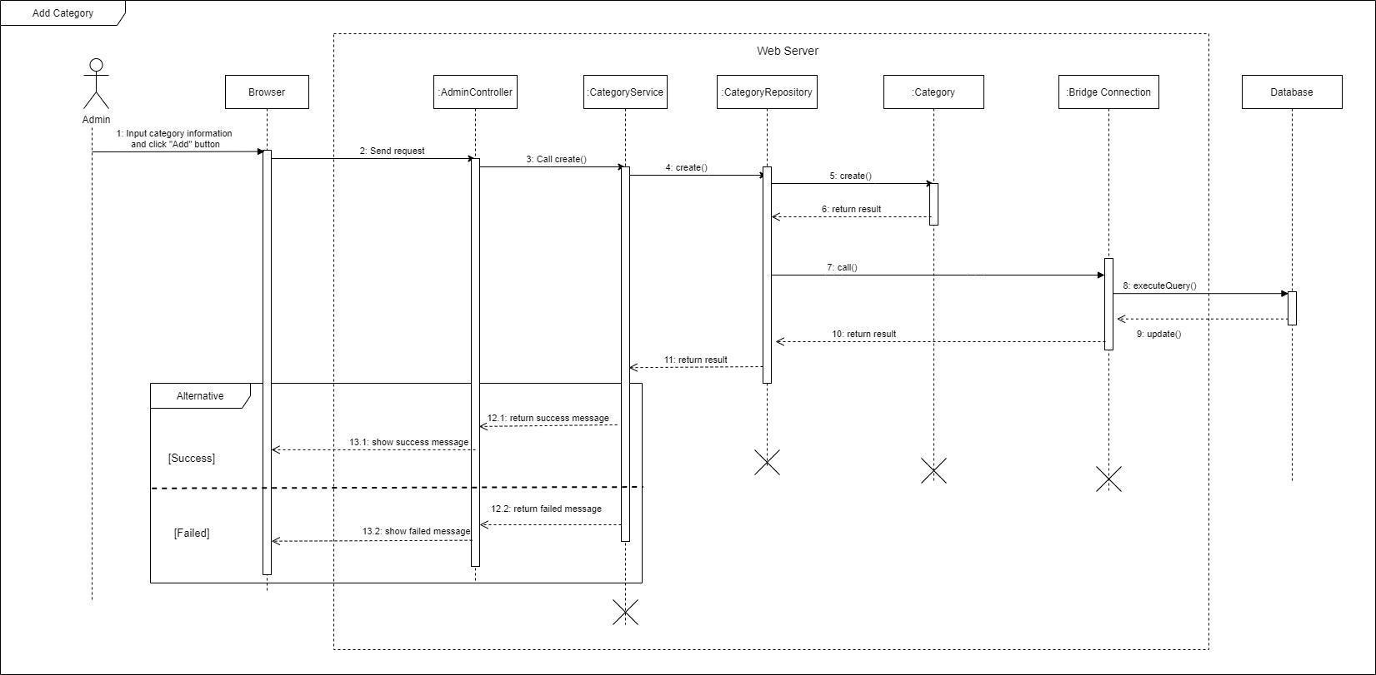

*Figure 64 Sequence Diagram - Add Category*

1. Edit Category

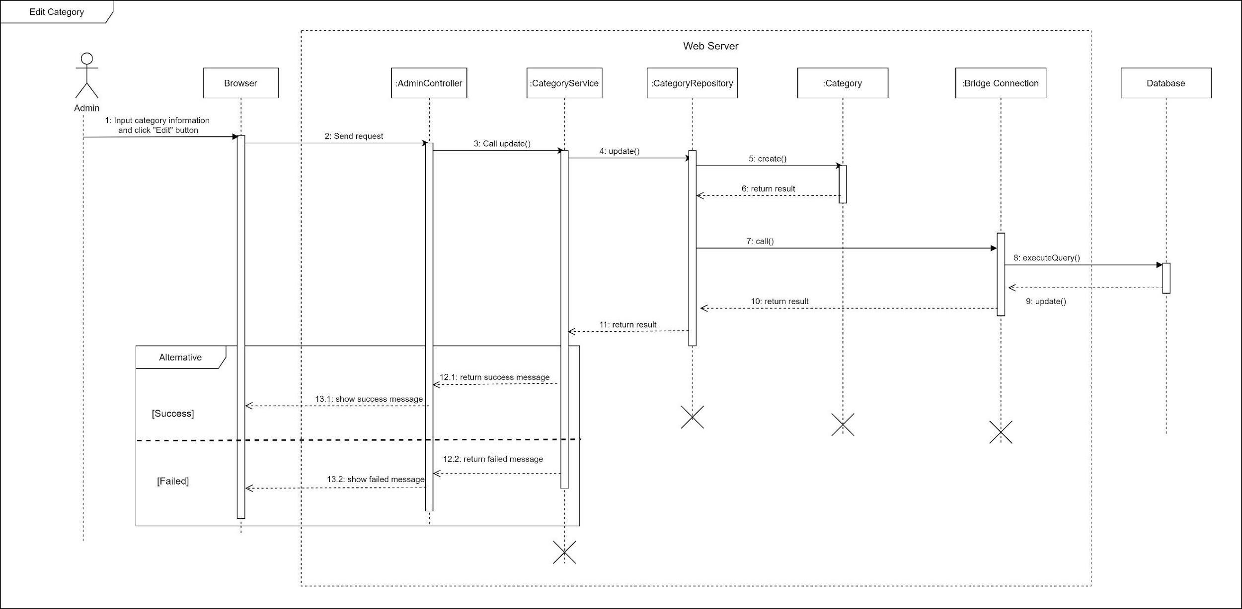

*Figure 65 Sequence Diagram - Edit Category*

1. Remove category

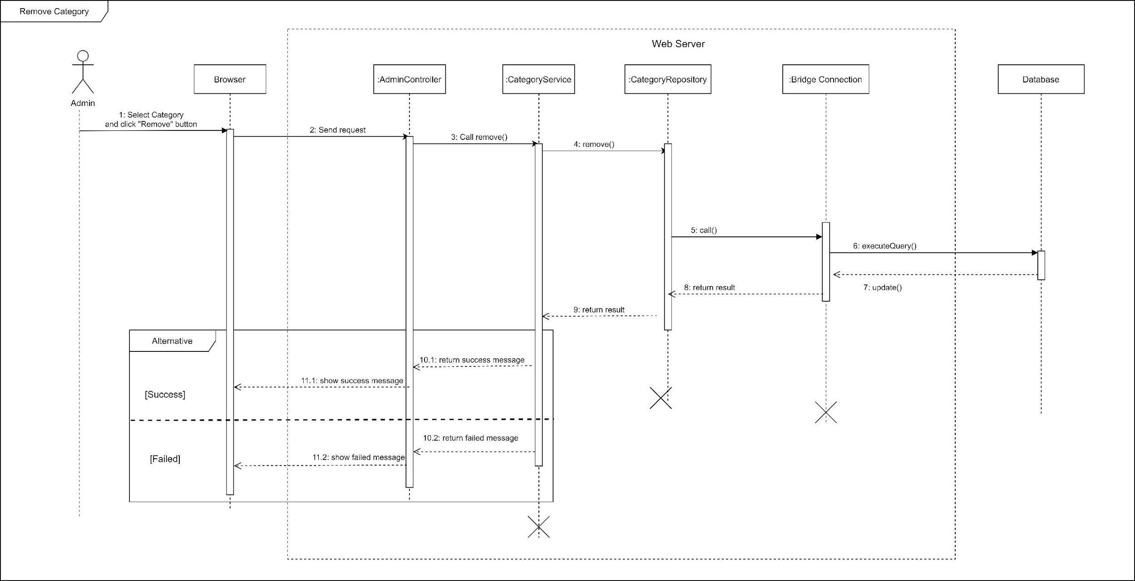

*Figure 66 Sequence Diagram - Remove Category*

1. Add returning type

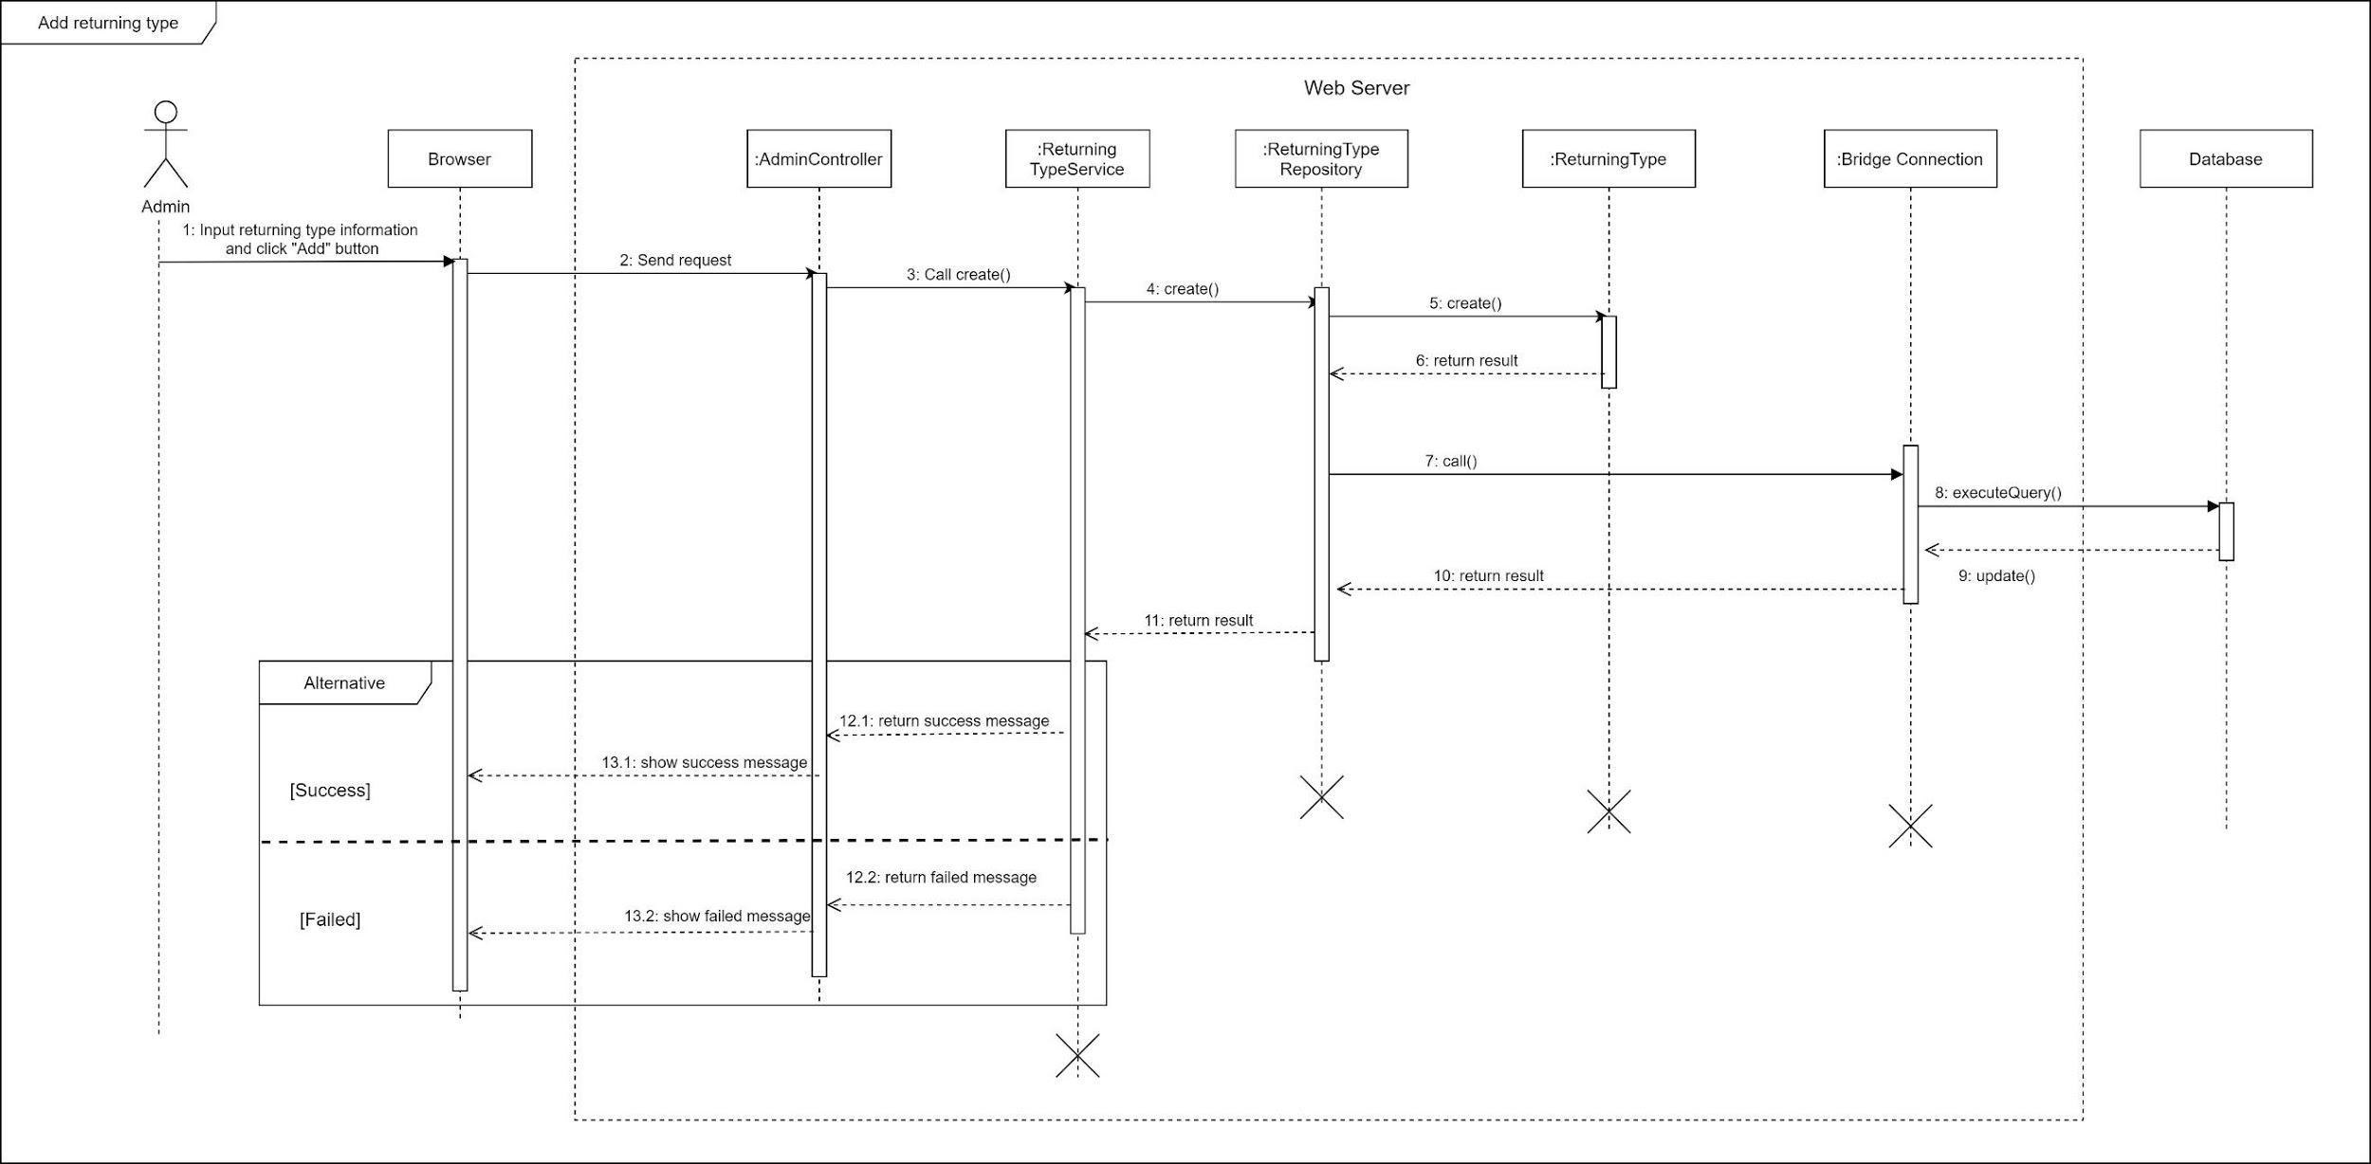

*Figure 67 Sequence Diagram - Add returning type*

1. Edit returning type

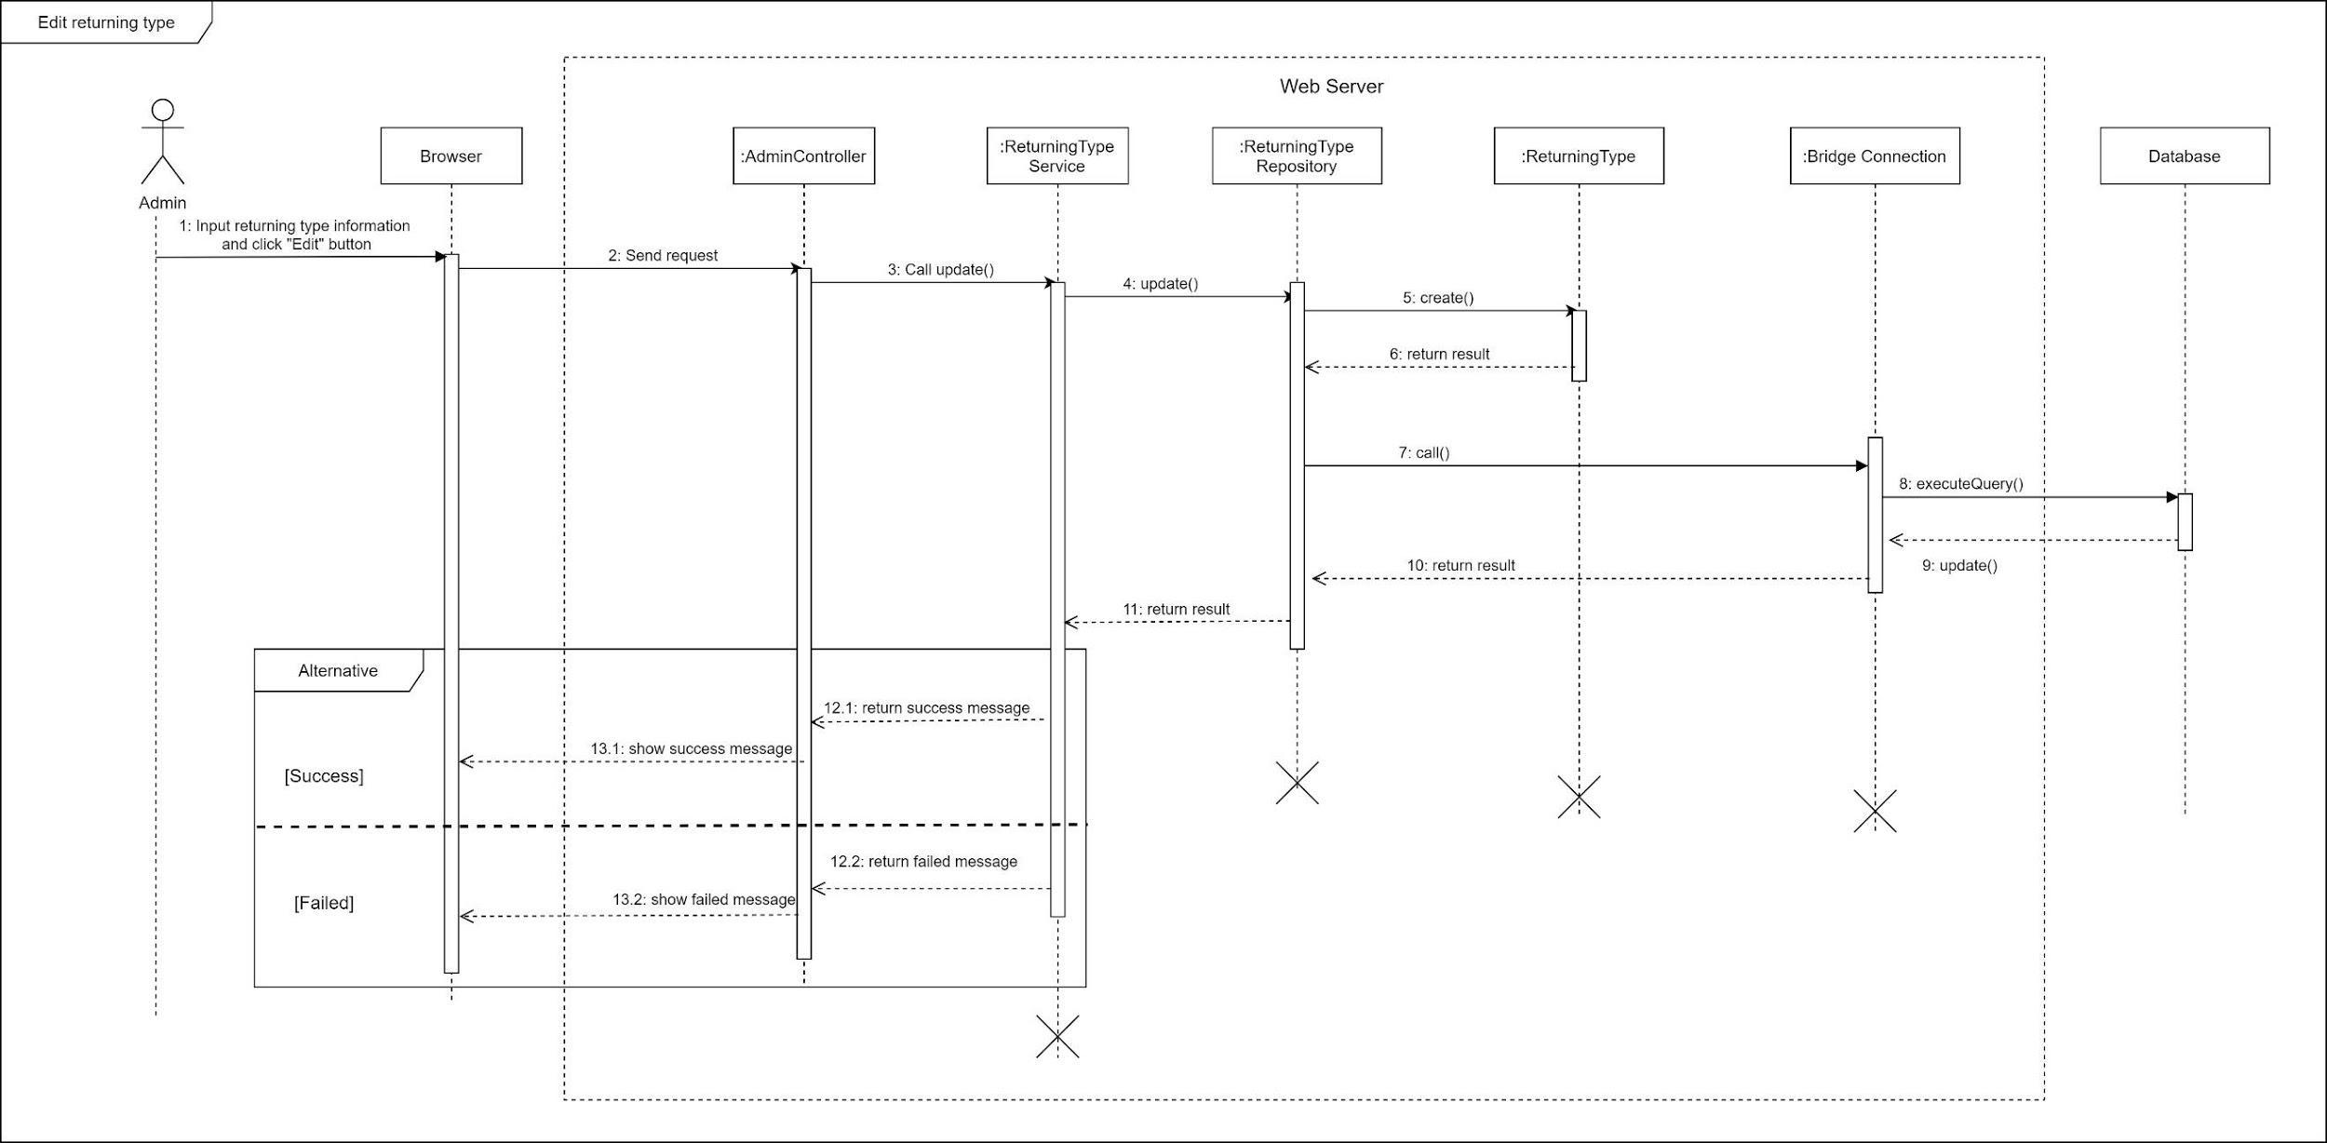

*Figure 68 Sequence Diagram - Edit returning type*

1. Remove returning type

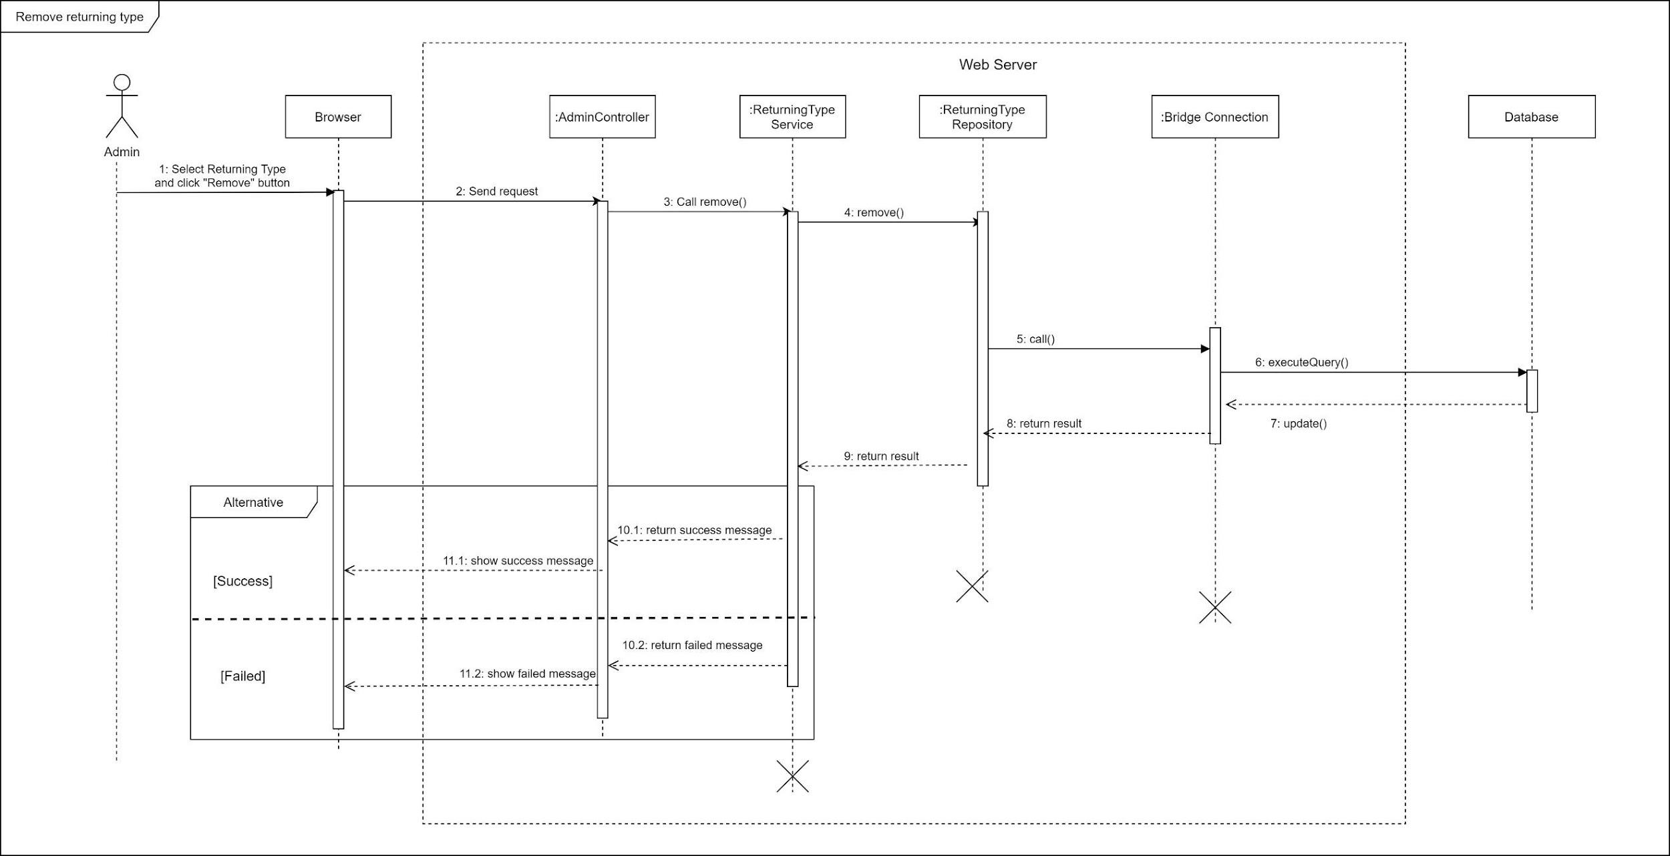

*Figure 69 Sequence Diagram - Remove returning type*

1. Block user

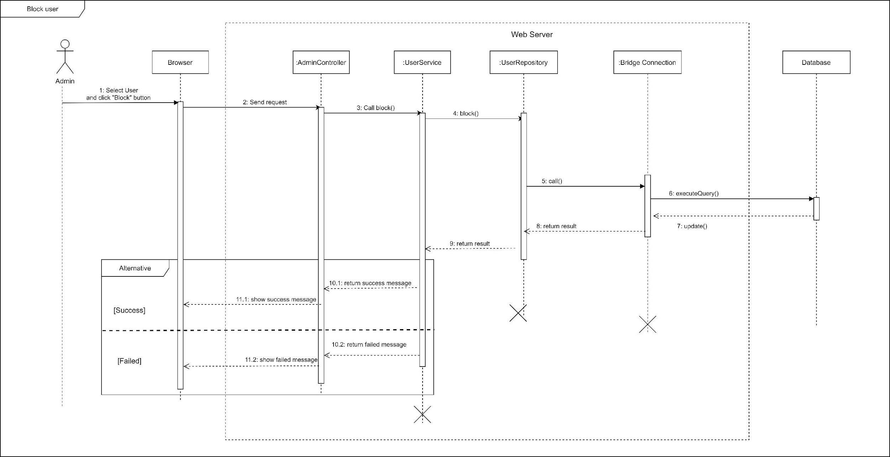

*Figure 70 Sequence Diagram - Block User*

1. Unblock user

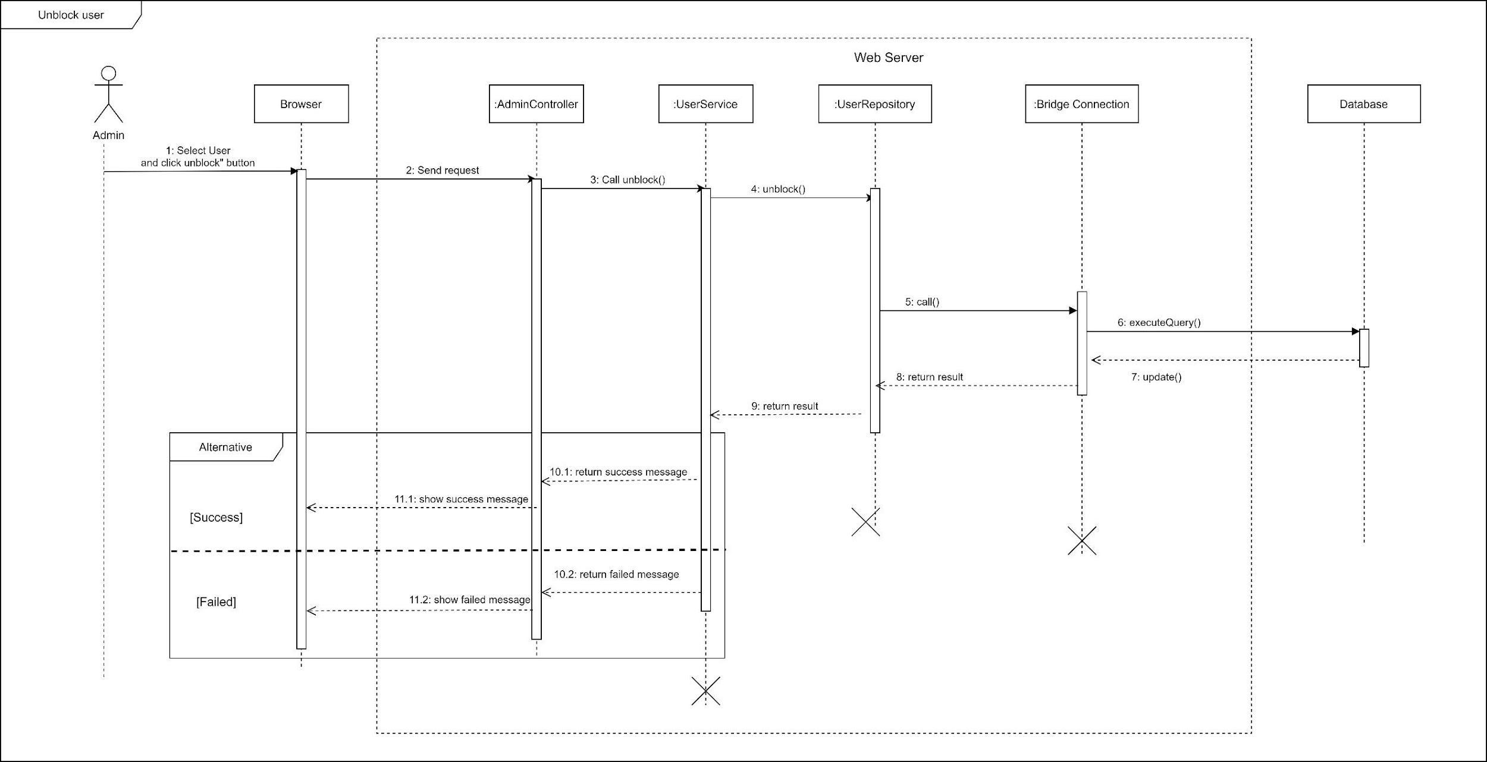

*Figure 71 Sequence Diagram - Unblock User*

1. Change variable

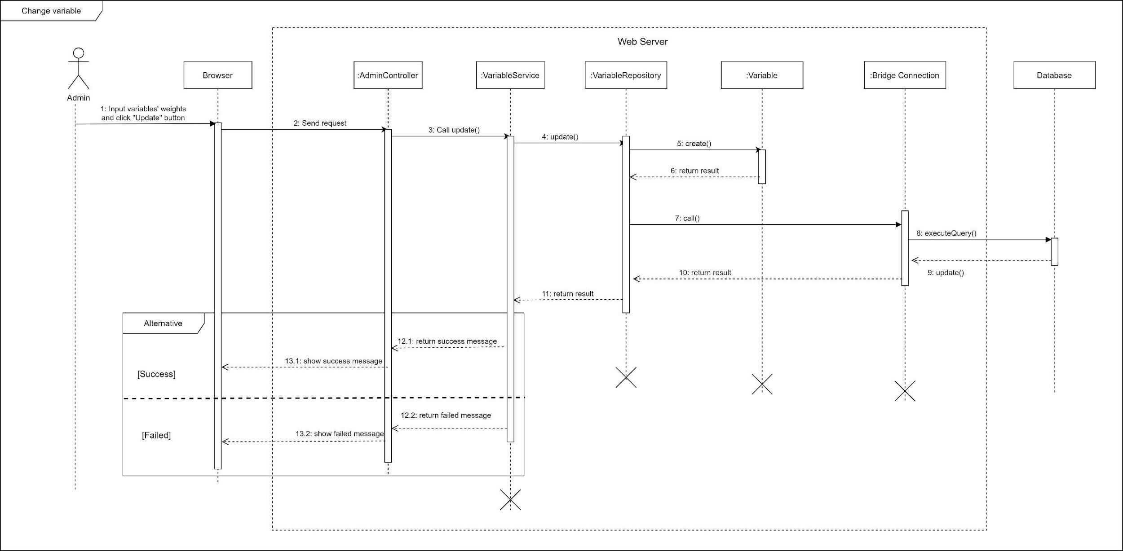

*Figure 72 Sequence Diagram - Change Variables*

#### c. Activity Diagram(s)

1. **<Customer>** **Make request**

Summary: This diagram shows the process when a customer makes booking request.

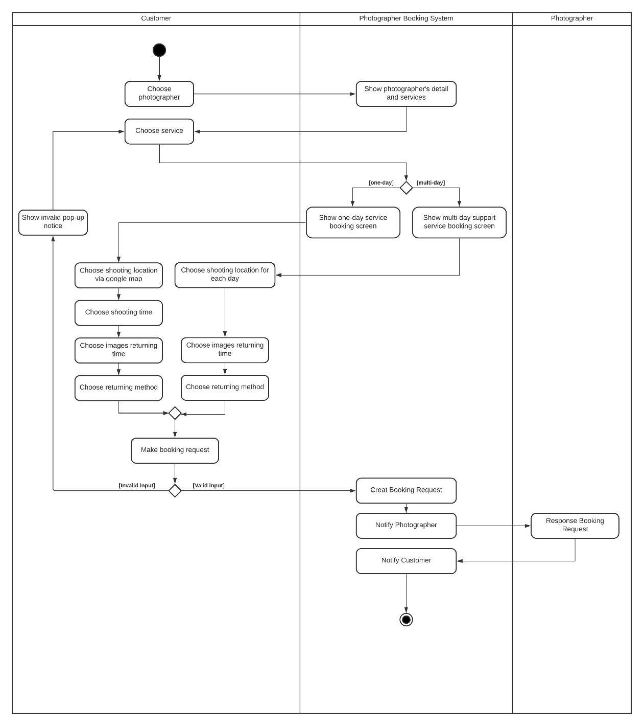

1. **<Customer> Edit request**

Summary: This diagram shows the process when a customer edits a request.

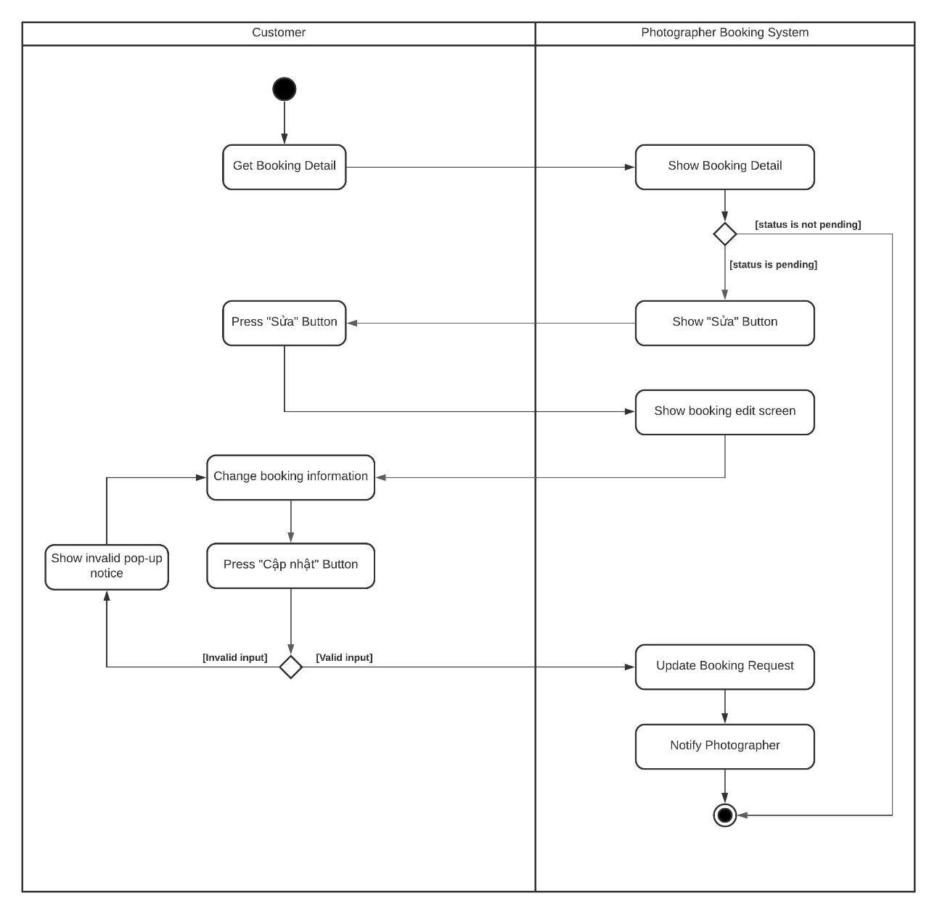

*Figure 74 Activity Diagram – Edit Request*



1. **<Customer> Cancel booking**

Summary: This diagram shows the process when a customer cancels a request.

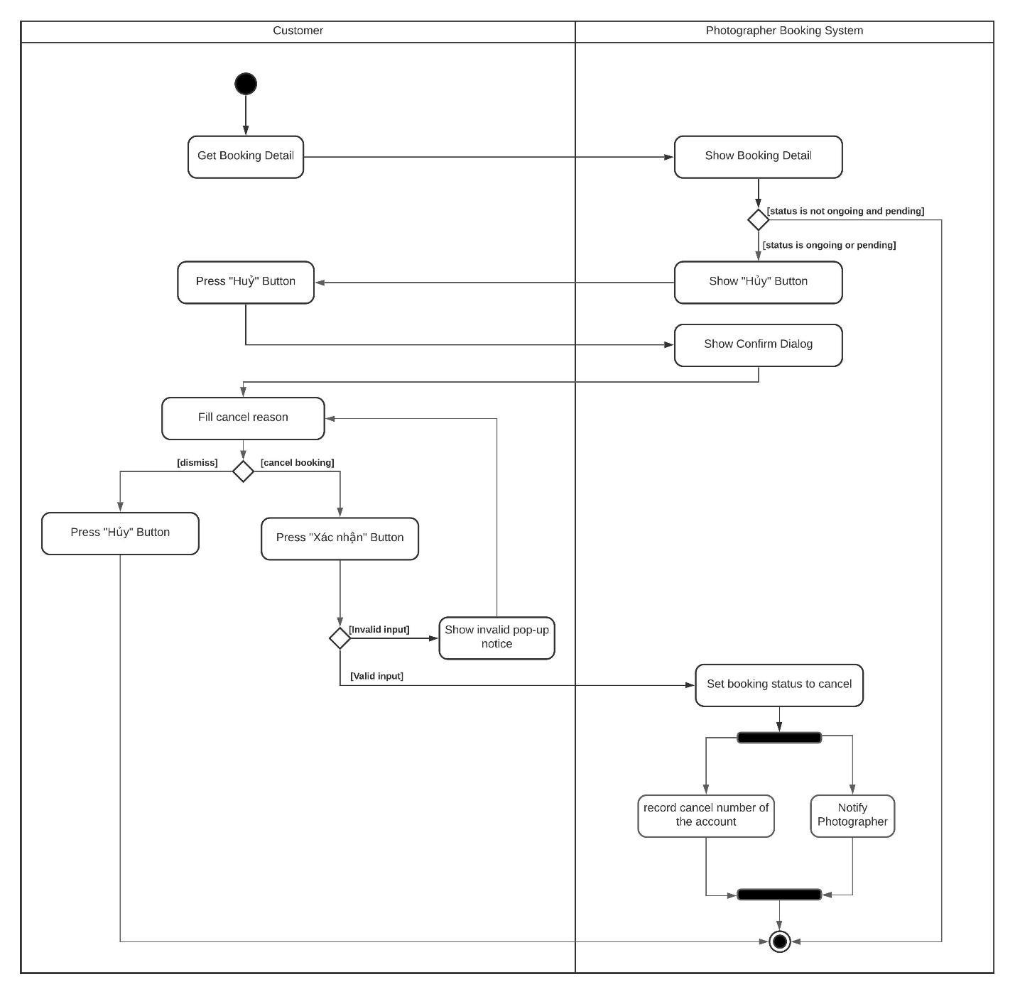

*Figure 75 Activity Diagram - Cancel booking*

1. **<Customer> Rating**

Summary: This diagram shows the process when a customer rates a photographer after booking finishes.

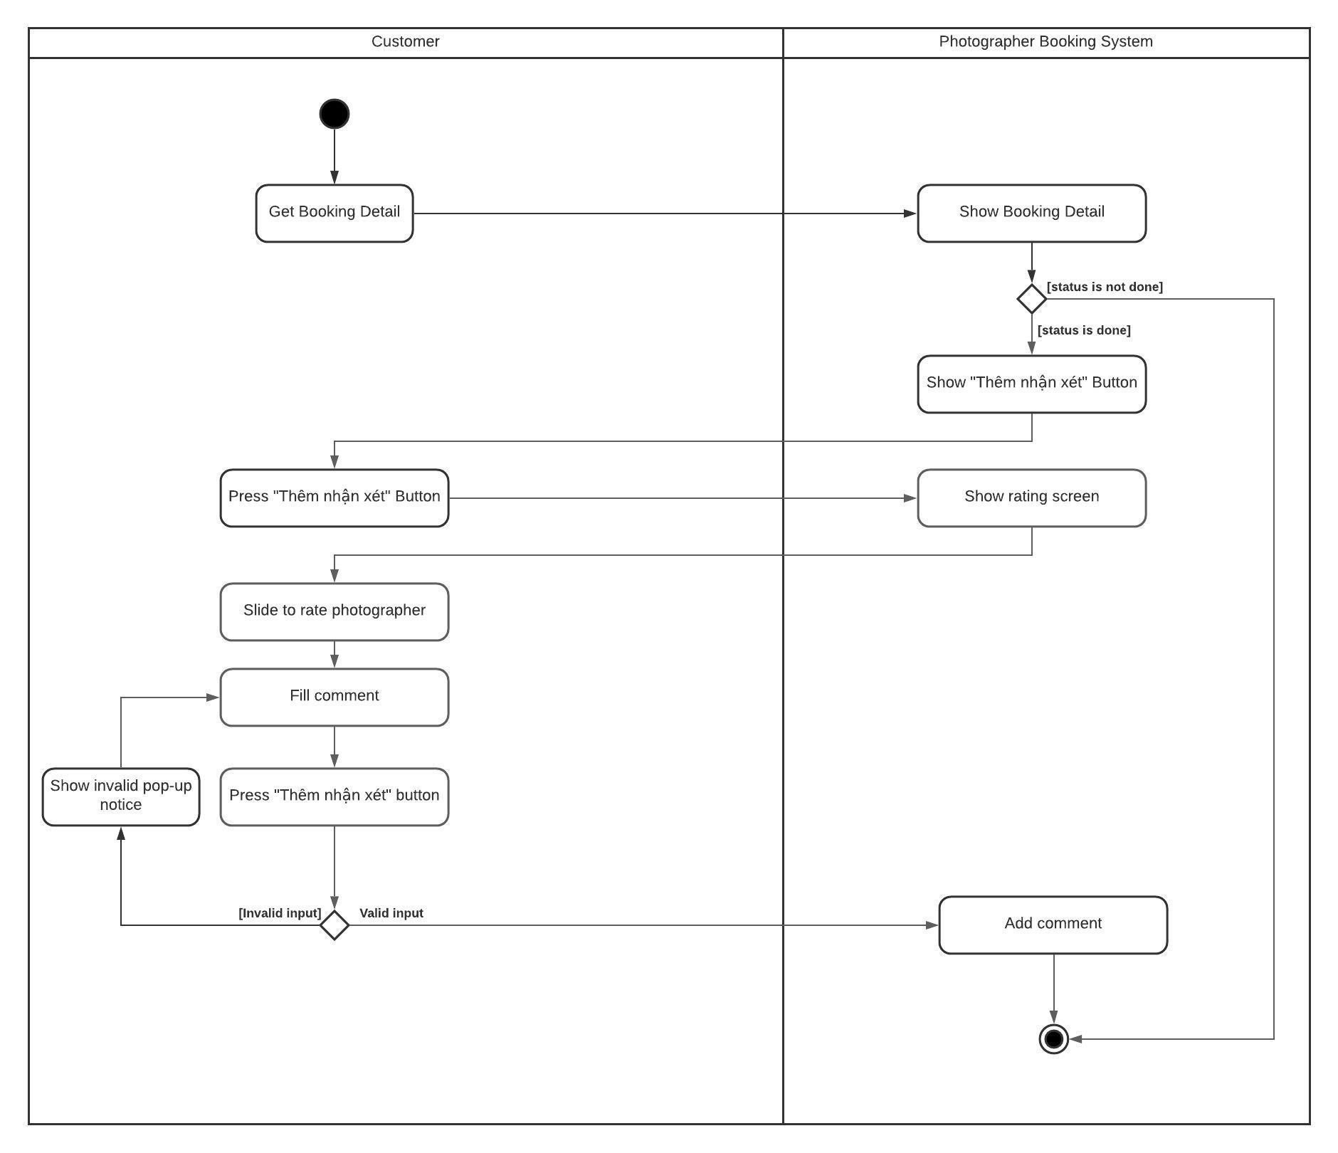

1. **<Photographer> Accept booking**

Summary: This diagram shows the process when a photographer accepts a request.

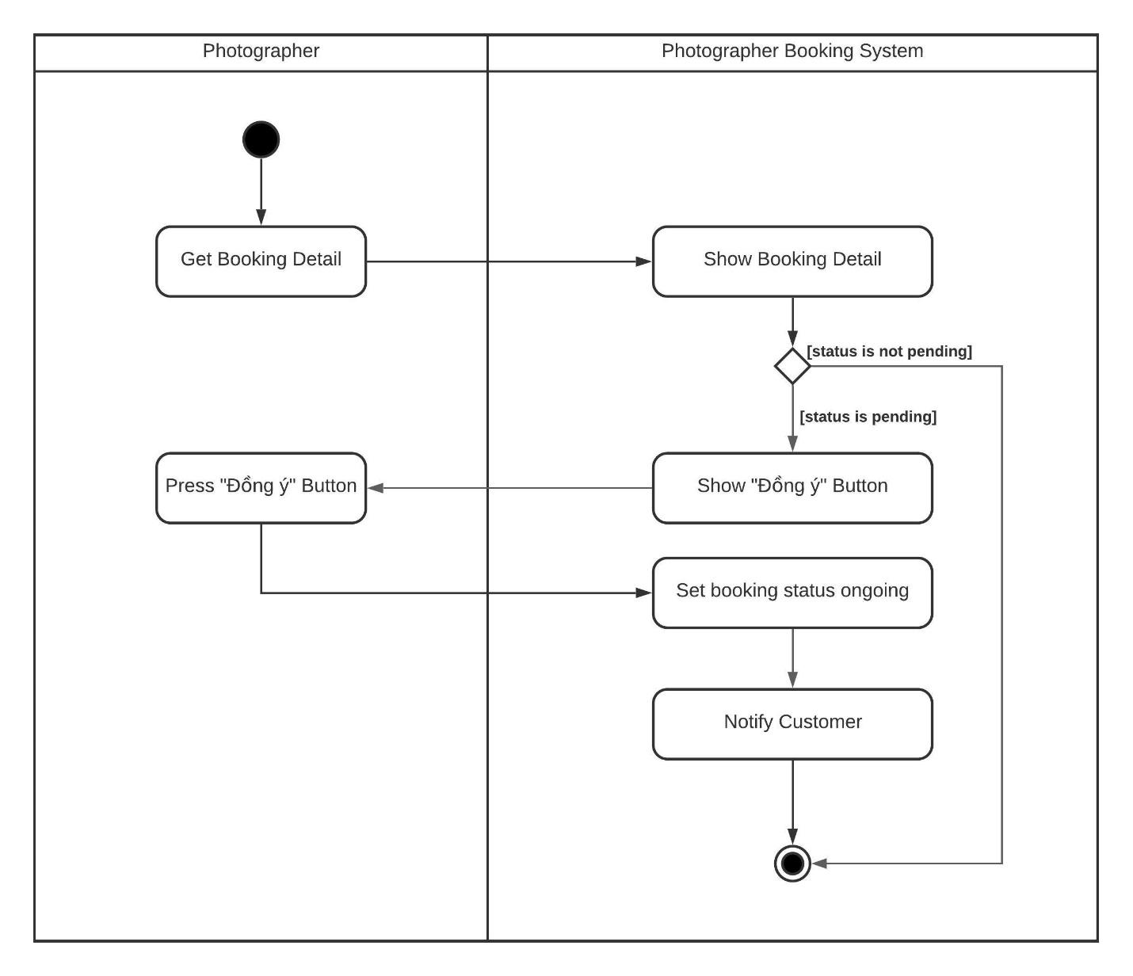

*Figure 77 Activity Diagram - Accept booking*

1. **<Photographer> Reject booking**

Summary: This diagram shows the process when a photographer rejects a request.

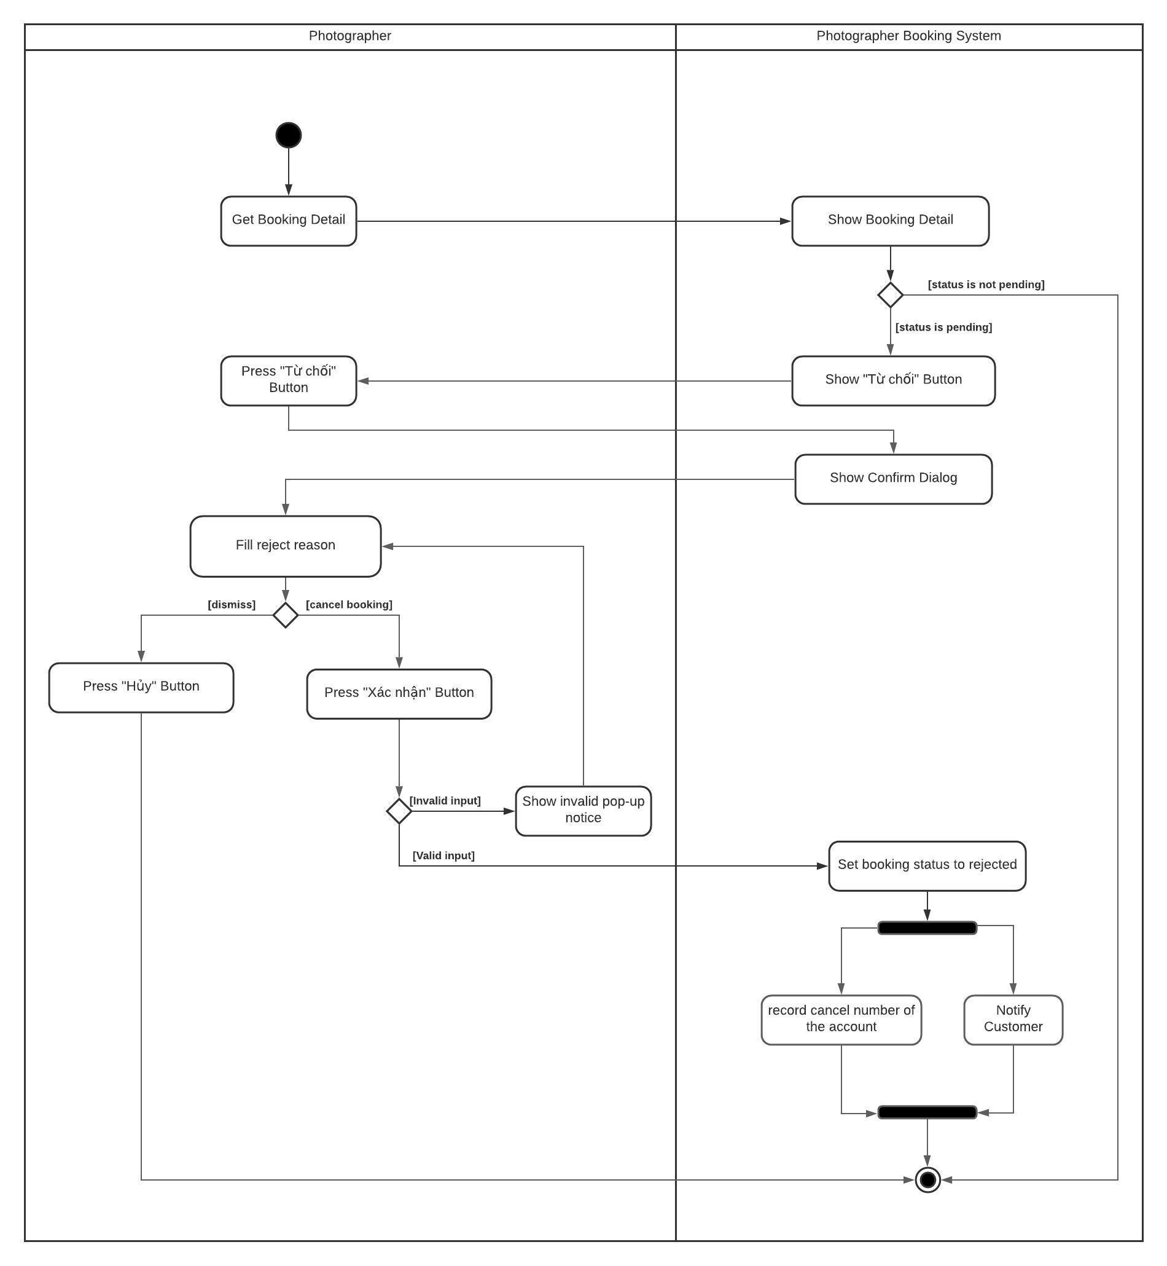

#### d. State Machine Diagram(s)

This state machine diagram describes states of a booking from start to done.

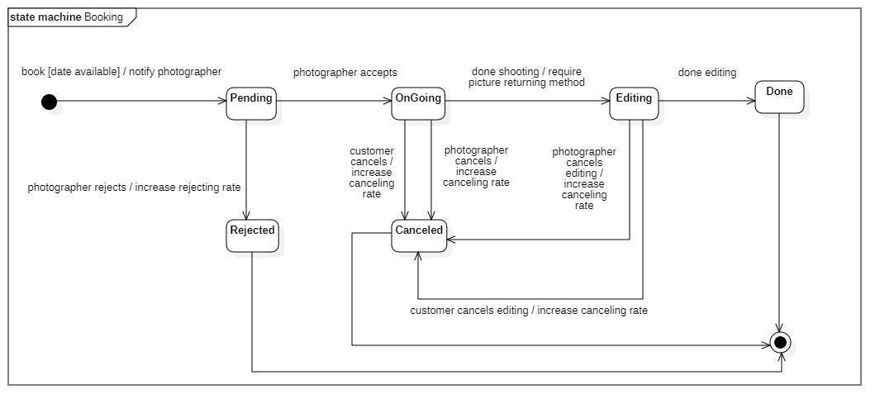

*Figure 79 State Machine Diagram - Booking*

## 4. Class Specifications

### 4.1 User

|  |  |  |  |
| --- | --- | --- | --- |
| **Attribute** | **Type** | **Visibility** | **Description** |
| id | Long | private | Unique identifier of a user |
| username | String | private | The attribute represents username of a user |
| password | String | private | The attribute represents password of a user |
| fullname | String | private | The attribute represents full name of a user |
| description | String | private | The attribute represents user self-description |
| avatar | String | private | The attribute represents avatar link of a user |
| phone | String | private | The attribute represents phone of a user |
| email | String | private | The attribute represents email of an user |
| ratingCount | Float | private | The attribute represents the rating count of a user whose role is photographer |
| isBlocked | Boolean | private | The attribute represents if user has been blocked |
| createdAt | Date | private | The attribute represents created date of a user object |
| updatedAt | Date | private | The attribute represents updated date of a user object |
| deviceToken | String | private | The attribute represents user’s firebase device token |

|  |  |  |  |  |
| --- | --- | --- | --- | --- |
| **No** | **Method** | **Visibility** | **Return Type** | **Description** |
| 1 | getter | public | Attribute Type | get attribute value |
| 2 | setter | public | void | set attribute value |

*Table 63 Class Diagram - User*

### 4.2 Role

|  |  |  |  |
| --- | --- | --- | --- |
| **Attribute** | **Type** | **Visibility** | **Description** |
| id | Long | private | Unique identifier of a role |
| role | ERole | private | The attribute represents role name |

|  |  |  |  |  |
| --- | --- | --- | --- | --- |
| **No** | **Method** | **Visibility** | **Return Type** | **Description** |
| 1 | getter | public | Attribute Type | get attribute value |
| 2 | setter | public | void | set attribute value |

*Table 64 Class Diagram - Role*

### 4.3 ERole

|  |  |  |  |
| --- | --- | --- | --- |
| **Attribute** | **Type** | **Visibility** | **Description** |
| ROLE_CUSTOMER |  |  | Enum attribute |
| ROLE_PHOTOGRAPHER |  |  | Enum attribute |
| ROLE_ADMIN |  |  | Enum attribute |

|  |  |  |  |  |
| --- | --- | --- | --- | --- |
| **No** | **Method** | **Visibility** | **Return Type** | **Description** |
| 1 | getter | public | Attribute Type | get attribute value |
| 2 | setter | public | void | set attribute value |

*Table 65 Class Diagram - ERole*

### 4.4 Package

|  |  |  |  |
| --- | --- | --- | --- |
| **Attribute** | **Type** | **Visibility** | **Description** |
| id | Integer | private | Unique identifier of a package |
| name | String | private | The attribute represents the package name |
| price | Integer | private | The attribute represents the package price |
| supportMultiDays | Boolean | private | The attribute represents if this package support multi days deal |
| description | String | private | The attribute represents the package description |
| isAvailable | Boolean | private | The attribute represents if the package still available |
| createdAt | Date | private | The attribute represents created date of a package object |
| updatedAt | Date | private | The attribute represents updated date of a package object |

|  |  |  |  |  |
| --- | --- | --- | --- | --- |
| **No** | **Method** | **Visibility** | **Return Type** | **Description** |
| 1 | getter | public | Attribute Type | get attribute value |
| 2 | setter | public | void | set attribute value |

*Table 66 Class Diagram - Package*

### 4.5 Service

|  |  |  |  |
| --- | --- | --- | --- |
| **Attribute** | **Type** | **Visibility** | **Description** |
| id | Long | private | Unique identifier of a package |
| name | String | private | The attribute represents the name of a service |
| description | String | private | The attribute represents the service’s description |
| isActive | Boolean | private | The attribute represents if the service is still available |

|  |  |  |  |  |
| --- | --- | --- | --- | --- |
| **No** | **Method** | **Visibility** | **Return Type** | **Description** |
| 1 | getter | public | Attribute Type | get attribute value |
| 2 | setter | public | void | set attribute value |

*Table 67 Class Diagram - Service*

### 4.6 Booking

|  |  |  |  |
| --- | --- | --- | --- |
| **Attribute** | **Type** | **Visibility** | **Description** |
| id | Long | private | Unique identifier of a booking |
| bookingStatus | EBookingStatus | private | The attribute represents the status of a booking |
| serviceName | String | private | The attribute represents the service of a booking |
| price | Integer | private | The attribute represents the service price of a booking |
| customerCancelledReason | String | private | The attribute represents the reason if customer decided to cancel a booking |
| photographerCancelledReason | String | private | The attribute represents the reason if photographer decided to cancel a booking |
| rejectedReason | String | private | The attribute represents the reason if photographer decided to reject a booking |

|  |  |  |  |  |
| --- | --- | --- | --- | --- |
| **No** | **Method** | **Visibility** | **Return Type** | **Description** |
| 1 | getter | public | Attribute Type | get attribute value |
| 2 | setter | public | void | set attribute value |

*Table 68 Class Diagram - Booking*

### 4.7 EBookingStatus

|  |  |  |  |
| --- | --- | --- | --- |
| **Attribute** | **Type** | **Visibility** | **Description** |
| Pending |  |  | Enum attribute |
| OnGoing |  |  | Enum attribute |
| Editing |  |  | Enum attribute |
| Rejected |  |  | Enum attribute |
| Cancelled |  |  | Enum attribute |
| Done |  |  | Enum attribute |

|  |  |  |  |  |
| --- | --- | --- | --- | --- |
| **No** | **Method** | **Visibility** | **Return Type** | **Description** |
| 1 | getter | public | Attribute Type | get attribute value |
| 2 | setter | public | void | set attribute value |

*Table 69 Class Diagram - EBookingStatus*

### 4.8 Album

|  |  |  |  |
| --- | --- | --- | --- |
| **Attribute** | **Type** | **Visibility** | **Description** |
| id | Long | private | Unique identifier of album |
| name | String | private | The attribute represents the name album |
| thumbnail | String | private | The attribute represents the album’s thumbnail link |
| description | String | private | The attribute represents the album’s description |
| createdAt | Date | private | The attribute represents the created date of album object |
| isActive | Boolean | private | The attribute represents if album still active |
| likes | Integer | private | The attribute represents the album like count |

|  |  |  |  |  |
| --- | --- | --- | --- | --- |
| **No** | **Method** | **Visibility** | **Return Type** | **Description** |
| 1 | getter | public | Attribute Type | get attribute value |
| 2 | setter | public | void | set attribute value |

*Table 70 Class Diagram - Album*

### 4.9 Image

|  |  |  |  |
| --- | --- | --- | --- |
| **Attribute** | **Type** | **Visibility** | **Description** |
| id | Long | private | Unique identifier of image |
| description | String | private | The attribute represents the description of album |
| imageLink | String | private | The attribute represents the album’s image link |
| comment | String | private | The attribute represents the album’s comment |
| createdAt | Date | private | The attribute represents the created date of image object |

|  |  |  |  |  |
| --- | --- | --- | --- | --- |
| **No** | **Method** | **Visibility** | **Return Type** | **Description** |
| 1 | getter | public | Attribute Type | get attribute value |
| 2 | setter | public | void | set attribute value |

*Table 71 Class Diagram - Image*

### 4.10 Category

|  |  |  |  |
| --- | --- | --- | --- |
| **Attribute** | **Type** | **Visibility** | **Description** |
| id | Long | private | Unique identifier of category |
| category | String | private | The attribute represents the category name |
| iconLink | String | private | The attribute represents the category icon link |
| createdAt | Date | private | The attribute represents the created date of category object |
| updatedAt | Date | private | The attribute represents the updated date of category object |

|  |  |  |  |  |
| --- | --- | --- | --- | --- |
| **No** | **Method** | **Visibility** | **Return Type** | **Description** |
| 1 | getter | public | Attribute Type | get attribute value |
| 2 | setter | public | void | set attribute value |

*Table 72 Class Diagram - Category*

### 4.11 DayOfWeek

|  |  |  |  |
| --- | --- | --- | --- |
| **Attribute** | **Type** | **Visibility** | **Description** |
| id | Long | private | Unique identifier of day of week |
| day | Int | private | The attribute represents the day of the week |
| startTime | Date | private | The attribute represents the start time of photographer’s working time |
| endTime | Date | private | The attribute represents the end time of photographer’s working time |
| isWorkingDay | Boolean | private | The attribute represents if this day of week is working day |

|  |  |  |  |  |
| --- | --- | --- | --- | --- |
| **No** | **Method** | **Visibility** | **Return Type** | **Description** |
| 1 | getter | public | Attribute Type | get attribute value |
| 2 | setter | public | void | set attribute value |

*Table 73 Class Diagram - DayOfWeek*

### 4.12 Location

|  |  |  |  |
| --- | --- | --- | --- |
| **Attribute** | **Type** | **Visibility** | **Description** |
| id | Long | private | Unique identifier of location |
| formattedAddress | String | private | The attribute represents the location full address |
| longitude | String | private | The attribute represents the longitude of a location |
| latitude | Double | private | The attribute represents the latitude of a location |

|  |  |  |  |  |
| --- | --- | --- | --- | --- |
| **No** | **Method** | **Visibility** | **Return Type** | **Description** |
| 1 | getter | public | Attribute Type | get attribute value |
| 2 | setter | public | void | set attribute value |

*Table 74 Class Diagram - Location*

### 4.13 BookingComment

|  |  |  |  |
| --- | --- | --- | --- |
| **Attribute** | **Type** | **Visibility** | **Description** |
| id | Long | private | Unique identifier of booking comment |
| comment | String | private | The attribute represents the comment of user |
| rating | Float | private | The attribute represents the rating of user |
| commentedAt | Date | private | The attribute represents the commented date of a booking |

|  |  |  |  |  |
| --- | --- | --- | --- | --- |
| **No** | **Method** | **Visibility** | **Return Type** | **Description** |
| 1 | getter | public | Attribute Type | get attribute value |
| 2 | setter | public | void | set attribute value |

*Table 75 Class Diagram - BookingComment*

### 4.14 BookingDetail

|  |  |  |  |
| --- | --- | --- | --- |
| **Attribute** | **Type** | **Visibility** | **Description** |
| id | Long | private | Unique identifier of booking detail |
| serviceName | String | private | The attribute represents the booked service’s name |
| serviceDescription | String | private | The attribute represents the booked service’s description |

|  |  |  |  |  |
| --- | --- | --- | --- | --- |
| **No** | **Method** | **Visibility** | **Return Type** | **Description** |
| 1 | getter | public | Attribute Type | get attribute value |
| 2 | setter | public | void | set attribute value |

*Table 76 Class Diagram - BookingDetail*

### 4.15 BusyDay

|  |  |  |  |
| --- | --- | --- | --- |
| **Attribute** | **Type** | **Visibility** | **Description** |
| id | Long | private | Unique identifier of busy day |
| startDate | Date | private | The attribute represents the start date of photographer’s busy event |
| endDate | Date | private | The attribute represents the end date of photographer’s busy event |
| title | String | private | The attribute represents the title of photographer’s busy event |
| description | String | private | The attribute represents the description of this busy event |

|  |  |  |  |  |
| --- | --- | --- | --- | --- |
| **No** | **Method** | **Visibility** | **Return Type** | **Description** |
| 1 | getter | public | Attribute Type | get attribute value |
| 2 | setter | public | void | set attribute value |

*Table 77 Class Diagram - BusyDay*

### 4.16 Thread

|  |  |  |  |
| --- | --- | --- | --- |
| **Attribute** | **Type** | **Visibility** | **Description** |
| id | Long | private | Unique identifier of thread |
| title | String | private | The attribute represents the title of thread |
| content | String | private | The attribute represents the content of a thread |
| createdAt | Date | private | The attribute represents the created date of a thread |
| updatedAt | Date | private | The attribute represents the updated date of a thread |

|  |  |  |  |  |
| --- | --- | --- | --- | --- |
| **No** | **Method** | **Visibility** | **Return Type** | **Description** |
| 1 | getter | public | Attribute Type | get attribute value |
| 2 | setter | public | void | set attribute value |

*Table 78 Class Diagram - Thread*

### 4.17 ThreadTopic

|  |  |  |  |
| --- | --- | --- | --- |
| **Attribute** | **Type** | **Visibility** | **Description** |
| id | Long | private | Unique identifier of thread topic |
| topic | String | private | The attribute represents the topic name of a thread |
| createdBy | String | private | The attribute represents the name of the person who created this topic |
| createdAt | Date | private | The attribute represents the created date of a thread |
| updateAt | Date | private | The attribute represents the updated date of a thread |

|  |  |  |  |  |
| --- | --- | --- | --- | --- |
| **No** | **Method** | **Visibility** | **Return Type** | **Description** |
| 1 | getter | public | Attribute Type | get attribute value |
| 2 | setter | public | void | set attribute value |

*Table 79 Class Diagram - ThreadTopic*

### 4.18 ThreadComment

|  |  |  |  |
| --- | --- | --- | --- |
| **Attribute** | **Type** | **Visibility** | **Description** |
| id | Long | private | Unique identifier of thread comment |
| comment | String | private | The attribute represents the comment of a thread |
| createdAt | Date | private | The attribute represents the created date of this record |
| updateAt | Date | private | The attribute represents the updated date of this record |

|  |  |  |  |  |
| --- | --- | --- | --- | --- |
| **No** | **Method** | **Visibility** | **Return Type** | **Description** |
| 1 | getter | public | Attribute Type | get attribute value |
| 2 | setter | public | void | set attribute value |

*Table 80 Class Diagram - ThreadComment*

### 4.19 ReturningType

|  |  |  |  |
| --- | --- | --- | --- |
| **Attribute** | **Type** | **Visibility** | **Description** |
| id | Long | private | Unique identifier of returning type |
| type | EReturningType | private | The attribute represents the type |

|  |  |  |  |  |
| --- | --- | --- | --- | --- |
| **No** | **Method** | **Visibility** | **Return Type** | **Description** |
| 1 | getter | public | Attribute Type | get attribute value |
| 2 | setter | public | void | set attribute value |

*Table 81 Class Diagram - ReturningType*

### 4.20 EReturningType

|  |  |  |  |
| --- | --- | --- | --- |
| **Attribute** | **Type** | **Visibility** | **Description** |
| LINK |  |  | Enum attribute |
| OFFLINE |  |  | Enum attribute |

|  |  |  |  |  |
| --- | --- | --- | --- | --- |
| **No** | **Method** | **Visibility** | **Return Type** | **Description** |
| 1 | getter | public | Attribute Type | get attribute value |
| 2 | setter | public | void | set attribute value |

*Table 82 Class Diagram - EReturningType*

### 4.21 TimeLocationDetail

This table used for saving time and location details of a booking

|  |  |  |  |
| --- | --- | --- | --- |
| **Attribute** | **Type** | **Visibility** | **Description** |
| id | Long | private | Unique identifier of time location detail |
| lat | Double | private | The attribute represents the latitude of a user |
| lon | Double | private | The attribute represents the longitude of a user |
| formattedAddress | String | private | The attribute represents the formatted address of a user |
| start | Date | private | The attribute represents start time of a booking |
| end | Date | private | The attribute represents end time of a booking |

|  |  |  |  |  |
| --- | --- | --- | --- | --- |
| **No** | **Method** | **Visibility** | **Return Type** | **Description** |
| 1 | getter | public | Attribute Type | get attribute value |
| 2 | setter | public | void | set attribute value |

*Table 83 Class Diagram - TimeLocationDetail*

## 5. Data & Database Design

### 5.1 Database Design

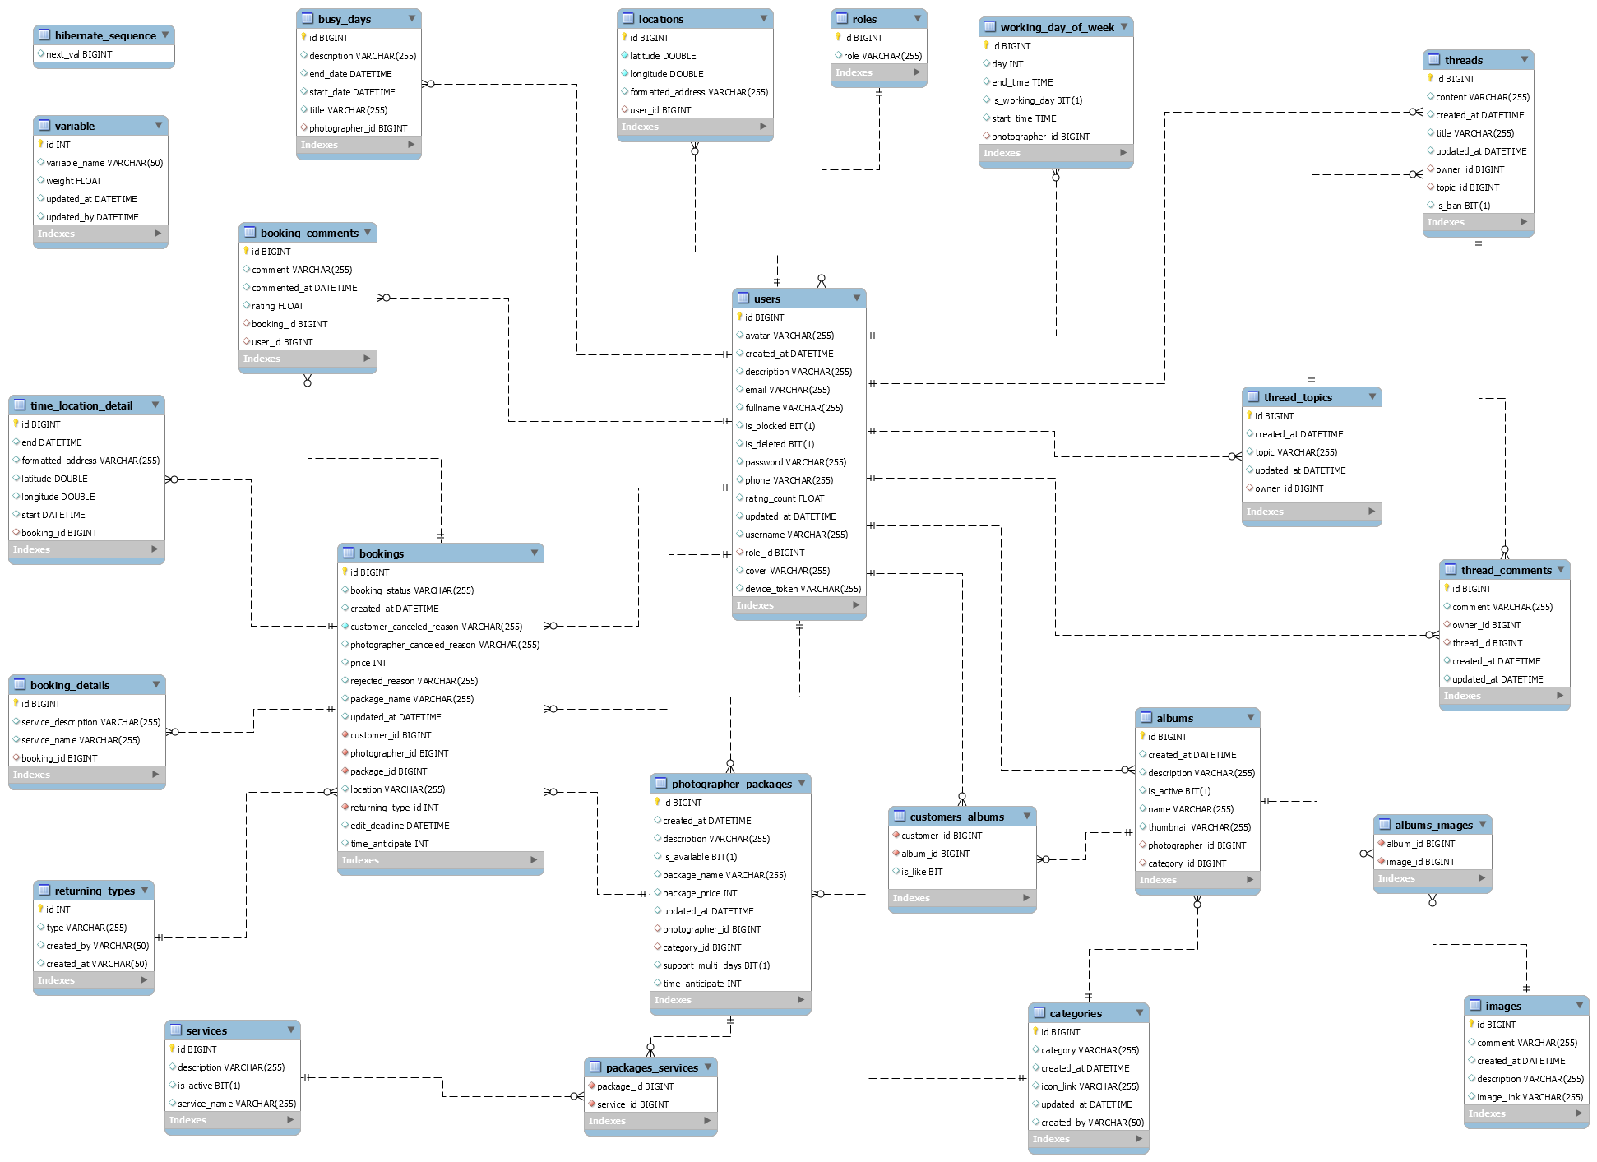

*Figure 80 Database Design*

#### users

|  |  |  |  |  |  |  |  |
| --- | --- | --- | --- | --- | --- | --- | --- |
| **#** | **Field name** | **Type** | **Size** | **Unique** | **Not Null** | **PK/FK** | **Notes** |
| 1 | id | bigint |  | X | X | X |  |
| 2 | username | varchar | 50 | X | X |  |  |
| 3 | password | varchar | 100 |  | X |  |  |
| 4 | fullname | varchar | 50 |  | X |  |  |
| 5 | description | varchar | 200 |  |  |  |  |
| 6 | avatar | varchar | 200 |  |  |  | Avatar image link of user |
| 7 | phone | varchar | 50 |  |  |  |  |
| 8 | email | varchar | 100 |  |  |  |  |
| 9 | device_token | varchar | 100 |  |  |  | The firebase token of device, using for firebase messaging. |
| 9 | is_blocked | boolean |  |  |  |  |  |
| 10 | is_active | boolean |  |  |  |  |  |
| 11 | created_at | datetime |  |  |  |  |  |
| 12 | role_id | int |  |  | X | X |  |

*Table 84 Database - users*

#### roles

|  |  |  |  |  |  |  |  |
| --- | --- | --- | --- | --- | --- | --- | --- |
| **#** | **Field name** | **Type** | **Size** | **Unique** | **Not Null** | **PK/FK** | **Notes** |
| 1 | id | int |  | X | X | X |  |
| 2 | role_name | varchar | 50 |  | X |  |  |

*Table 85 Database - roles*

#### photographer_packages

|  |  |  |  |  |  |  |  |
| --- | --- | --- | --- | --- | --- | --- | --- |
| **#** | **Field name** | **Type** | **Size** | **Unique** | **Not Null** | **PK/FK** | **Notes** |
| 1 | id | bigint |  | X | X | X |  |
| 2 | package_name | varchar | 70 |  | X |  |  |
| 3 | package_price | int |  |  | X |  |  |
| 4 | is_available | boolean |  |  |  |  |  |
| 5 | package _description | varchar | 100 |  |  |  |  |
| 6 | photographer _id | int |  |  | X | X |  |

*Table 86 Database - photographer_packages*

#### packages_services

|  |  |  |  |  |  |  |  |
| --- | --- | --- | --- | --- | --- | --- | --- |
| **#** | **Field name** | **Type** | **Size** | **Unique** | **Not Null** | **PK/FK** | **Notes** |
| 1 | id | bigint |  | X | X | X |  |
| 2 | package_id | Int |  |  | X | X |  |
| 3 | service_id | Int |  |  | X | X |  |

*Table 87 Database - packages_services*

#### services

|  |  |  |  |  |  |  |  |
| --- | --- | --- | --- | --- | --- | --- | --- |
| **#** | **Field name** | **Type** | **Size** | **Unique** | **Not Null** | **PK/FK** | **Notes** |
| 1 | id | bigint |  | X | X | X |  |
| 2 | name | varchar | 50 |  | X |  |  |
| 3 | description | varchar | 200 |  |  |  |  |
| 4 | is_active | boolean |  |  |  |  |  |

*Table 88 Database - services*

#### bookings

|  |  |  |  |  |  |  |  |
| --- | --- | --- | --- | --- | --- | --- | --- |
| **#** | **Field name** | **Type** | **Size** | **Unique** | **Not Null** | **PK/FK** | **Notes** |
| 1 | id | bigint |  | X | X | X |  |
| 2 | status | enum |  |  | X |  | There will be 6 status: Pending, Ongoing, Editing, Done, Rejected, Canceled |
| 3 | start_date | datetime |  |  | X |  |  |
| 4 | end_date | datetime |  |  | X |  |  |
| 5 | service_name | varchar | 100 |  | X |  | Package’s name |
| 6 | price | int |  |  | X |  | Package’s price |
| 7 | customer  _canceled  _reason | varchar | 100 |  |  |  | In case customers cancel and provide their reason |
| 8 | photographer _canceled _reason | varchar | 100 |  |  |  | In case photographers cancel and provide their reason |
| 9 | rejected_reason | varchar | 100 |  |  |  | In case photographers reject the request and provide reason |
| 10 | rating | float |  |  |  |  | After booking is done, customer can rate the booking |
| 11 | comment | varchar | 100 |  |  |  | After booking is done, customer can comment on the booking |
| 12 | longitude | varchar | 100 |  |  |  |  |
| 13 | latitude | varchar | 100 |  |  |  |  |
| 14 | location_name | varchar | 100 |  |  |  | The shooting location picked by customer |
| 15 | customer_id | int |  |  | X | X |  |
| 16 | photographer _id | int |  |  | X | X |  |
| 17 | package_id | int |  |  | X | X |  |

*Table 89 Database - bookings*

#### albums

|  |  |  |  |  |  |  |  |
| --- | --- | --- | --- | --- | --- | --- | --- |
| **#** | **Field name** | **Type** | **Size** | **Unique** | **Not Null** | **PK/FK** | **Notes** |
| 1 | id | bigint |  | X | X | X |  |
| 2 | name | varchar | 50 |  | X |  |  |
| 3 | description | varchar | 100 |  |  |  |  |
| 4 | created_at | datetime |  |  |  |  |  |
| 5 | is_active | boolean |  |  |  |  |  |
| 6 | photographer _id | int |  |  | X | X |  |
| 7 | category_id | int |  |  |  | X |  |

*Table 90 Database - albums*

#### locations

|  |  |  |  |  |  |  |  |
| --- | --- | --- | --- | --- | --- | --- | --- |
| **#** | **Field name** | **Type** | **Size** | **Unique** | **Not Null** | **PK/FK** | **Notes** |
| 1 | id | bigint |  | X | X | X |  |
| 2 | Formatted_address | varchar | 255 |  | X |  |  |
| 3 | longitude | double | 100 |  | X |  |  |
| 4 | latitude | double | 100 |  | X |  |  |
| 5 | user_id | int |  |  | X | X |  |

*Table 91 Database - locations*

#### categories

|  |  |  |  |  |  |  |  |
| --- | --- | --- | --- | --- | --- | --- | --- |
| **#** | **Field name** | **Type** | **Size** | **Unique** | **Not Null** | **PK/FK** | **Notes** |
| 1 | id | int |  | X | X | X |  |
| 2 | name | varchar | 50 |  | X |  |  |
| 3 | icon_link | varchar | 100 |  | X |  | Link for the icon of category |
| 4 | created_by | varchar | 100 |  |  |  | Name of the admin who created the category |
| 5 | Created_on | datetime |  |  |  |  |  |

*Table 92 Database - categories*

#### album_images

|  |  |  |  |  |  |  |  |
| --- | --- | --- | --- | --- | --- | --- | --- |
| **#** | **Field name** | **Type** | **Size** | **Unique** | **Not Null** | **PK/FK** | **Notes** |
| 1 | id | int |  | X | X | X |  |
| 2 | album_id | int |  |  | X | X |  |
| 3 | image_id | int |  |  | X | X |  |

*Table 93 Database - album_images*

#### images

|  |  |  |  |  |  |  |  |
| --- | --- | --- | --- | --- | --- | --- | --- |
| **#** | **Field name** | **Type** | **Size** | **Unique** | **Not Null** | **PK/FK** | **Notes** |
| 1 | id | bigint |  | X | X | X |  |
| 2 | image_link | varchar | 200 |  | X |  |  |
| 3 | description | varchar | 200 |  |  |  |  |
| 4 | is_active | boolean |  |  |  |  |  |
| 5 | album_id | int |  |  | X | X |  |

*Table 94 Database - images*

#### customers_albums

|  |  |  |  |  |  |  |  |
| --- | --- | --- | --- | --- | --- | --- | --- |
| **#** | **Field name** | **Type** | **Size** | **Unique** | **Not Null** | **PK/FK** | **Notes** |
| 1 | id | int |  | X | X | X |  |
| 2 | liked | boolean |  |  |  |  | represent if customer has liked the album |
| 3 | album_id | int |  |  | X | X |  |
| 4 | customer_id | int |  |  | X | X |  |

*Table 95 Database - customer_albums*

#### working_day_of_week

|  |  |  |  |  |  |  |  |
| --- | --- | --- | --- | --- | --- | --- | --- |
| **#** | **Field name** | **Type** | **Size** | **Unique** | **Not Null** | **PK/FK** | **Notes** |
| 1 | id | bigint |  | X | X | X |  |
| 2 | day | int |  |  |  |  |  |
| 3 | start_time | datetime |  |  |  |  |  |
| 4 | end_time | datetime |  |  |  |  |  |
| 5 | is_working_day | bit |  |  |  |  |  |
| 6 | photographer _id | bigint |  |  | X | X |  |

*Table 96 Database - working_day_of_week*

#### busy_days

|  |  |  |  |  |  |  |  |
| --- | --- | --- | --- | --- | --- | --- | --- |
| **#** | **Field name** | **Type** | **Size** | **Unique** | **Not Null** | **PK/FK** | **Notes** |
| 1 | id | bigint |  | X | X | X |  |
| 2 | description | varchar | 255 |  |  |  |  |
| 3 | start_date | datetime |  |  |  |  |  |
| 4 | end_date | datetime |  |  |  |  |  |
| 5 | title | varchar | 255 |  |  |  |  |
| 6 | photographer _id | bigint |  |  | X | X |  |

*Table 97 Database - busy_days*

#### returning_types

|  |  |  |  |  |  |  |  |
| --- | --- | --- | --- | --- | --- | --- | --- |
| **#** | **Field name** | **Type** | **Size** | **Unique** | **Not Null** | **PK/FK** | **Notes** |
| 1 | id | int |  | X | X | X |  |
| 2 | type | varchar | 255 |  | X |  |  |
| 3 | created_at | datetime |  |  |  |  |  |
| 4 | created_by | varchar | 100 |  | X |  |  |

*Table 98 Database - returning_types*

#### booking_details

|  |  |  |  |  |  |  |  |
| --- | --- | --- | --- | --- | --- | --- | --- |
| **#** | **Field name** | **Type** | **Size** | **Unique** | **Not Null** | **PK/FK** | **Notes** |
| 1 | id | bigint |  | X | X | X |  |
| 2 | service_name | varchar | 255 |  | X |  |  |
| 3 | service_description | varchar | 255 |  | X |  |  |
| 4 | booking_id | bigint |  |  | X | X |  |

*Table 99 Database - booking_details*

#### time_location_details

|  |  |  |  |  |  |  |  |
| --- | --- | --- | --- | --- | --- | --- | --- |
| **#** | **Field name** | **Type** | **Size** | **Unique** | **Not Null** | **PK/FK** | **Notes** |
| 1 | id | bigint |  | X | X | X |  |
| 2 | formatted_address | varchar | 255 |  |  |  |  |
| 3 | laitude | double |  |  |  |  |  |
| 4 | longitude | double |  |  |  |  |  |
| 5 | start | datetime |  |  |  |  |  |
| 6 | end | datetime |  |  |  |  |  |
| 7 | booking_id | bigint |  |  | X | X |  |

*Table 100 Database - time_location_details*

#### booking_comments

|  |  |  |  |  |  |  |  |
| --- | --- | --- | --- | --- | --- | --- | --- |
| **#** | **Field name** | **Type** | **Size** | **Unique** | **Not Null** | **PK/FK** | **Notes** |
| 1 | id | bigint |  | X | X | X |  |
| 2 | comment | varchar | 255 |  |  |  |  |
| 3 | commented_at | datetime |  |  |  |  |  |
| 4 | rating | float |  |  |  |  |  |
| 5 | user_id | bigint |  |  |  |  |  |
| 6 | booking_id | bigint | 100 |  |  |  |  |

*Table 101 Database - booking_comments*

#### threads

|  |  |  |  |  |  |  |  |
| --- | --- | --- | --- | --- | --- | --- | --- |
| **#** | **Field name** | **Type** | **Size** | **Unique** | **Not Null** | **PK/FK** | **Notes** |
| 1 | id | bigint |  | X | X | X |  |
| 2 | title | varchar | 255 |  |  |  |  |
| 3 | content | varchar | 255 |  |  |  |  |
| 4 | update_at | datetime |  |  |  |  |  |
| 5 | created_at | datetime |  |  |  |  |  |
| 6 | topic_id | bigint |  |  | X | X |  |
| 7 | owner_id | bigint |  |  | X | X |  |

*Table 102 Database - threads*

#### thread_comments

|  |  |  |  |  |  |  |  |
| --- | --- | --- | --- | --- | --- | --- | --- |
| **#** | **Field name** | **Type** | **Size** | **Unique** | **Not Null** | **PK/FK** | **Notes** |
| 1 | id | bigint |  | X | X | X |  |
| 2 | comment | varchar | 255 |  |  |  |  |
| 3 | update_at | datetime |  |  |  |  |  |
| 4 | created_at | datetime |  |  |  |  |  |
| 5 | thread_id | bigint |  |  |  | X |  |
| 6 | owner_id | bigint |  |  |  | X |  |

*Table 103 Database - thread_comments*

#### thread_topics

|  |  |  |  |  |  |  |  |
| --- | --- | --- | --- | --- | --- | --- | --- |
| **#** | **Field name** | **Type** | **Size** | **Unique** | **Not Null** | **PK/FK** | **Notes** |
| 1 | id | bigint |  | X | X | X |  |
| 2 | topic | varchar | 255 |  |  |  |  |
| 3 | owner_id | bigint |  |  | X | X |  |
| 3 | created_by | varchar | 255 |  |  |  |  |
| 4 | update_at | datetime |  |  |  |  |  |
| 5 | created_at | datetime |  |  |  |  |  |

*Table 104 Database - thread_topics*

### 5.2 Data File Design

We use Aws S3 to store files and images.

|  |  |  |  |
| --- | --- | --- | --- |
| **#** | **File Name** | **Type** | **Notes** |
| 1 | User avatar | Image | url: “{baseUrl}/api/users/{userId}/{userId}-avatar” |
| 2 | Photographer album thumbnail | Image | url: “{baseUrl}/api/photographers/{ptgId}/{albumid}/{albumId}-thumbnail” |
| 3 | Photographer album image | Image | url: “{baseUrl}/api/photographers /{ptgId}/{albumId}/{imageId}-image” |
| 4 | Photographer cover image | Image | url: “{baseUrl}/api/photographers/{ptgId}/{ptgId}-cover” |
| 5 | Category icon image | Image | url: ““{baseUrl}/api/categories/{categoryId}-category” |

*Table 105 Date File Design*

## 6. Algorithm

### 6.1 Multiple-factors weighted sorting

#### 6.1.1 Definition

Multiple-factors weighted ranking is considered to be a simple yet effective algorithm for recommendation purpose.

#### 6.1.2 Define problem

A suggestion method is always needed in every kind of commercial application. Since it gives the customers an objective way to decide whether a photographer is trustable or not.

It also boosts the photographers’ motivation to give the best of them in order to connect to more customers.

#### 6.1.3 Solution

**Step 1: Choose suitable factors**

We will rank the photographers based on the following factors:

* Customers’ ratings.
* Photographer’s average service price.
* Distance (from photographer’s working location to the booked location).

**Step 2: Specify weight for each factor**

(Admin can change the weights)

|  |  |
| --- | --- |
| **Factor** | **Weight** |
| Rating | 0.3 |
| Distance | 0.3 |
| Price | 0.4 |

**Step 3: Set a common scale for factors**

Common scale = from 0 (worst) to 100 (best)

**Step 4: Transform each object’s factors score to the common scale**

* Rating: 1 rating point on scale of 5 will equal 20 points on scale of 100
* Distance:

Calculate total distances of all photographers in the list

Calculate score of a photographer’s distance factor = (1 – distance / sum) * max scale

(photographers with higher distance will get lower score)

* Photographer’s average service price

Calculate total prices of all photographers in the list

Calculate score of a photographer’s price factor = (1 – price / sum) * max scale

(Photographer with higher price will get lower score)

**Step 5: Sum the scores**

Score of a photographer = 0.3 * rating score + 0.3 * distance score + 0.4 * price score

**Step 6: Sort photographers based on the score.**

#### 6.1.4 Complexity

The complexity of this algorithm is O(n) for finding n photographers.

#### 6.1.5 Flowchart

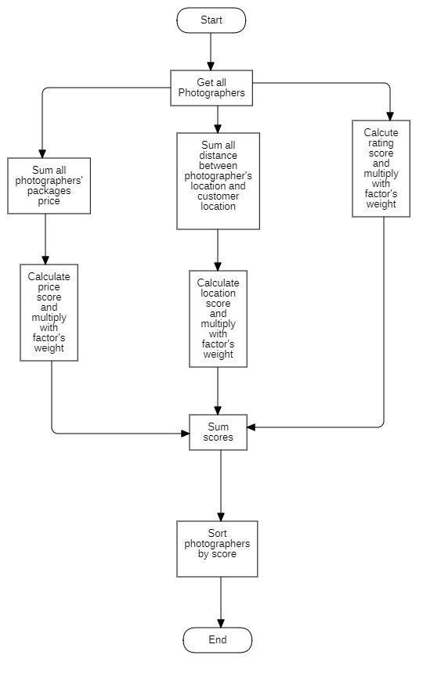

*Figure 81 Flowchart - Multiple factors sorting*

### 6.2 Naive Bayes Classifier

#### 6.2.1 Definition

Naive bayes classifiers is a simple technique mostly used for building classifiers based on Bayes’ theorem from probability theory and statistics.

It best suited to solve problems which has categorizable variables Some application of naive bayes includes: Spam e-mail filtering, sentiment prediction, or in our case, weather prediction.

#### 6.2.2 Define problem

Our application domain is photography, which has highly dependence on weather in order to make the most out of a shooting session. So, the problem here is we need a tool which could warn customer or photographer on bad weather days.

#### 6.2.3 Solution

Some definitions:

Bayes’ Theorem: $P\left(A|B\right)=\frac{P\left(B|A\right)P\left(A\right)}{P\left(B\right)}$

P(A|B) - Posterior: The probability of “A” being true given that “B” is already true.

P(B|A) - Likelihood: The probability of “B” being true given that “A” is already true.

P(A) - Prior: The probability of “A” being true.

P(B) - Evidence: The probability of “B” being true.

Input:

* A set of features x = {x1, x2… xn}, in our case x = {Outlook, Temperature, Humidity, Windy}
* A fixed set of classes C = {c1, c2… cn}, in our case C = {Yes, No}

Output

* A predicted class c from C.

For documenting purpose, we use a fictional example dataset below:

|  |  |  |  |  |
| --- | --- | --- | --- | --- |
| **Outlook** | **Temperature** | **Humidity** | **Windy** | **Shooting** |
| Sunny | High | High | Strong | No |
| Overcast | Normal | Normal | Normal | Yes |
| Rainy | High | Normal | Strong | No |
| Sunny | Normal | Normal | Normal | Yes |
| Rainy | High | Normal | Strong | No |
| Overcast | Normal | High | Normal | Yes |
| Rainy | High | High | Strong | No |

We will convert this to Frequency tables:

|  |  |  |  |
| --- | --- | --- | --- |
| **Class** | **Outlook** | | |
| Sunny | Overcast | Rainy |
| Yes | 1 | 2 | 0 |
| No | 1 | 0 | 3 |

|  |  |  |
| --- | --- | --- |
| **Class** | **Temperature** | |
| High | Normal |
| Yes | 0 | 4 |
| No | 4 | 0 |

|  |  |  |
| --- | --- | --- |
| **Class** | **Humidity** | |
| High | Normal |
| Yes | 1 | 2 |
| No | 2 | 1 |

|  |  |  |
| --- | --- | --- |
| **Class** | **Windy** | |
| Strong | Normal |
| Yes | 0 | 4 |
| No | 4 | 0 |

For example, if we want to know if a set of features {Sunny, High Temperature, High Humidity, Strong Windy} is suitable for photographing or not.

According to Bayes theorem we need to calculate posterior probability.

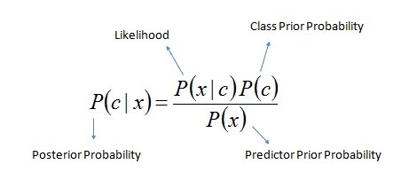

Or we can simply calculate in expanded form:

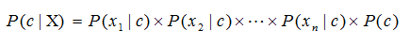

We calculate for each class (Yes and No) and then compare it to find out which gives higher score.

Since we want to classify sunny outlook, high temperature, high humidity and strong wind, we need to calculate following probabilities:

P (Yes) = $\frac{3}{7}$

P (No) = $\frac{4}{7}$

P (Sunny | Yes) = $\frac{1}{3}$

P (Sunny | No) = $\frac{1}{4}$

P (Temperature = High | Yes) = $\frac{0}{3}$

In this case, to avoid the multiplication of probabilities become 0, we will add 1 to the value.

-> P (Temperature = High | Yes) = $\frac{1}{3}$

P (Temperature = High | No) = $\frac{4}{4}$

P (Humidity = High | Yes) = $\frac{1}{3}$

P (Humidity = High | No) = $\frac{2}{4}$

P (Windy = Strong | Yes) = $\frac{0}{3}$

Same as the case above, we will add to 1 to the value.

-> P (Windy = Strong | Yes) = $\frac{1}{3}$

P (Windy = Normal | No) = $\frac{4}{4}$

Final step, we will find two posterior probabilities in expanded form (Without divide it for the evidence):

* P (Yes | X):

$P\left(Yes\right)×P\left(Yes\right)×P\left(HighHumidity|Yes\right)×P(StrongWindy|Yes)×P(Yes)$

$=\frac{1}{3}×\frac{1}{3}×\frac{1}{3}×\frac{1}{3}×\frac{3}{7} \sim 0.00529$

* P (No | X):

$P\left(No\right)×P\left(No\right)×P\left(HighHumidity|No\right)×P(StrongWindy|No)×P(No)$

$=\frac{1}{4}×\frac{4}{4}×\frac{2}{4}×\frac{4}{4}×\frac{4}{7}\sim 0.0714$

As 0.0714 > 0.00529 so we can predict that the weather is not suitable for shooting.

#### 6.2.4 Complexity

The complexity of Naive Bayes is O(nK), where n is number of features and K is number of classes.

# V. Software Testing Documentation

## 1. Overall Description

### 1.1 Test Model

We use a software development process model is V-model because this model is suitable for project conditions. For each stage, there will be a corresponding check it helps us to detect errors from the beginning.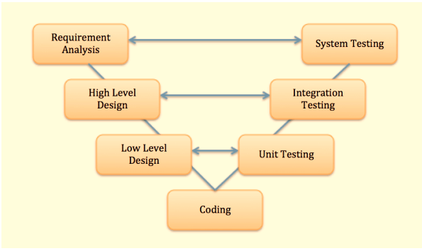

References: *https://en.wikipedia.org/wiki/V-Model_(software_development)*

### 1.2 Testing Levels

|  |  |
| --- | --- |
| **Testing Level** | **Description** |
| Unit Testing | Checks if software components are fulfilling functionalities or not. |
| Integration Testing | Checks the data flow from one module to other modules. |
| System Testing | Evaluates both functional and non-functional needs for the testing. |
| Acceptance Testing | Checks the requirements of a specification or contract are met as per its delivery. |

*Table 106 Testing levels*

### 1.3 Testing Types

|  |  |
| --- | --- |
| **Testing types** | **Description** |
| Functional Testing | Include:   * Unit Testing * Integration Testing * System Testing * Interface Testing * Regression Testing |
| Non-functional Testing | Include:   * Performance Testing * Load Testing |

*Table 107 Testing Types*

## 2. Test Plan

### 2.1 Test Stages

|  |  |  |  |  |
| --- | --- | --- | --- | --- |
| **Type of Test** | **Stage of Test** | | | |
| ***Unit*** | ***Integration*** | ***System*** | ***Acceptance*** |
| Interface test | X |  | X |  |
| Performance Testing | X | X |  |  |
| Load Test |  |  | X | X |

*Table 108 Test Stages*

### 2.2 Resources

#### a. Human Resources

|  |  |  |
| --- | --- | --- |
| **Worker/Doer** | **Role** | **Specific Responsibilities/Comments** |
| Trần Thiên Thảo | Leader | * Functional Testing * Non-functional Testing |
| Bồ Công Đạt | Member | * Functional Testing * Non-functional Testing |
| Đào Sỹ Trung Kiên | Member | * Functional Testing * Non-functional Testing |
| Trương Ngọc Mỹ | Member | * Functional Testing * Non-functional Testing |

*Table 109 Human Resources*

#### b. Environment

|  |  |  |  |
| --- | --- | --- | --- |
| **Purpose** | **Tool** | **Provider** | **Version** |
| Unit Test | Postman | Postman, Inc. | 7.36.0 |
| Unit Testing  Integration Testing  System Testing  Interface Testing  Regression Testing  Performance Testing  Load Testing | Chrome | Google LLC | 87.0.4280.66 |
| Android phone | Sony Corporation | XZ1 |

*Table 110 Environment*

### 2.3 Test Milestones

|  |  |  |  |
| --- | --- | --- | --- |
| **Milestone Task** | **Effort (md)** | **Start Date** | **End Date** |
| Unit test case | 25 | 20/11/2020 | 15/12/2020 |
| System test case | 25 | 20/11/2020 | 15/12/2020 |
| Test procedures | 8 | 05/12/2020 | 13/12/2020 |
| Defect reports | 5 | 15/12/2020 | 20/12/2020 |

*Table 111 Test Milestones*

### 2.4 Deliverables

|  |  |  |
| --- | --- | --- |
| **No** | **Deliverables** | **Due Date** |
| 1 | Unit test case | 15/12/2020 |
| 2 | System Test case | 15/12/2020 |

*Table 112 Deliverables*

## 3. Test Cases

Test cases are included in these two excel files:

|  |  |
| --- | --- |
| **No** | **Filename** |
| 1 | Unit Test Cases: Report5_Unit_Test_Case.xls |
| 2 | System Test case |

*Table 113 Test Cases*

## 4. Test Reports

Test reports are included in this file:

|  |  |
| --- | --- |
| **No** | **Filename** |
| 1 | Report5_Test_Case_Document.xlsx |

*Table 114 Test Reports*

# VI. Release Package & User Guides

## 1. Deliverable Package

### 1.1 Source codes & documents

|  |  |  |  |  |
| --- | --- | --- | --- | --- |
| **No.** | **Items** | **Sub-Items** | **Type** | **Version** |
| ***Code Package*** | | | | |
| 1 | Web API | pbs_webapi | New | 1.0.1 |
| 2 | Mobile Apps | photographer_mobile_app | New | 1.0.1 |
| customer_mobile_app | New | 1.0.1 |
| ***Database*** | | | | |
| 1 | Tables | pbs_users.sql | New | 1.0.1 |
| pbs_roles.sql | New | 1.0.1 |
| pbs_photographer_packages.sql | New | 1.0.1 |
| pbs_packages_services.sql | New | 1.0.1 |
| pbs_services.sql | New | 1.0.1 |
| pbs_returning_types.sql | New | 1.0.1 |
| pbs_bookings.sql | New | 1.0.1 |
| pbs_booking_details.sql | New | 1.0.1 |
| pbs_booking_time_location_detail.sql | New | 1.0.1 |
| pbs_booking_comments.sql | New | 1.0.1 |
| pbs_albums.sql | New | 1.0.1 |
| pbs_customers_albums.sql | New | 1.0.1 |
| pbs_album_images.sql | New | 1.0.1 |
| pbs_images.sql | New | 1.0.1 |
| pbs_categories.sql | New | 1.0.1 |
| pbs_threads.sql | New | 1.0.1 |
| pbs_thread_comments.sql | New | 1.0.1 |
| pbs_thread_topics.sql | New | 1.0.1 |
| pbs_locations.sql | New | 1.0.1 |
| pbs_working_day_of_week.sql | New | 1.0.1 |
| pbs_busy_days.sql | New | 1.0.1 |
| ***Documents*** | | | | |
| 1 | Introduction | Report1_Project-Introduction.docx | New | 1.0.1 |
| 2 | Management Plan | Report2_Project-Management-Plan.docx | New | 1.0.1 |
| 3 | Requirement | Report3_Software Requirement Specification.docx | New | 1.0.1 |
| 4 | Design | Report4_Software Design Document.docx | New | 1.0.1 |
| 5 | Testing | Report5_Test Documentation.docx | New | 1.0.1 |
| Report5_Test Case Document.xlsx | New | 1.0.1 |
| Report5_Unit Test Case.xls | New | 1.0.1 |
| 6 | User guides | Report6_Software User Guides.docx | New | 1.0.1 |
| 7 | Final | Report7_Final Project Report.docx | New | 1.0.1 |

*Table 115 Deliverable Package*

### 1.2 Known Issues, Limitations & Restrictions

* The application has not supported payment.
* The system does not have a photo verification feature.
* The system has not provided a website version to both customers and photographers. Users may find it uncomfortable to use applications.

## 2. Installation Guides

### 2.1 System Requirements

**2.1.1 Hardware requirements**

**For PC**

|  |  |  |
| --- | --- | --- |
| **PC** | **Minimum Requirements** | **Recommended** |
| Internet Connection | Cable, Wi-Fi (4 Mbps) | Cable, Wi-Fi (8 Mbps) |
| Operating System | Windows 7 | Windows 7 or more. |
| Computer Processor | Intel® Core i3 1.4GHz | Intel® Core i5 2.50GHz |
| Computer Memory | 1GB RAM | 2GB RAM or more |
| Web Browser | Chromes (v42 or higher) | Chrome latest stable version |

*Table 116 PC Hardware requirements*

**For Android Devices**

|  |  |
| --- | --- |
| **Operating system** | Android 8.0 or higher |
| **Processor** | Intel Atom® Processor Z2520 1.2 GHz, or faster processor |
| **Storage** | Between 850 MB and 1.2 GB, depending on the language version |
| **RAM** | Minimum of 512 MB, 2 GB is recommended |
| **Hard Disk** | * 2 GB of available hard-disk space for installation; extra free space is required during installation. * You cannot install using a removable flash storage device. |
| **Video** | 1920 x 1080 pixels or higher |
| **Browser/Internet** | * This application is designed to work online. * To download and launch Google Play Store apps within the application, a high-speed Internet connection is recommended. |

*Table 117 Android Hardware requirements*

**2.1.2 Software requirements**

|  |  |  |
| --- | --- | --- |
| **Software** | **Name / Version** | **Description** |
| Operation System | Windows 7, Windows 10 | Operating system and platform for development |
| Web browser | Chrome 69 or above, Mozilla Firefox | For web app |
| Android System | Android 4.0 or higher | For mobile app |

*Table 118 Software requirements*

### 2.2 Setup Files

* PBS for photographer.apk



*Figure 83 Setup files - 1*

* PBS for customer.apk



*Figure 84 Setup files - 2*

### 2.3 Installation Instruction

The installation steps of 2 android apps are the same, so we provide one guideline for both of them.

1. Install PBS by pressing the “Install” button.

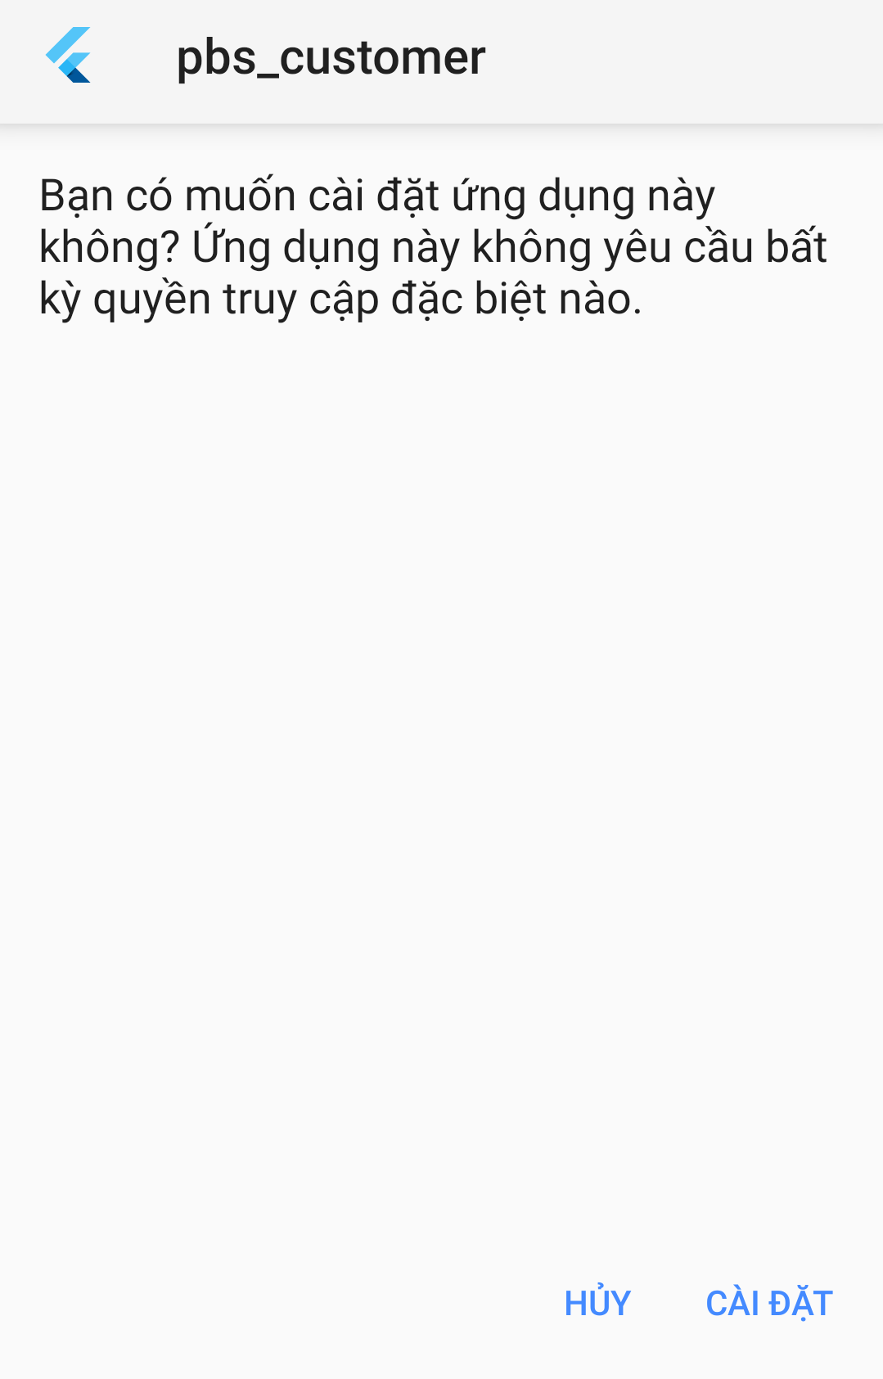

*Figure 85 Installation - 1*

1. Press “Accept” to accept application permissions.

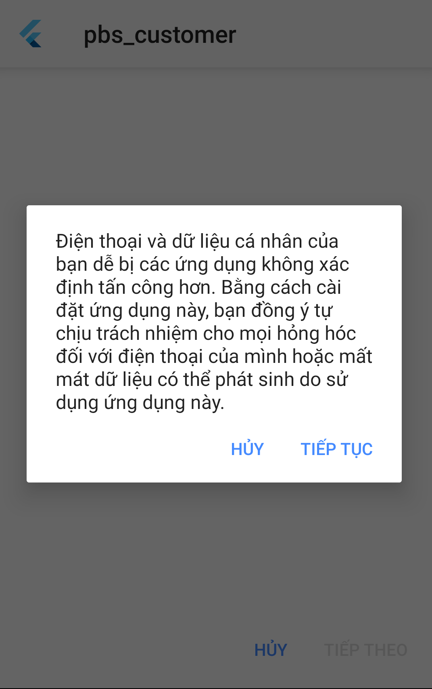

*Figure 86 Installation - 2*

1. Wait for installation of the PBS App.

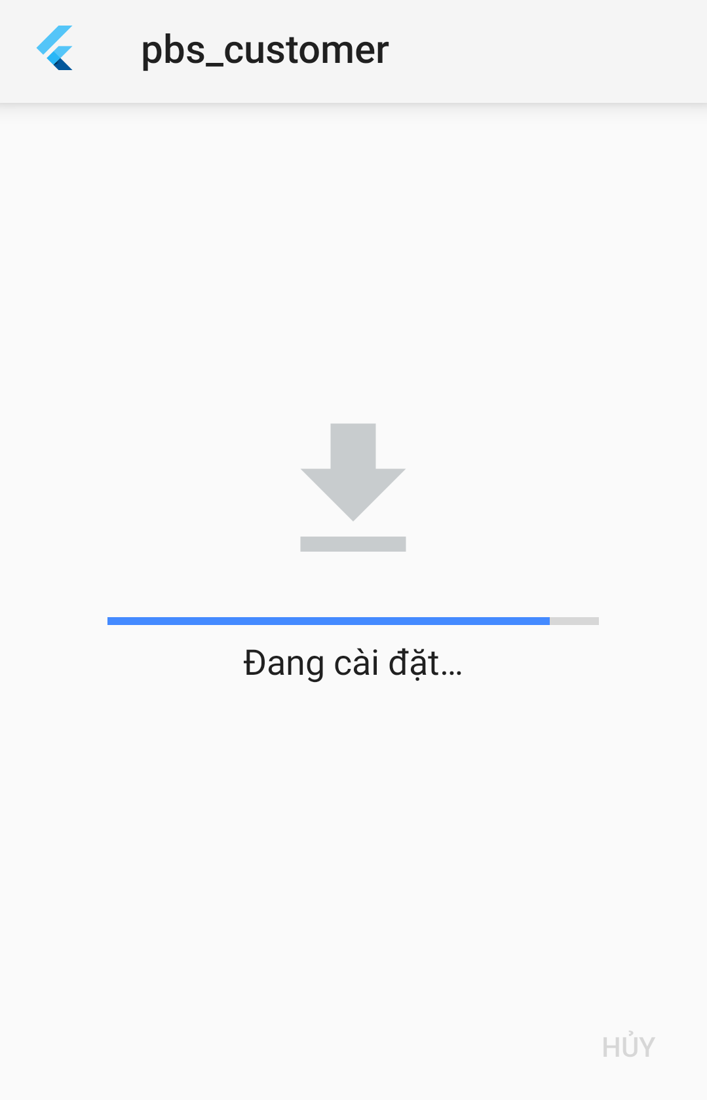

*Figure 87 Installation - 3*

1. Press “Mở” to start the main App.

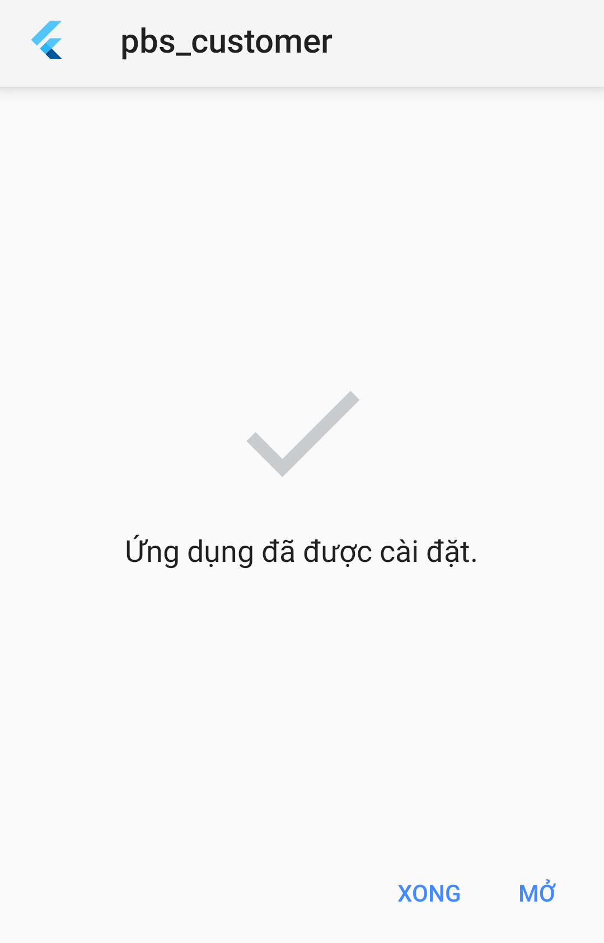

*Figure 88 Installation - 4*

1. Read the manual for more information.

### 2.4 Server-side deployment

Step 1: Navigate to webapi folder

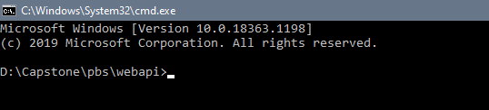

*Figure 89 Deployment - 1*

Step 2: Using command “mvnw spring-boot:run” to run server api

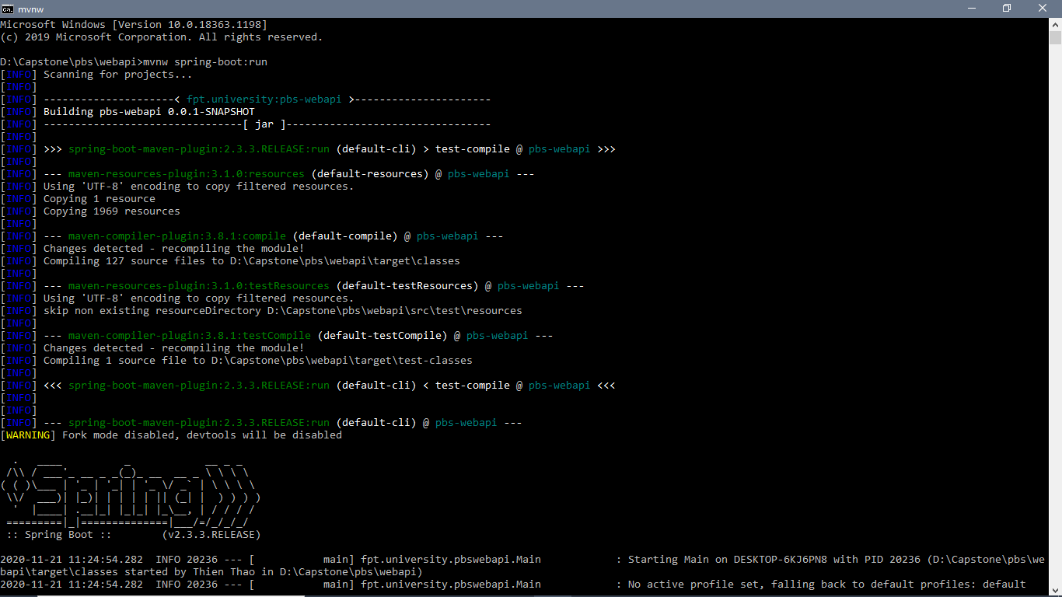

*Figure 90 Deployment -2*

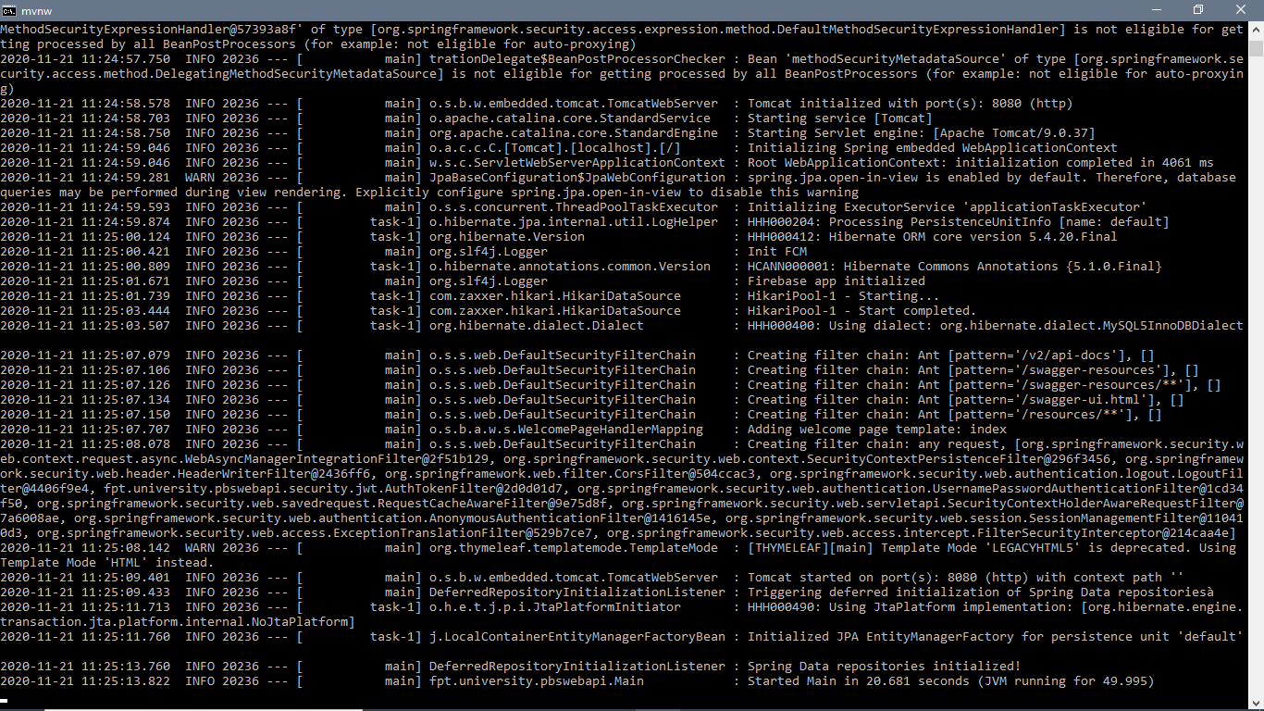

*Figure 91 Deployment - 3*

## 3. User Manual

### 3.1 Terms and definitions

* Accounts are the accounts that you register to sign in as users.
* Photographers’ application is an application provided by PBS for photographers to contact customers.
* Customers’ application is an application provided by PBS for users to contact photographers.
* Mobile devices are your mobile phones, tablets, or other devices that can be used to download and run Photographers’ application and Customers’ application.
* System is the system provided by PBS to support photographers’ and customers’ contact, including the Photographers’ application, Customers’ application, website, and platform.
* Photographers are independent third-party who provide shooting services that customers can book via the system.
* Customers are the ones who have Customers’ application’s accounts.
* Website is the website run by PBS.

### 3.2 System requirements

**3.2.1 Hardware requirements**

**For PC**

|  |  |  |
| --- | --- | --- |
| **PC** | **Minimum Requirements** | **Recommended** |
| Internet Connection | Cable, Wi-Fi (4 Mbps) | Cable, Wi-Fi (8 Mbps) |
| Operating System | Windows 7 | Windows 7 or higher. |
| Computer Processor | Intel® Core i3 1.4GHz | Intel® Core i5 2.50GHz |
| Computer Memory | 1GB RAM | 2GB RAM or more |
| Web Browser | Chromes (v42 or higher) | Chrome latest stable version |

**For Android devices**

|  |  |
| --- | --- |
| **Operating system** | Android 8.0 or higher |
| **Processor** | Intel Atom® Processor Z2520 1.2 GHz, or faster processor |
| **Storage** | Between 850 MB and 1.2 GB, depending on the language version |
| **RAM** | Minimum of 512 MB, 2 GB is recommended |
| **Hard Disk** | * 2 GB of available hard-disk space for installation; extra free space is required during installation. * You cannot install using a removable flash storage device. |
| **Video** | 1920 x 1080 pixels or higher |
| **Browser/Internet** | * This application is designed to work online. * To download and launch Google Play Store apps within the application, a high-speed Internet connection is recommended. |

**3.2.2 Software requirements**

|  |  |  |
| --- | --- | --- |
| **Software** | **Name / Version** | **Description** |
| Operation System | Windows 7, Windows 10 | Operating system and platform for development |
| Web browser | Chrome 69 or above, Mozilla Firefox | For web app |
| Android System | Android 4.0 or higher | For mobile app |

### 3.3 Application Usage

#### 3.3.1. Overview

Customers’ application allows customers to search for and book photographers. Then customers can rate photographers based on their experiences. The rates are displayed as stars and they can also write reviews, which would be shown on photographers’ profiles. To give users more information about photography as well as trendy styles, there is also a forum on the system where they can share information and images.

Photographers’ application helps photographers reach a wide range of potential customers. In addition, they can manage their shooting schedule and receive customers’ bookings. They can also edit their profile, add albums and services that they offer. They can join the forums as well.

The system also provides admins with a website so that they can easily control the system. Admins can add, delete, and edit shooting categories, and manage photo delivery methods. They can block users who violate community standards.

#### 3.3.2. Register

* **Purpose**
  + Create users’ accounts
* **Function**
  + Register for PBS account
* **User Interfaces**

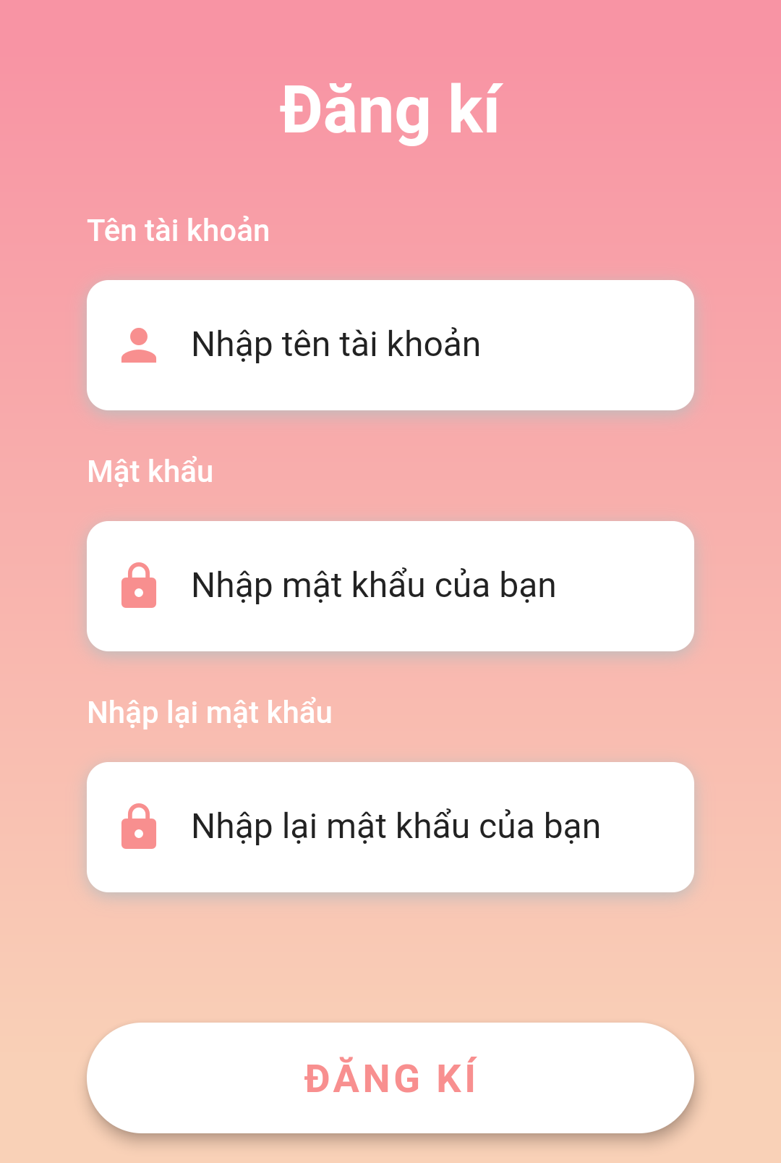

*Figure 92 Register*

#### 3.3.3. Login

* **Purpose**
  + Allow users to sign in
* **Function**
  + Sign in with PBS account
* **User Interfaces**

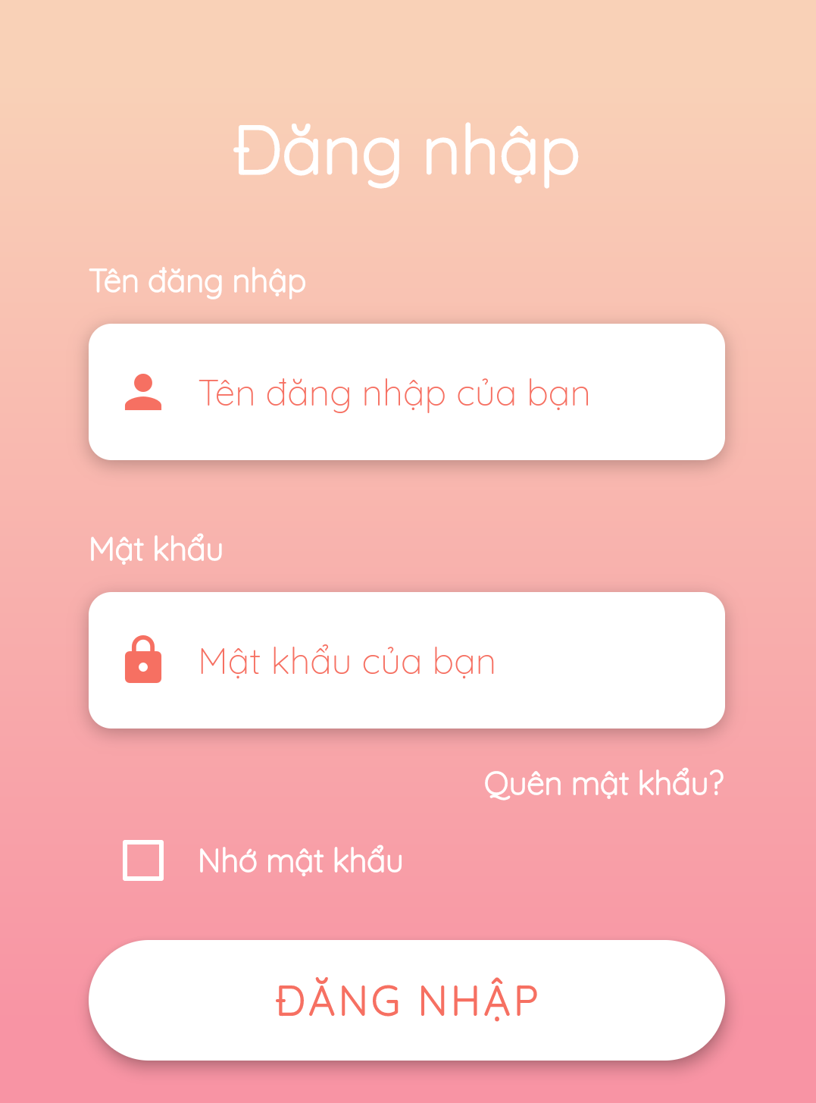

*Figure 93 - Login*

#### 3.3.4. Logout

* **Purpose**
  + Allow users to sign out
* **Function**
  + Sign out
* **User Interfaces**

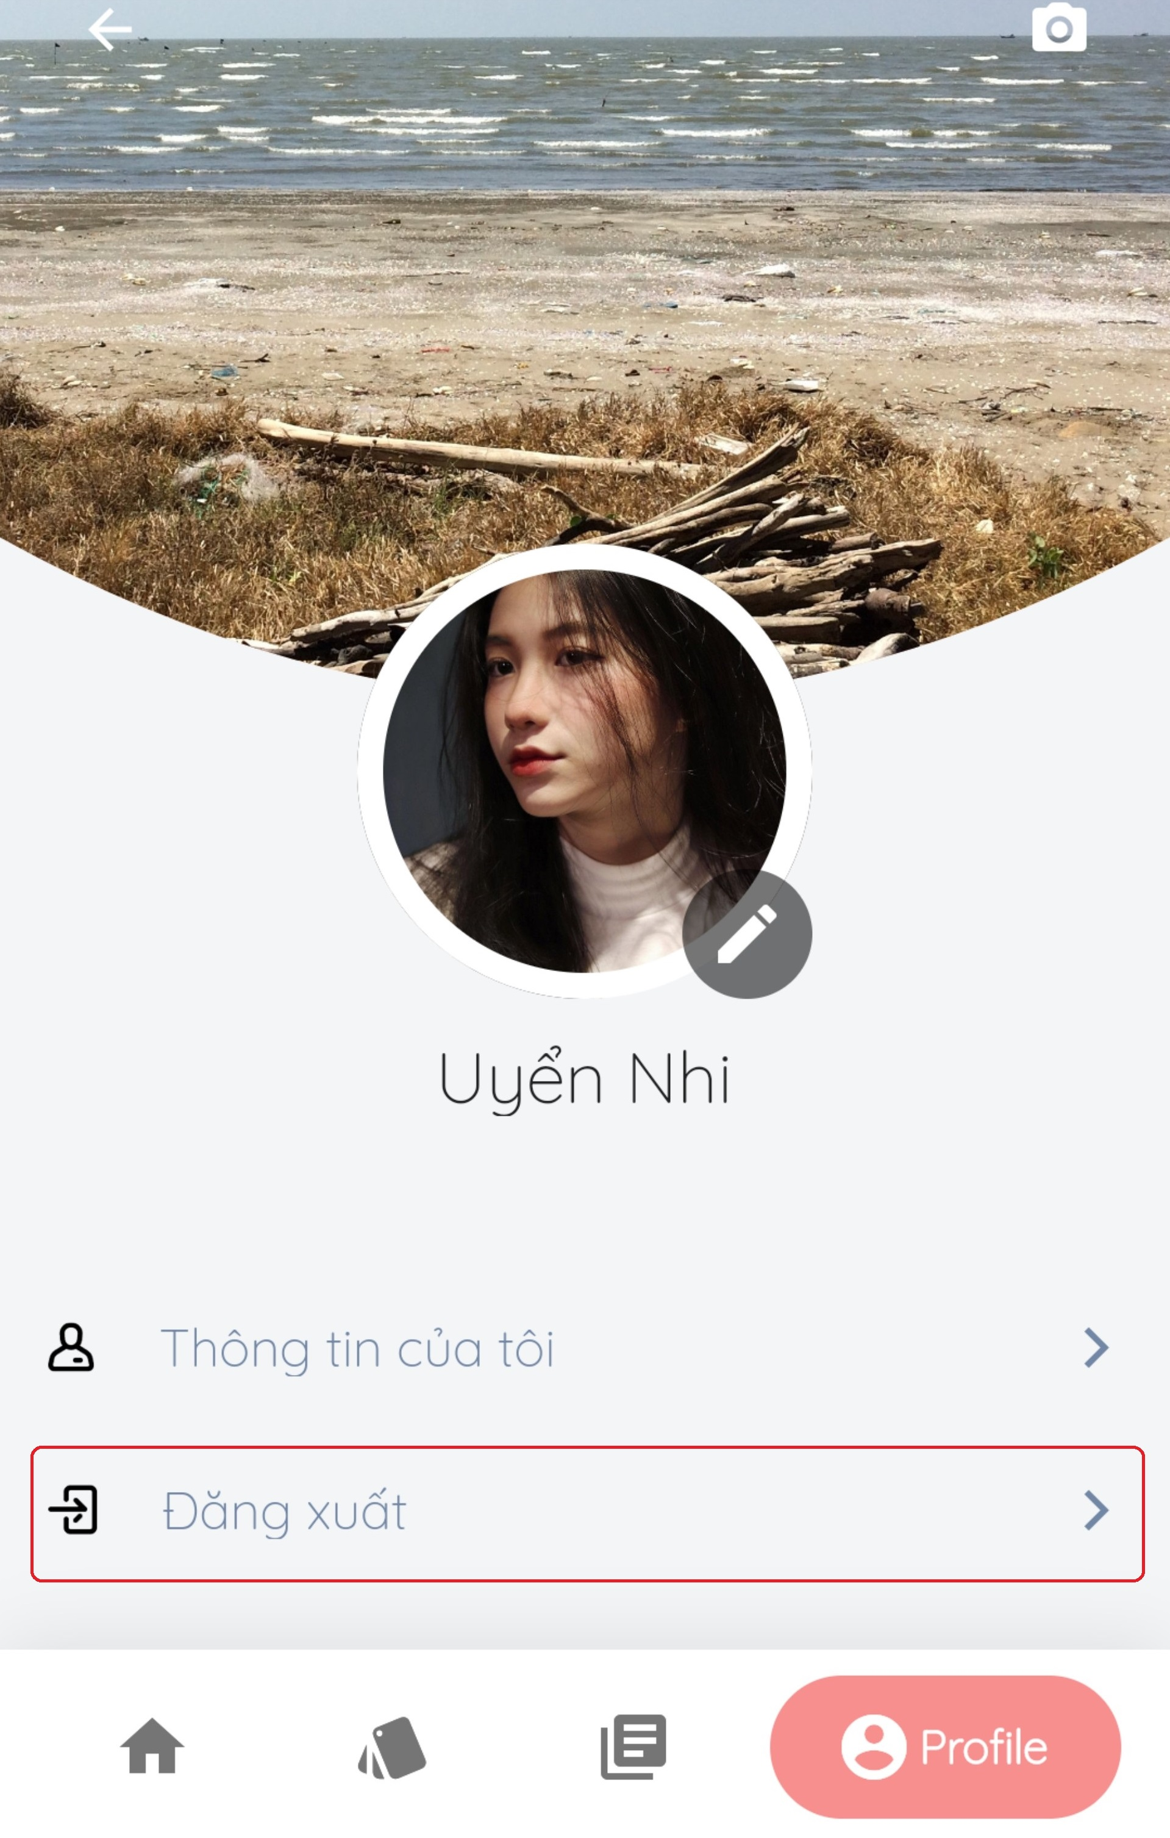

*Figure 94 - Logout*

#### 3.3.5. Search photographer

* **Purpose**
  + Allow customers to find photographers and appropriate services
* **Function**
  + Search for photographers
  + Search for services
* **User Interfaces**

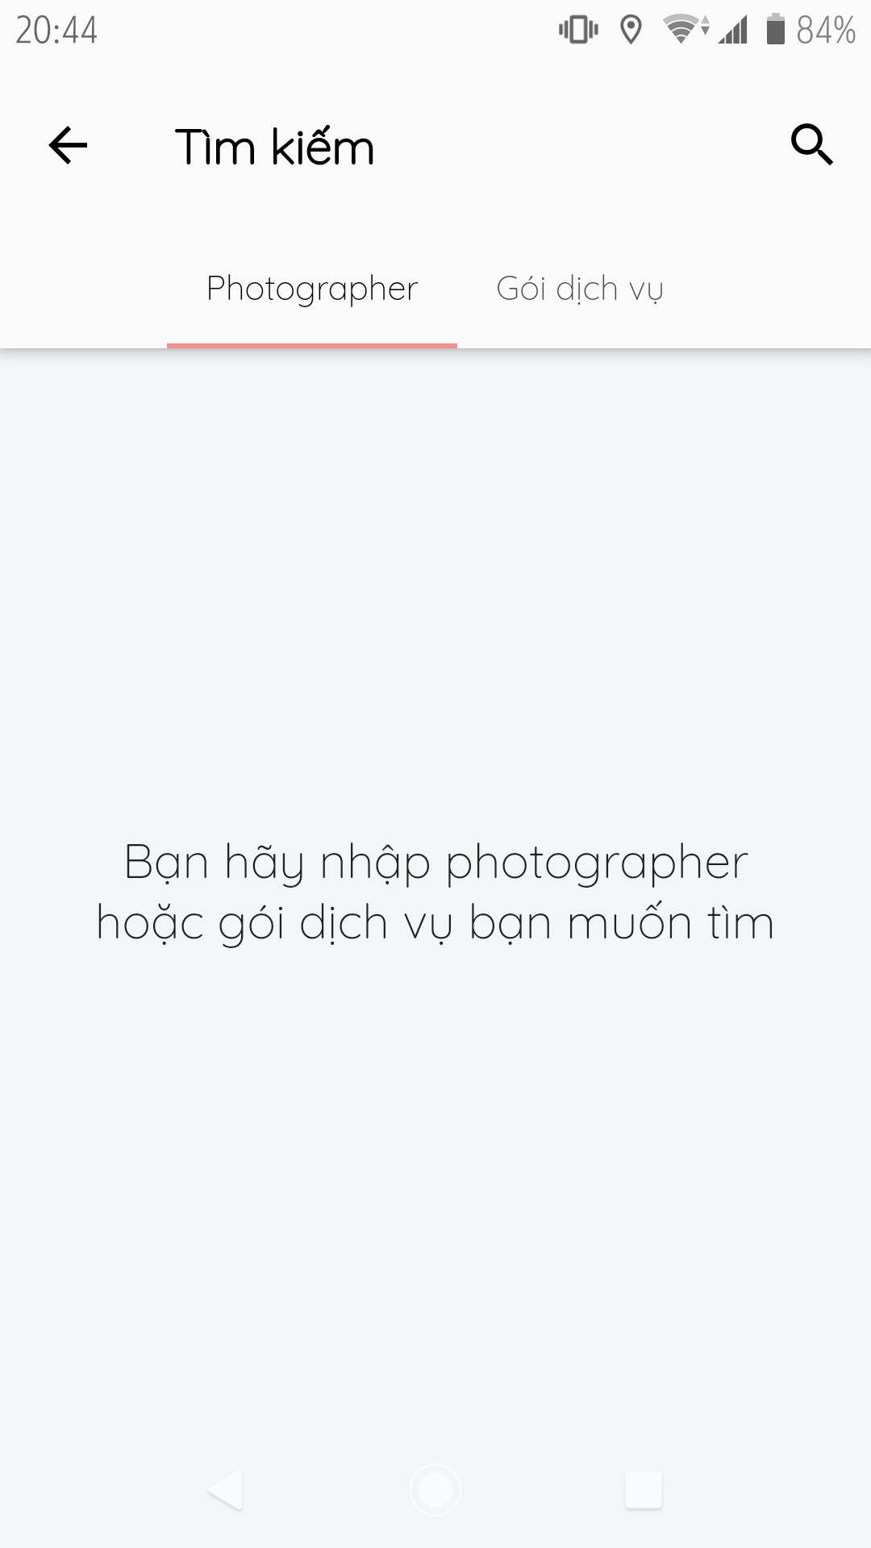

*Figure 95 Search photographers*

#### 3.3.6. Manage request

* **Purpose**
  + Allow customers to manage their bookings
* **Function**
  + Make request for days (customers only)
  + Make request for a day (customers only)
  + Make changes to their bookings (customers only)
  + Cancel their bookings (customers only)
  + Accept bookings (photographers only)
  + Decline bookings (photographers only)
* **User Interfaces**

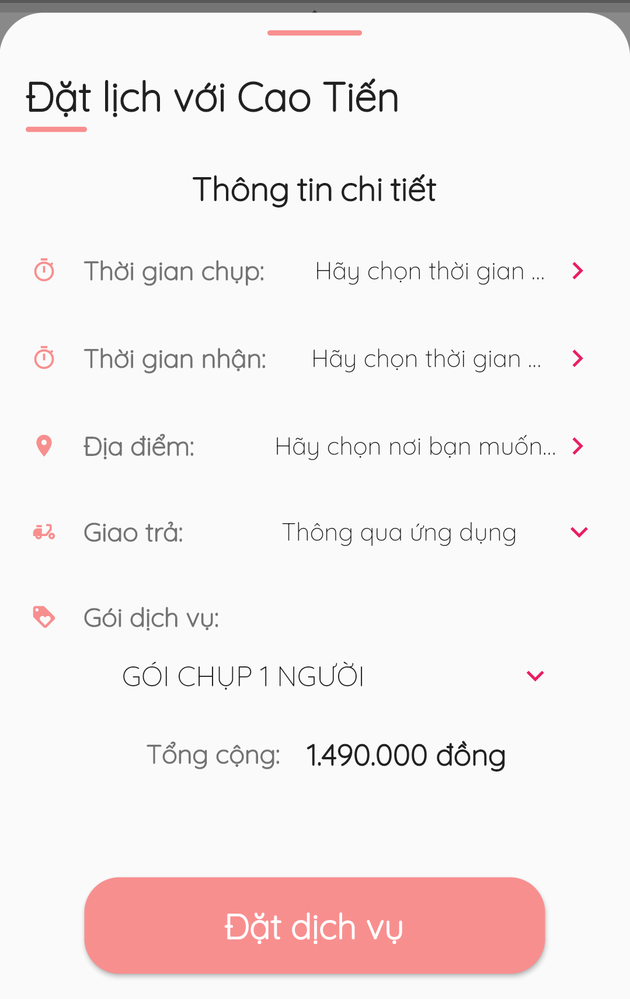

*Figure 96 - Make request for a day*

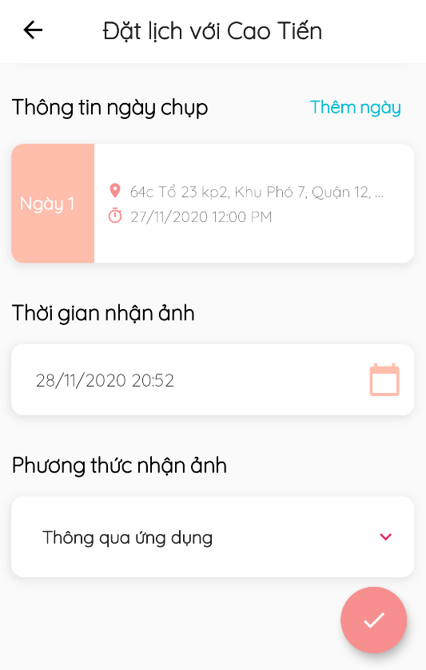

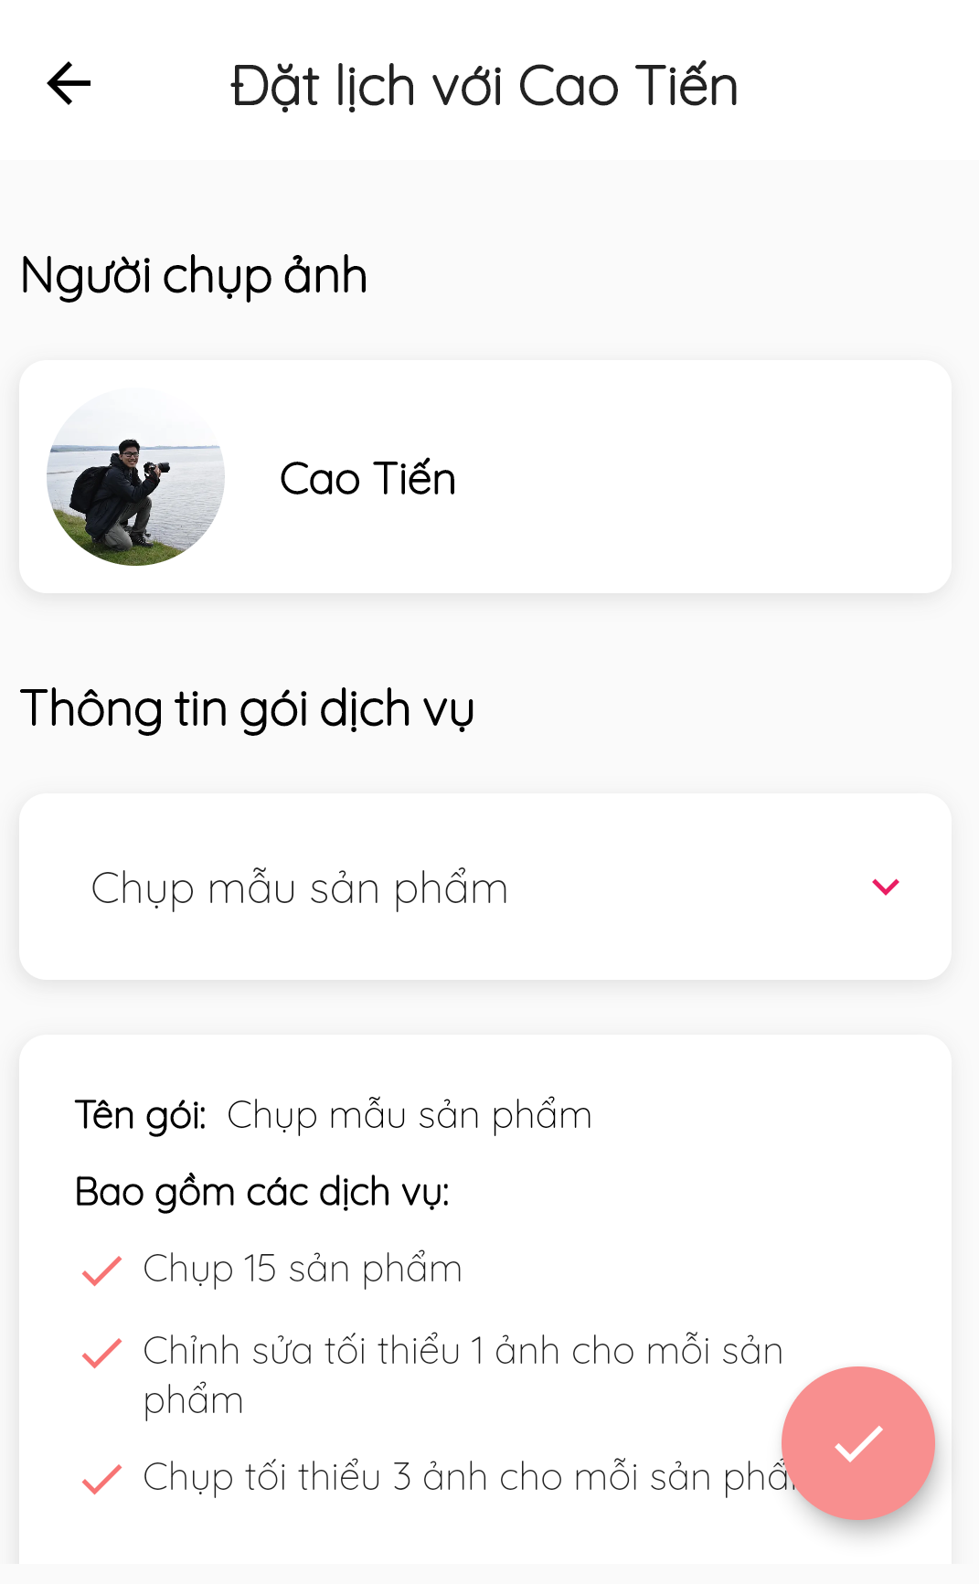

*Figure 97 - Make request for days*

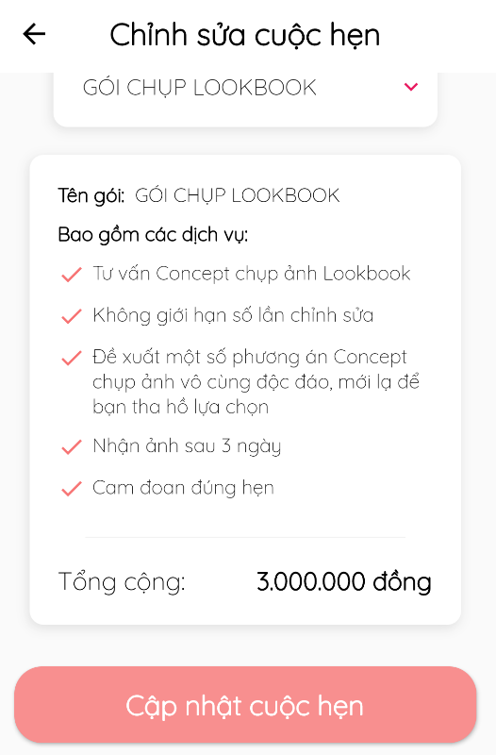

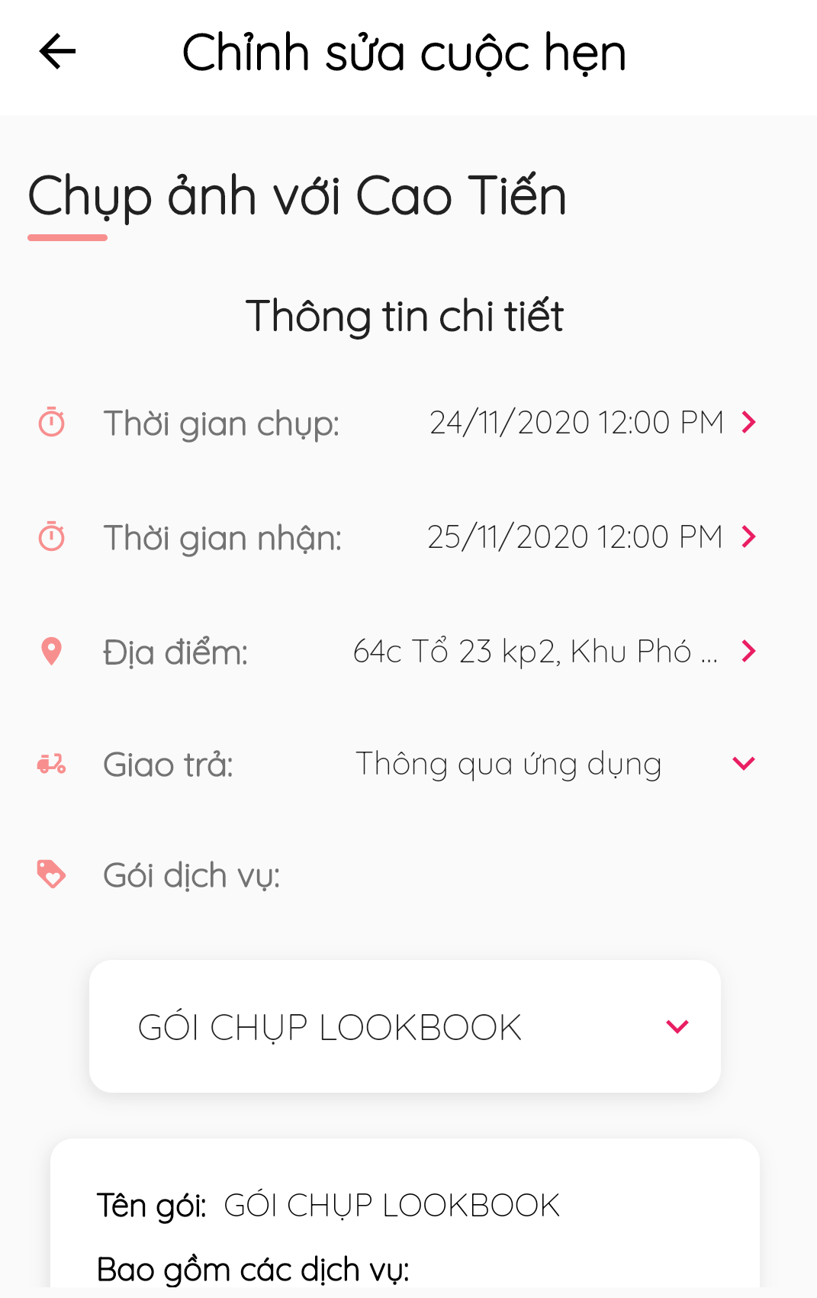

*Figure 98 - Update booking for a day*

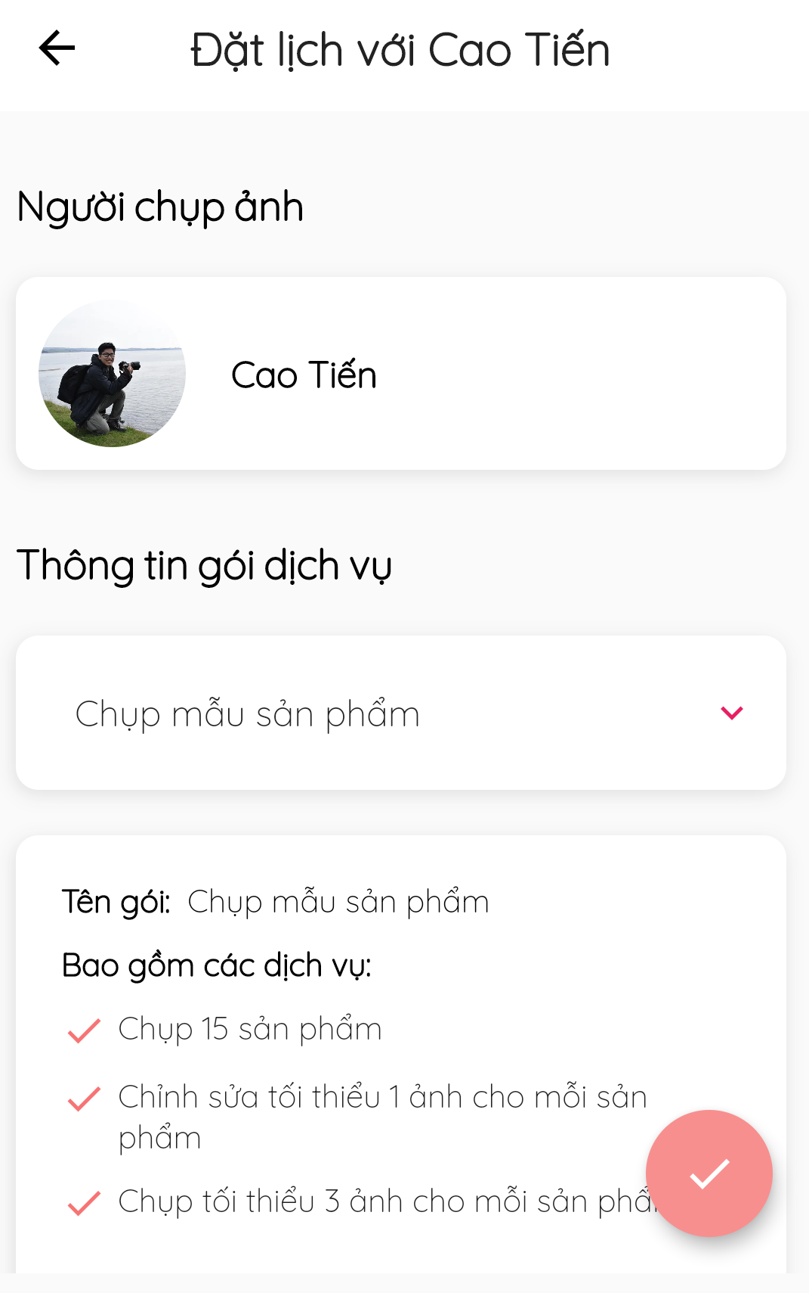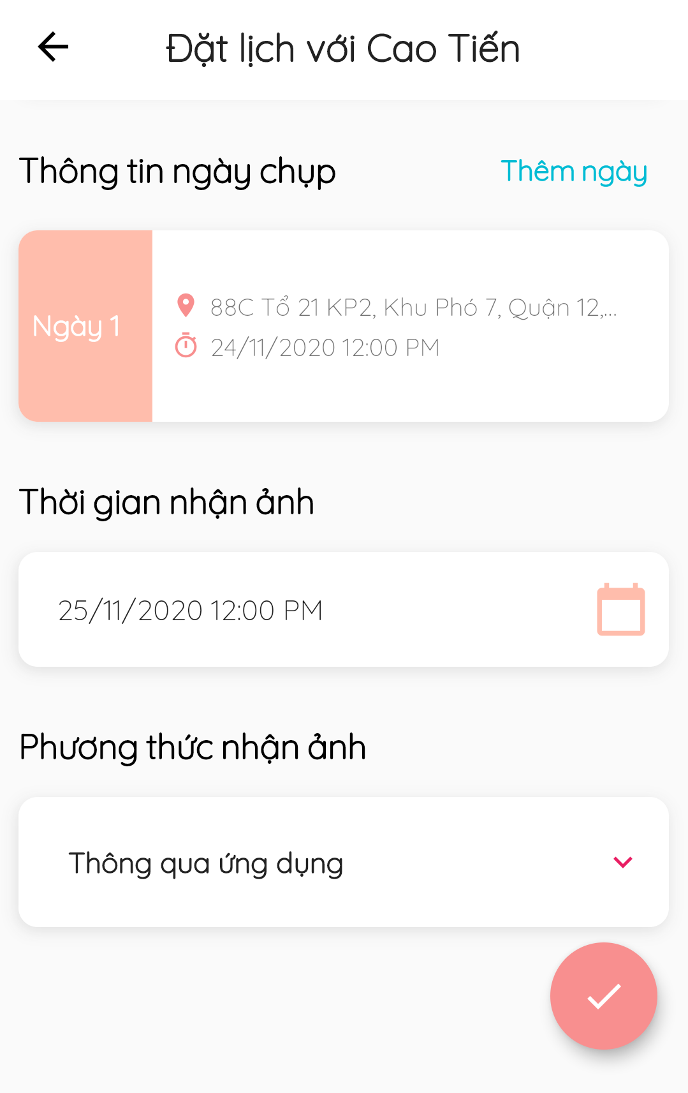

*Figure 99 - Update booking for days*

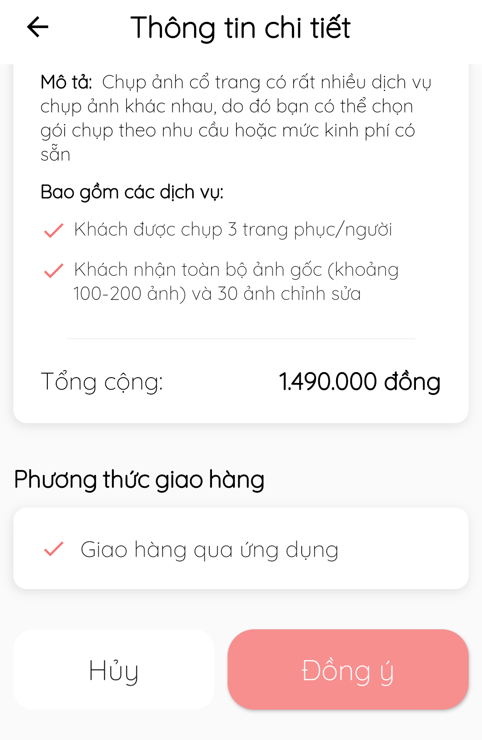

*Figure 100 - Decline /Accept /Cancel Booking*

#### 3.3.7. Manage review

* **Purpose**
  + Allow customers to review shooting services
  + Manage reviews
* **Function**
  + View reviews
  + Write reviews (customers only)
* **User Interfaces**

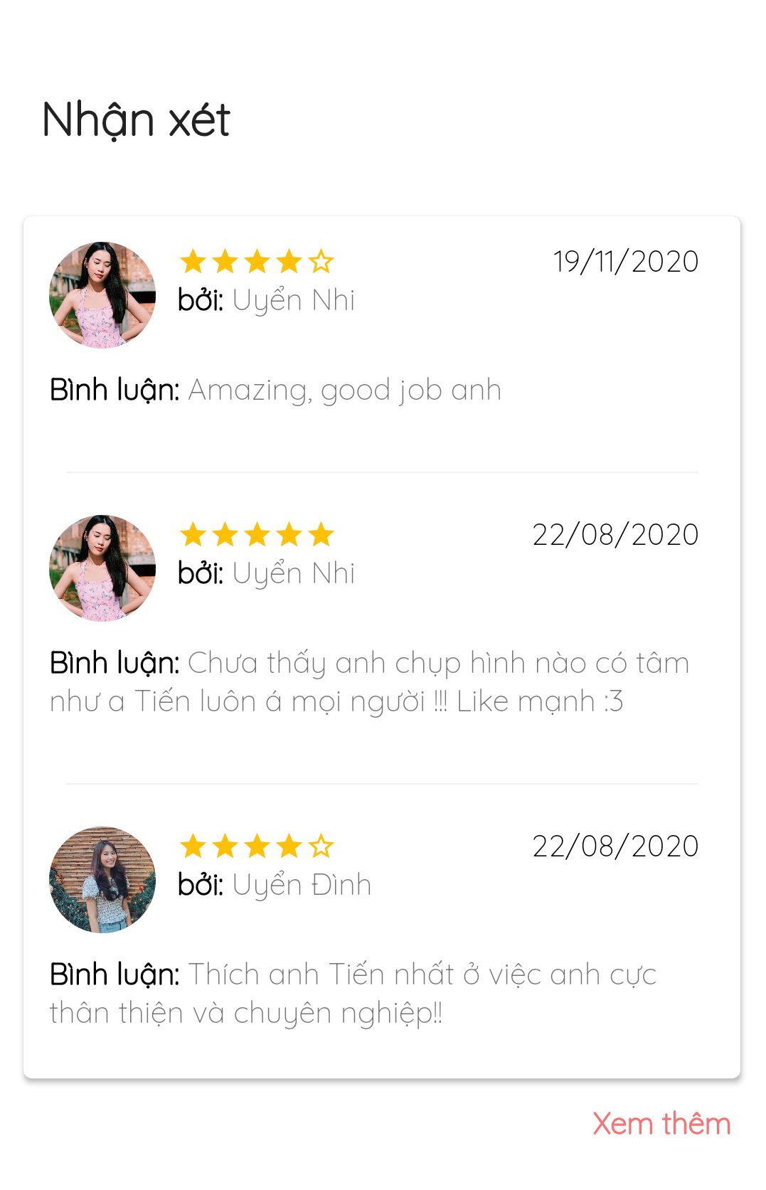

*Figure 101 - View Reviews*

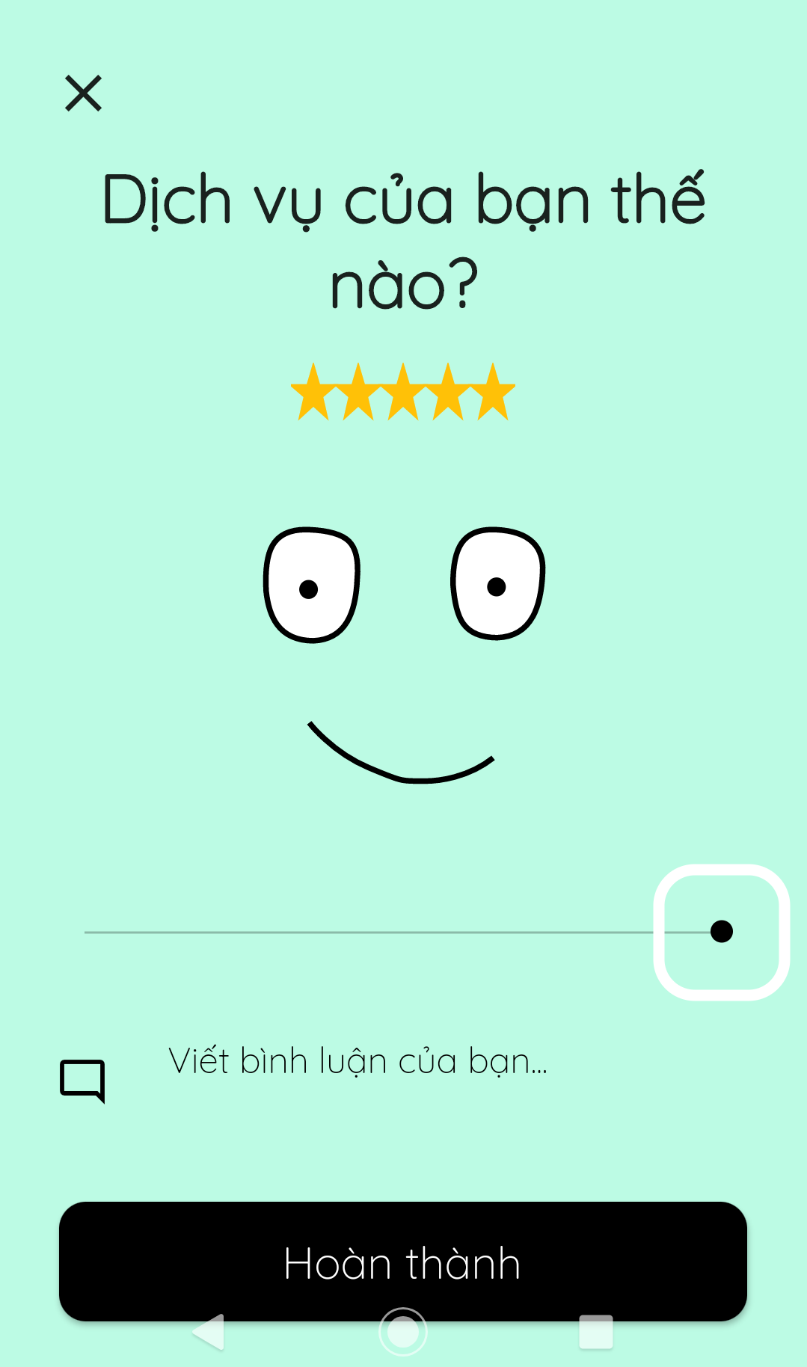

*Figure 102 - Write reviews*

#### 3.3.8. Manage request status

* **Purpose**
  + Allow photographers to update request status
* **Function**
  + Update request status
* **User Interfaces**



*Figure 103 - Change Booking Status*

#### 3.3.9. Manage calendar

* **Purpose**
  + Allow photographers to make changes to shooting schedule
* **Function**
  + Manage daily shooting schedule
  + Make changes to daily shooting schedule
  + Add unexpected unavailability
* **User Interfaces**

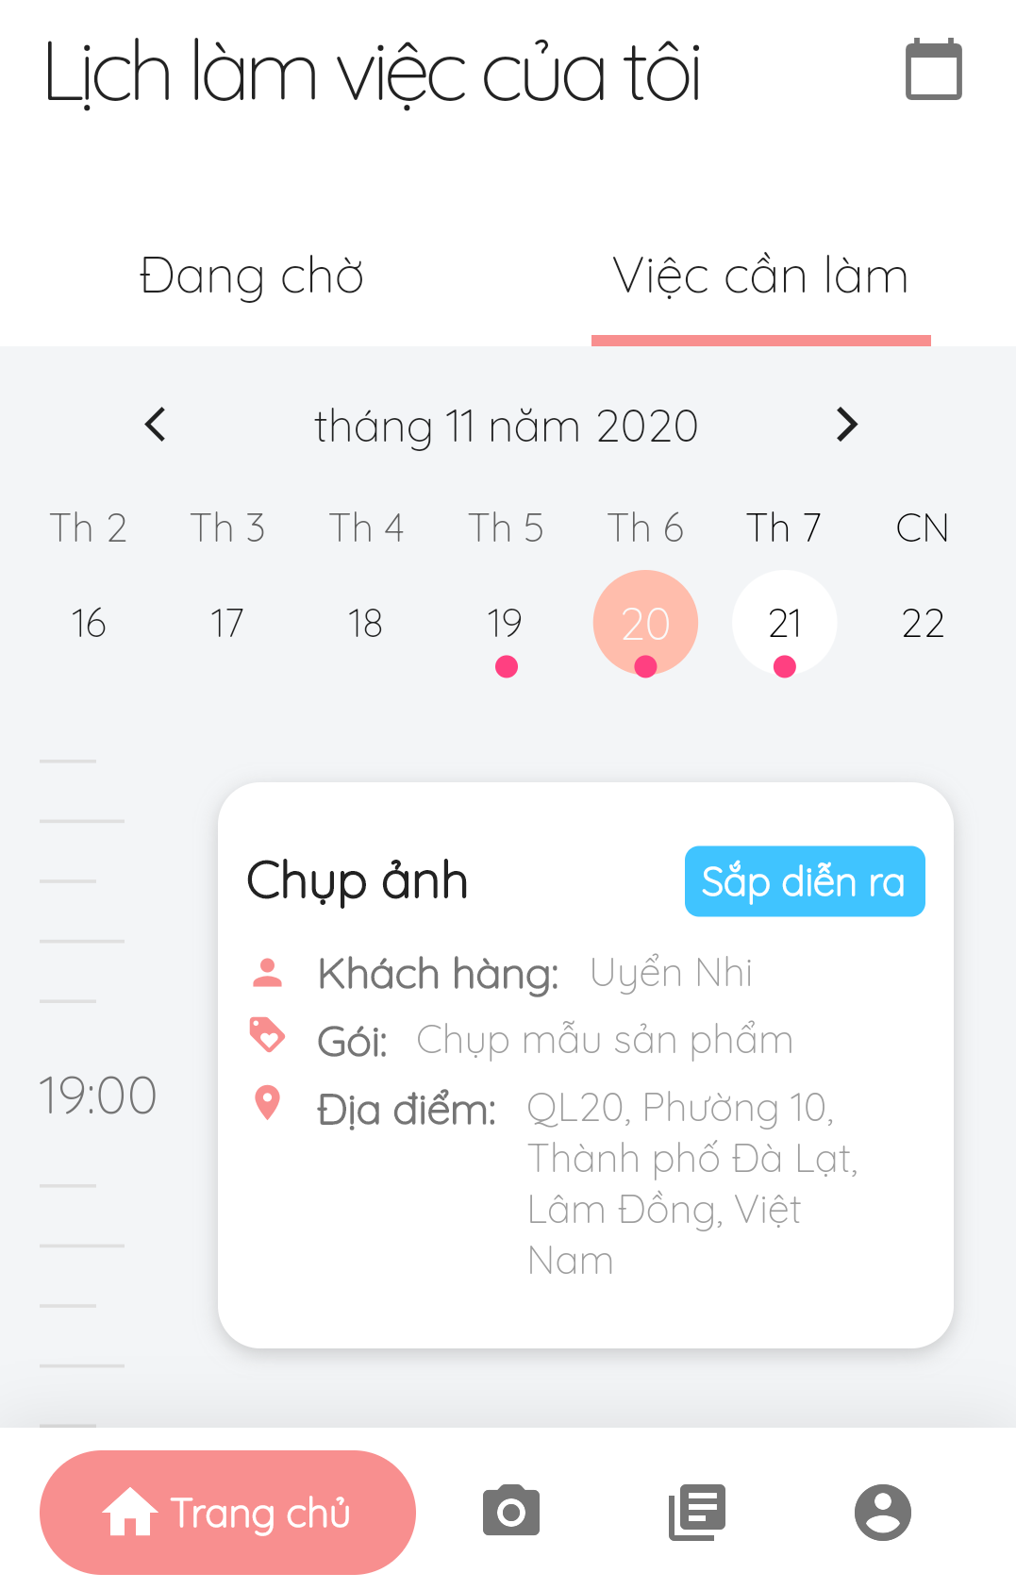

*Figure 104 - Shooting schedule*

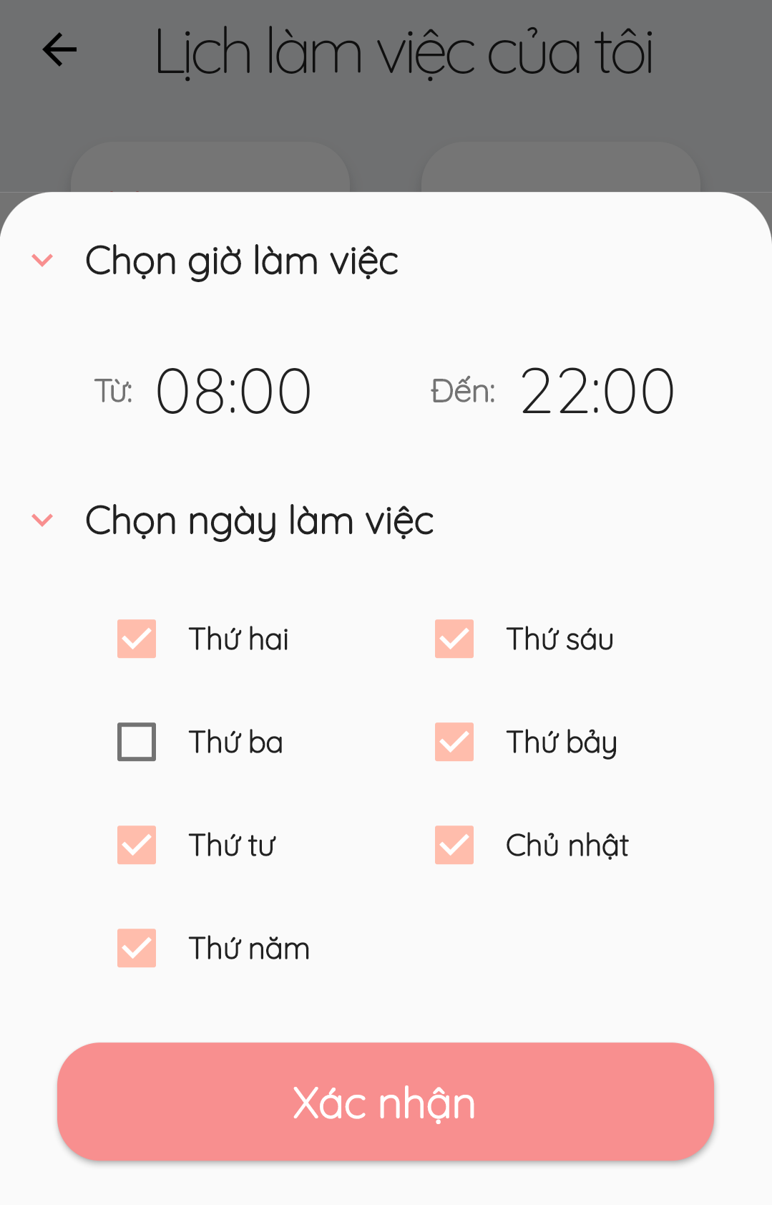

*Figure 105 - Make changes to daily shooting schedule*

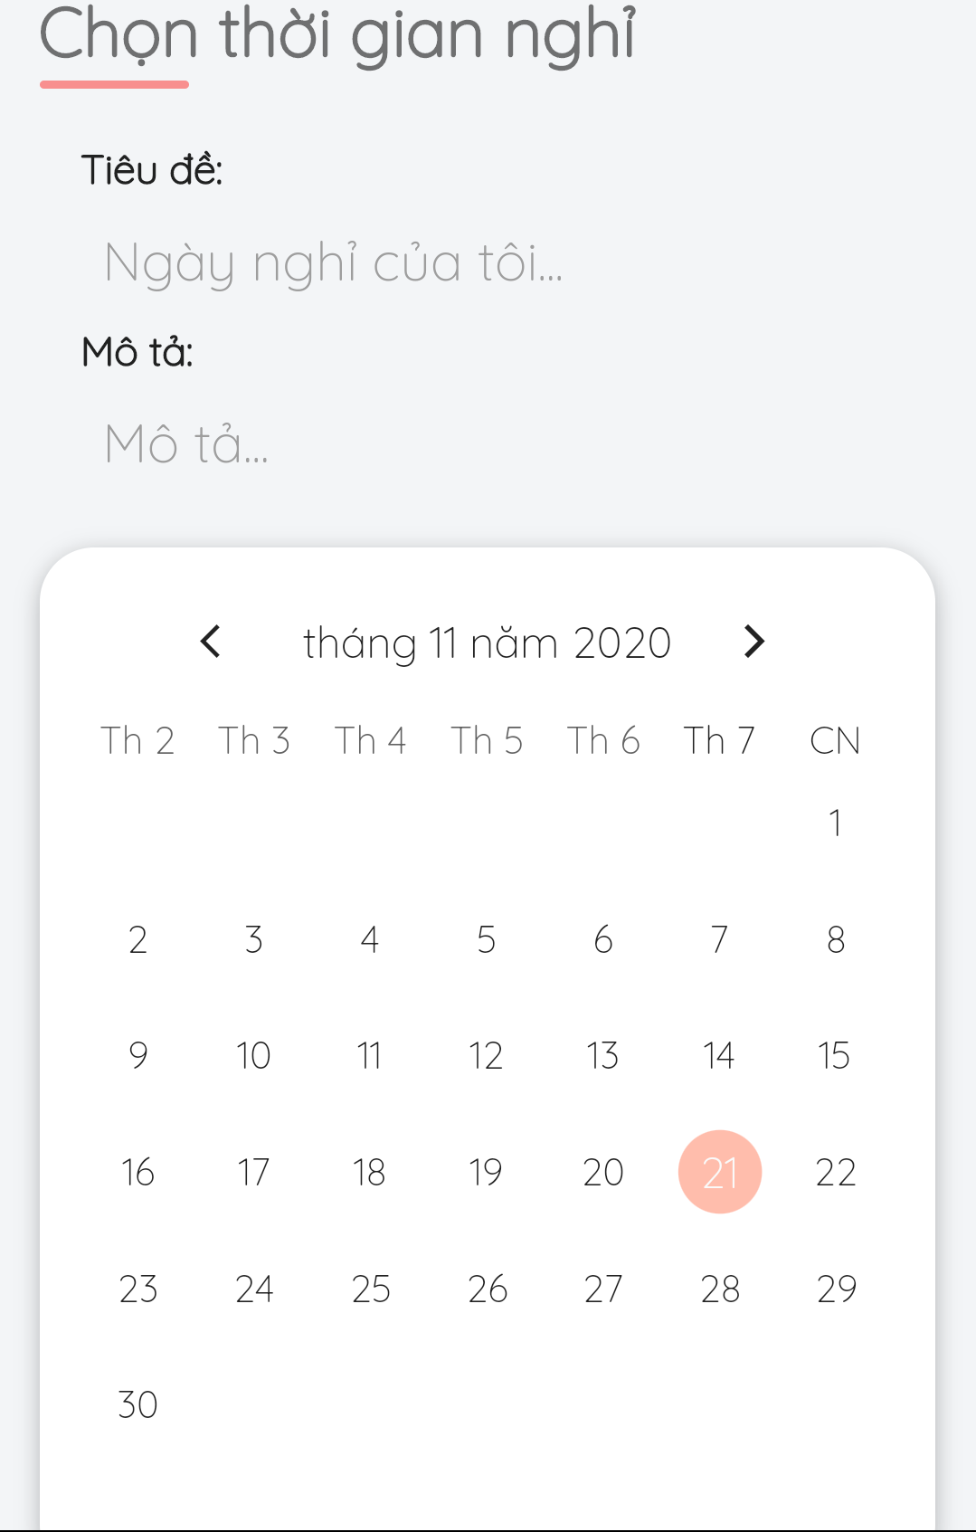

*Figure 106 - Add busy days*

#### 3.3.10. Manage album

* **Purpose**
  + Allow photographers to manage their albums
  + Allow customers to follow their favourite albums
* **Function**
  + Add album (photographers only)
  + Edit album (photographers only)
  + Delete album (photographers only)
  + Follow album (customers only)
* **User Interfaces**

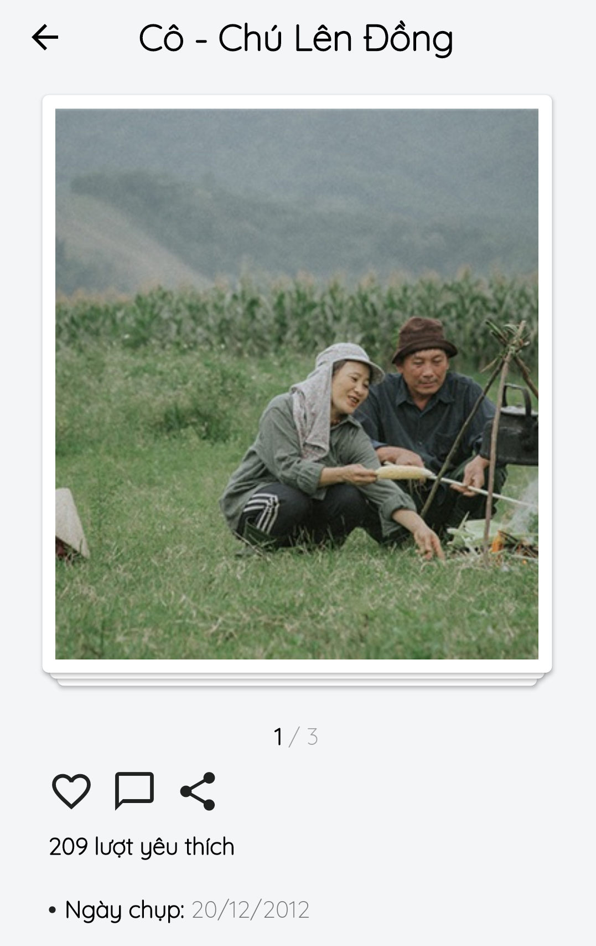

*Figure 107 - Follow Album*

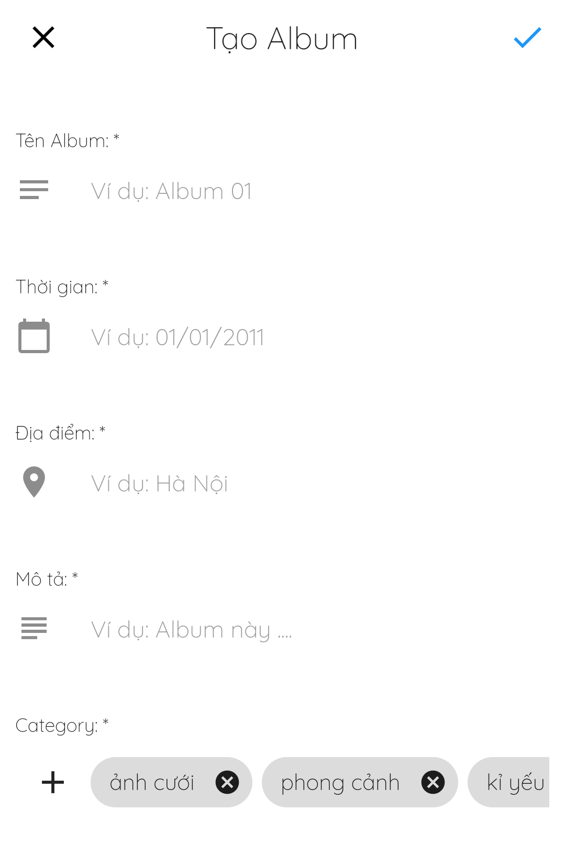

*Figure 108 - Add Album*

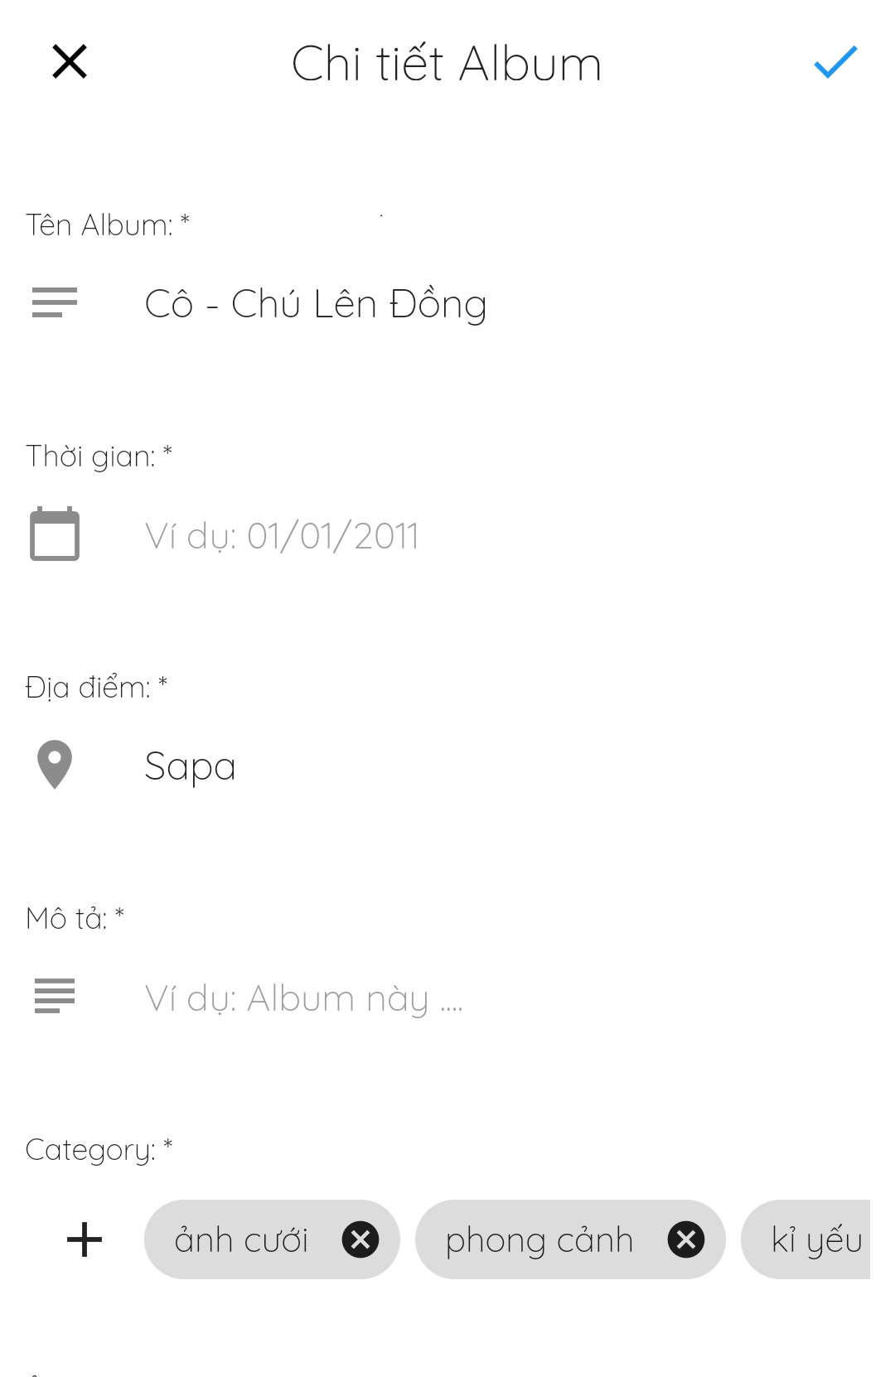

*Figure 109 - Edit Album*

#### 3.3.11. Manage package

* **Purpose**
  + Allow photographers to manage their packages
  + Allow customers to view photographers’ packages
* **Function**
  + Add package (photographers only)
  + Update package (photographers only)
  + Remove package (photographers only)
  + View packages
* **User Interfaces**

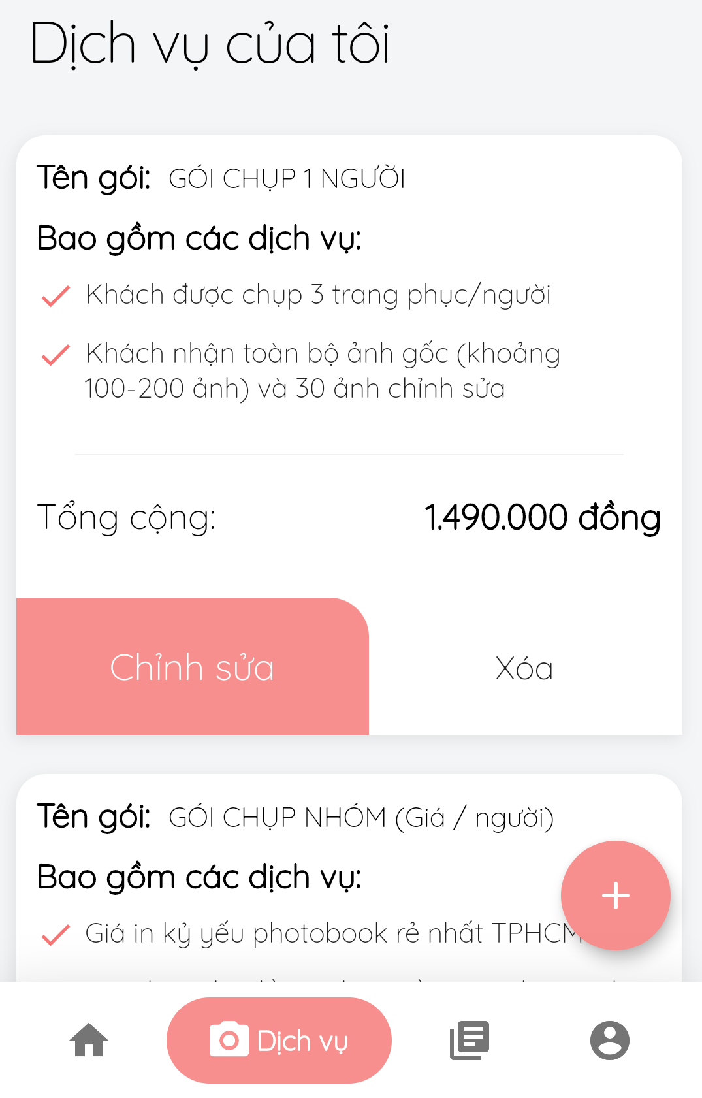

*Figure 110 - View Services*

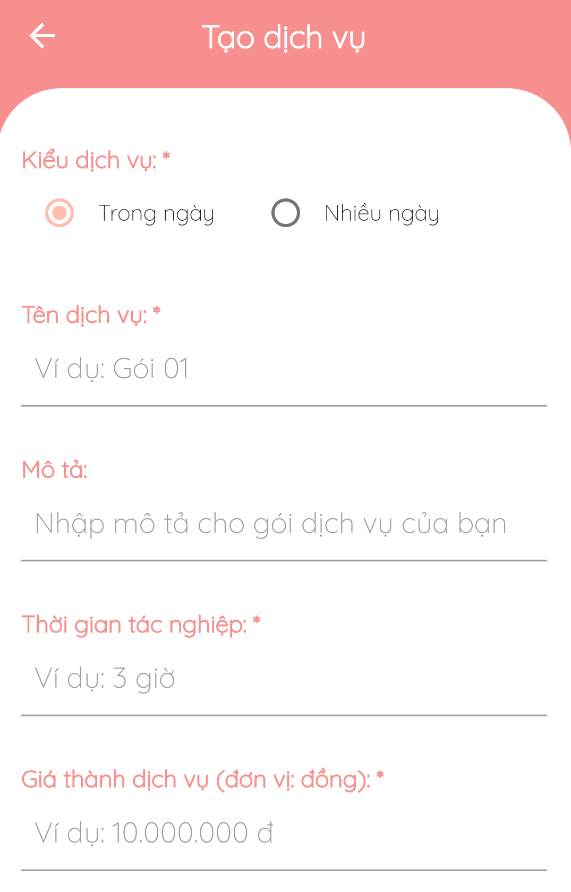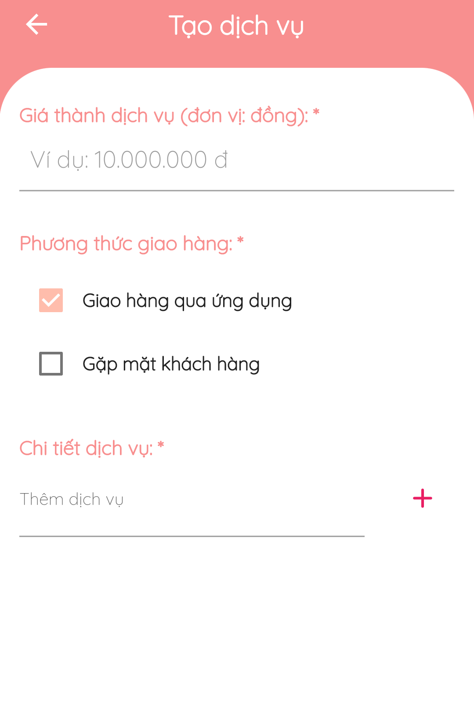

*Figure 111 - Add Service*

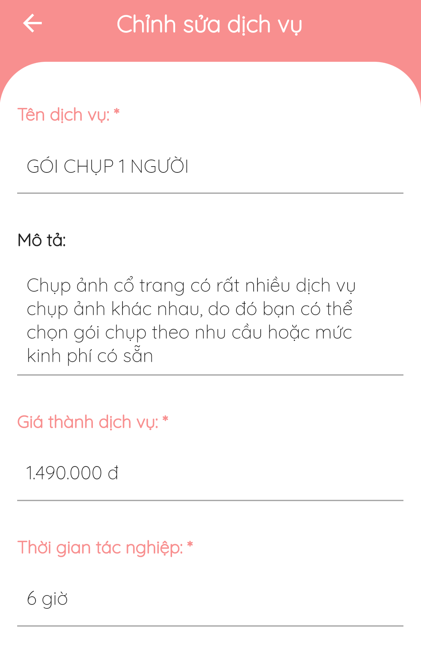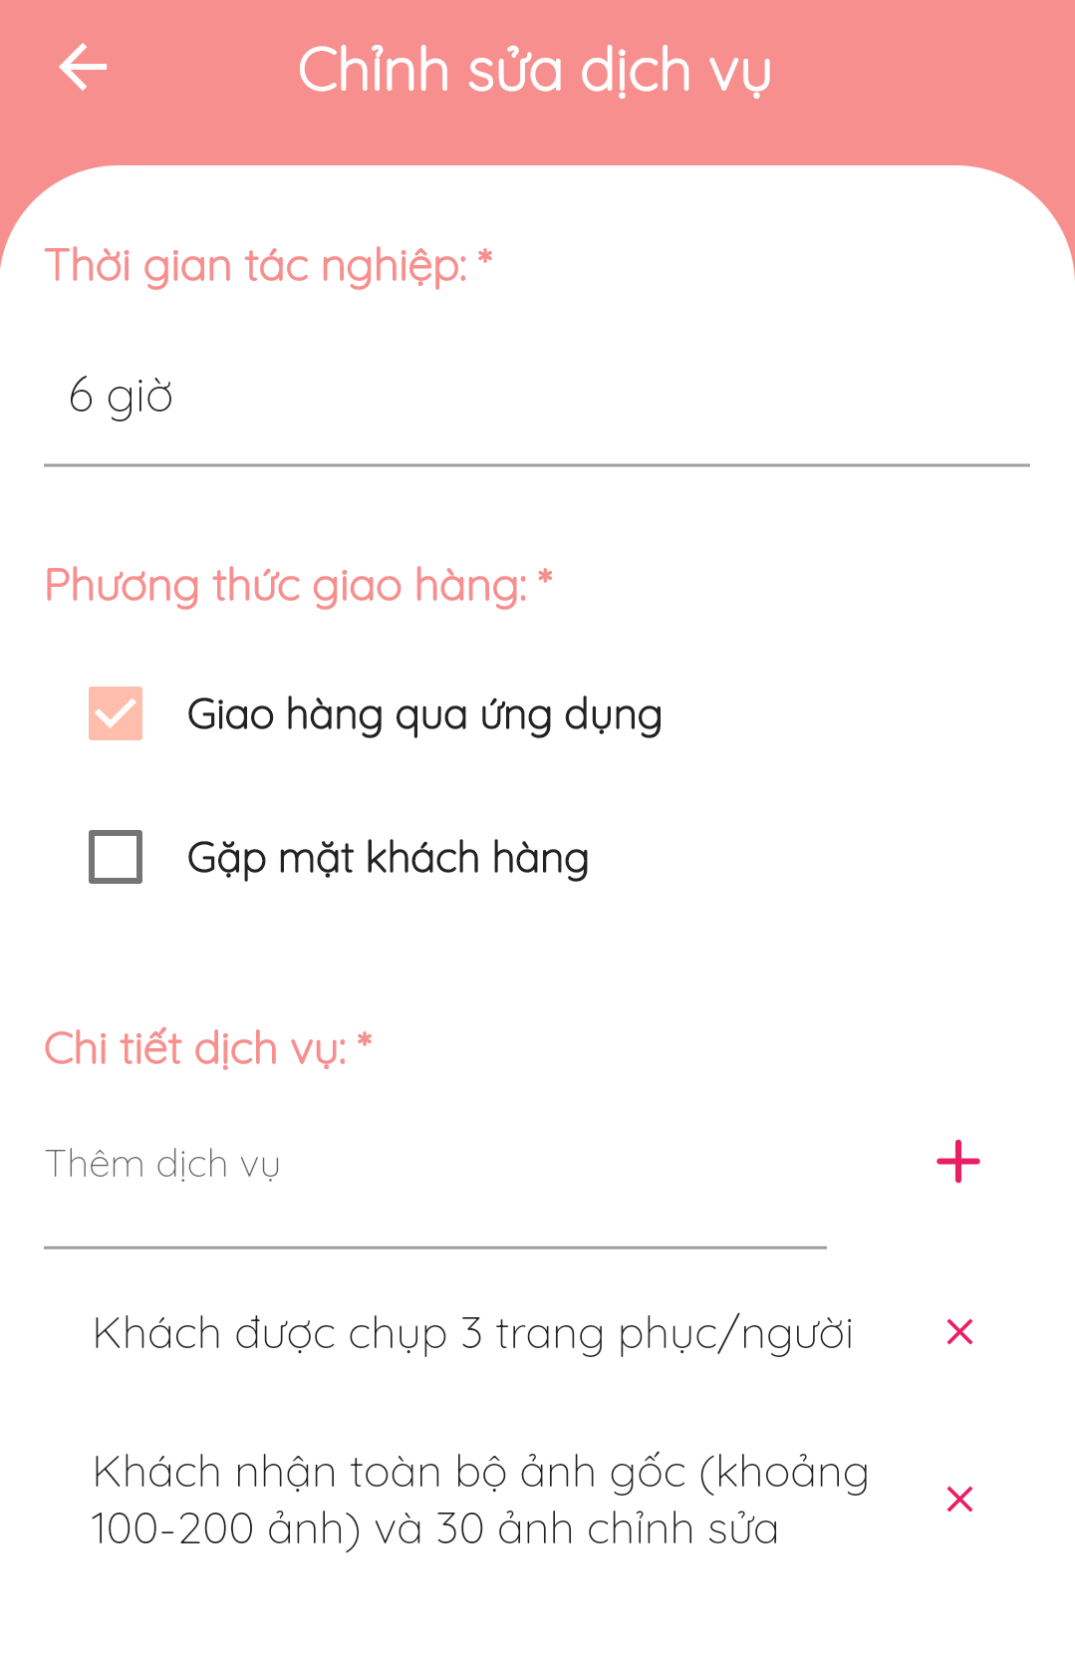

*Figure 112 - Update Service*

#### 3.3.12. Manage categories

* **Purpose**
  + Allow admins to manage shooting categories
  + Allow customers to view and select categories
* **Function**
  + View categories
  + Select categories
* **User Interfaces**

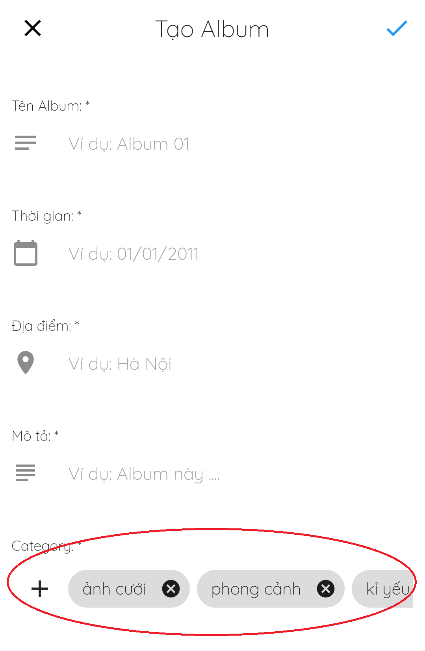

*Figure 113 - Select / View Categories*

#### 3.3.13. Chat

* **Purpose**
  + Allow customers and photographers to easily contact each other
* **Function**
  + Chat
* **User Interfaces**

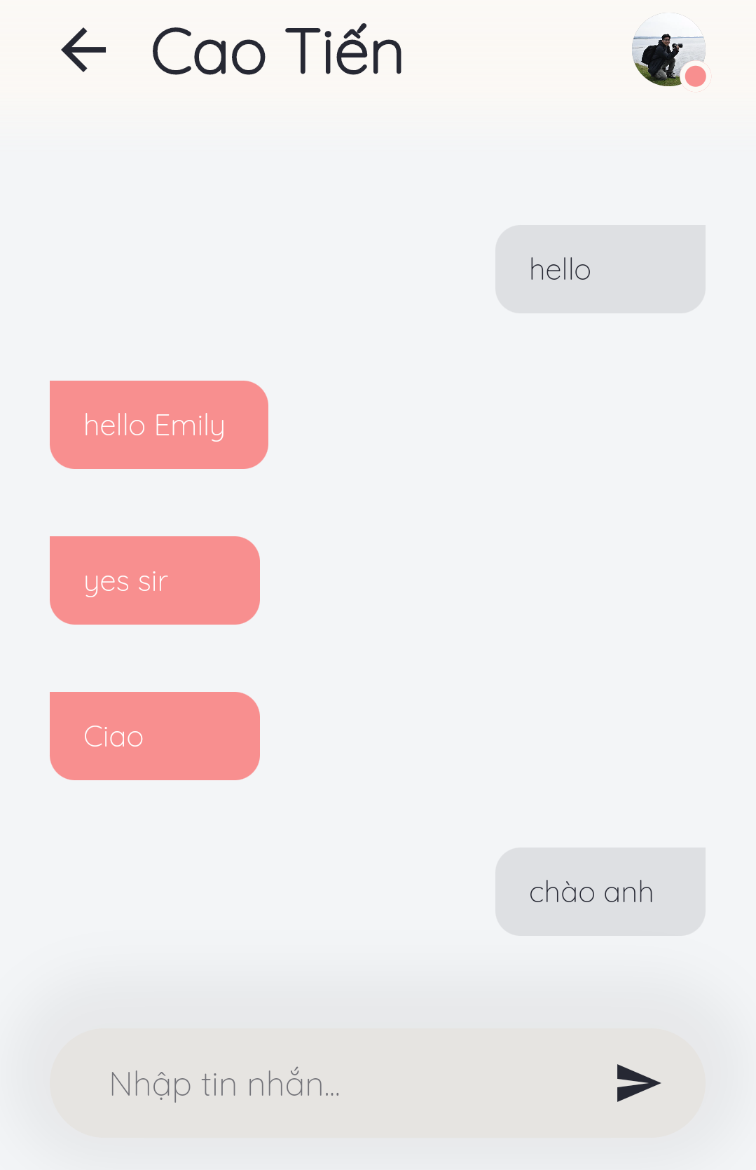

*Figure 114 - Chat*

#### 3.3.14. Forum

* **Purpose**
  + Allow users to view forum’s content
  + Comment in threads
  + Manage threads
  + Manage categories
* **Function**
  + View threads
  + View comments
  + Add threads
  + Edit threads
  + Delete threads
  + Add comments
  + Edit comments
  + Delete comments
* **User Interfaces**

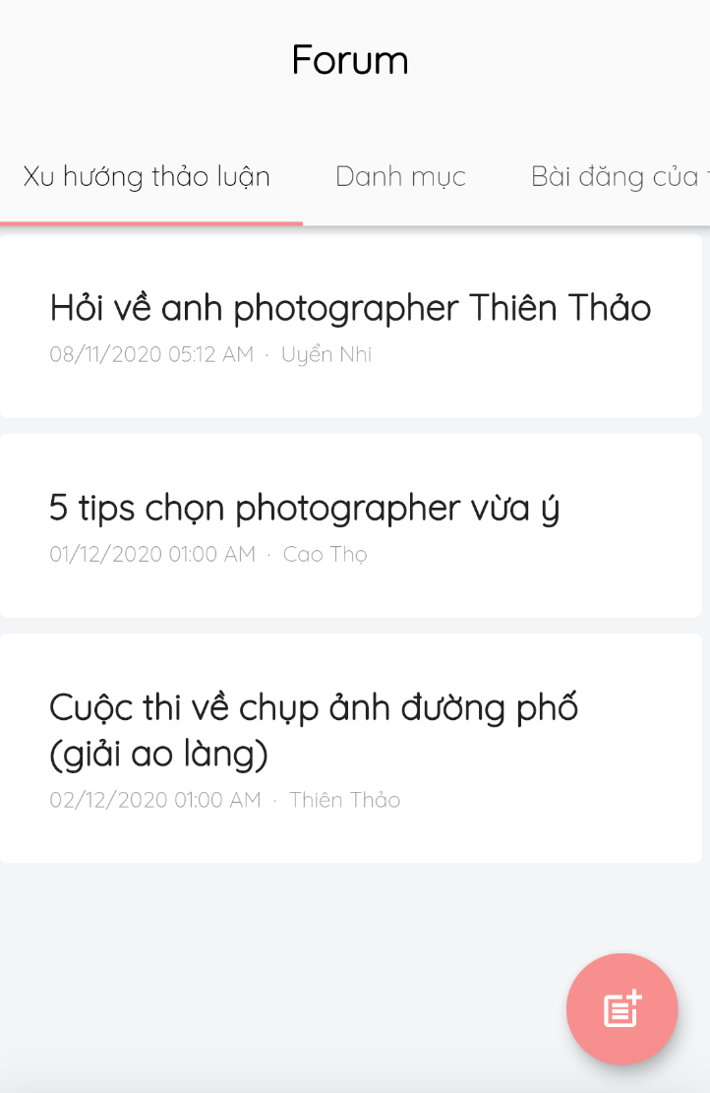

*Figure 115 - View Thread*

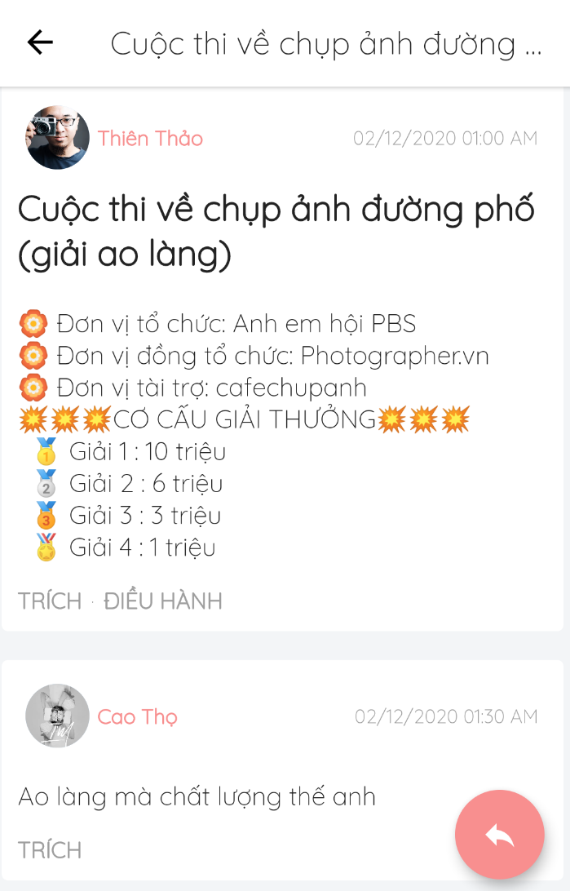

*Figure 116 - View Comment*

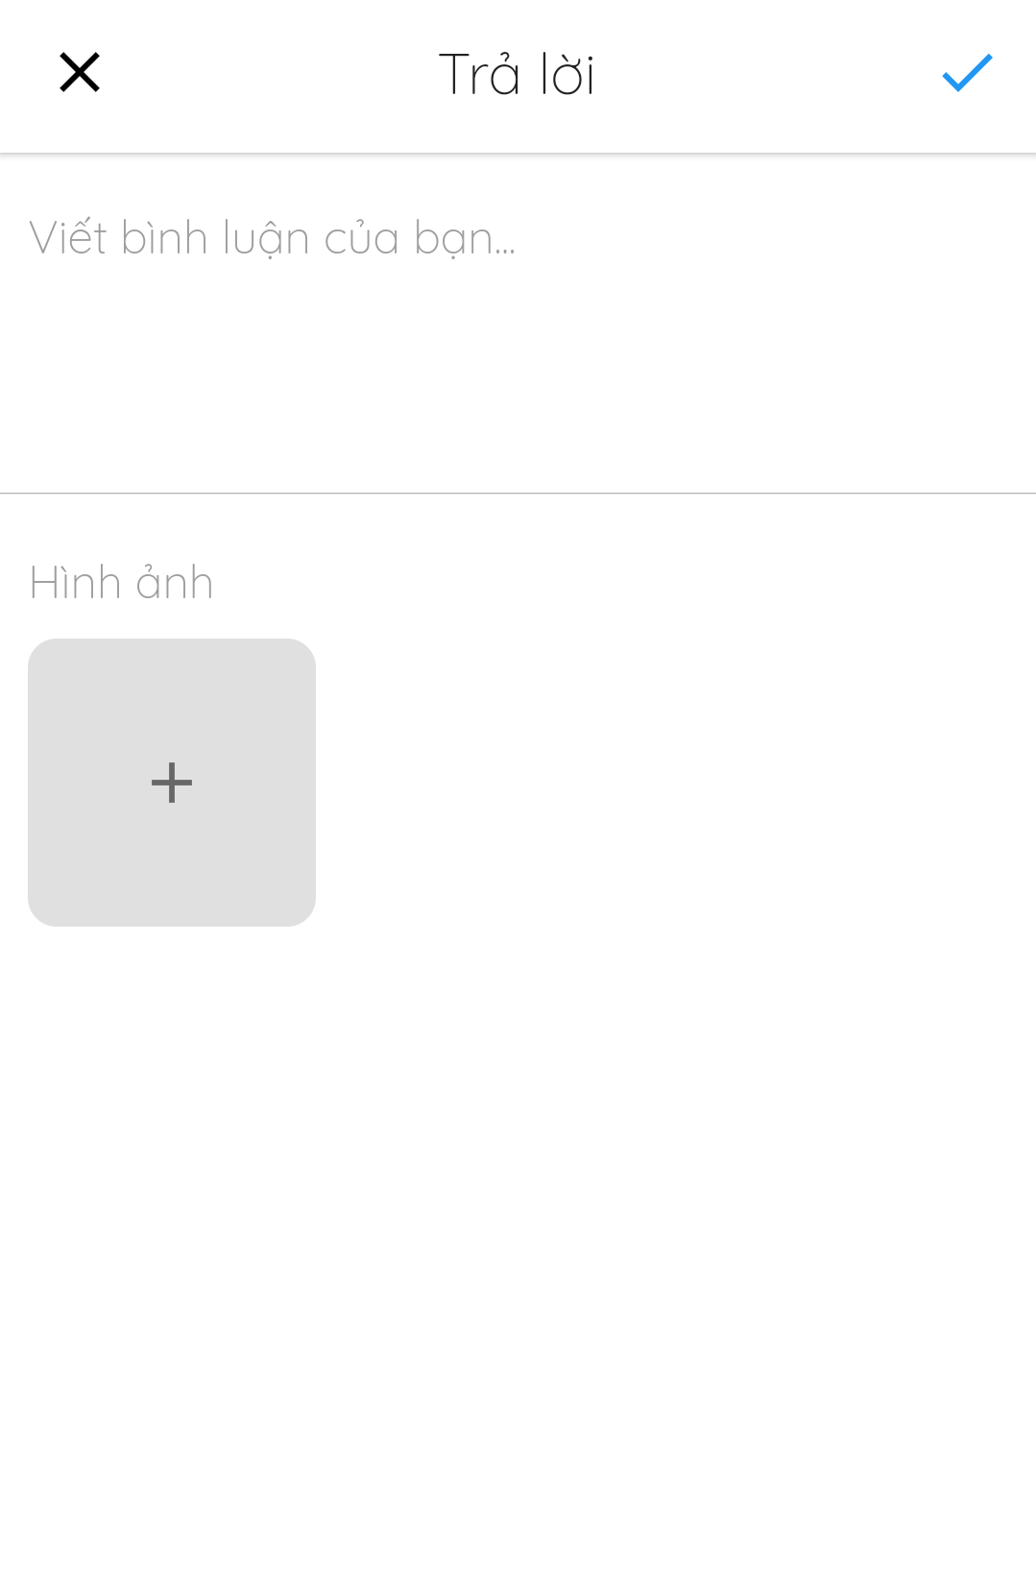

*Figure 117 - Add Comment*

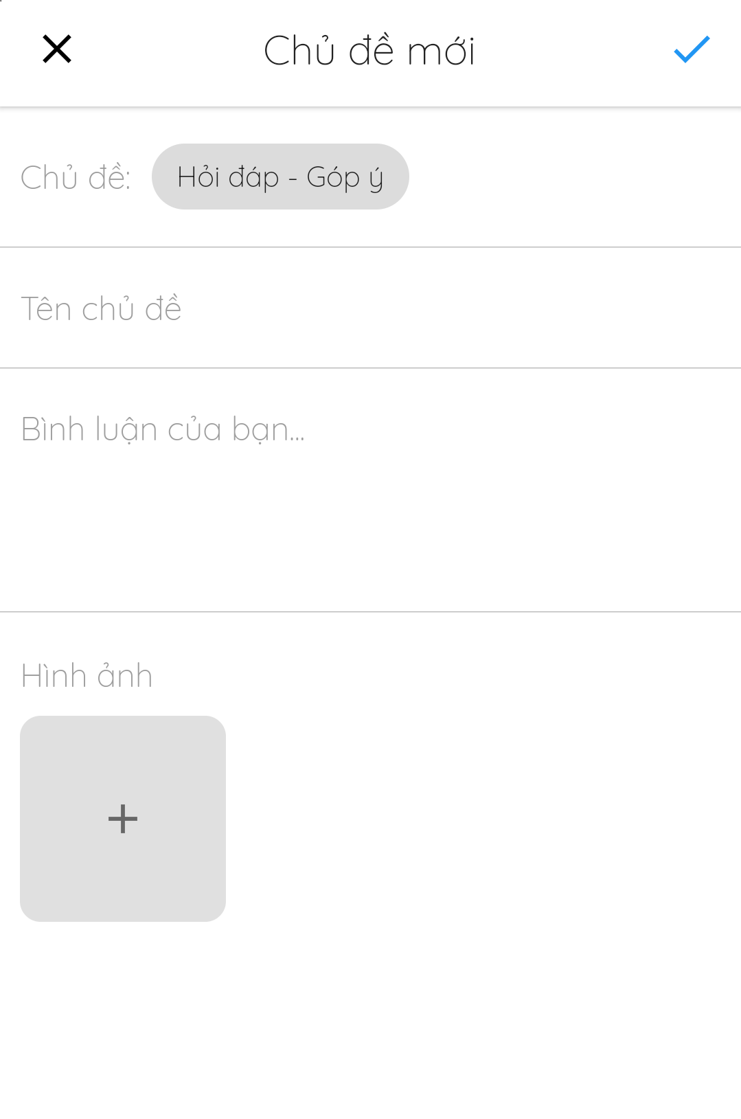

*Figure 118 - Create Thread*

#### 3.3.15. Manage delivery method

* **Purpose**
  + Allow admins to manage delivery method
  + Allow customers and photographer to view and select delivery method
* **Function**
  + Select photo delivery methods (for photographers and customers)
* **User Interfaces**

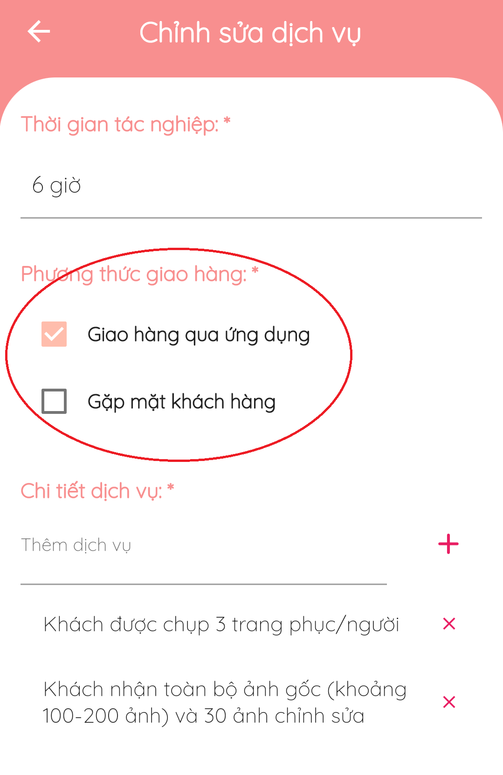

*Figure 119 - Select Photo Delivery Methods*

#### 3.3.16. Manage profile

* **Purpose**
  + Allow users to edit their profile
* **Function**
  + Edit profiles
  + Edit avatar and cover photos
* **User Interfaces**

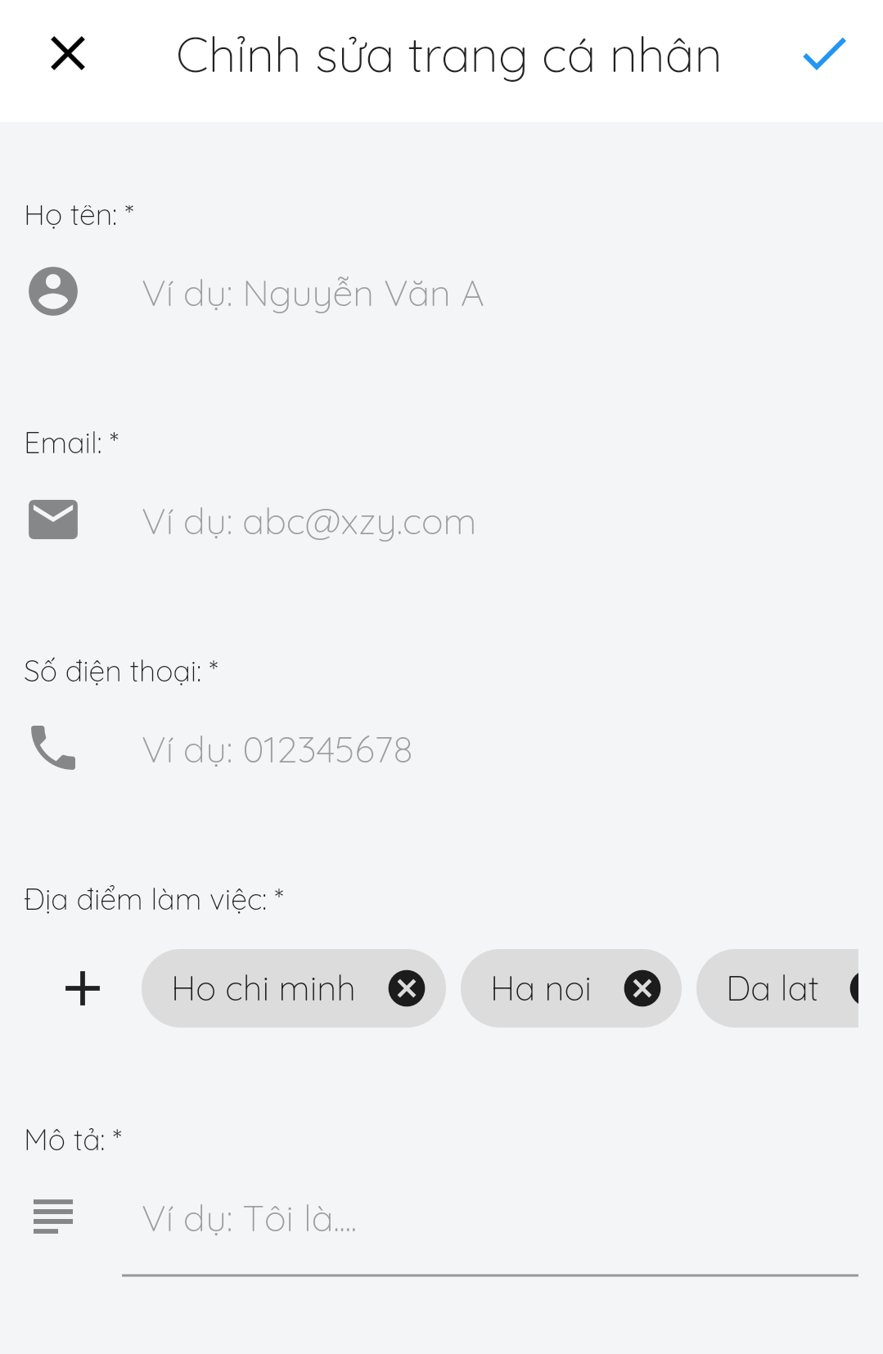

*Figure 120 - Update Profile*

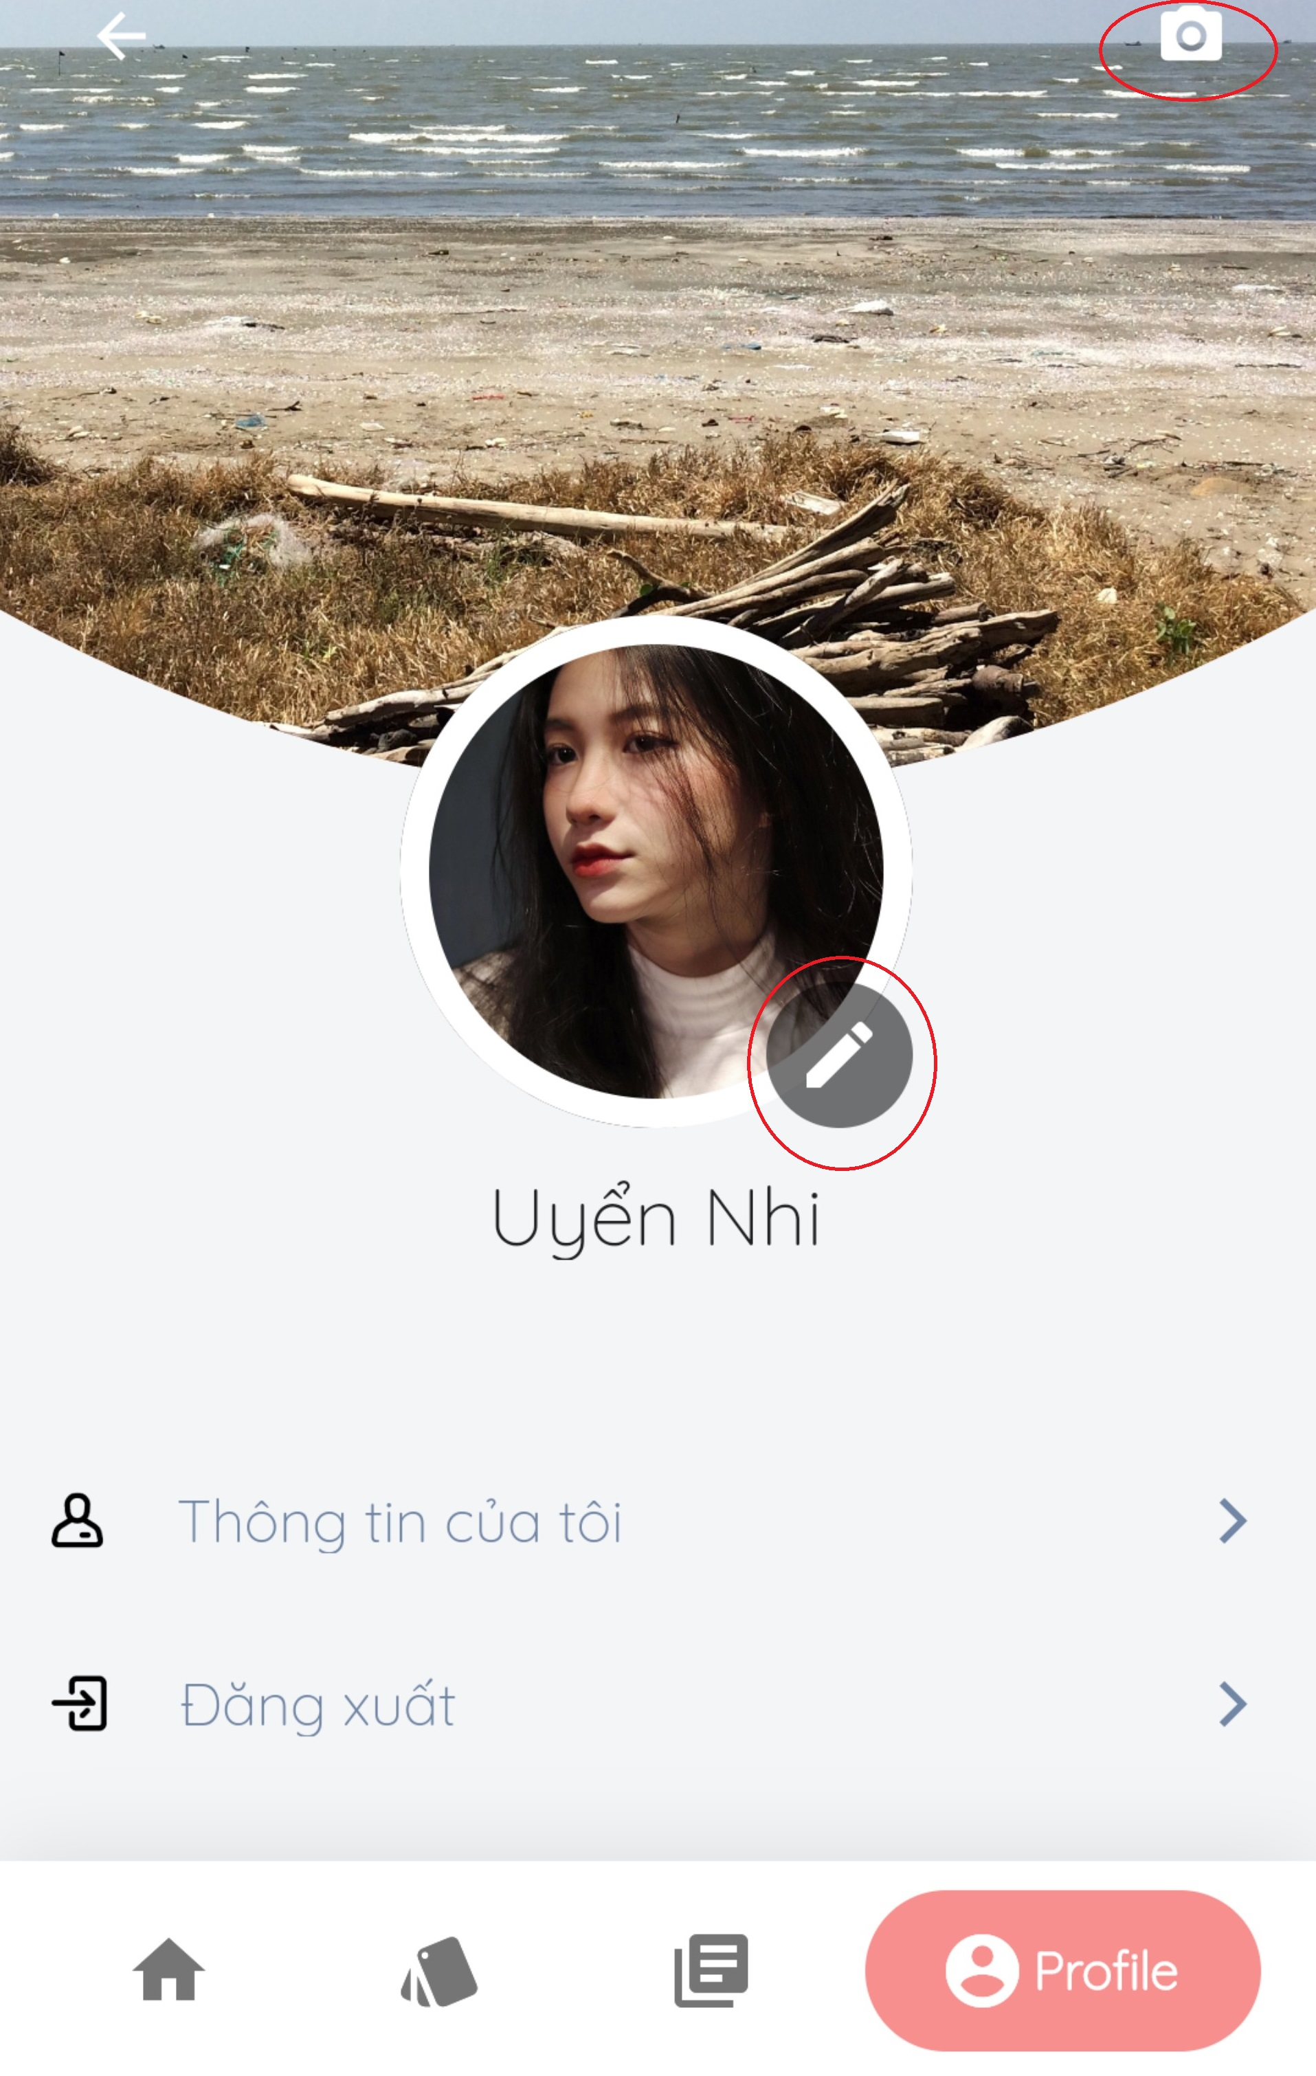

*Figure 121 - Update Avatar/ Cover*

### 3.4 Troubleshooting

1. **Current location sometimes cannot be determined**

First occurrence

* During testing time

Problem

* Current locations on phone are not allowed

**Workaround**

Do the following steps:

* **Go to Setting** > **Current locations** > **On**

1. **Profile photos are sometimes unsuccessfully updated**

First occurrence

* During testing time

Problem

* Image size exceeds maximum allowable size

**Workaround**

* Choose another photo smaller than … size

## 4.ユーザーマニュアル

### 4.1 用語と定義

アカウントはユーザーとしてサインインするために登録するアカウントです。

フォトグラファーのアプリはフォトグラファーが客に連絡するための「ＰＢＳ」によって提供されるアプリです。

客のアプリは客がフォトグラファーに連絡するための「ＰＢＳ」によって提供されるアプリです。

モバイル デバイスはフォトグラファーのアプリや客のアプリをダウンロードして実行するために使えるケイタイ、タブレット、他のデバイスです。

システムとはフォトグラファーのアプリ、客のアプリ、ウェブサイト、プラットフォームなど、フォトグラファーや客の連絡をサポートするために「ＰＢＳ」によって提供するシステムです。

フォトグラファーは客がシステムで予約できる撮るサービスを提供する独立した第三者です。

客は客のアプリのアカウントを持っている人です。

ウェブサイトは「ＰＢＳ」が運営するウェブサイトです。

### 4.2システム要件

**4.2.1ハードウェア**要件

**パソコン**

|  |  |  |
| --- | --- | --- |
| **パソコン** | **最小要**件 | おすすめ |
| インターネット接続 | ケーブル、ワイファイ　（４Ｍｂｐｓ） | ケーブル、ワイファイ　（８Ｍｂｐｓ） |
| オペレーティング システム | ＷＩＮＤＯＷＳ７ | ＷＩＮＤＯＷＳ７以上 |
| コンピュータプロセッサ | インテル®コア i3 1.4GHz | インテル®コア i3 ２．５GHz |
| コンピュータメモリ | 1GB RAM | 2GB RAM以上 |
| ウェブブラウザ | グーグル クローム(v42 以上) | グーグル クロームの最新安定版 |

**アンドロイドデバイス**

|  |  |
| --- | --- |
| **オペレーティング システム** | アンドロイド8.0以上 |
| **プロセッサ** | インテル Atom® プロセッサ Z2520 1.2 GHz 以上のプロセッサ |
| **ストレージ** | 言語バージョンに応じて 850 MB と1.2 GB の間です。 |
| **RAM** | 最小は512 MB です。  2 GB はおすすめです。 |
| **ハードディスク** | インストール用は 2 GB のハード ディスクのスペースが必要です。  フラッシュ ストレージ デバイスを使用してインストールすることはできません。. |
| **ビデオ** | 1920 x 1080 ピクセル以上。 |
| **ブラウザ/インターネット** | このアプリは、オンラインで使うように設計されています。  「GOOGLEPLAY」ストアアプリをダウンロードして起動するには、高速インターネット接続をおすすめします。 |

**4.2.2ソフトウェア要件**

|  |  |  |
| --- | --- | --- |
| **ソフトウェア** | **名前/バージョン** | **説明** |
| オペレーションシステム | ウィンドウズ 7, ウィンドウズ 10 | 開発用のオペレーティング システムとプラットフォーム |
| ウェブブラウザ | クロム 69以上, *ファイアーフォックス* | ウェブアプリ用 |
| アンドロイドシステム | アンドロイド4.0以上 | モバイルアプリ用 |

### 4.3アプリの使用

#### 4.3.1. 概要

客のアプリでは客がフォトグラファーを検索し、予約することができます。その後、客は自分の体験に基づいてフォトグラファーを評価することができます. 評価は星として表示され、フォトグラファーのプロフィールに表示されるレビューすることができます. ユーザーに写真や流行のスタイルについての情報を提供するために、システムにフォーラムもあります。

フォトグラファーのアプリはフォトグラファーが潜在的な客の広い範囲に達するのに役立ちます. また、撮るスケジュールを管理したり、客の予約を受け取ることができます。そして、プロフィールを編集したり、アルバムや提供するサービスを追加したりすることができます。フォーラムに参加することもできます。

システムには「ＡＤＭＩＮＩＳＴＲＡＴＯＲ」に簡単にシステムを制御できるように、ウェブサイトを提供します。「ＡＤＭＩＮＩＳＴＲＡＴＯＲ」には撮るカテゴリを追加、デリート、編集したり、写真配信方法を管理したりできます。コミュニティ標準に違反しているユーザーをブロックできます。

#### 4.3.2. 登録

* **目標**
  + ユーザーのアカウントを作成します
* **機能**
  + 「ＰＢＳ」アカウントを作成します
  + グーグルでサインアップします
  + フェイスブックでサインアップします
* **ユーザ インターフェイス**

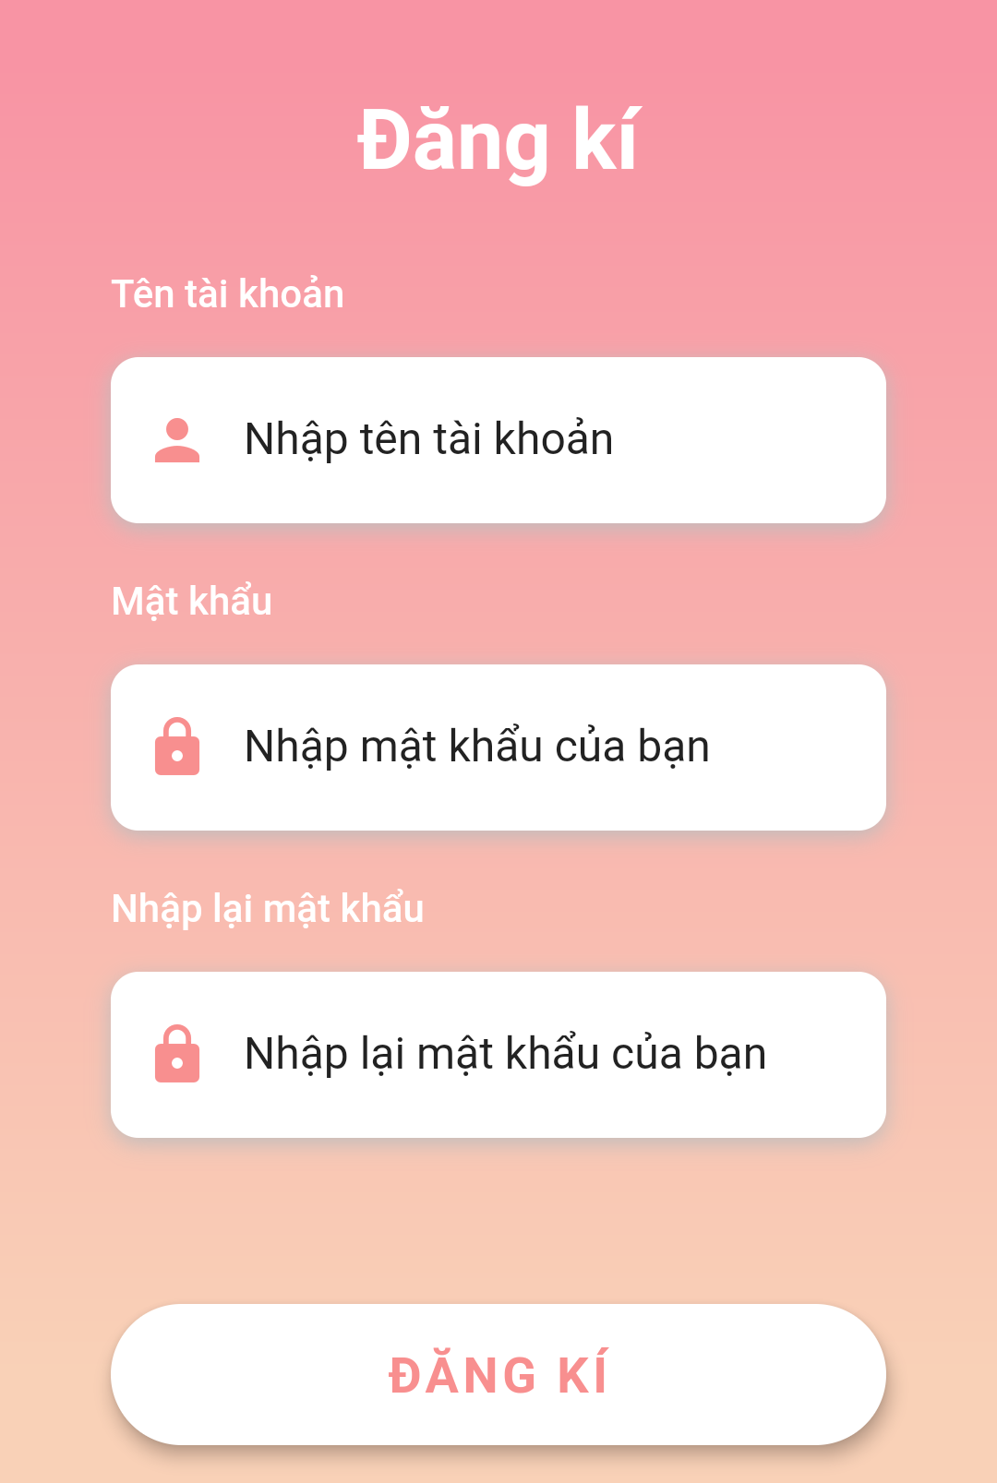

*図１－「ＰＢＳ」アカウントを作成する*



*図２－フェイスブック／グーグルでサインアップ*

#### 4.3.3. ログイン

* **目標**
  + ユーザーがサインインします
* **機能**
  + 「ＰＢＳ」 アカウントでサインインします
  + グーグルでサインインします
  + フェイスブック アカウントでサインインします
* **ユーザーインターフェース**

#### 4.3.4. ログアウト

* **目標**
  + ユーザーがサインアウトします
* **機能**
  + サインアウトします
* **ユーザーインターフェース**

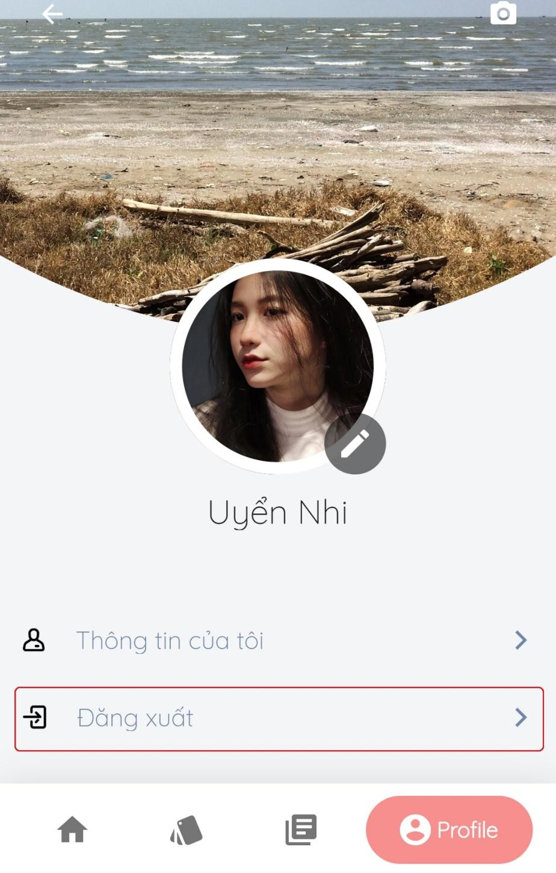

*図122 – ログアウト*

#### 4.3.5. フォトグラファーを検索

* **目標**
  + 客が適用な***フォトグラファー***やサービスを見つけます
* **機能**
  + フォトグラファーを検索します
  + サービスを検索します
* **ユーザーインターフェース**

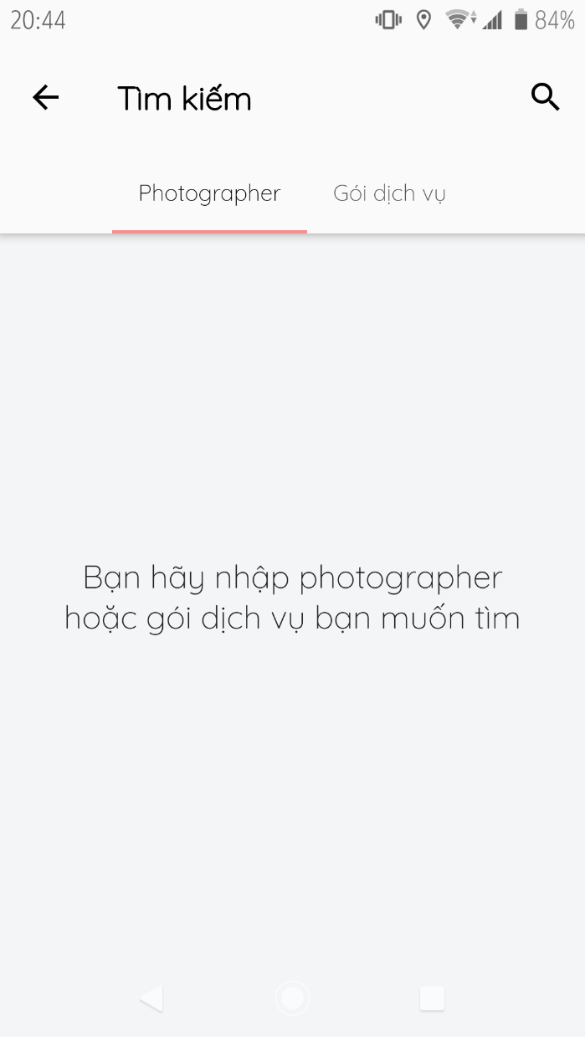

*図123-フォトグラファー／サービスの検索*

#### 4.3.6. リクエストの管理

* **目標**
  + 客が予約を管理できます
* **機能**
  + 数日を予約します (客のみ)
  + 一日を予約します(客のみ)
  + 予約を変更します(客のみ)
  + 予約をキャンセルします(客のみ)
  + 予約の受け入れます(フォトグラファーのみ)
  + 予約を断ります(フォトグラファーのみ)
* **ユーザーインターフェース**

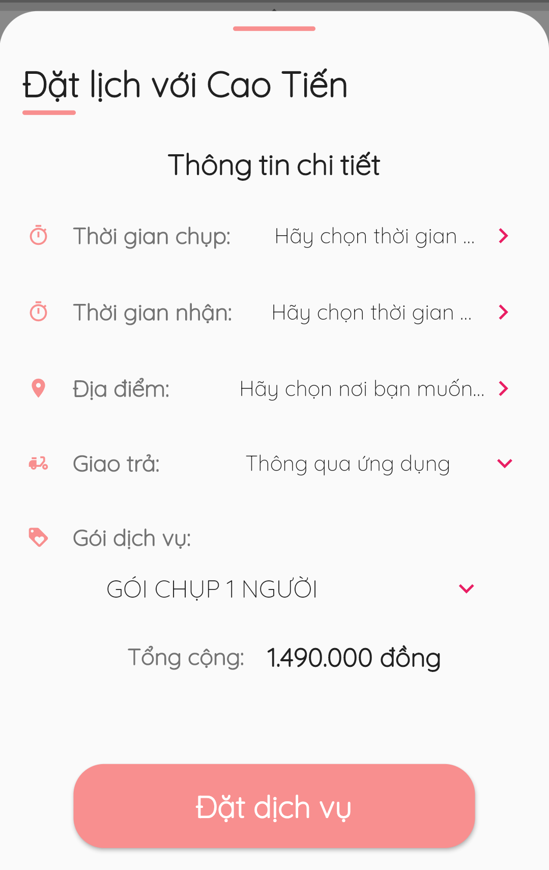

*図124 –一日の予約*

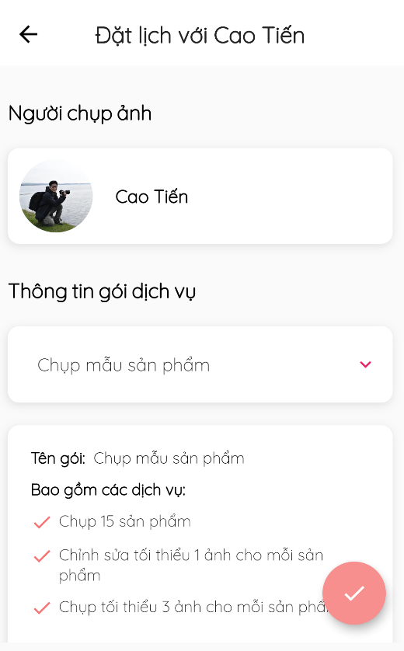

*図125 –数日の予約*

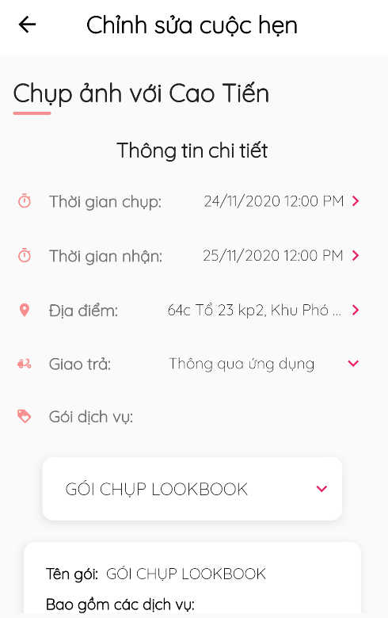

*図126 - 一日の予約の変更*

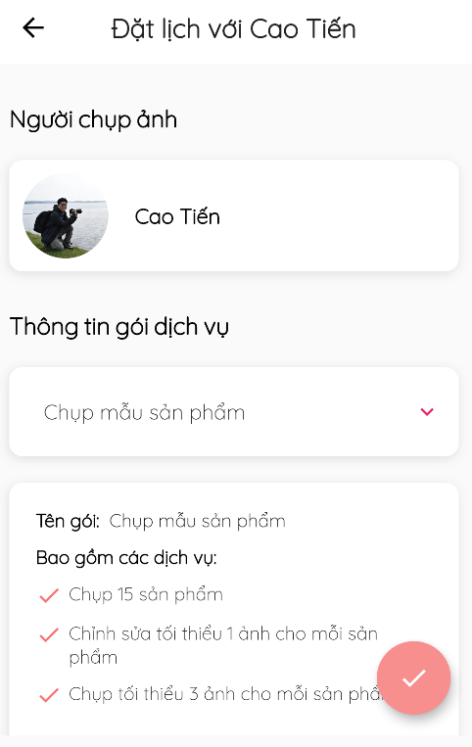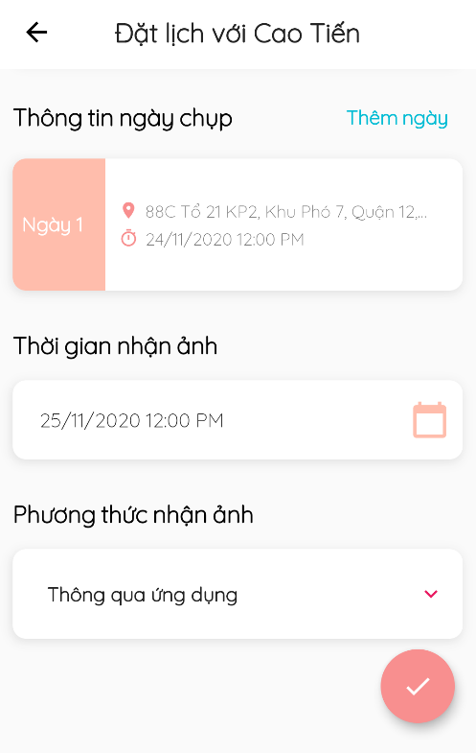

*図127 -数日の予約の変更*

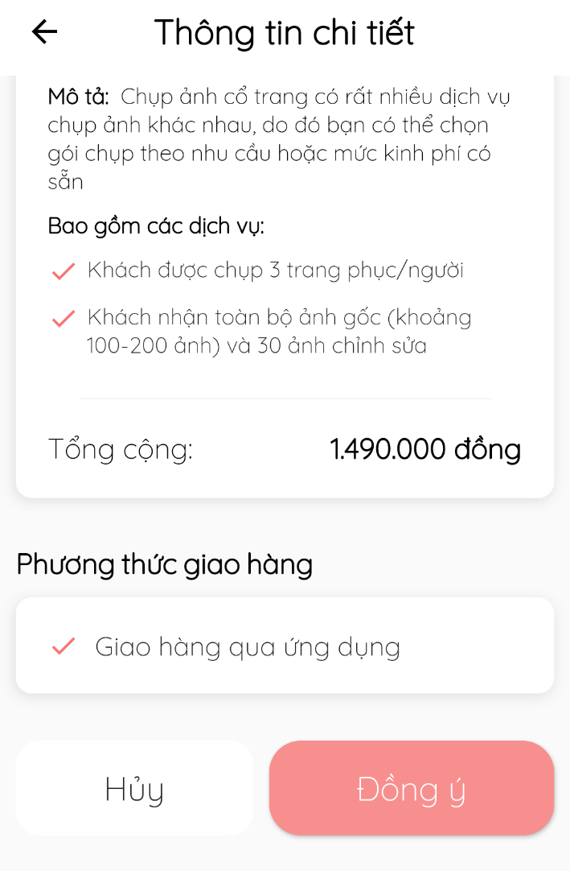

*図128 – 予約の断り/受入 /キャンセル*

#### 4.3.7. レビューの管理

* **目標**
  + 客がサービスをレビューします
  + レビューを管理します
* **機能**
  + レビューを観ます
  + レビューを書きます(客のみ)
* **ユーザーインターフェース**

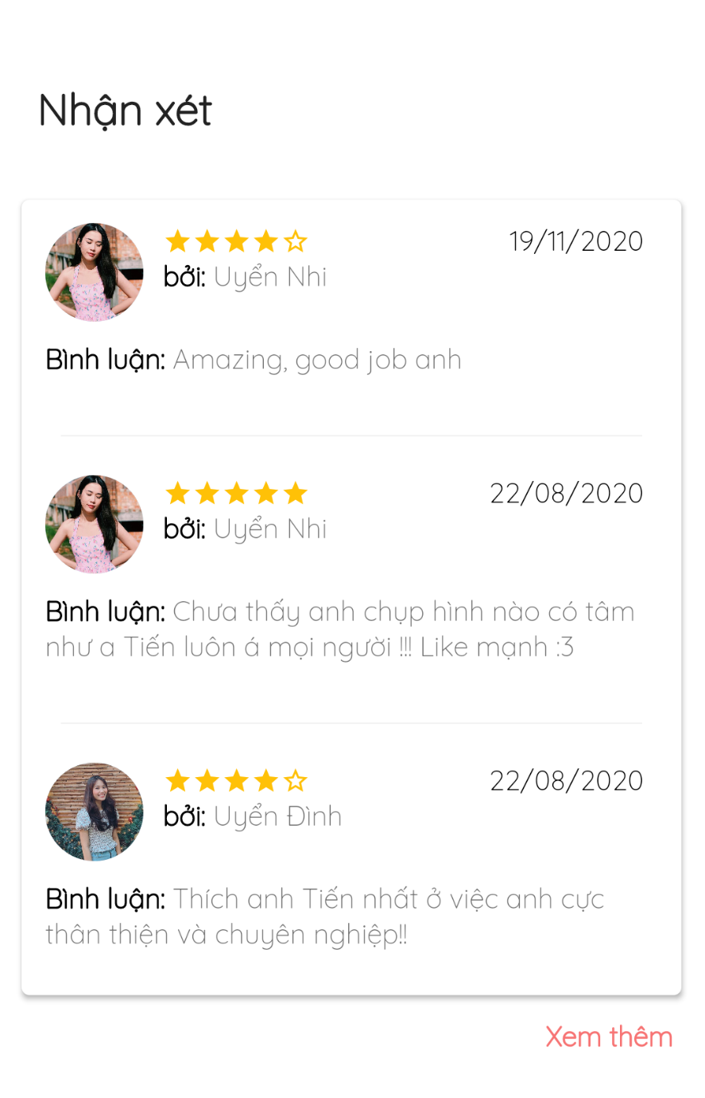

*図129 – レビューをを観ます*

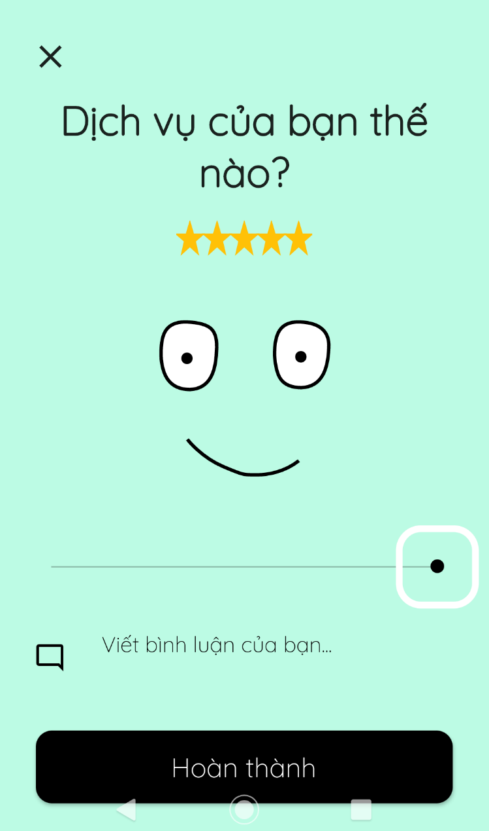

*図130 – レビューを書きます*

#### 4.3.8. リクエストの状態の管理

* **目標**
  + フォトグラファーがリクエストの状態を変更します
* **機能**
  + リクエストの状態を変更します
* **ユーザーインターフェース**

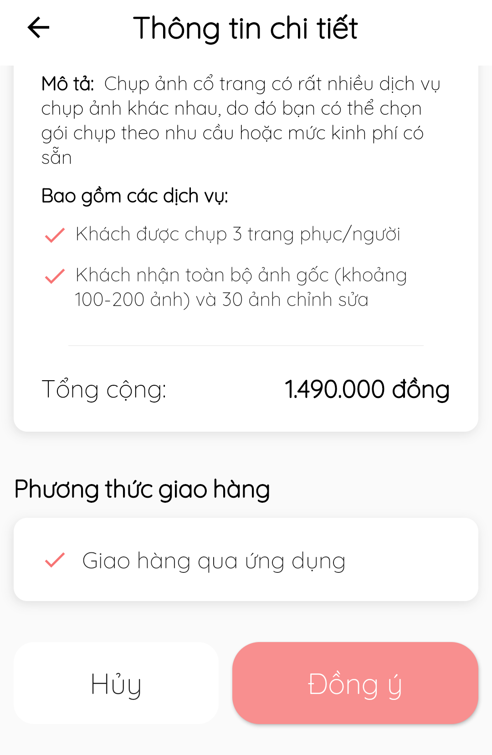

*図131 - 予約の状態を変更します*

#### 4.3.9. カレンダーの管理

* **目標**
  + フォトグラファーが撮るスケジュールを変更します
* **機能**
  + 毎日の撮るスケジュールを管理します
  + 毎日の撮るスケジュールを変更します
  + 都合がない日を追加します
* **ユーザーインターフェース**

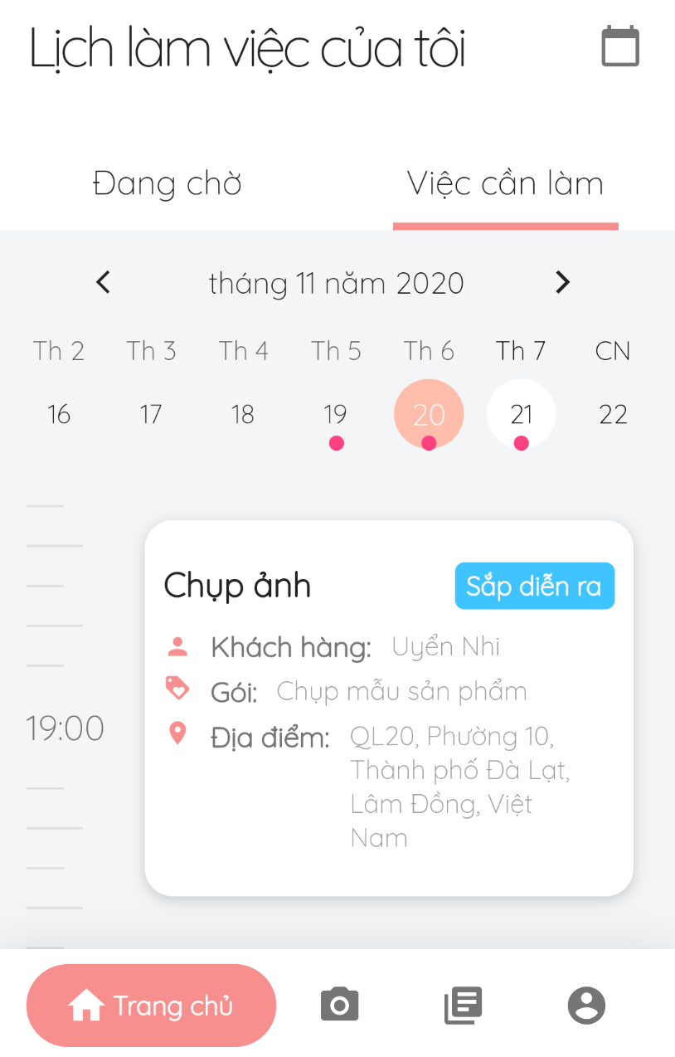

*図132 - 撮るスケジュール*

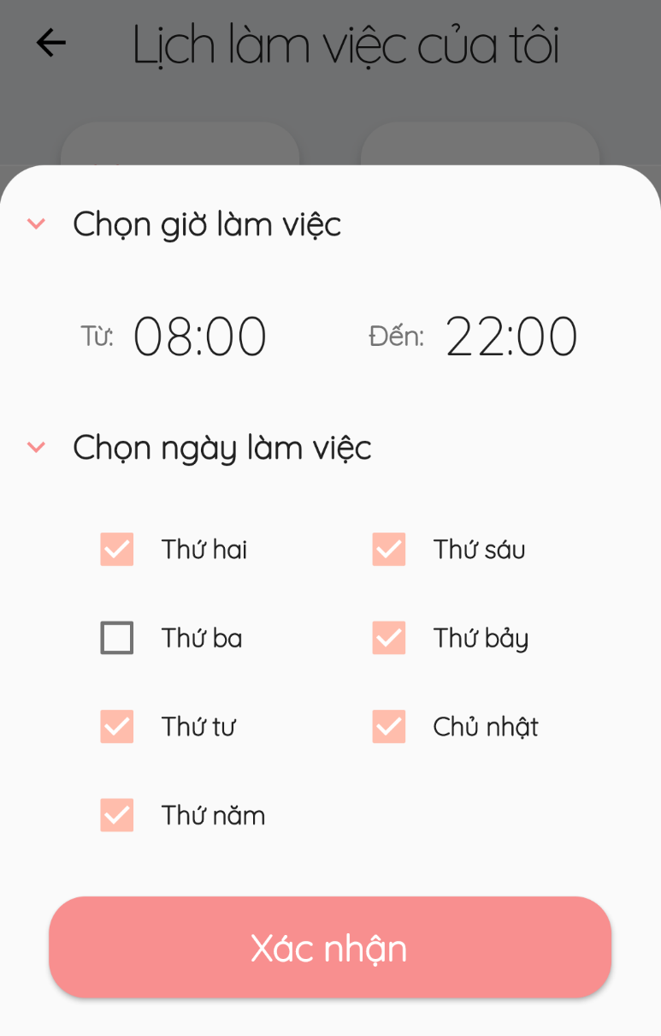

*図133 – 毎日の撮るスケジュールを変更します*

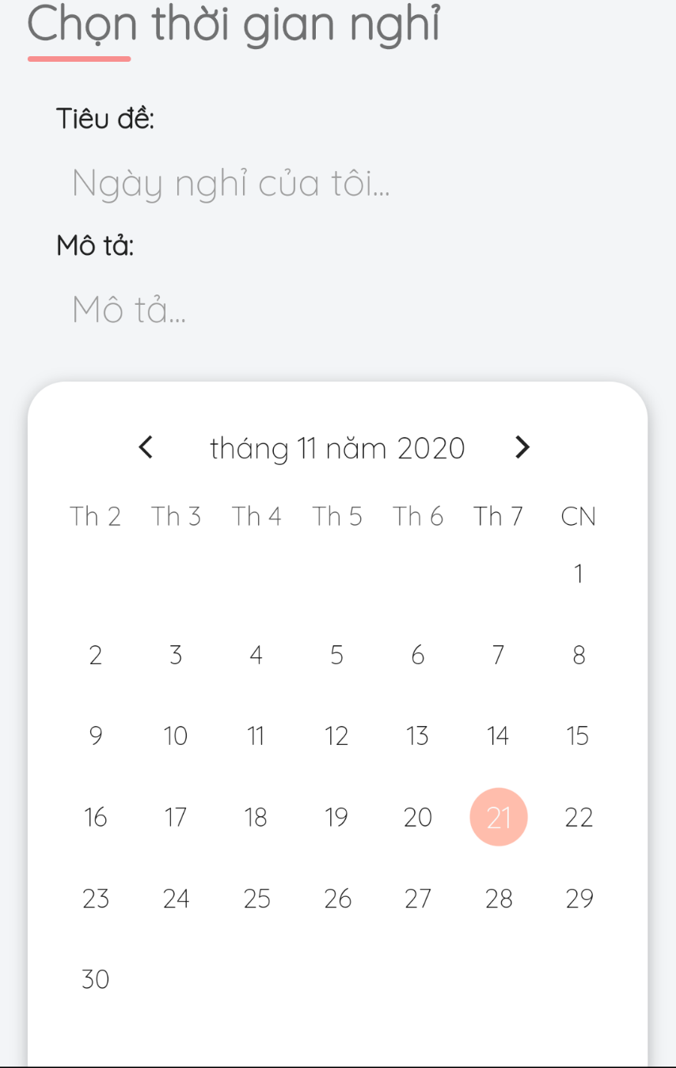

*図134 – 都合がない日を追加します*

#### 4.3.10. アルバムの管理

* **目標**
  + フォトグラファーがアルバムを管理します
  + 客が好きなアルバムをフォローします
* **機能**
  + アルバムを追加します(フォトグラファーのみ)
  + アルバムを変更します(フォトグラファーのみ)
  + アルバムをデリートします (フォトグラファーのみ)
  + アルバムをフォローします (客のみ)
* **ユーザーインターフェース**

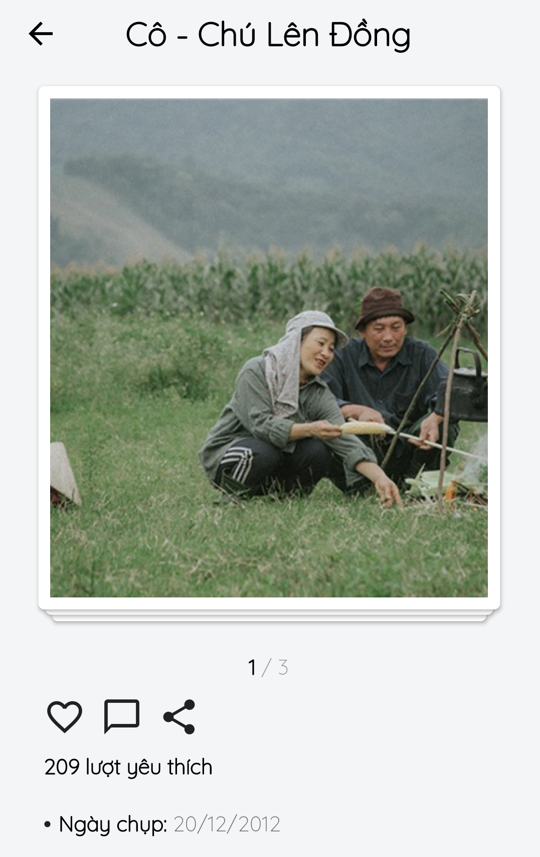

*図135 – アルバムをフォローする*

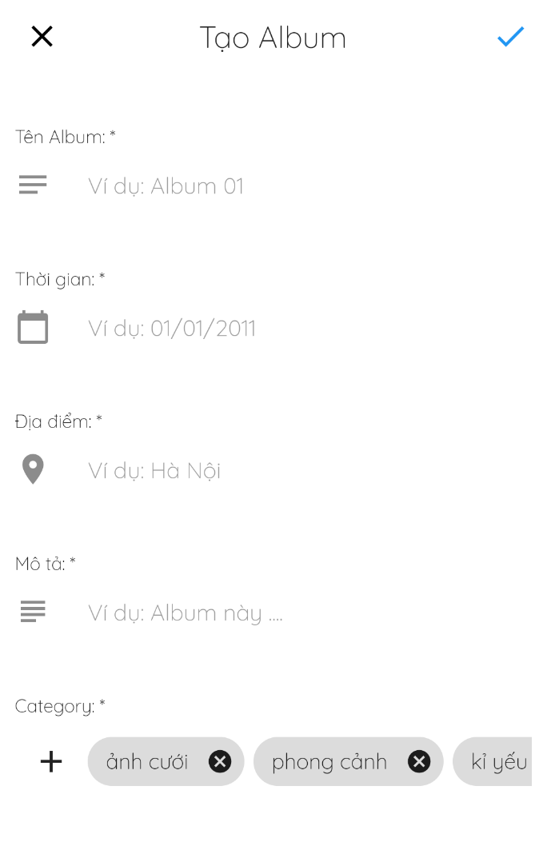

*図136 - アルバムを追加します*

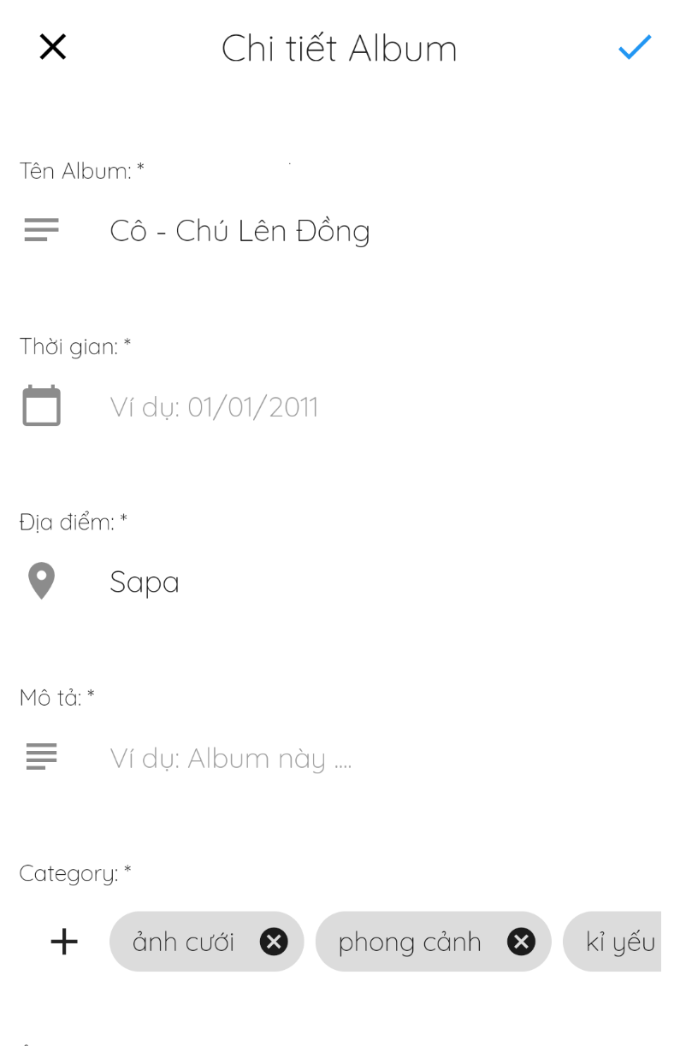

*図137 – アルバムを変更します*

#### 4.3.11. サービスの管理

* **目標**
  + フォトグラファーがサービスを管理します
  + 客がフォトグラファーのサービスを観ます
* **機能**
  + サービスを追加します(フォトグラファーのみ)
  + サービスを変更します(フォトグラファーのみ)
  + サービスを削除します(フォトグラファーのみ)
  + サービスを観ます
* **ユーザーインターフェース**

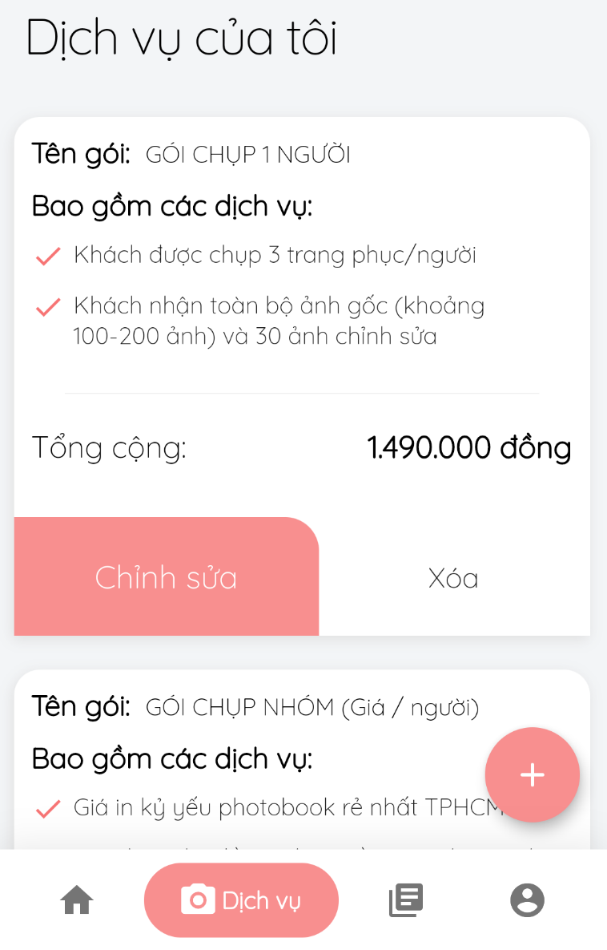

*図138 – サービスを観ます*

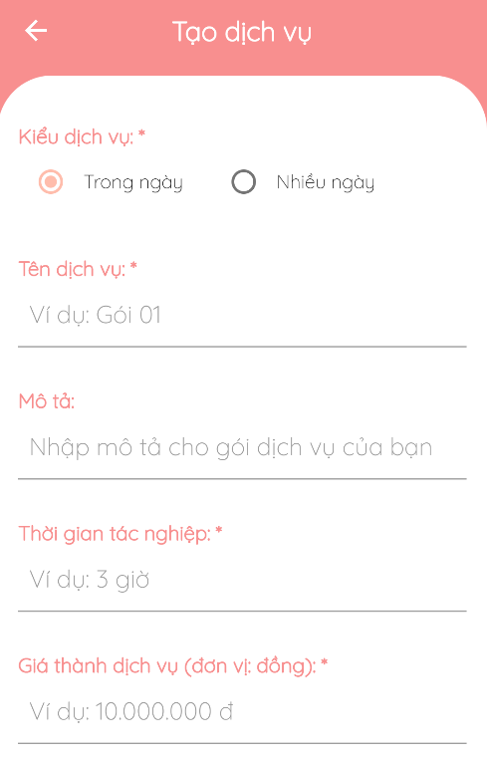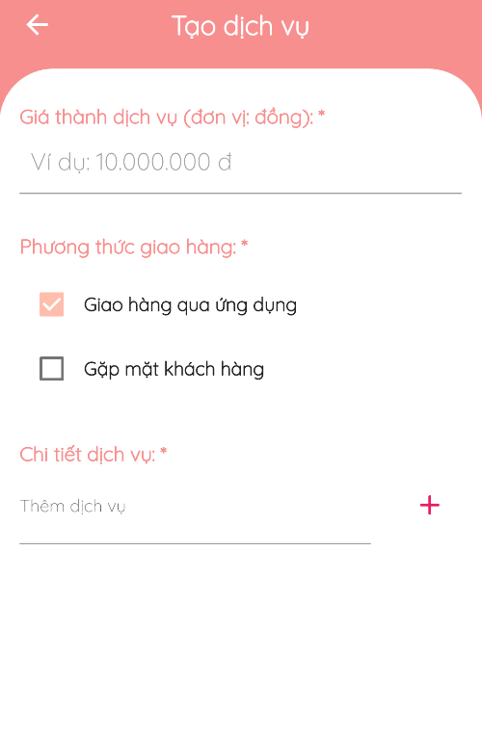

*図139 - サービスを追加します*

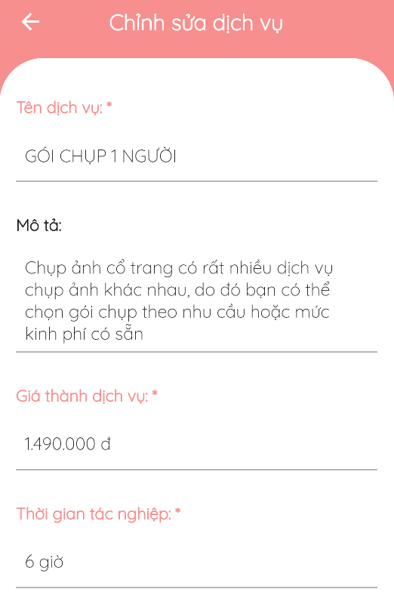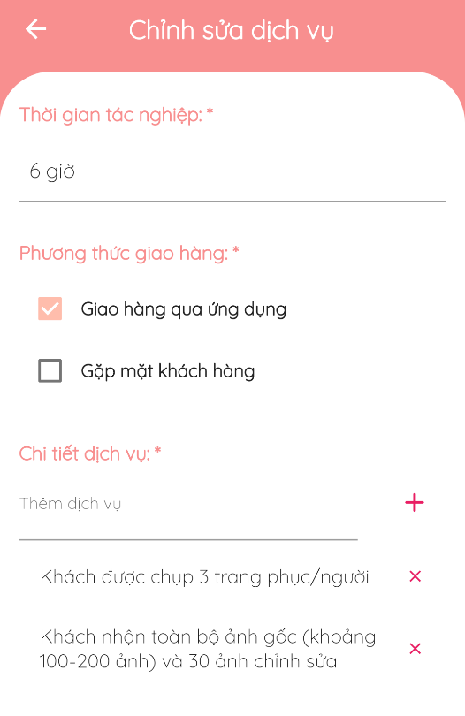

*図140 – サービスを変更します*

#### 4.3.12. カテゴリーの管理

* **目標**
  + 客がカテゴリーを観たり、選択します
* **機能**
  + カテゴリーを観ます
  + カテゴリーを選択します
* **ユーザーインターフェース**

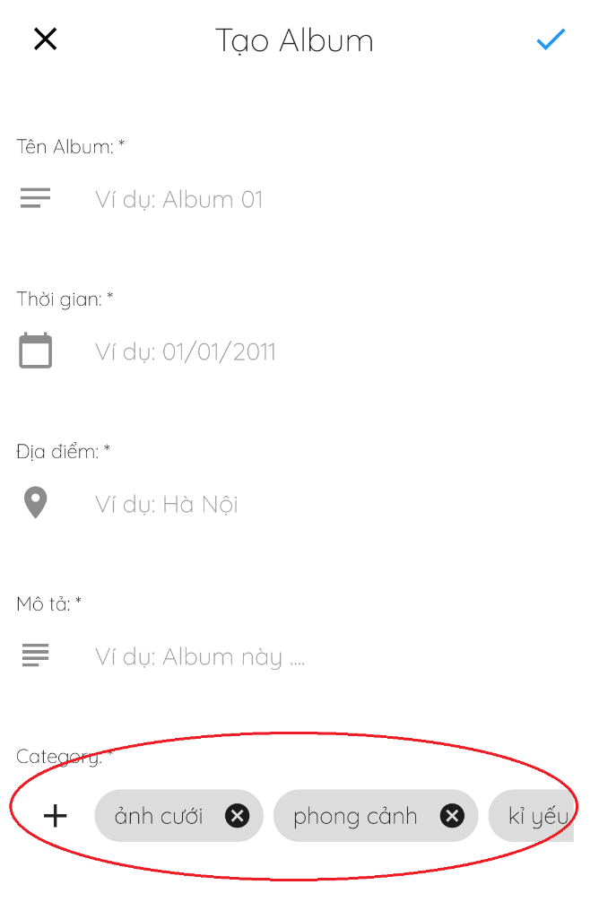

*図141 – カテゴリーを観ます／選択します*

#### 4.3.13. チャット

* **目標**
  + 客とフォトグラファーが簡単に連絡します
* **機能**
  + チャット
* **ユーザーインターフェース**

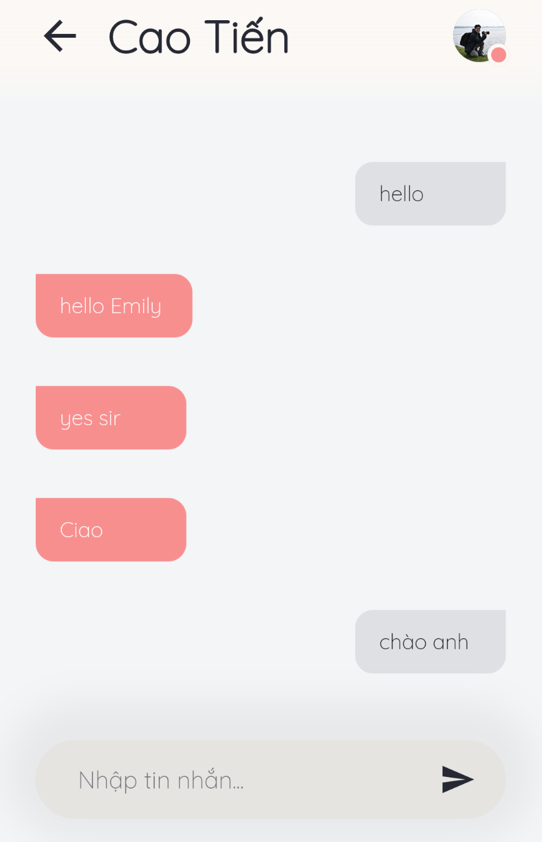

*図142 – チャット*

#### 4.3.14. フォーラム

* **目標**
  + ユーザーがフォーラムのコンテンツを観ます
  + スレッドにコメントします
  + スレッドを管理します
  + カテゴリーを管理します
* **機能**
  + スレッドを観ます
  + コメントを観ます
  + スレッドを追加します
  + スレッドを編集します
  + スレッドをデリートします
  + コメントを追加します
  + コメントを編集します
  + コメントをデリートします
* **ユーザーインターフェース**



*図143 – スレッドを観ます*



*図144 – コメントを観ます*

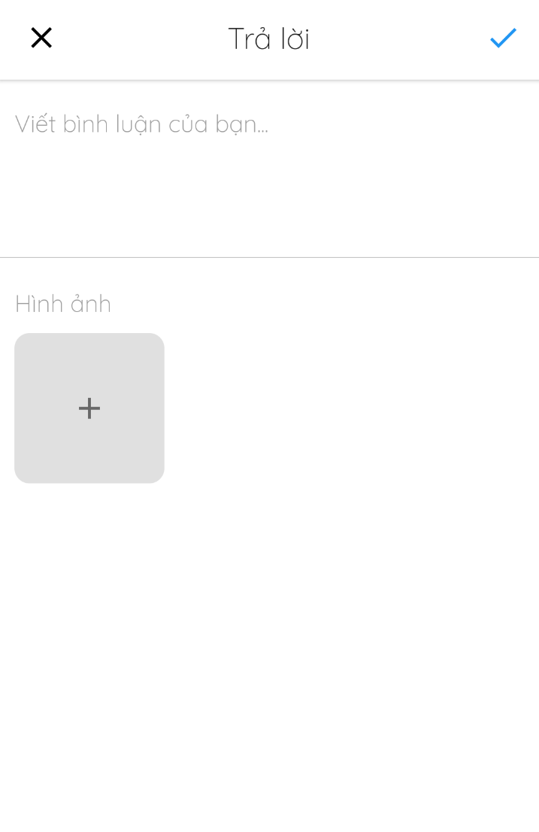

*図145 – コメントをを追加します*

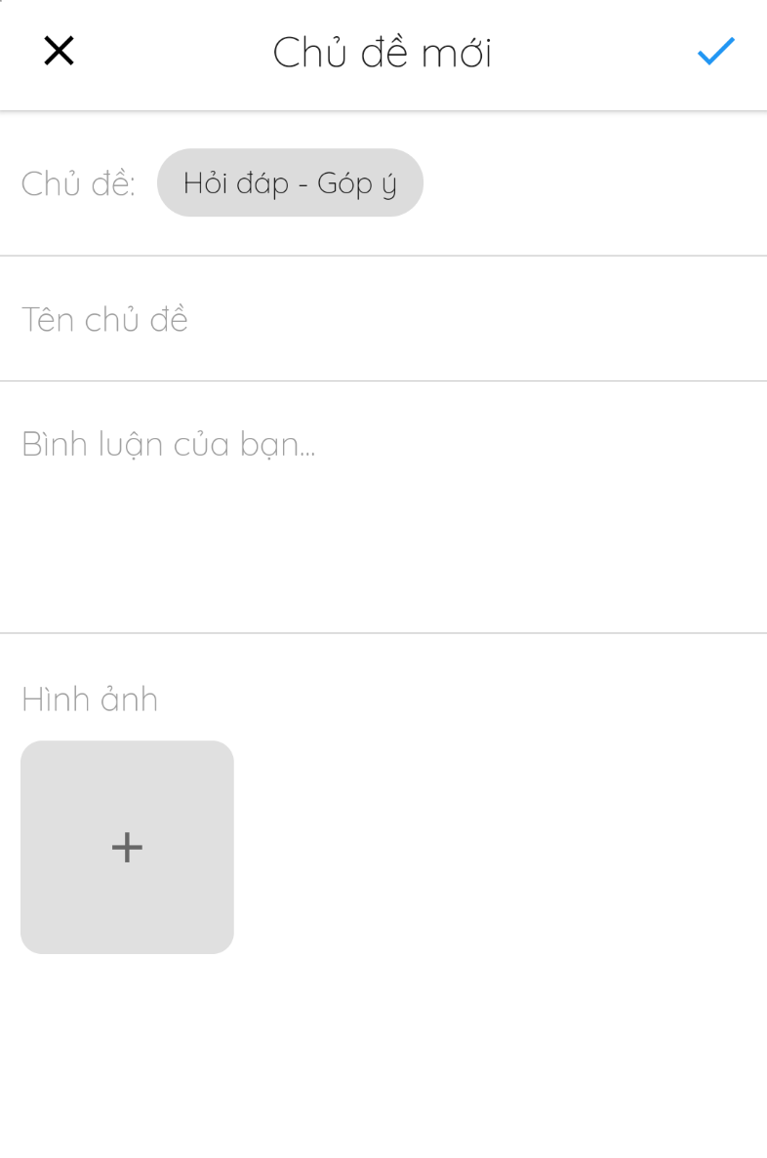

*図146 – スレッドを追加します*

#### 4.3.15. 配信方法の管理

* **目標**
  + 管理者が配信方法の管理します
  + 客やフォトグラファーが配信方法を観たり、選択します
* **機能**
  + 配信方法を選択します(客やフォトグラファー)
* **ユーザーインターフェース**

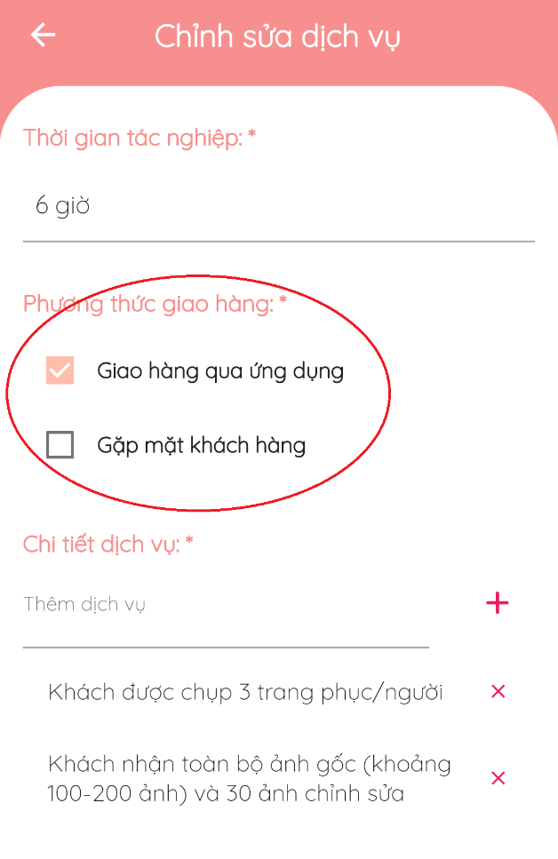

*図147 - 配信方法を選びます*

#### 4.3.16. プロファイルの管理

* **目標**
  + ユーザーがプロファイルを編集します
* **機能**
  + プロファイルを編集します
  + アバターやカバーを変更します
* **ユーザーインターフェース**

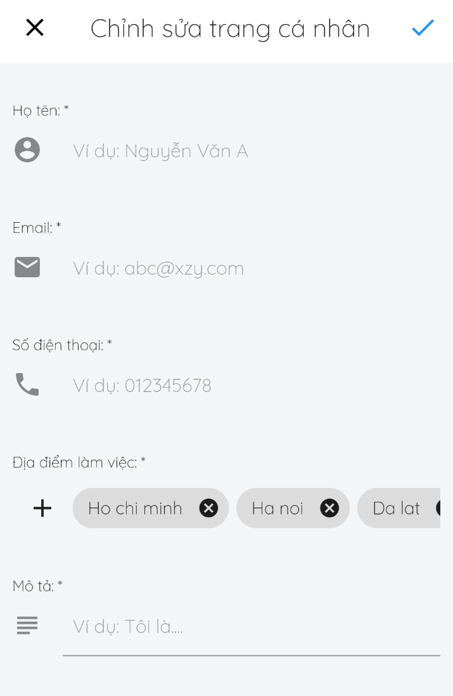

*図148 – プロファイルを編集します*

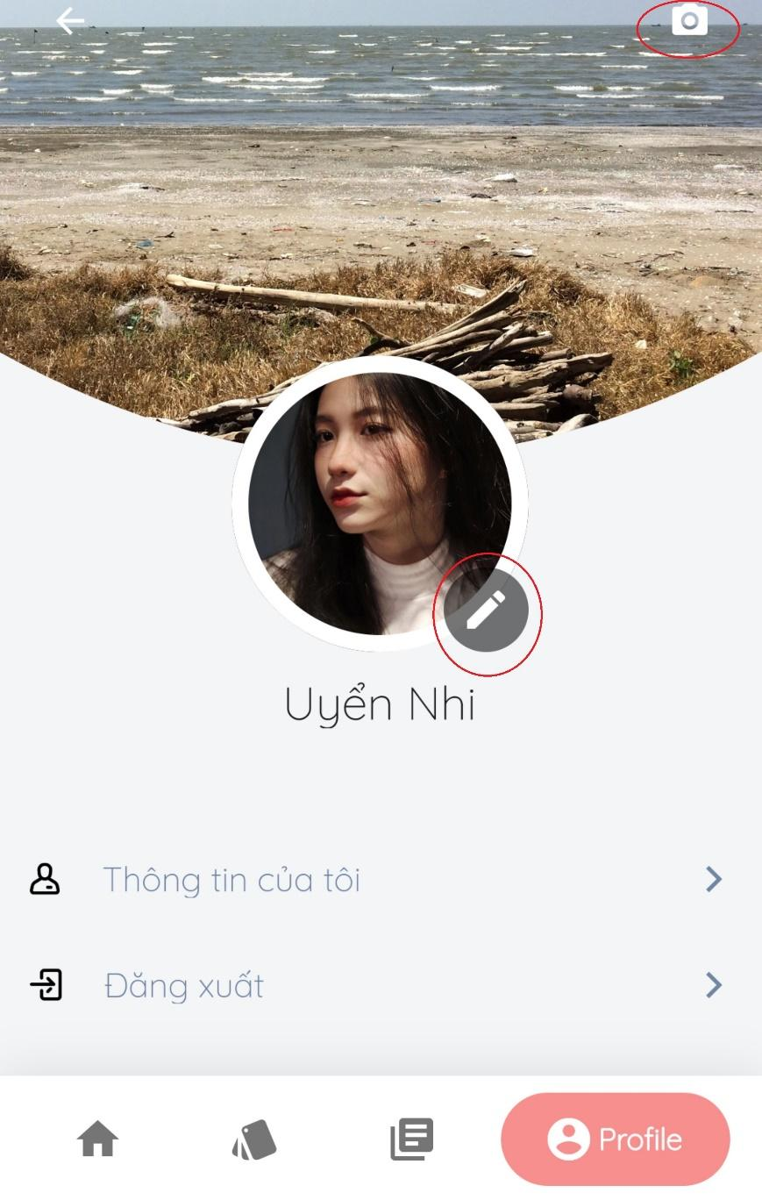

*図149 –アバター／コバーを変更します*

### 4.4トラブルシューティング

**1.現在の場所を特定できない場合があります**

最初の発生

* テストの間に

問題

* ケイタイの現在の場所は許可されていません

回避策

次のステップを実行します:

* **設定**> **現在の場所** > **オン**

**2. プロファイルのイメージを失敗しに変更する場合があります**

最初の発生

* テストの間に

問題

* イメージのサイズが最大許容サイズを超えています

回避策

* 他の小さなイメージを選択します

# VII. Appendix

## 1. Glossary [Optional]

|  |  |
| --- | --- |
| **Acronym** | **Definition** |
| PWM | Psychology website |
| AWS | Amazon Web Services |
| BA | Business Analysis |
| BR | Business Rule |
| ERD | Entity Relationship Diagram |
| GUI | Graphical User Interface |
| PM | Project Manager |
| SDD | Software Design Description |
| SPMP | Software Project Management Plan |
| SRS | Software Requirement Specification |
| UAT | User Acceptance Test |
| UC | Use Case |
| API | Application Program Interface |

*Table 119 Glossary*

## 2. References [Optional]

1. **MySQL** [Online] Available: <https://www.mysql.com/>**.**
2. **Android Studio** [Online] Available: <https://developer.android.com/docs>.

## 3. Others [Optional]